HTTP:

Used to access information back and forth from internet.

GET / HTTP/1.1

HOST: www.example.com

/ is the root of the web page.

and response would be like,

HTTP / 1.1 200 OK

Content-Type: text/html

some of the http status codes are;

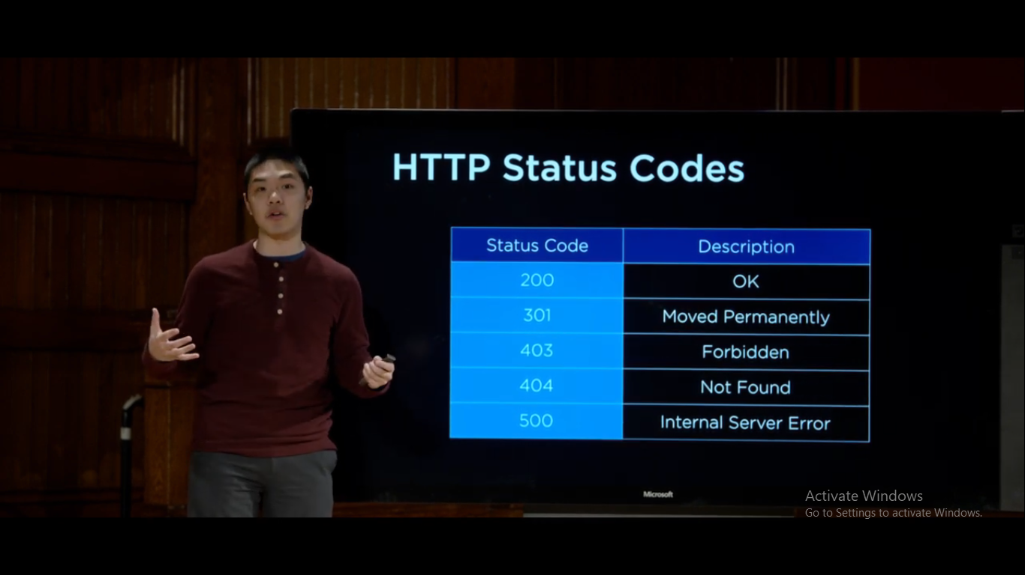

pip:

(python packet manager) used to install new packages.

Install django:

pip3 install Django

To create a django project:

django-admin startproject PROJECT_NAME

It create a starter file.