Torry Harris Integrated Solutions

**Age and Gender Detection using Deep learning**

**Introduction:**

This project aims to explore the realm of age and gender prediction using advanced machine learning and computer vision techniques.

**Objectives:**

The primary objectives of this project is,

* To build a machine learning model capable of accurately predicting the age of individuals from facial images.
* The model should be able to provide age estimates within a reasonable margin of error, taking into account the variations and complexities associated with aging patterns.

**Dataset Used:**

We have used a most popular dataset called the “**UTKFace**” dataset which has more than 23,000 face images from age 1 to 116.

**Steps Involved:**

* Pre-processing and cleaning the dataset
* We split the file name of each image on the underscore (_) and append them in separate lists.
* We normalize the pixel values to the range of [0,1] for better accuracy.
* Creating data frame
* We convert unstructured data to structured data.
* Plotting the images
* We create a subplot for the images.
* Splitting of the dataset as train and test as 70% and 30% respectively.
* Extracting the features
* Converting the image into NumPy array.
* Normalizing the training data
* Normalize the pixel values within [0,1].
* The height and width of the image is taken as 128 pixels.
* Creating a model
* We use convolutional neural networks with residual connections to improve performance of deep neural networks.
* We use “**ReLU**” activation function for the fully connected dense layers and “**sigmoid**” function for output layer (probability).
* Training the model
* We train the model with a batch size of 10, with 10% of validation split on 20epochs.
* We got the accuracy around 85% - 90%.
* Visualizing the loss
* We plot training and validation loss for gender classification as well as age prediction over the epochs.

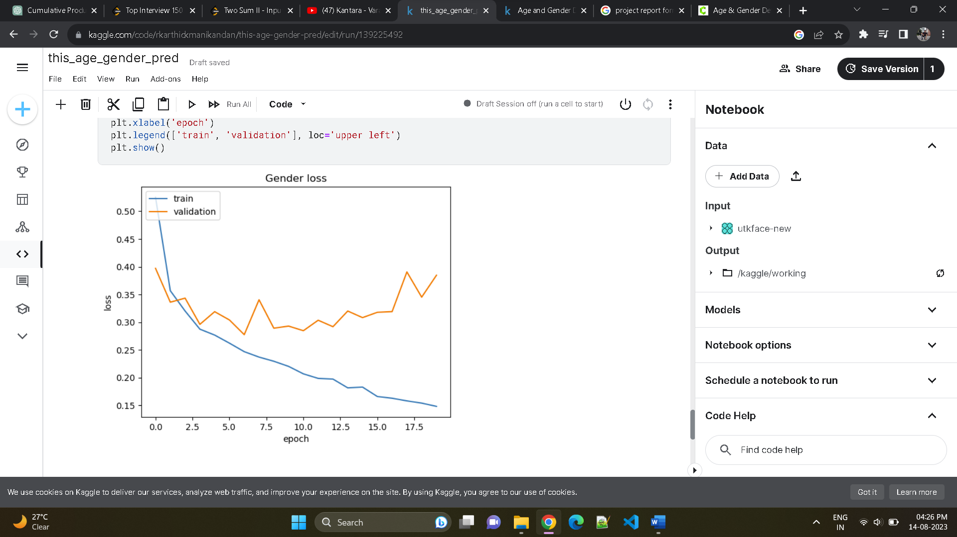

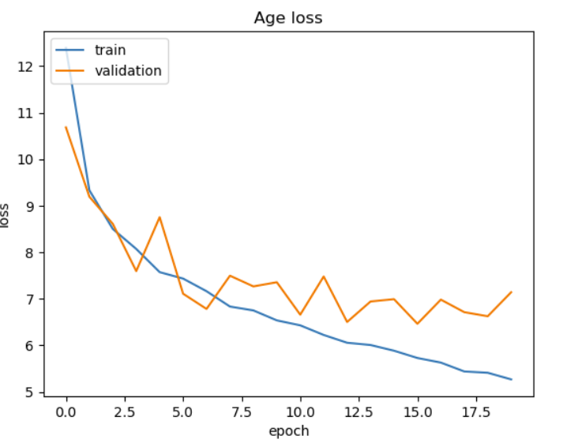

* Predicting the test image
* We take a random image index and pass it as input to the model.

The original gender was Female and age 29. The model predicted the gender correctly and age as 30.

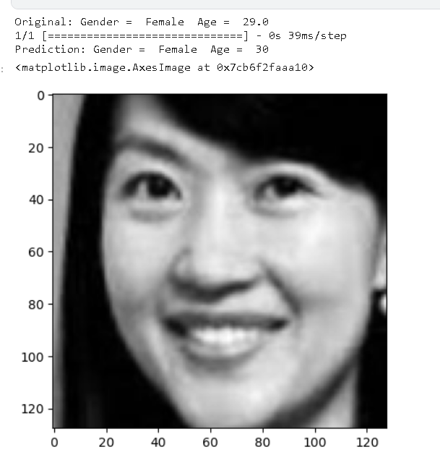

**Use Cases:**

This model can be used in,

* Product recommendation
* Behaviour analysis
* Authentication
* Target marketing strategies
* User engagement and satisfaction and many more..

**Conclusion:**

Through the integration of machine learning algorithms and computer vision techniques, we were able to achieve accurate and reliable predictions. The age detection module demonstrated remarkable performance, accurately estimating the age of individuals within a reasonable margin of error.