UAE Real Estate Analytics Dashboard
Dashboard Page Layout & Visual Reference Guide | 4 Pages | 8,000 Properties

Dashboard Summary — All Pages

Page # | Page Name | Purpose | KPIs | Charts | Slicers
1 | Home | Portfolio overview with For Sale/For Rent toggle | 4 | 4 | 5
2 | Sold Property | Sales transactions, monthly trend, broker leaderboard | 4 | 3 | 3
3 | Rental Insights | Rental occupancy, monthly trend, broker leaderboard | 4 | 3 | 4
4 | Broker Performance | Cross-portfolio broker ranking & full commission matrix | 5 | 3 | 3

Color Theme Reference

Color Name | Hex Code | Used For
Navy Blue | #1A2E4A | Page headers, key labels
Royal Blue | #2563EB | Sales charts, KPI cards
Teal | #0D9488 | Rental charts, occupancy KPIs
Gold / Amber | #F59E0B | Rank #1 highlight in leaderboards
Orange | #EA580C | Days-on-market KPI, cumulative line
Green | #16A34A | Revenue / value KPI cards
Light Grey | #F3F4F6 | Slicer bar background, alt table rows

Recommended Build Order

Step | Action
1 | Set up data model & all 7 relationships (see Setup Guide)
2 | Add 2 helper tables: SaleStatus and ViewSelector (Enter Data)
3 | Create all DAX measures inside a blank _Measures table
4 | Build Page 2 (Sold Property) — validates sales measures
5 | Build Page 3 (Rental Insights) — mirrors Page 2 for rentals
6 | Build Page 1 (Home) — toggle logic needs Pages 2 & 3 complete
7 | Build Page 4 (Broker Performance) — uses combined measures
8 | Add page navigation buttons/tabs on all 4 pages
9 | Apply consistent color theme, fonts (Segoe UI), and padding

PAGE 1 — Home — Portfolio Overview
Page 1 of 4

Purpose
Entry point for the report. Gives an executive snapshot of the entire portfolio with a For Sale / For Rent toggle that switches all visuals between the two listing streams. All four charts respond to the toggle via SWITCH(SELECTEDVALUE(...)) measures.
Layout Diagram

+---------------------------------------------------------------------------+
| HEADER 'UAE Real Estate Analytics Dashboard' [For Sale | For Rent o] |
+--------------------------------------------+------------------------------+
| SLICERS [Emirate v] [Year v] [Prop Type v] [Broker v] |
+-------------+---------------+-----------------+----------------------------+
| KPI: | KPI: | KPI: | KPI: |
| Total Comm | Props Closed | Avg Days on Mkt | Total Listings |
| AED 311M | 5,125 | 38 days | 8,000 |
+------------------------------------+---------------------------------------+
| Col Chart: Commission by Month | Donut: Commission by Sale Status |
| (Jan-Dec, AED M, 60 % width) | (Sold AED 292.6M / Rented 18.6M, 40%)|
+----------------------------+-------+-------------------+-------------------+
| Stacked Bar: Props by Type | (55%) | Bubble Map: UAE | (45%) |
| Sold (blue) / Total (grey) | | size=Sale Value | |
+----------------------------+-------+-------------------+-------------------+

Sample Dashboard Preview

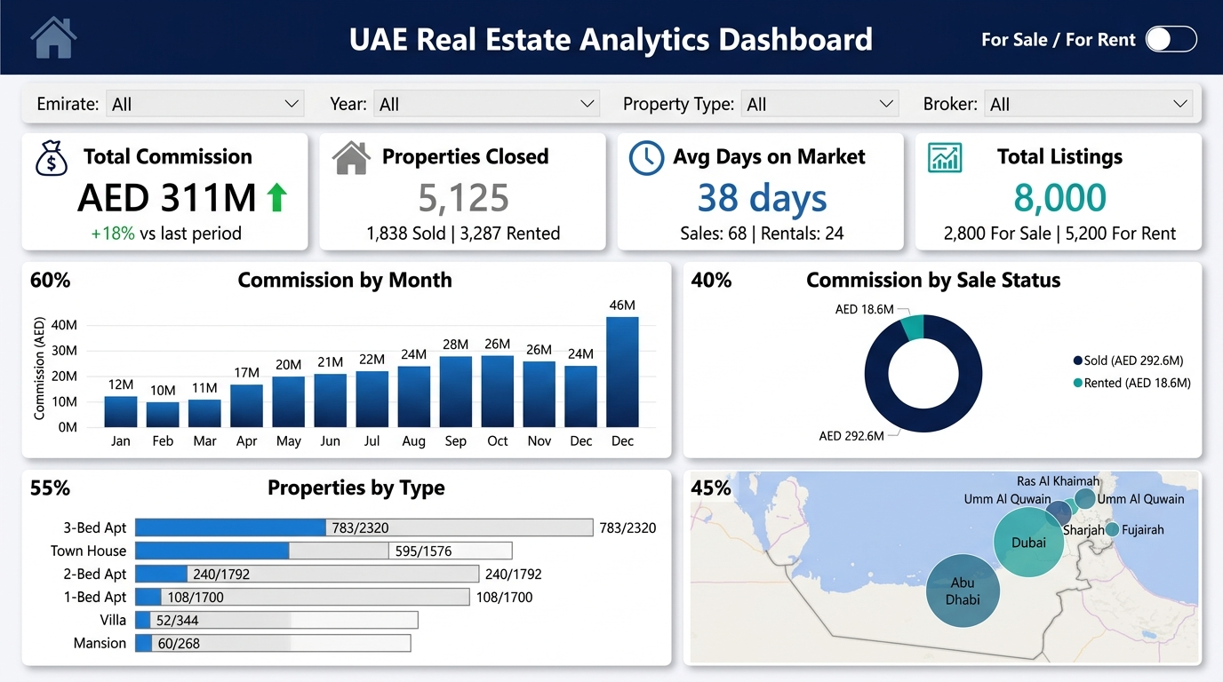

Slicers (5 total)

Slicer Name | Field / Table[Column] | Style | Position on Page
Emirate | Dim_State[Emirate] | Dropdown | Filter bar — Position 1
Year | Dim_Date[Year] | Dropdown | Filter bar — Position 2
Property Type | Dim_Property[PropertyType] | Dropdown | Filter bar — Position 3
Broker | Dim_Broker[BrokerTeamName] | Dropdown | Filter bar — Position 4
For Sale / For Rent Toggle | ViewSelector[SelectedView] | Button Tile | Header — top right corner

KPI Cards (4 total)

Card Title | DAX Measure | Sample Value | Position
Total Commission | [Total Commission Combined] | AED 311.1M | 1st card — left
Properties Closed | [Properties Sold] + [Properties Rented] | 5,125 | 2nd card
Avg Days on Market | Blended avg (Sales = 68 days, Rentals = 24 days) | 38 days | 3rd card
Total Listings | COUNTROWS(Dim_Property) | 8,000 | 4th card — right

Charts (4 total)

Chart Title | Visual Type | Fields / Measure | Zone & Width
Commission by Month | Clustered Column | [Selected Commission] by Dim_Date[MonthName] | Middle left — 60 %
Commission by Sale Status | Donut Chart | [Commission by Status] via SaleStatus helper table | Middle right — 40 %
Properties by Type | Stacked Horiz Bar | [Selected Closed Count] (filled) vs total (grey) | Bottom left — 55 %
Properties by Emirate | Bubble Map (UAE) | [Property Value Sold] drives bubble size; Dim_State[Emirate] | Bottom right — 45 %

Experienced Data Analyst | 1.5 years of experience | Power BI,
SQL, Excel & Python | Business Intelligence & Data Visualization
| Azure | Dashboard Development | Data-Driven Insights | Open to
work in Dubai.
PAGE 2 — Sold Property Analysis
Page 2 of 4

Purpose
Deep-dive into all 1,838 completed sales transactions. Shows monthly volume, per-property-type conversion rates (Sold / Total Available), and a ranked broker leaderboard sorted by commission earned with conditional-format data bars.
Layout Diagram

+---------------------------------------------------------------------------+
| HEADER 'Sold Property Analysis' |
| NAV: Home | [Sold Property] | Rental Insights | Broker Perf |
+--------------------------------------------+------------------------------+
| SLICERS [Emirate v] [Year v] [Property Type v] |
+-------------+----------------+----------------+----------------------------+
| KPI: | KPI: | KPI: | KPI: |
| Props Sold | Total Sale Val | Avg Sale Price | Avg Days on Market |
| 1,838 | AED 8.25B | AED 4.49M | 68 days |
+------------------------------------+---------------------------------------+
| Combo: Sold by Month | Stacked Bar: Sales by Property Type |
| Bars=count, Line=cumulative (55%) | Sold/Total per type (45%) |
+-------------------------------------------------------------------+-------+
| TABLE: Broker Leaderboard | |
| Rank | Broker Team | Props Sold | % of Total | Commission | Contrib % (100%)|
+-----------------------------------------------------------------------+---+

Sample Dashboard Preview

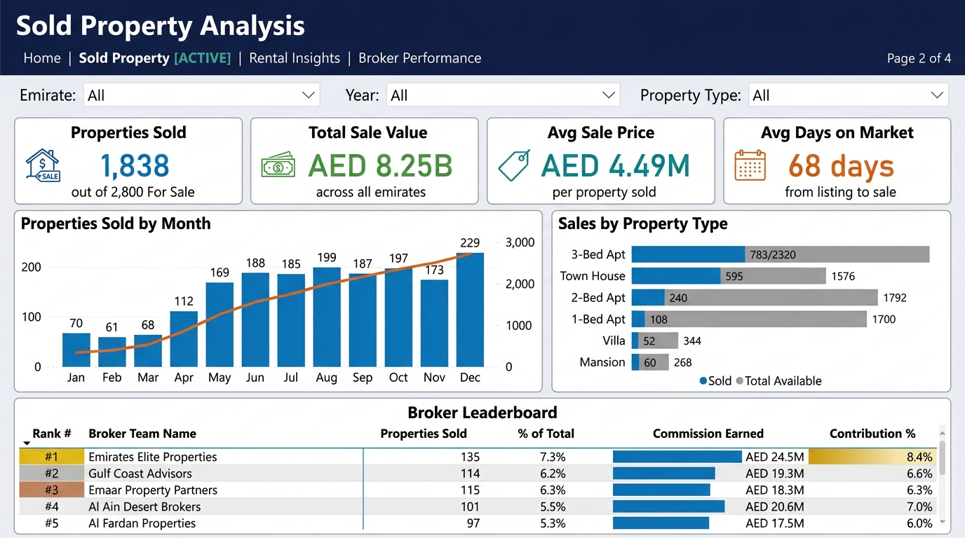

Slicers (3 total)

Slicer Name | Field / Table[Column] | Style | Position on Page
Emirate | Dim_State[Emirate] | Dropdown | Filter bar — Position 1
Year | Dim_Date[Year] | Dropdown | Filter bar — Position 2
Property Type | Dim_Property[PropertyType] | Dropdown | Filter bar — Position 3

KPI Cards (4 total)

Card Title | DAX Measure | Sample Value | Position
Properties Sold | [Properties Sold] | 1,838 | 1st card
Total Sale Value | [Property Value Sold] | AED 8.25B | 2nd card
Avg Sale Price | DIVIDE([Property Value Sold], [Properties Sold]) | AED 4.49M | 3rd card
Avg Days on Market | [Avg Days on Market Sales] | 68 days | 4th card

Charts (3 total)

Chart Title | Visual Type | Fields / Measure | Zone & Width
Properties Sold by Month | Combo: Bar + Line | Bars=[Properties Sold] by month; Line=running cumulative total | Middle left — 55 %
Sales by Property Type | Stacked Horiz Bar | [Sold - Type Sold Count] (filled) vs [Sold - Type Total Count] (grey) | Middle right — 45 %
Broker Leaderboard | Table / Matrix | [Broker-Sold Rank], [Broker-Commission], [Broker-Contribution%] | Bottom — full width

PAGE 3 — Rental Insights
Page 3 of 4

Purpose
Mirrors the Sold Property page but scoped entirely to rental transactions. Tracks occupancy rate (3,287 / 5,200 = 63.2 %), monthly rental flow, per-property-type conversion, and a separate broker leaderboard for rental commissions.
Layout Diagram

+---------------------------------------------------------------------------+
| HEADER 'Rental Insights' |
| NAV: Home | Sold Property | [Rental Insights] | Broker Perf |
+--------------------------------------------+------------------------------+
| SLICERS [Emirate v] [Year v] [Prop Type v] [Lease Term v] |
+-------------+----------------+----------------+----------------------------+
| KPI: | KPI: | KPI: | KPI: |
| Props Rented| Annual Rent | Occupancy Rate | Avg Days on Market |
| 3,287 | AED 581.3M | 63.2 % | 24 days |
+------------------------------------+---------------------------------------+
| Combo: Rented by Month | Stacked Bar: Rentals by Prop Type |
| Bars=count, Dashed=new listings(55%)| Rented(teal)/Total(grey) (45%) |
+-------------------------------------------------------------------+-------+
| TABLE: Broker Leaderboard - Rentals | |
| Rank | Broker Team | Props Rented | Rent Commission | Occ% | DOM (100%) |
+-----------------------------------------------------------------------+---+

Sample Dashboard Preview

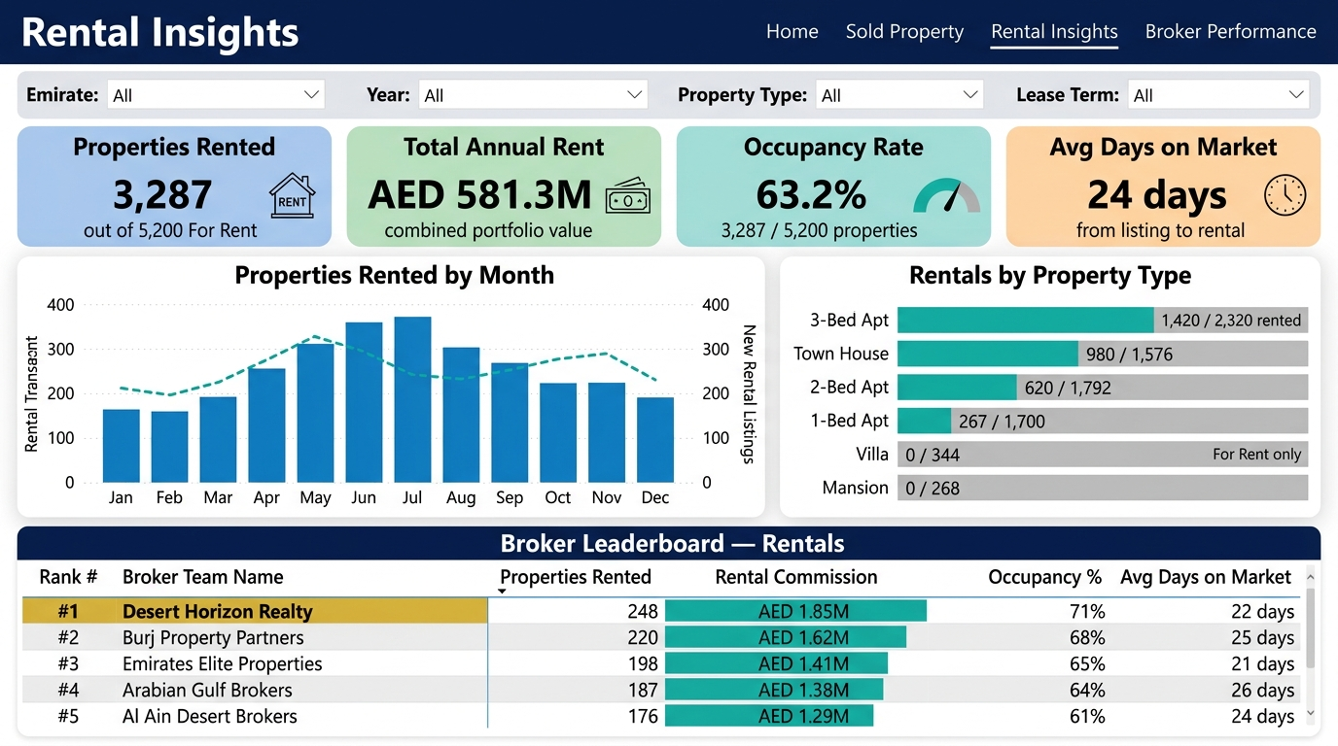

Slicers (4 total)

Slicer Name | Field / Table[Column] | Style | Position on Page
Emirate | Dim_State[Emirate] | Dropdown | Filter bar — Position 1
Year | Dim_Date[Year] | Dropdown | Filter bar — Position 2
Property Type | Dim_Property[PropertyType] | Dropdown | Filter bar — Position 3
Lease Term | Fact_Rentals[LeaseTermMonths] | Dropdown | Filter bar — Position 4

KPI Cards (4 total)

Card Title | DAX Measure | Sample Value | Position
Properties Rented | [Properties Rented] | 3,287 | 1st card
Total Annual Rent | [Total Annual Rent] | AED 581.3M | 2nd card
Occupancy Rate | [Occupancy Rate] | 63.2 % | 3rd card
Avg Days on Market | [Avg Days on Market Rentals] | 24 days | 4th card

Charts (3 total)

Chart Title | Visual Type | Fields / Measure | Zone & Width
Properties Rented by Month | Combo: Bar + Dashed Line | Bars=[Properties Rented] by month; Line=[New Listings For Rent] | Middle left — 55 %
Rentals by Property Type | Stacked Horiz Bar | [Rent-Type Rented Count] (teal) vs [Rent-Type Total Count] (grey) | Middle right — 45 %
Broker Leaderboard Rentals | Table / Matrix | [Commission Earned Rentals], [Occupancy Rate], Avg DOM | Bottom — full width

PAGE 4 — Broker Performance Overview
Page 4 of 4

Purpose
Cross-portfolio view combining Sales and Rentals for all 18 broker teams. Ranks brokers by total commission, breaks performance down by emirate, and displays a full comparative matrix with Sales Props, Sales Commission, Rental Props, Rental Commission, and a Combined Rank column.
Layout Diagram

+---------------------------------------------------------------------------+
| HEADER 'Broker Performance Overview' |
| NAV: Home | Sold Property | Rental Insights | [Broker Perf] |
+--------------------------------------------+------------------------------+
| SLICERS [Broker Team v] [Emirate v] [Year v] |
+--------+-----------+---------------+------------------+--------------------+
| KPI: | KPI: | KPI: | KPI: | KPI: |
| Brokers| Total Comm| Avg Comm | Top Broker | Combined Closed |
| 18 | AED 311M | AED 17.3M | Emirates Elite | 5,125 |
+------------------------------------+---------------------------------------+
| Ranked Bar: Top Brokers by Comm | Stacked Col: Broker Perf by Emirate |
| (10 brokers, blue, sorted DESC,50%)| (7 emirates, stacked segments, 50%) |
+-------------------------------------------------------------------+-------+
| MATRIX: Broker Full Performance | |
| Team | Emirate | Size | Yrs | Sales Props | Sales Comm | Rent Props | Rent Comm | Total | Rank|
+-----------------------------------------------------------------------+---+

Sample Dashboard Preview

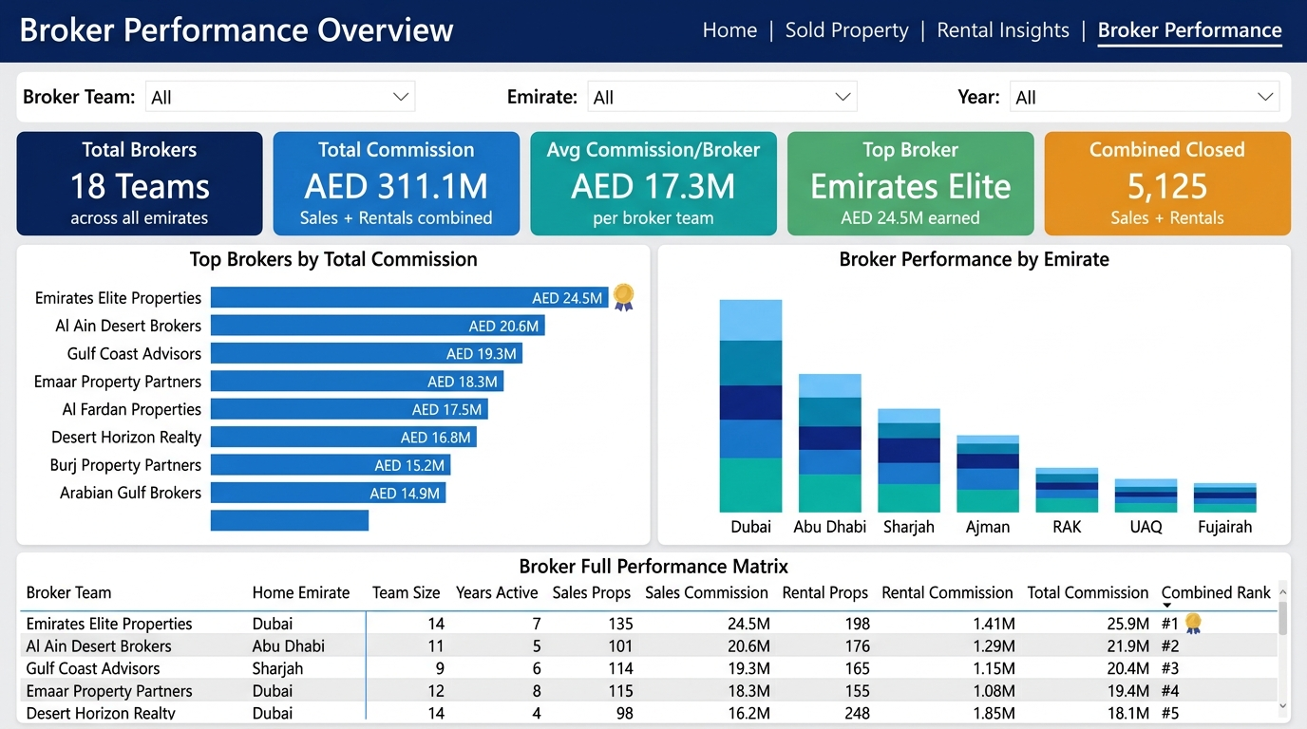

Slicers (3 total)

Slicer Name | Field / Table[Column] | Style | Position on Page
Broker Team | Dim_Broker[BrokerTeamName] | Dropdown | Filter bar — Position 1
Emirate | Dim_State[Emirate] | Dropdown | Filter bar — Position 2
Year | Dim_Date[Year] | Dropdown | Filter bar — Position 3

KPI Cards (5 total)

Card Title | DAX Measure | Sample Value | Position
Total Brokers | COUNTROWS(Dim_Broker) | 18 Teams | 1st card
Total Commission | [Total Commission Combined] | AED 311.1M | 2nd card
Avg Commission/Broker | DIVIDE([Total Commission Combined], COUNTROWS(Dim_Broker)) | AED 17.3M | 3rd card
Top Broker | Text measure: name of #1 broker by [Total Commission Combined] | Emirates Elite | 4th card
Combined Closed | [Properties Sold] + [Properties Rented] | 5,125 | 5th card

Charts (3 total)

Chart Title | Visual Type | Fields / Measure | Zone & Width
Top Brokers by Commission | Ranked Horizontal Bar | [Total Commission Combined] per broker — sorted DESC, 10 bars shown | Middle left — 50 %
Broker Performance by Emirate | Stacked Column | [Total Commission Combined] stacked by Dim_Broker per Dim_State[Emirate] | Middle right — 50 %
Broker Full Performance Matrix | Matrix Table | Sales + Rental KPIs side by side: Props|Comm|OccRate|DOM|TotalComm|CombinedRank | Bottom — full width

