Assignment-1

1. Trigger a pipeline using Git when push on develop branch

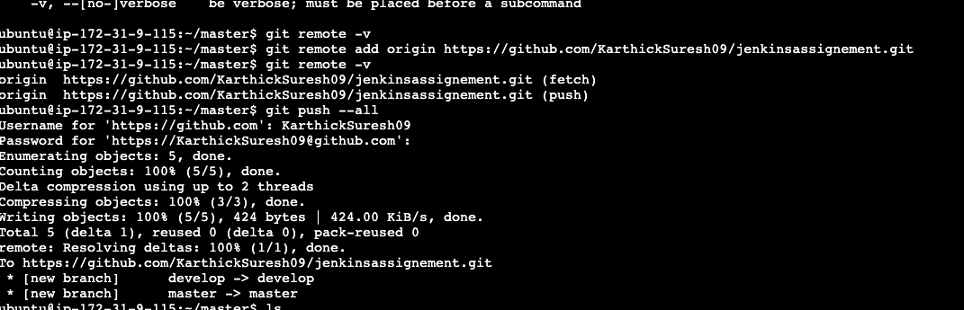

2. Pipeline should pull Git content to a folder

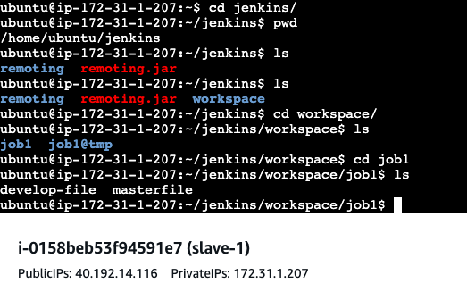

Assignment-2

1. Add 2 nodes to Jenkins master

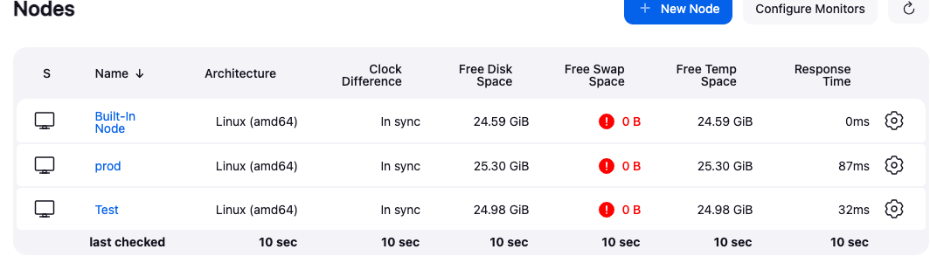

2. Create 2 jobs with the following jobs:

a. Push to test b. Push to prod

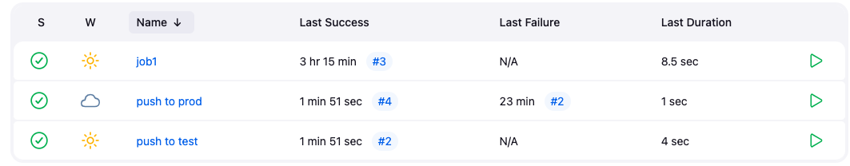

3. Once a push is made to test branch, copy Git files to test server

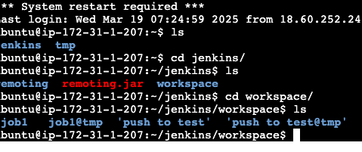

4. Once a push is made to master branch, copy Git files to prod server

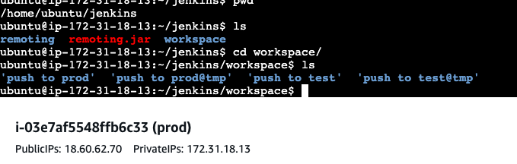

Assignment-3

1. Create a pipeline in Jenkins

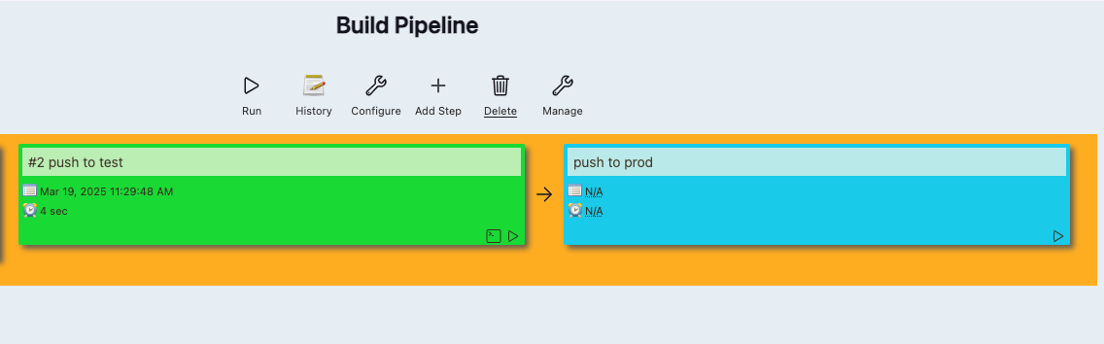

2. Once push is made to “develop” a branch in Git, trigger job “test”. This will copy Git files to test node

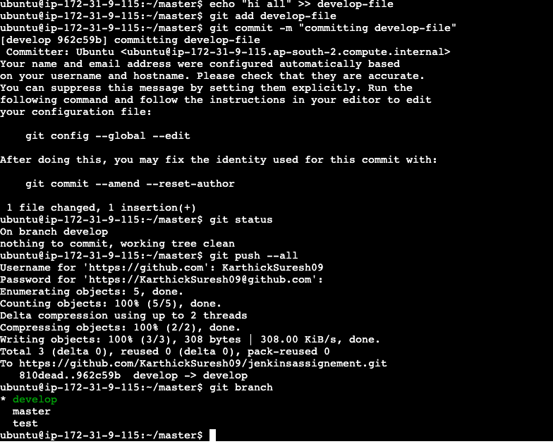

3. If test job is successful, then prod job should be triggered

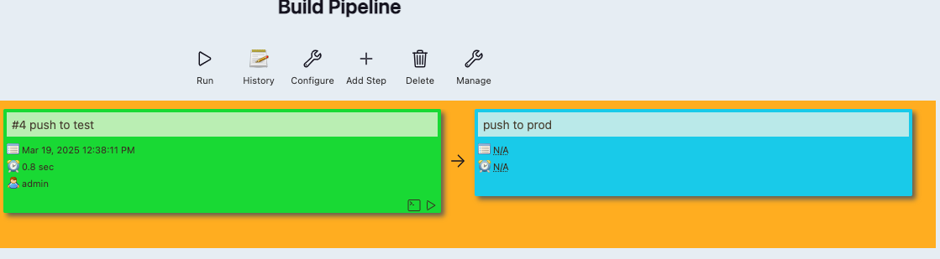

4. Prod jobs should copy files to prod node

