**Insight Stream – Navigate the news landscape**

**1.Introduction**

Category:Frontend development with DBA by MongoDB

Project Title: Insight Stream – Navigate the news lanscape

**Team Members**

1.R.Karthicka

2.V.Kalaivani

3.R.Jayasri

4.N.Karthika

**2. Project Overview**

**Purpose:**

The goal of Insight Stream is to provide users with real-time, categorized, and reliable news articles in a clean and interactive interface.

**Features:**

Live news updates fetched via API

Category-wise filtering (Politics, Technology, Sports, Entertainment, etc.).

Search functionality for specific news topics.

Responsive design for mobile and desktop users.

Bookmarking favorite articles.

**3.Architecture**

**Component Structure:**

App.js → Root component.

Navbar.js → Navigation bar with categories.

NewsList.js → Displays news articles.

NewsCard.js → Individual news article card.

SearchBar.js → For searching news topics.

**State Management:**

Implemented using Context API for global state.

Handles news data, bookmarks, and category filtering.

**Routing:**

Implemented with React Router DOM.

Routes: /, /category/:name, /search, /bookmarks.

**4. Setup Instruction**:

**Prerequisites:**

Node.js (v16+ recommended)

npm or yarn

**Installation:**

git clone https://github.com/username/insight-stream.git

cd insight-stream

npm install

npm start

**5. Folder Structure**

/insight-stream

┣ /public

┣ /src

┃ ┣ /components

┃ ┃ ┣ Navbar.js

┃ ┃ ┣ NewsCard.js

┃ ┃ ┣ SearchBar.js

┃ ┃ ┣ Bookmark.js

┃ ┣ /pages

┃ ┃ ┣ Home.js

┃ ┃ ┣ Category.js

┃ ┃ ┣ SearchResults.js

┃ ┃ ┣ Bookmarks.js

┃ ┣ /context

┃ ┃ ┗ NewsContext.js

┃ ┣ App.js

┃ ┣ index.js

┣ package.json

**6. Running the Application**

**Frontend:**

npm start

Runs the app in development mode at http://localhost:3000/.

**7. Component Documentation**

**Key Components:**

Navbar → Navigation across categories.

NewsList → Renders fetched articles.

NewsCard → Displays article title, description, image, and source.

**Reusable Components:**

Button, Loader, Modal.

**8.State Management**

**Global State:**

News API data, selected category, search results.

**Local State:**

Pagination handling, modal visibility, input fields.

**9. User Interface**

Responsive Material UI + Tailwind CSS design.

Mobile-friendly layout.

Screenshots/GIFs showing:

Home Page with latest news.

Category selection.

Bookmarked articles view.

**10. Styling**

**CSS Frameworks/Libraries**:

Tailwind CSS

Material UI Components

**Theming:**

Light/Dark mode toggle.

**11. Testing**

**Testing Strategy**:

Unit tests for components with Jest.

UI testing with React Testing Library.

**Code Coverage:**

Ensuring >80% coverage.

**12. Screenshots :**

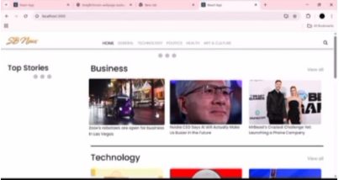

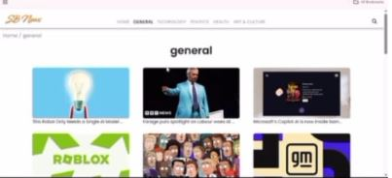

**Demo link:**

<https://drive.google.com/file/d/1RUw5Y6cMZVBr0QrmIf7adCrgJzFd9Inl/view?usp=drivesdk>

**13. Known Issues**

Sometimes API rate limits may cause delays.

Search performance can be optimized for large datasets.

**14. Future Enhancements**

Add AI-powered news summarization.

Implement push notifications for breaking news

Support for multiple languages.

Progressive Web App (PWA) support.