KalviCore
Complete Campus. One Intelligent System.
Complete Screen Documentation
Built by AutoMystics
Affiliated to Madurai Kamaraj University
Tamil Nadu, India
Version 1.0 | April 16, 2026

Table of Contents
1. Login Page
2. Dashboard Overview
3. Departments
4. Students
5. Staff Management
6. Courses
7. Subjects
8. Attendance
9. Fees & Payments
10. Examinations
11. Hostel Management
12. Transport Management
13. Library Management
14. Events & Cultural
15. Communications
16. Inventory & Assets
17. Timetable
18. Assignments
19. Certificates
20. Staff Leaves
21. Settings & Configuration
22. User Management
23. Reports & Analytics
24. Activity Log
25. Academic Calendar
26. Payroll Management
27. CGPA Tracker
28. Bulk Import / Export
29. Hall Tickets
30. Student Portal
31. Data Backup & Restore
32. ID Cards
33. Notifications
34. Document Vault
35. Print Templates
36. Parent Portal
37. Dashboard Customization
38. Training & Placement
39. Fundraising & Donations
40. Visitor Management
41. Access Management

1. Login Page
The login screen is the entry point to KalviCore. It features the AutoMystics logo with the KalviCore branding and tagline "Complete Campus. One Intelligent System." Users can sign in using username and password, with a show/hide toggle for the password field. Six Quick Login buttons provide one-click demo access for Admin, Principal, HOD, Faculty, Staff, and Student roles, each with distinct color-coded icons. The dark navy/teal background conveys a professional, enterprise-grade aesthetic.
Key Features:
- Username & password login with show/hide toggle
- 6 Quick Login role buttons (Admin, Principal, HOD, Faculty, Staff, Student)
- AutoMystics logo and KalviCore branding
- Dark teal/navy enterprise theme

2. Dashboard Overview
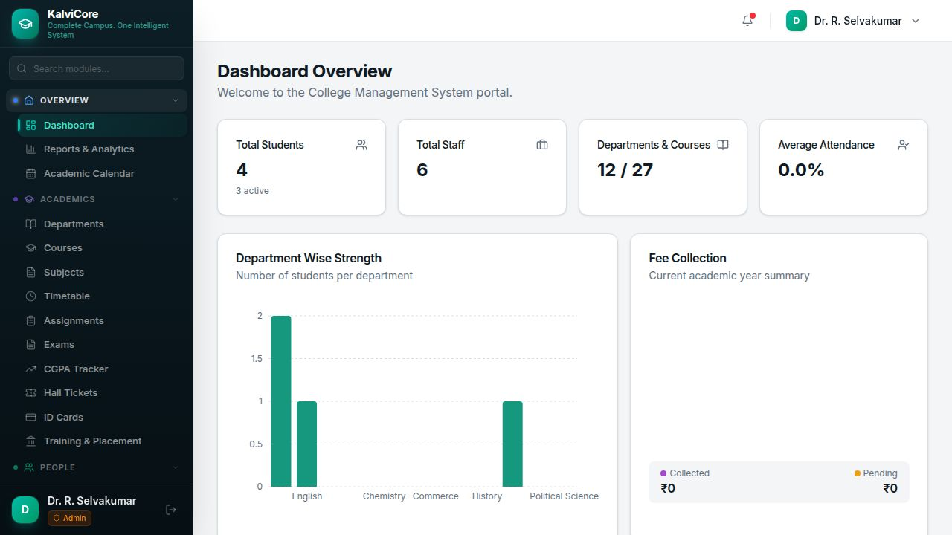
The Dashboard provides a real-time snapshot of the institution. Summary cards display Total Students, Total Staff, Departments & Courses count, and Average Attendance percentage. A Department Wise Strength bar chart shows student distribution across departments. A Fee Collection donut chart shows Collected vs Pending amounts in Indian Rupees. The collapsible sidebar organizes all 38+ modules under Overview, Academics, People, Finance, Campus, and Administration categories with a module search bar.
Key Features:
- Real-time stat cards (Students, Staff, Departments, Attendance)
- Department-wise student strength bar chart
- Fee collection summary with Collected/Pending breakdown
- Sidebar navigation with module search

3. Departments
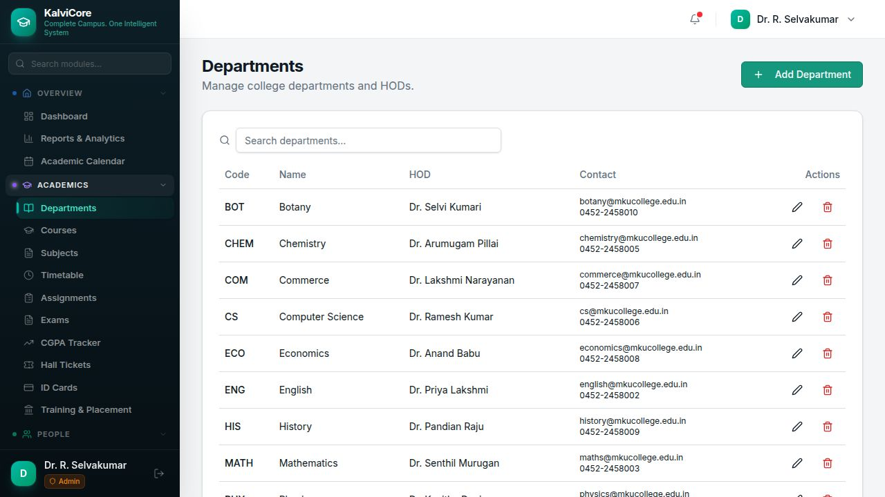
Manage all college departments with full CRUD operations. The table displays Department Code, Name, Head of Department (HOD), and Contact details (email and phone). 12 departments are pre-loaded including Botany, Chemistry, Commerce, Computer Science, Economics, English, History, Mathematics, Physics, Political Science, Tamil, and Zoology. Each department can be edited or deleted, and new departments can be added via the "Add Department" button.
Key Features:
- Department listing with Code, Name, HOD, Contact
- Search/filter departments
- Add, Edit, Delete operations
- 12 pre-loaded departments

4. Students
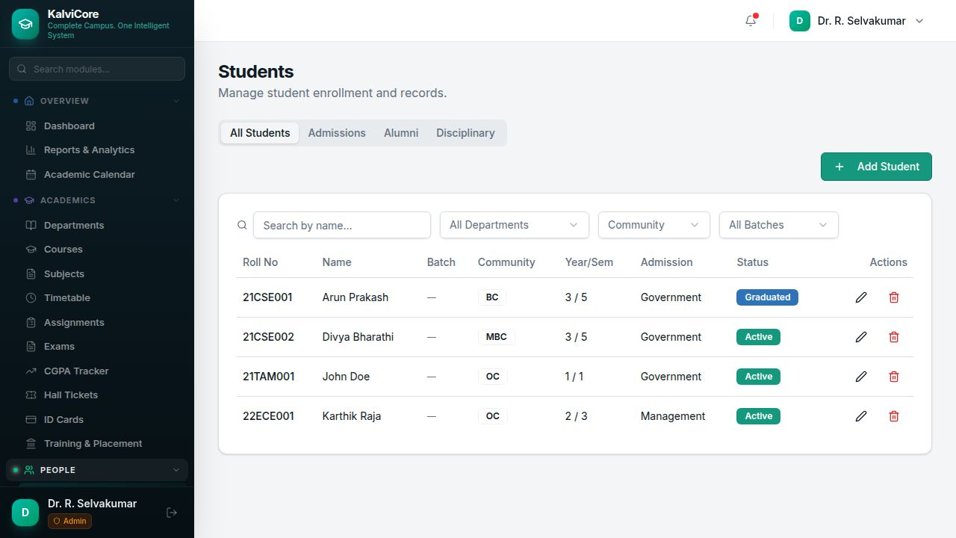
Comprehensive student management with tabbed views for All Students, Admissions, Alumni, and Disciplinary records. The student table shows Roll Number, Name, Batch, Community (BC/MBC/OC), Year/Semester, Admission Type (Government/Management), and Status (Active/Graduated). Filters allow searching by name, department, community, and batch. Status badges are color-coded green for Active and teal for Graduated.
Key Features:
- All Students / Admissions / Alumni / Disciplinary tabs
- Filters: Name, Department, Community, Batch
- Community badges (BC, MBC, OC)
- Status tracking (Active, Graduated)

5. Staff Management
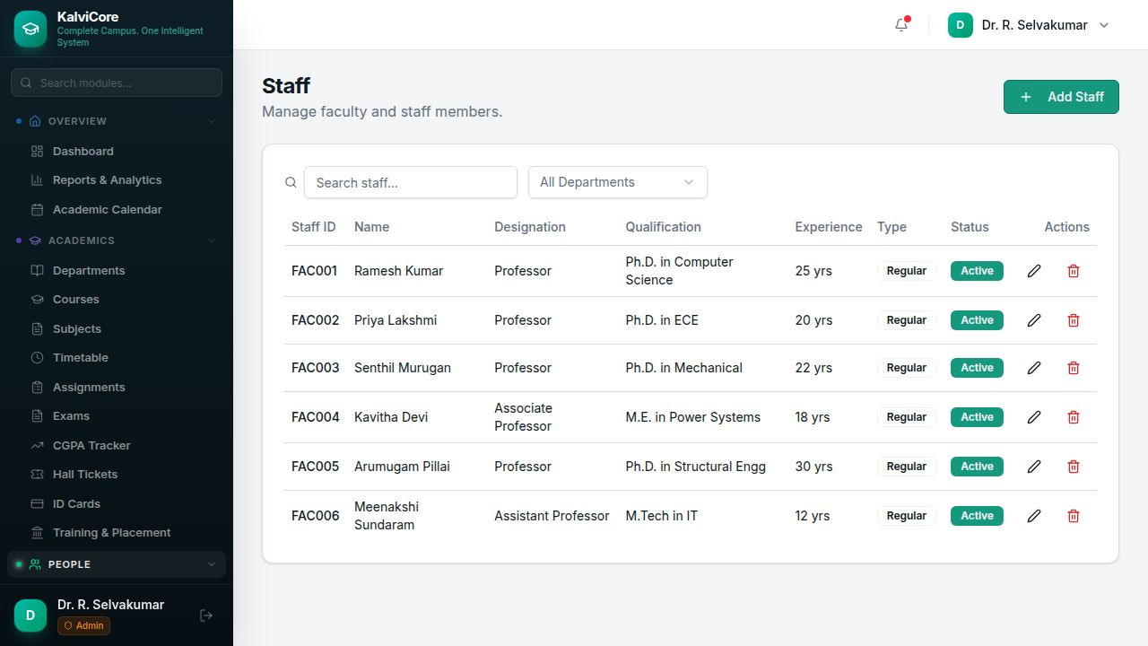
Faculty and staff management module displaying Staff ID, Name, Designation (Professor, Associate Professor, Assistant Professor), Qualification (Ph.D., M.E., M.Tech), Experience in years, Type (Regular/Contract), and Status (Active/Inactive). Staff can be filtered by department and searched by name or ID.
Key Features:
- Staff table with ID, Name, Designation, Qualification, Experience
- Department filter
- Regular/Contract type tracking
- Active/Inactive status badges

6. Courses
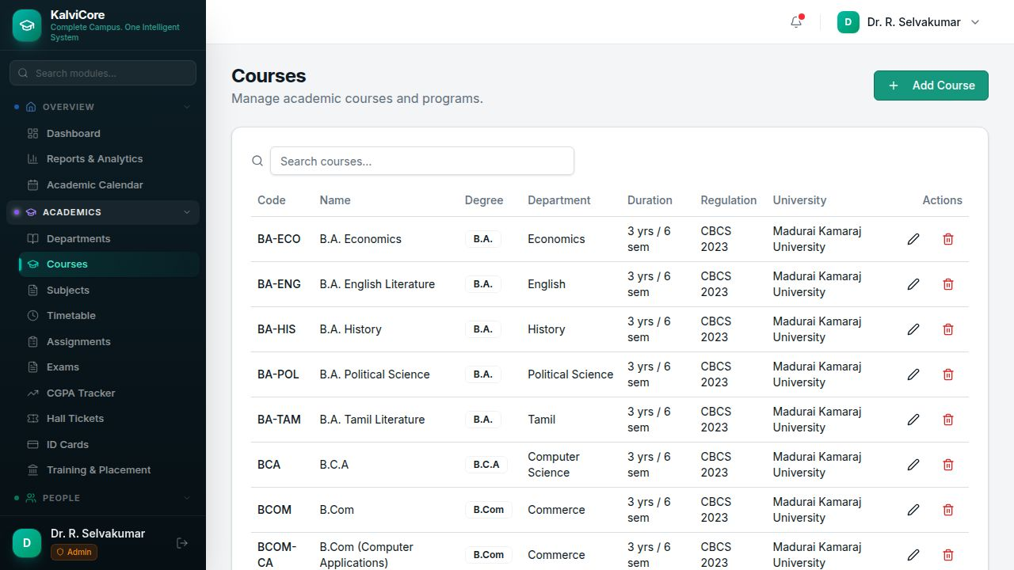
Academic course and program management listing 27 courses including B.A., B.Com, B.C.A, B.Sc., M.A., M.Sc., and M.Com programs. Each course shows Code, Name, Degree type, Department, Duration (years/semesters), Regulation (CBCS 2023), and University affiliation (Madurai Kamaraj University).
Key Features:
- 27 pre-loaded UG and PG courses
- Degree type badges (B.A., B.Com, B.C.A, B.Sc.)
- Duration, Regulation, and University details
- Search and Add Course functionality

7. Subjects
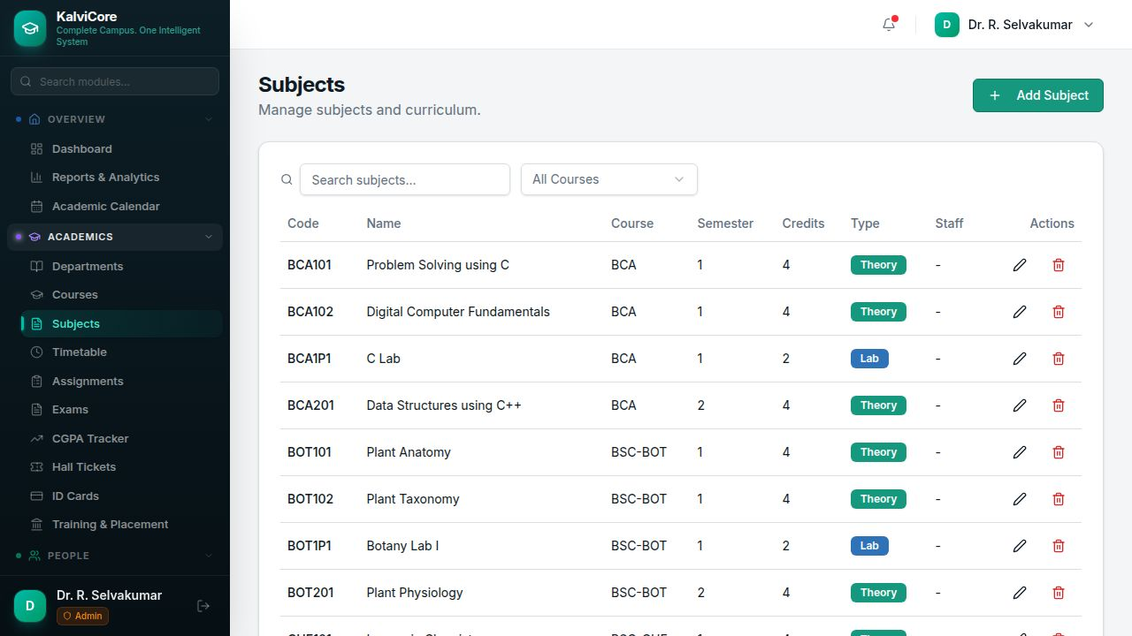
Curriculum and subject management with 57 pre-loaded subjects. The table shows Subject Code, Name, Course, Semester, Credits, Type (Theory/Lab), and assigned Staff. Subjects can be filtered by course and searched by name or code. Type badges are color-coded teal for Theory and green for Lab.
Key Features:
- 57 pre-loaded subjects across all courses
- Theory/Lab type badges
- Course filter and search
- Credits and semester mapping

8. Attendance
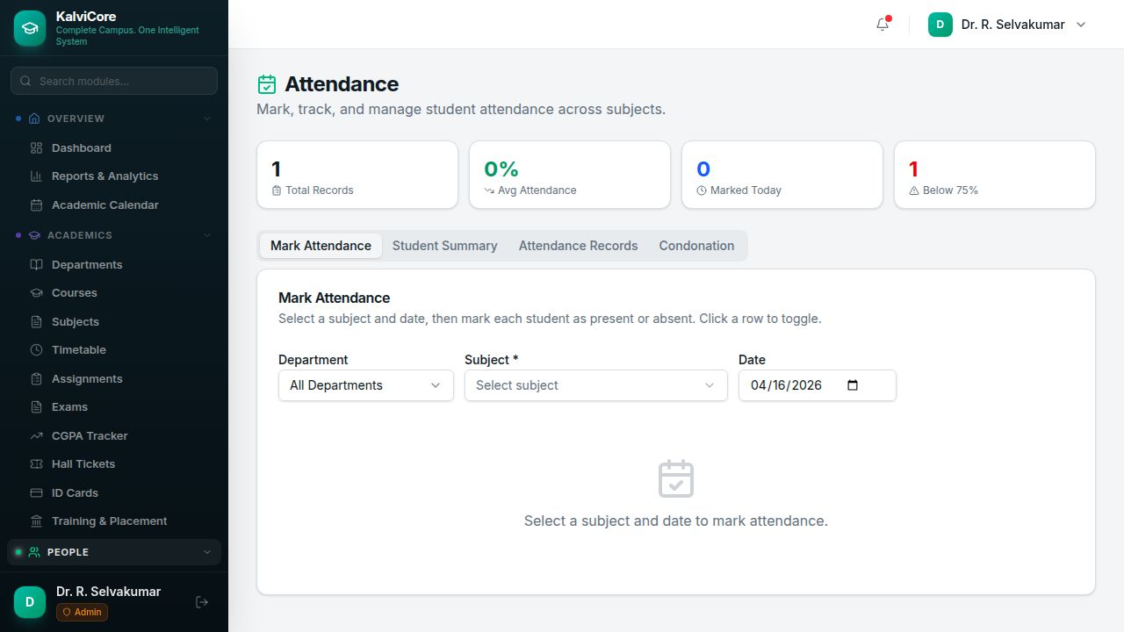
Complete attendance tracking with dashboard cards for Total Records, Average Attendance %, Marked Today, and Below 75% warnings. Four tabs provide Mark Attendance (select Department/Subject/Date to toggle attendance), Student Summary, Attendance Records history, and Condonation management for students below the threshold.
Key Features:
- Mark Attendance with toggle Present/Absent
- Student Summary and Records tabs
- Condonation management for below-threshold students
- Dashboard stats (Total, Average %, Today, Below 75%)

9. Fees & Payments
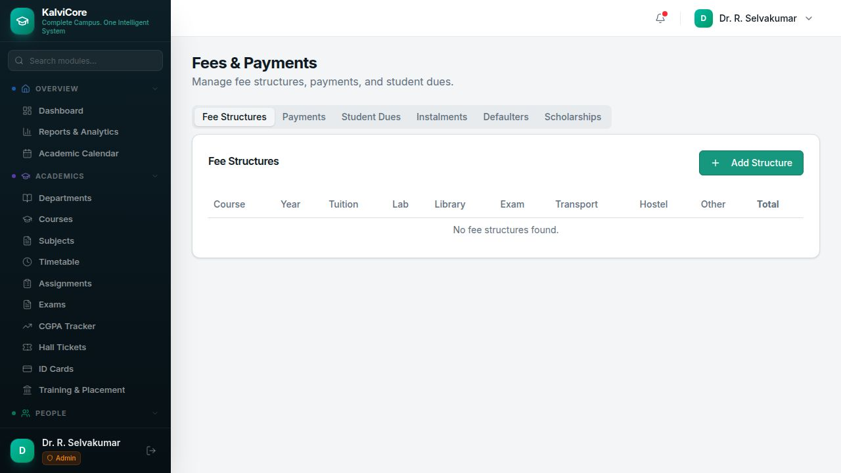
Comprehensive financial management with six tabs: Fee Structures (course-wise breakdown of Tuition, Lab, Library, Exam, Transport, Hostel, Other fees), Payments (record individual payments), Student Dues, Instalments (support installment plans), Defaulters (overdue payment tracking), and Scholarships (allocation and disbursement).
Key Features:
- Fee Structures with component-wise breakdown
- Payment recording and tracking
- Instalment plans support
- Defaulter identification and Scholarship management

10. Examinations
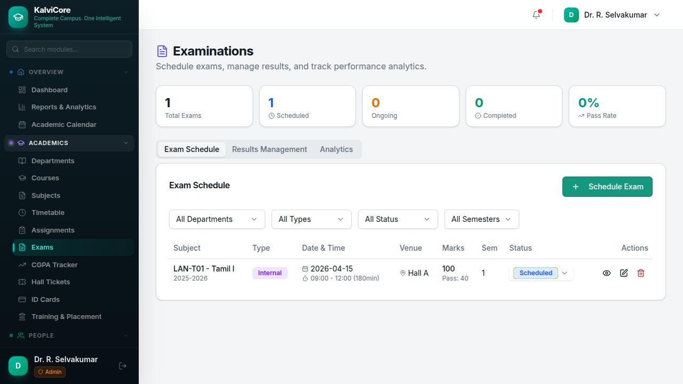
Exam scheduling, results, and analytics module. Dashboard cards show Total Exams, Scheduled, Ongoing, Completed, and Pass Rate. Three tabs cover Exam Schedule (Subject, Type Internal/External, Date & Time, Venue, Marks, Semester, Status), Results Management, and Analytics. Exam status can be changed via dropdown (Scheduled, Ongoing, Completed, Cancelled).
Key Features:
- Exam scheduling with venue and duration
- Internal/External exam types
- Results Management and Analytics tabs
- Status tracking (Scheduled, Ongoing, Completed, Cancelled)

11. Hostel Management
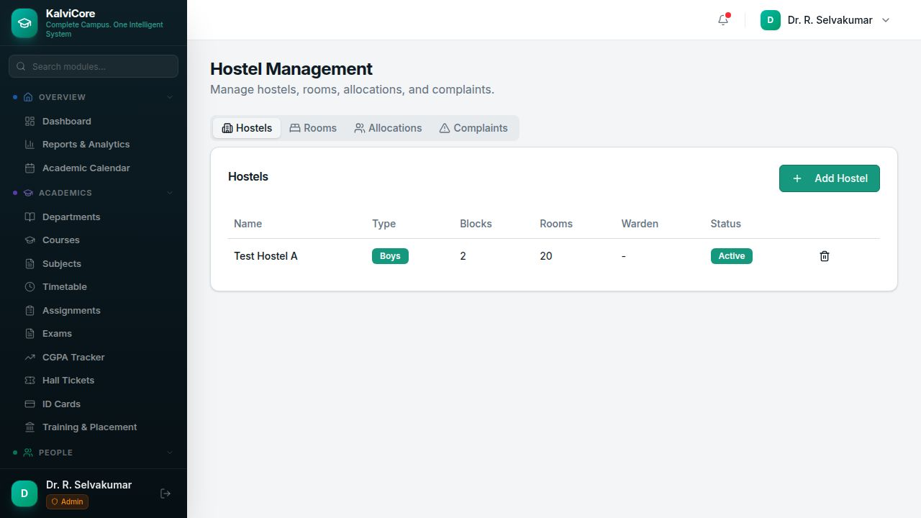
Campus hostel management with four tabs: Hostels (Name, Type Boys/Girls, Blocks, Rooms, Warden, Status), Rooms (individual room tracking), Allocations (assign students to rooms), and Complaints (maintenance requests). Type badges are color-coded blue for Boys and pink for Girls.
Key Features:
- Hostel listing with blocks and room counts
- Room capacity and occupancy tracking
- Student-to-room allocation
- Complaint/maintenance management

12. Transport Management
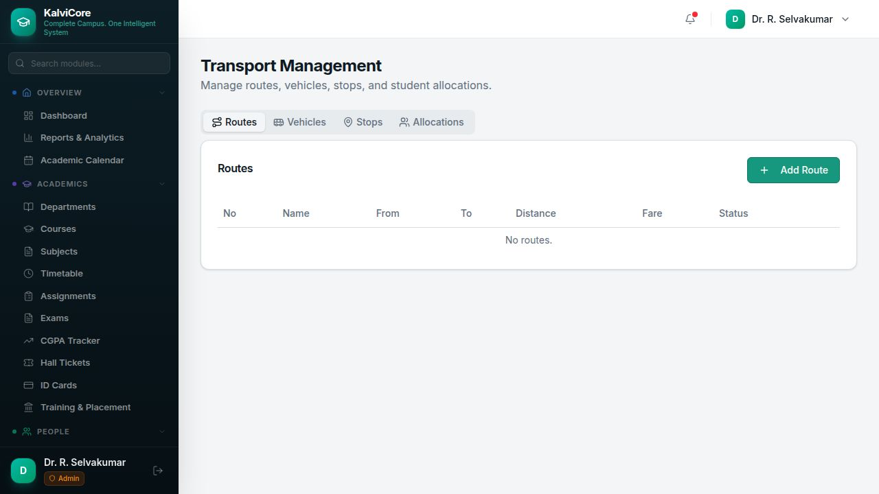
College transport route and vehicle management with four tabs: Routes (Number, Name, From, To, Distance, Fare, Status), Vehicles (bus/vehicle details), Stops (pickup/drop points), and Allocations (student-route assignments). New routes can be created with distance and fare details.
Key Features:
- Route management with distance and fare
- Vehicle tracking
- Stop/pickup point management
- Student transport allocation

13. Library Management
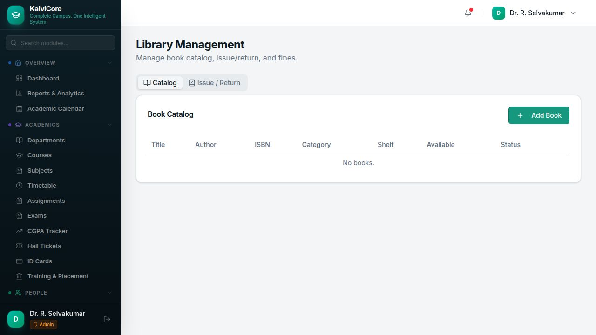
Digital library catalog and circulation system with two tabs: Catalog (Title, Author, ISBN, Category, Shelf location, Available copies, Status) and Issue/Return (track borrowing and returns). Books can be added with complete metadata.
Key Features:
- Book catalog with ISBN, author, category
- Issue and Return tracking
- Shelf location and availability
- Add Book functionality

14. Events & Cultural
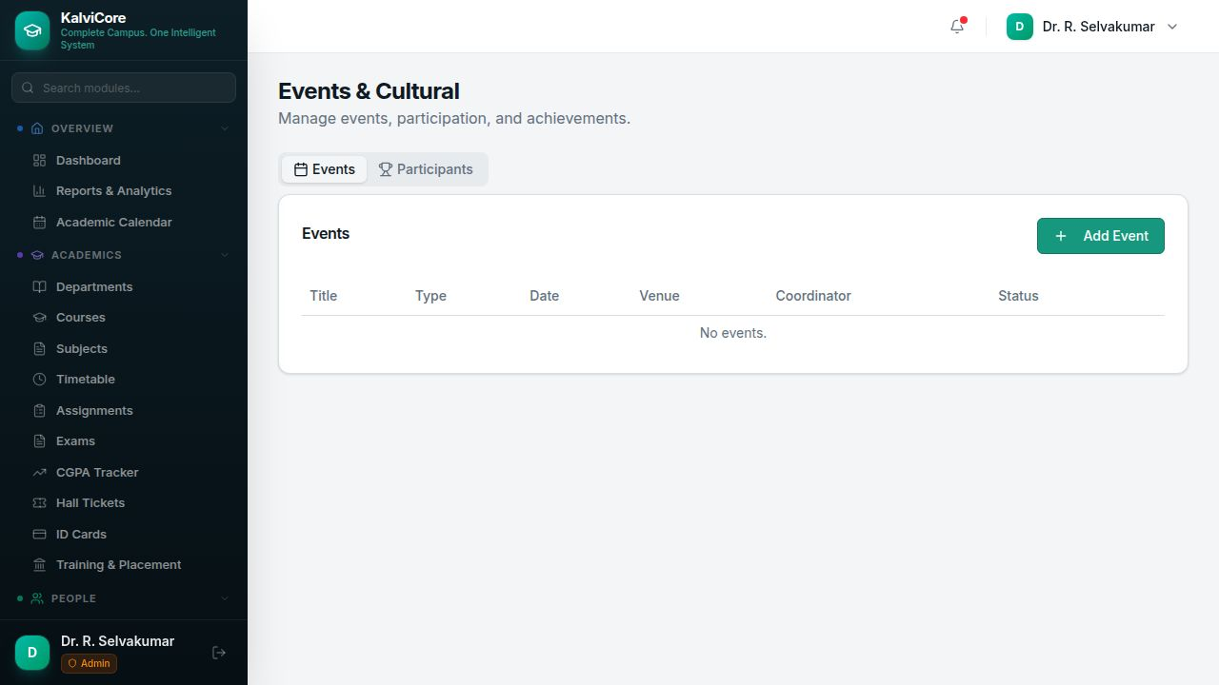
Campus event management with two tabs: Events (Title, Type, Date, Venue, Coordinator, Status) and Participants (student participation tracking). Supports academic, cultural, sports, and other event categories.
Key Features:
- Event creation with venue and coordinator
- Participant management
- Multiple event types (Academic, Cultural, Sports)
- Status tracking

15. Communications
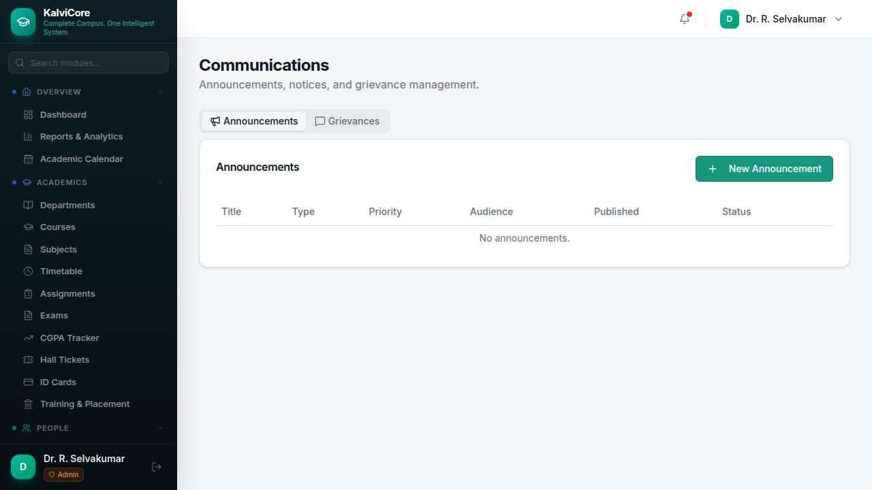
Announcements, notices, and grievance management. Two tabs: Announcements (Title, Type, Priority, Audience, Published date, Status) and Grievances (for student/staff issue resolution). Announcements can be targeted at specific audiences.
Key Features:
- Announcement creation with priority and audience targeting
- Grievance submission and resolution
- Published date and status tracking
- Audience-specific notifications

16. Inventory & Assets
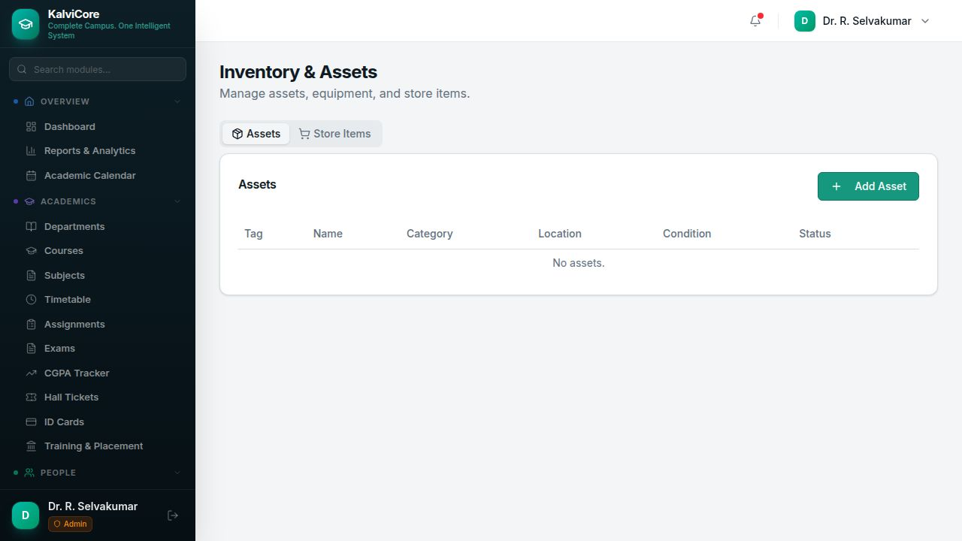
Institutional asset and inventory tracking with two tabs: Assets (Tag, Name, Category, Location, Condition, Status) and Store Items (consumable items with stock levels). Asset condition is tracked as New, Good, Fair, or Poor.
Key Features:
- Asset registration with tag and category
- Location and condition tracking
- Store item stock management
- Add Asset functionality

17. Timetable
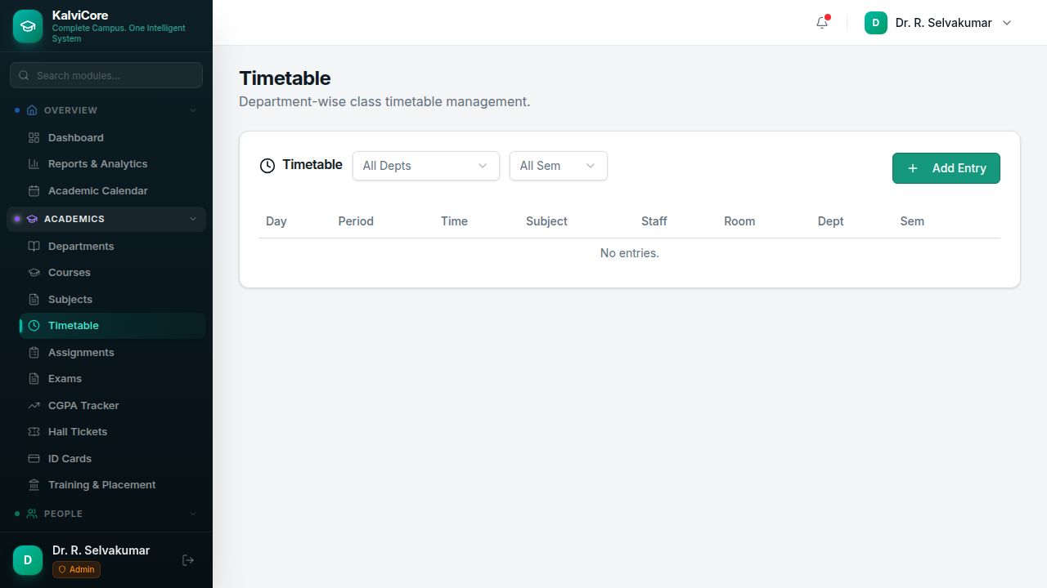
Department-wise class timetable management. Filter by Department and Semester to view the timetable grid showing Day, Period, Time, Subject, Staff, Room, Department, and Semester. New entries can be added with conflict detection for rooms and staff.
Key Features:
- Department and semester filters
- Timetable grid with day/period/time
- Staff and room assignment
- Add Entry with conflict detection

18. Assignments
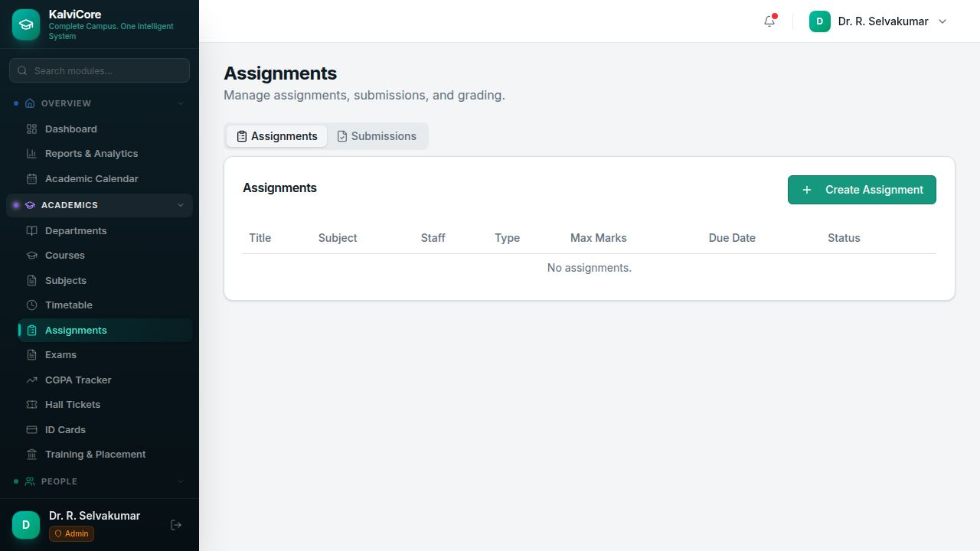
Assignment creation and submission tracking with two tabs: Assignments (Title, Subject, Staff, Type, Max Marks, Due Date, Status) and Submissions (student submission and grading). Assignments can be created with deadlines and maximum marks.
Key Features:
- Assignment creation with due dates
- Subject and staff assignment
- Submission tracking and grading
- Status management

19. Certificates
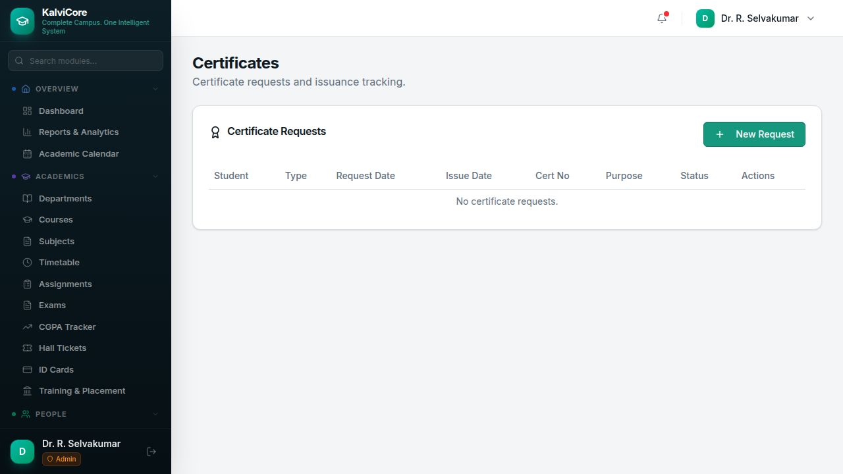
Certificate request and issuance management. The table shows Student, Type, Request Date, Issue Date, Certificate Number, Purpose, Status, and Actions. Supports Transfer, Bonafide, Character, Conduct, and other certificate types with auto-generated certificate numbers.
Key Features:
- Certificate request workflow
- Multiple certificate types (Transfer, Bonafide, Character, etc.)
- Auto-generated certificate numbers
- Status flow: Pending > Approved > Issued

20. Staff Leaves
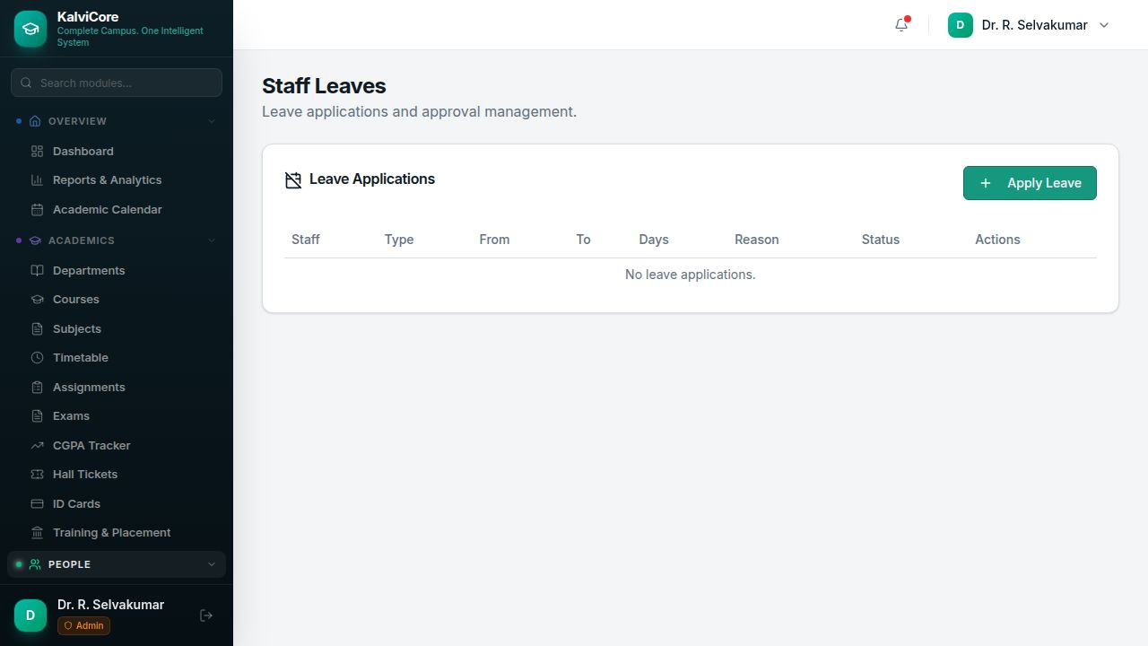
Leave application and approval workflow. The table shows Staff, Type, From/To dates, Days count, Reason, Status, and Actions. Supports Casual Leave, Sick Leave, Earned Leave, and other types with HOD/Principal approval chain.
Key Features:
- Leave application with type and reason
- From/To date selection with day calculation
- HOD/Principal approval workflow
- Multiple leave types

21. Settings & Configuration
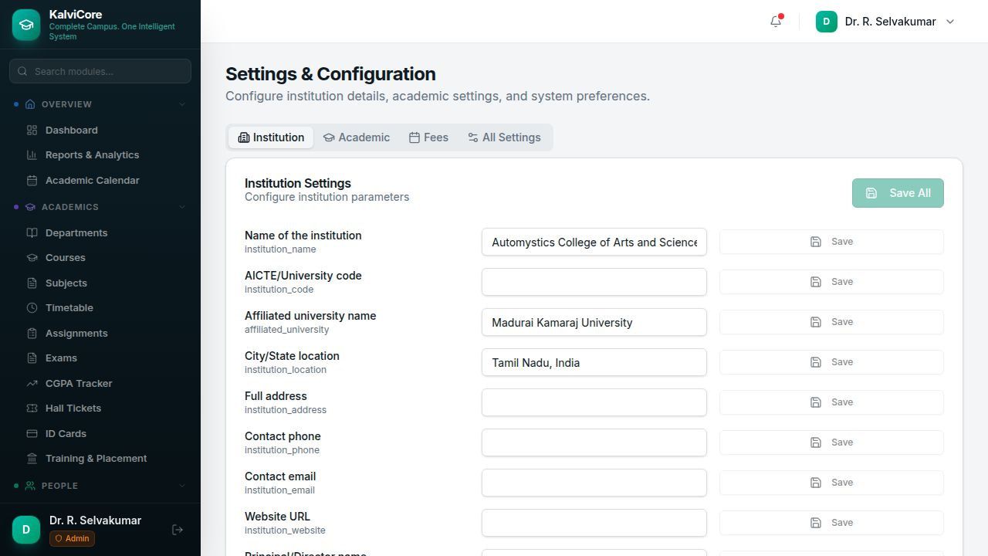
Centralized institution configuration with four tabs: Institution (Name, AICTE/University code, Affiliated university, Location, Address, Phone, Email, Website, Principal name), Academic, Fees, and All Settings. Each setting can be saved individually or in bulk.
Key Features:
- Institution details configuration
- Academic and Fee settings
- Individual and bulk save options
- Pre-configured for Madurai Kamaraj University affiliation

22. User Management
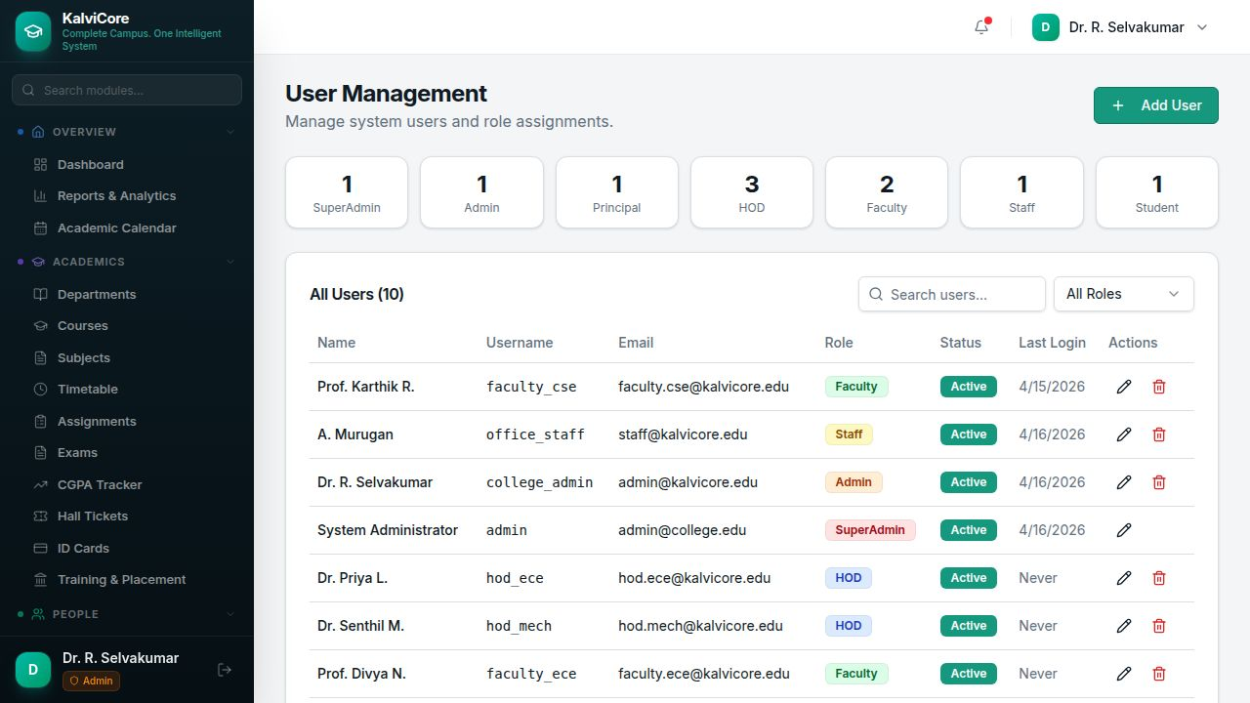
System user and role administration. Role distribution cards show counts for SuperAdmin, Admin, Principal, HOD, Faculty, Staff, and Student users. The user table displays Name, Username, Email, Role (color-coded badges), Status, Last Login, and Actions. 10 users are pre-created across all roles.
Key Features:
- Role distribution summary cards
- User listing with role badges
- Search and filter by role
- Add, Edit, Delete users

23. Reports & Analytics
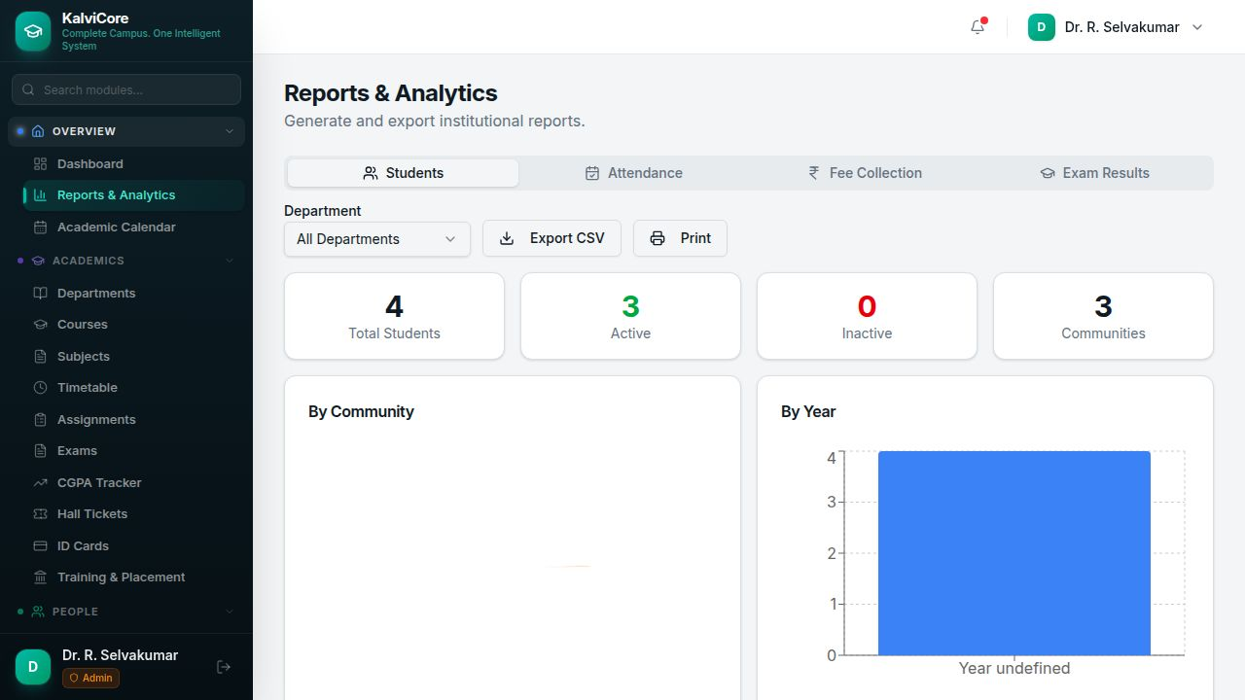
Comprehensive institutional reporting with four tabs: Students (Total, Active, Inactive, Communities), Attendance, Fee Collection, and Exam Results. Department filter and Export CSV/Print options are available. Visualizations include bar charts for community and year-wise distributions.
Key Features:
- Student, Attendance, Fee, Exam report tabs
- Department filter
- Export CSV and Print options
- Community and year-wise visualizations

24. Activity Log
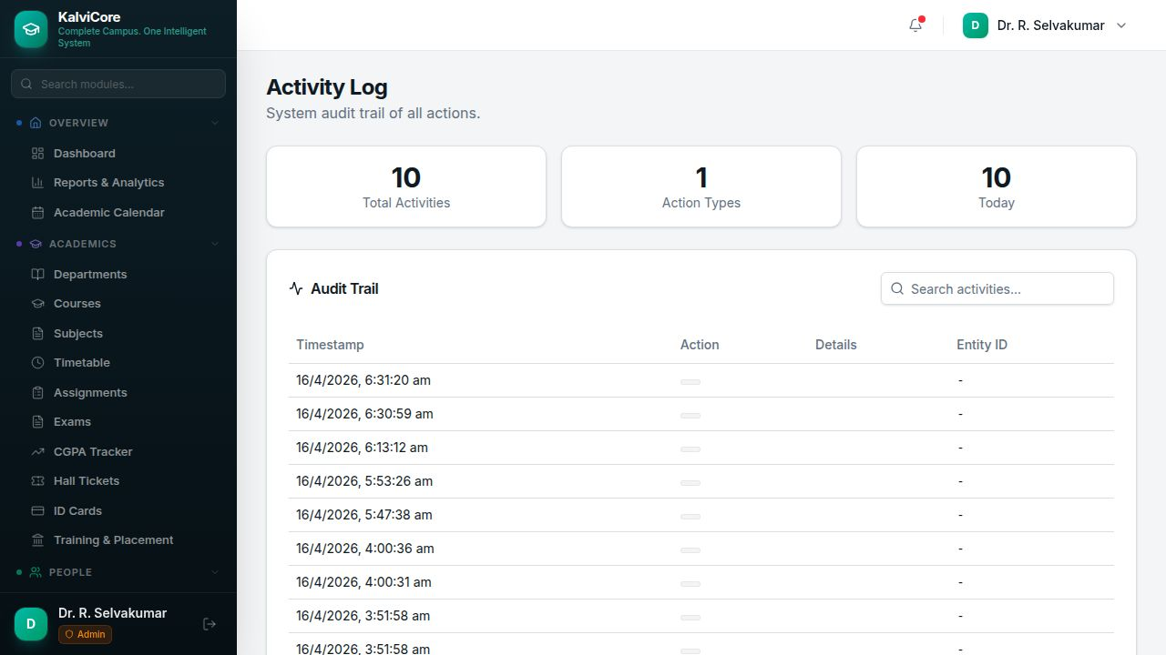
System audit trail for compliance and security. Dashboard cards show Total Activities, Action Types, and Today's count. The Audit Trail table logs Timestamp, Action, Details, and Entity ID for all system operations including logins, data changes, and configuration updates.
Key Features:
- Complete audit trail with timestamps
- Action type categorization
- Search activities
- Tracks all system operations

25. Academic Calendar
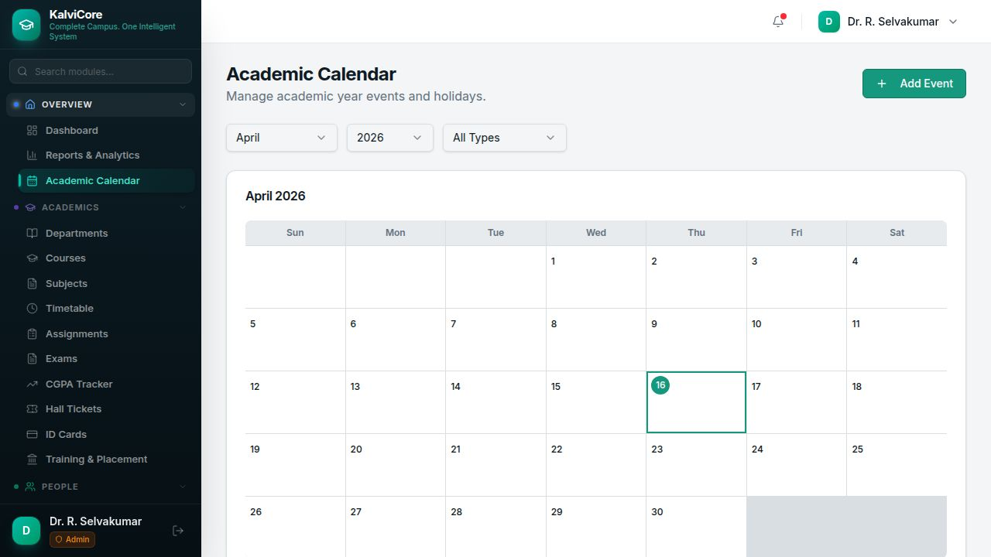
Visual academic year planning with a monthly calendar grid. Navigate between months and years, filter by event type (Holiday, Exam, Event), and add new events. The current date is highlighted in teal. Events, holidays, and important dates can be scheduled directly on the calendar.
Key Features:
- Monthly calendar grid view
- Month/Year navigation
- Event type filter
- Add events and holidays

26. Payroll Management
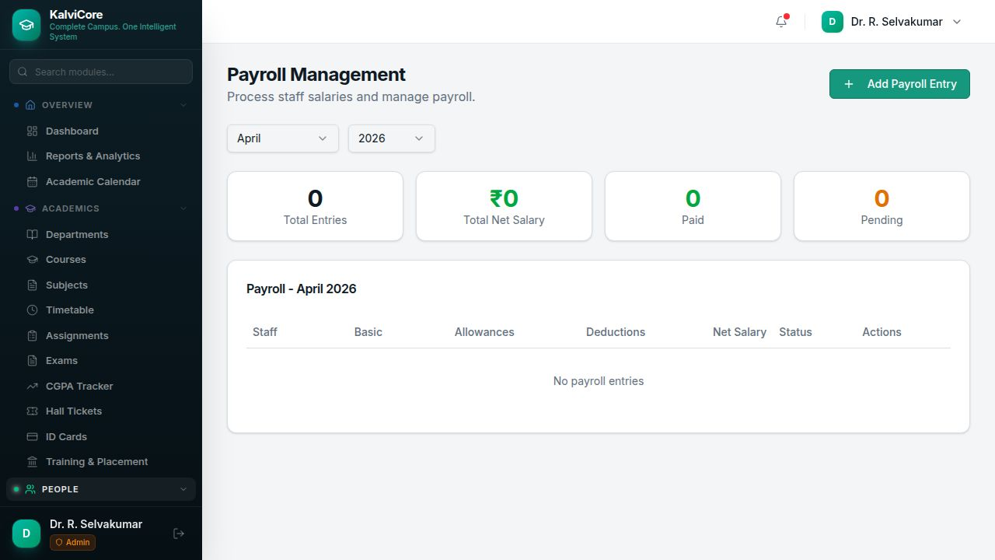
Staff salary processing and management. Select month/year to view payroll. Dashboard cards show Total Entries, Total Net Salary (INR), Paid, and Pending counts. The payroll table displays Staff, Basic salary, Allowances, Deductions, Net Salary, Status, and Actions. All amounts are in Indian Rupees.
Key Features:
- Month/Year payroll processing
- Basic, Allowances, Deductions, Net Salary breakdown
- Paid/Pending status tracking
- INR currency support

27. CGPA Tracker
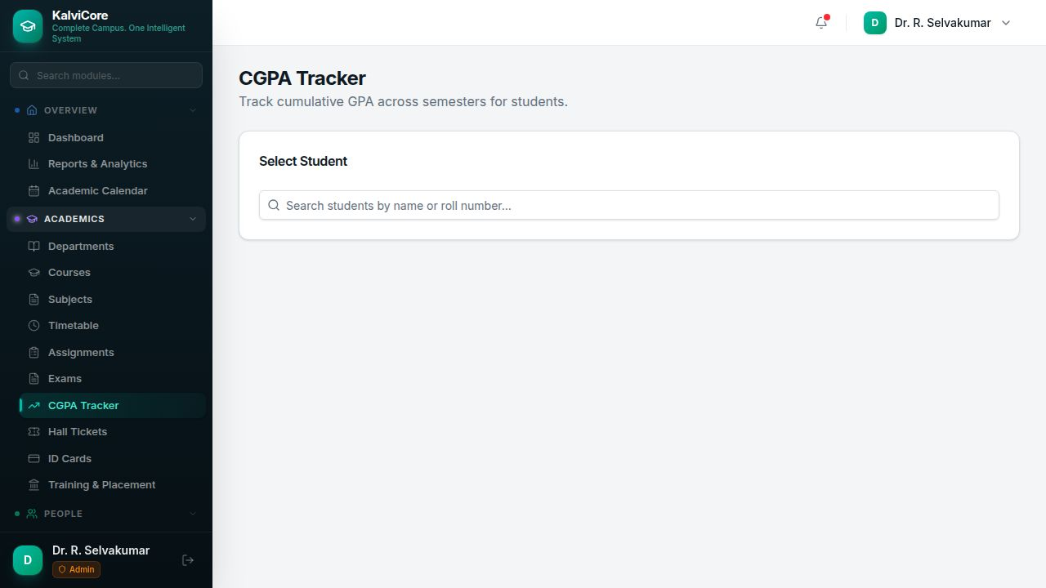
Cumulative GPA tracking across semesters. Search for a student by name or roll number to view their semester-wise GPA and cumulative CGPA. Based on the university's grading standards.
Key Features:
- Student search by name or roll number
- Semester-wise GPA display
- Automatic CGPA calculation
- University grading standards

28. Bulk Import / Export
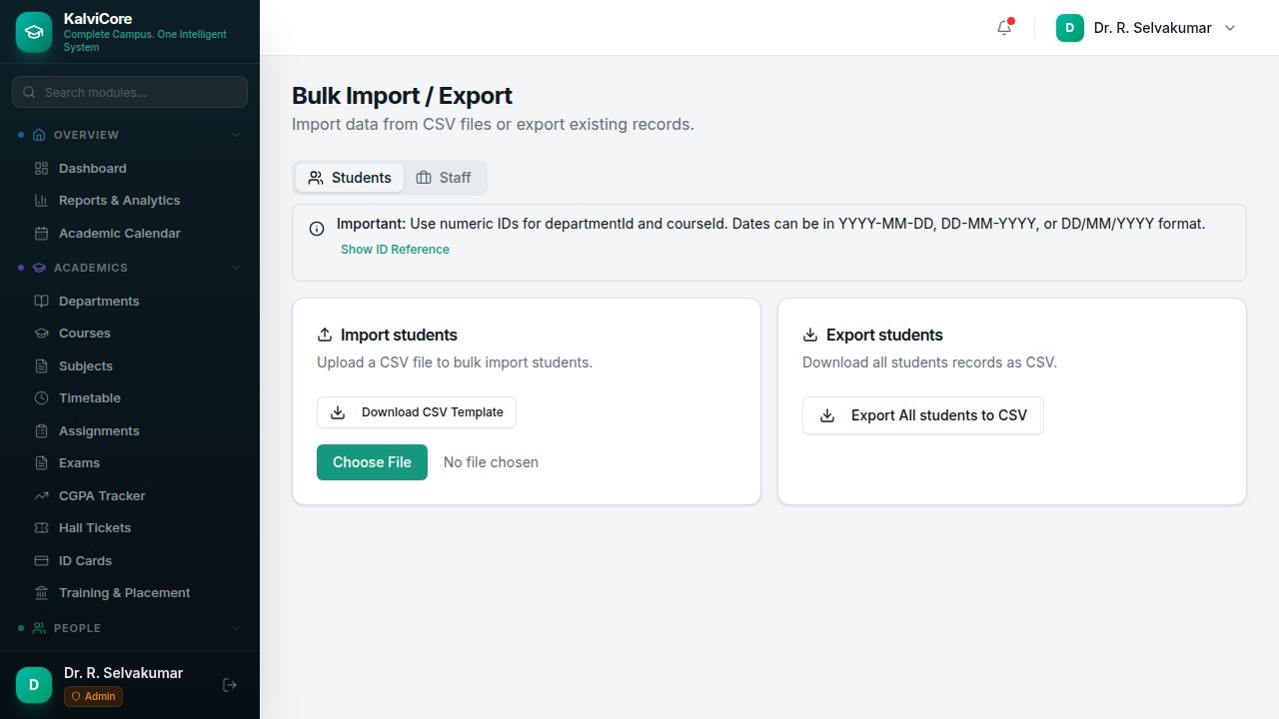
Mass data upload and download with tabs for Students and Staff. Import section allows CSV file upload with a downloadable template. Export section downloads all records as CSV. An expandable ID Reference section shows valid department and course IDs. Supports multiple date formats (YYYY-MM-DD, DD-MM-YYYY, DD/MM/YYYY) with detailed error messages for failed imports.
Key Features:
- CSV import with template download
- Export all records as CSV
- ID Reference section for valid IDs
- Multi-format date support and detailed error handling

29. Hall Tickets
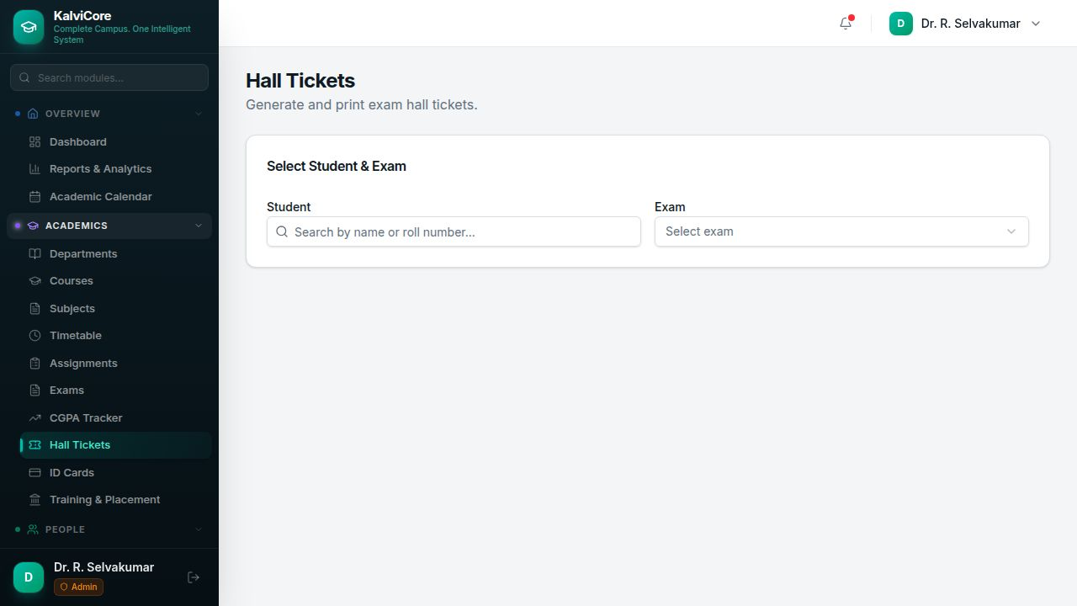
Exam hall ticket generation. Search for a student by name or roll number, select the target exam, and generate a printable hall ticket with student details, exam schedule, venue, and photo.
Key Features:
- Student search and exam selection
- Hall ticket preview
- Print/PDF functionality
- Student photo and exam details

30. Student Portal
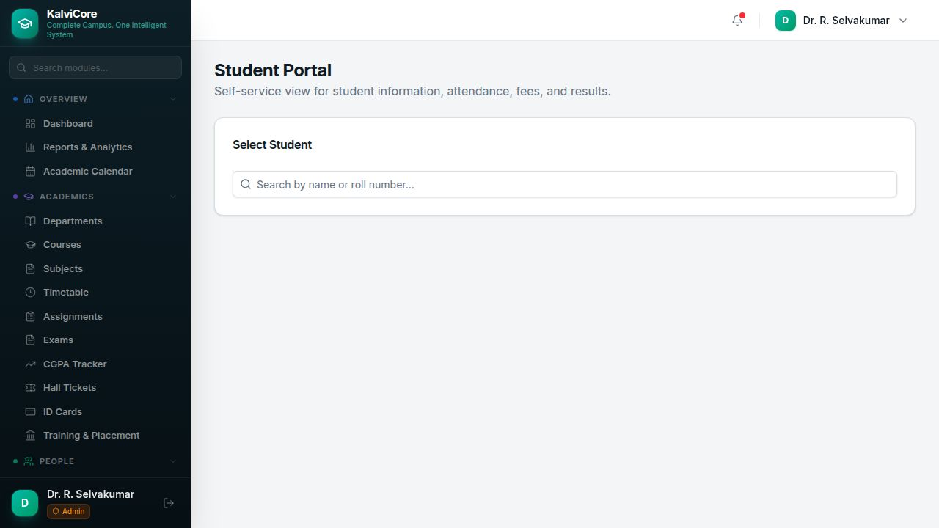
Self-service student information hub. Search for a student to view their complete profile including personal details, attendance summary, fee payment status, and exam results. Provides a consolidated view of all student-related information.
Key Features:
- Student profile view
- Attendance summary
- Fee status and dues
- Exam results and grades

31. Data Backup & Restore
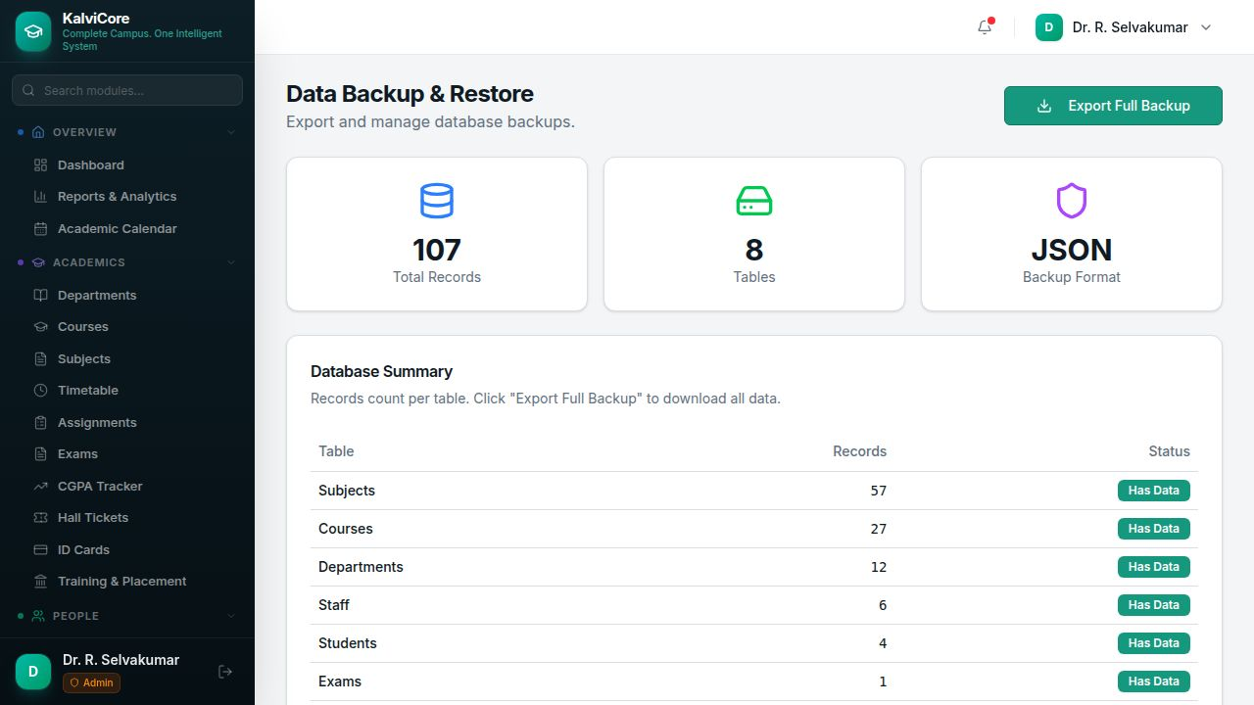
Database backup and management. Dashboard cards show Total Records (107), Tables (8), and Backup Format (JSON). The Database Summary lists per-table record counts with "Has Data" status badges. Full backup can be exported as JSON for safekeeping and disaster recovery.
Key Features:
- Total records and table summary
- Per-table record count
- Export Full Backup as JSON
- Restore from backup capability

32. ID Cards
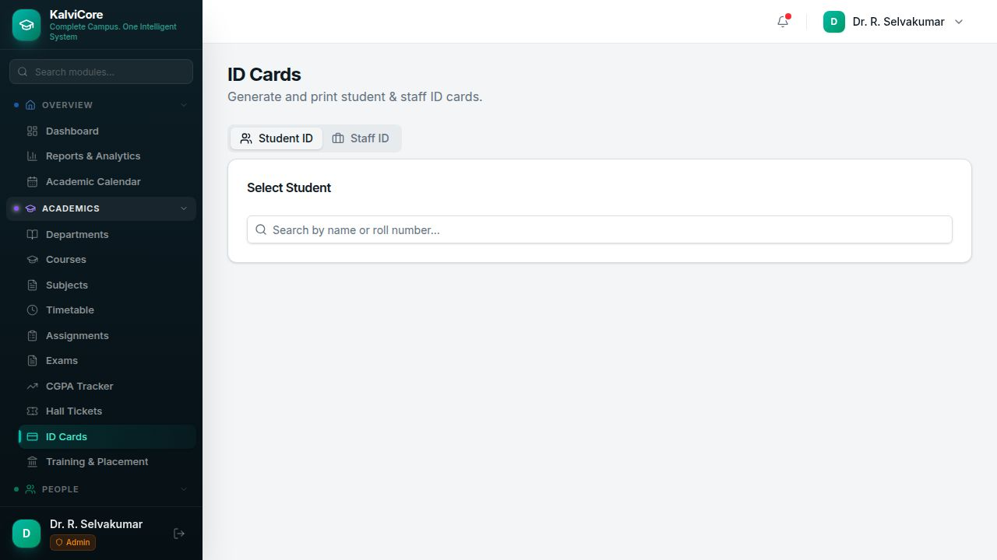
Student and staff ID card generation with tabs for Student ID and Staff ID. Search for a student or staff member to generate a professional ID card with photo, name, roll number/staff ID, department, course, and validity period. Direct print support for ID card production.
Key Features:
- Student ID and Staff ID tabs
- Professional ID card layout
- Photo, details, and validity
- Print support

33. Notifications
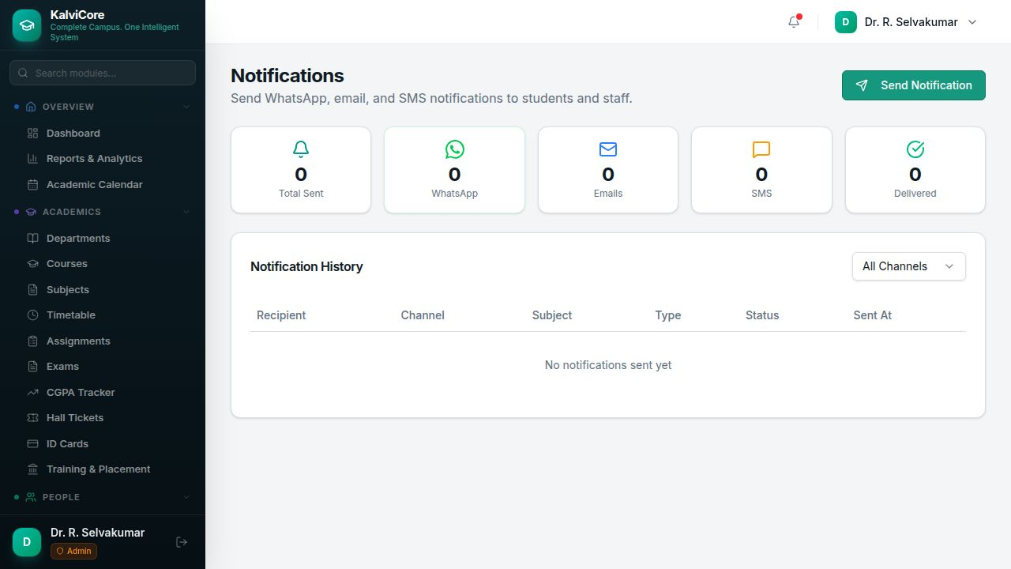
Multi-channel notification system. Dashboard cards show Total Sent, WhatsApp, Emails, SMS, and Delivered counts. The Notification History table lists Recipient, Channel, Subject, Type, Status, and Sent timestamp. Supports sending notifications via WhatsApp, Email, and SMS channels.
Key Features:
- WhatsApp, Email, SMS channels
- Notification history with status
- Channel filter
- Send Notification functionality

34. Document Vault
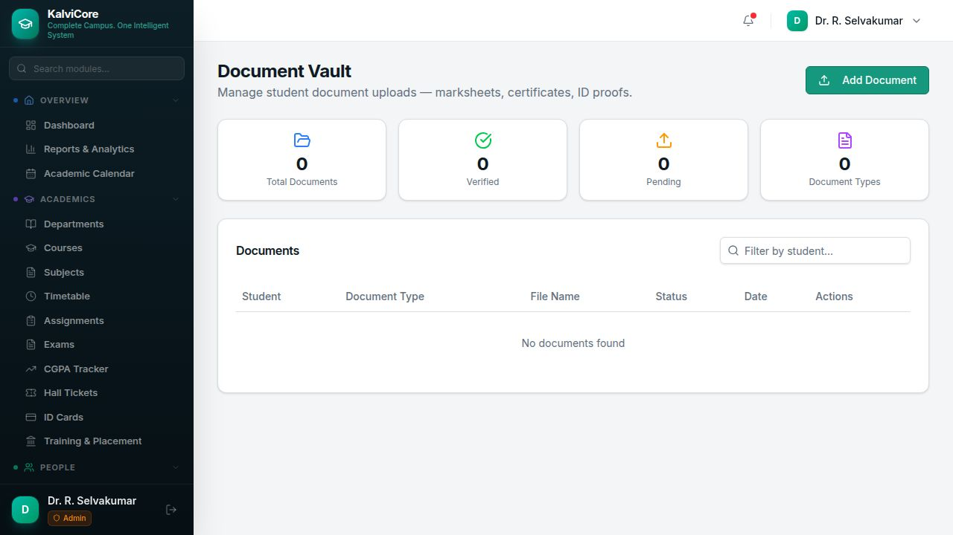
Student document upload and verification. Dashboard cards show Total Documents, Verified, Pending, and Document Types. The table lists Student, Document Type, File Name, Status, Date, and Actions. Supports uploading marksheets, certificates, ID proofs, and other documents with a verification workflow.
Key Features:
- Document upload and storage
- Verification workflow (Pending/Verified)
- Multiple document types
- Filter by student

35. Print Templates
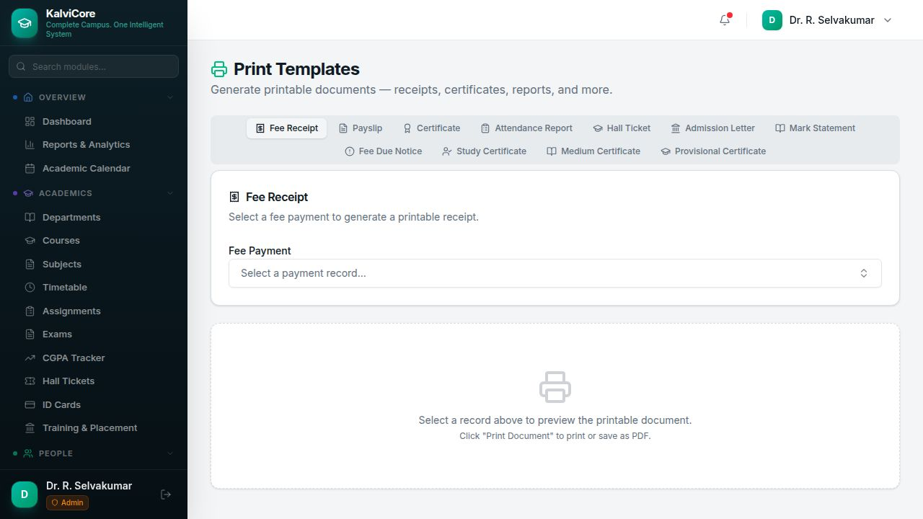
Printable document generation hub with 11 template types: Fee Receipt, Payslip, Certificate, Attendance Report, Hall Ticket, Admission Letter, Mark Statement, Fee Due Notice, Study Certificate, Medium Certificate, and Provisional Certificate. Select a record using searchable combobox to preview and print the formatted document.
Key Features:
- 11 document template types
- Searchable record selection
- Live document preview
- Print or save as PDF

36. Parent Portal
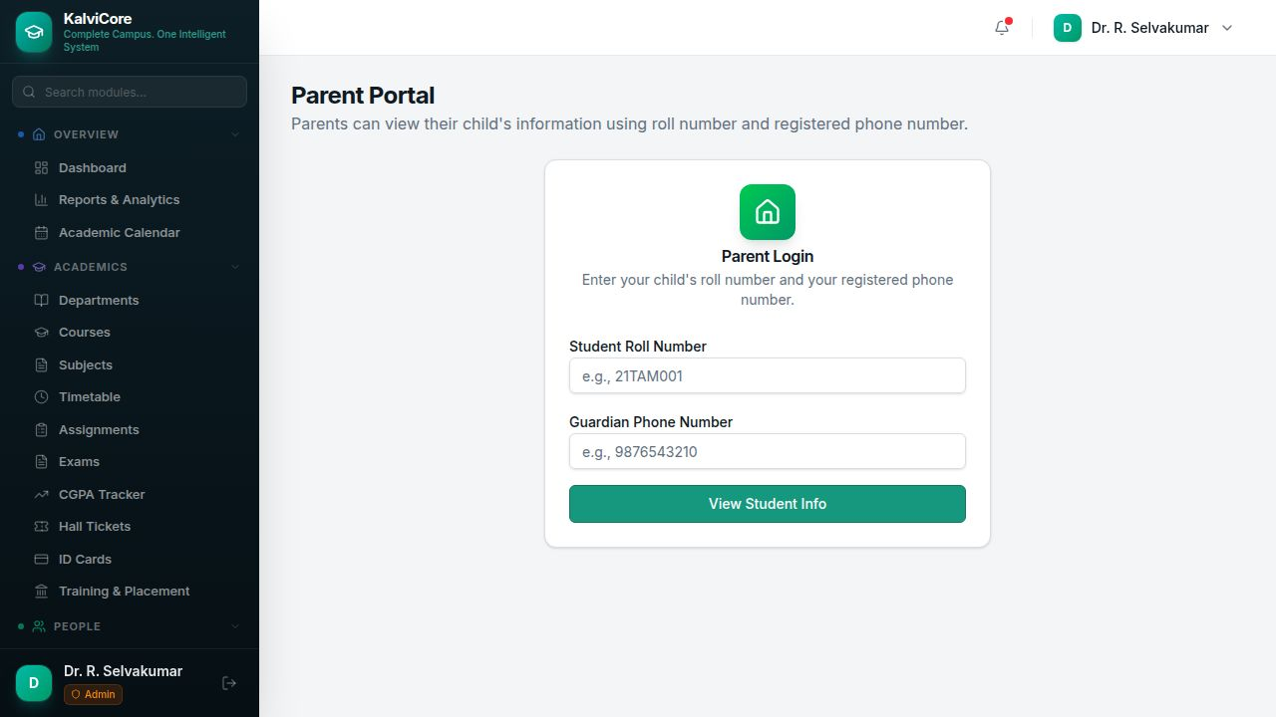
Parent access to student information without requiring an account. Parents enter their child's Roll Number and their registered Guardian Phone Number for verification. Once verified, they can view attendance, fees, grades, and academic details.
Key Features:
- Roll number + phone verification
- No account required
- View attendance, fees, grades
- Guardian phone matching

37. Dashboard Customization
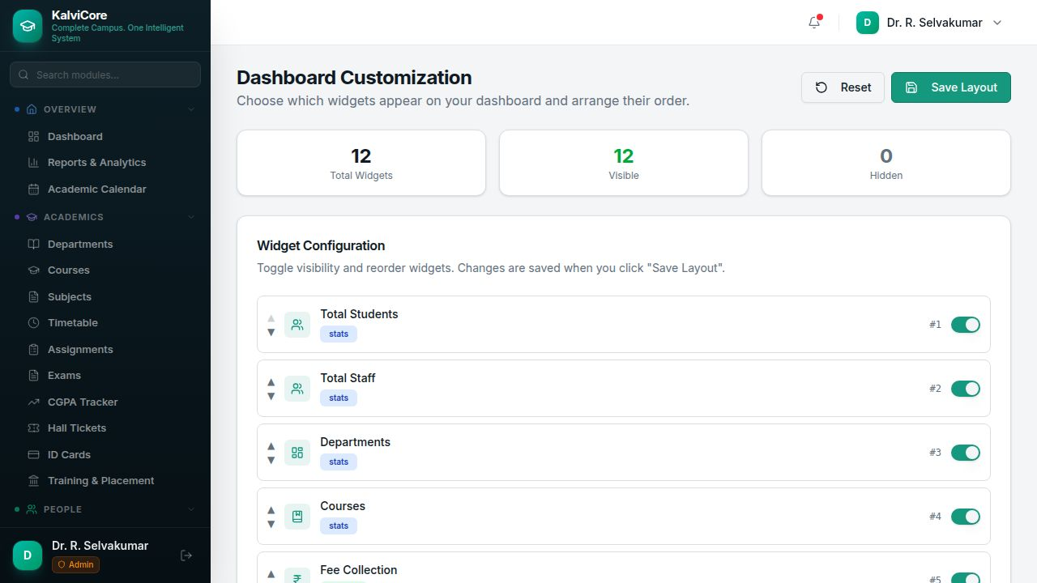
Personalize the dashboard layout. Shows Total Widgets (12), Visible (12), and Hidden (0) counts. Each widget (Total Students, Total Staff, Departments, Courses, Fee Collection, Attendance, etc.) can be toggled on/off and reordered using up/down arrows. Save Layout persists the configuration, and Reset restores defaults.
Key Features:
- Toggle widget visibility
- Reorder widgets with arrows
- Save Layout / Reset buttons
- 12 customizable widgets

38. Training & Placement
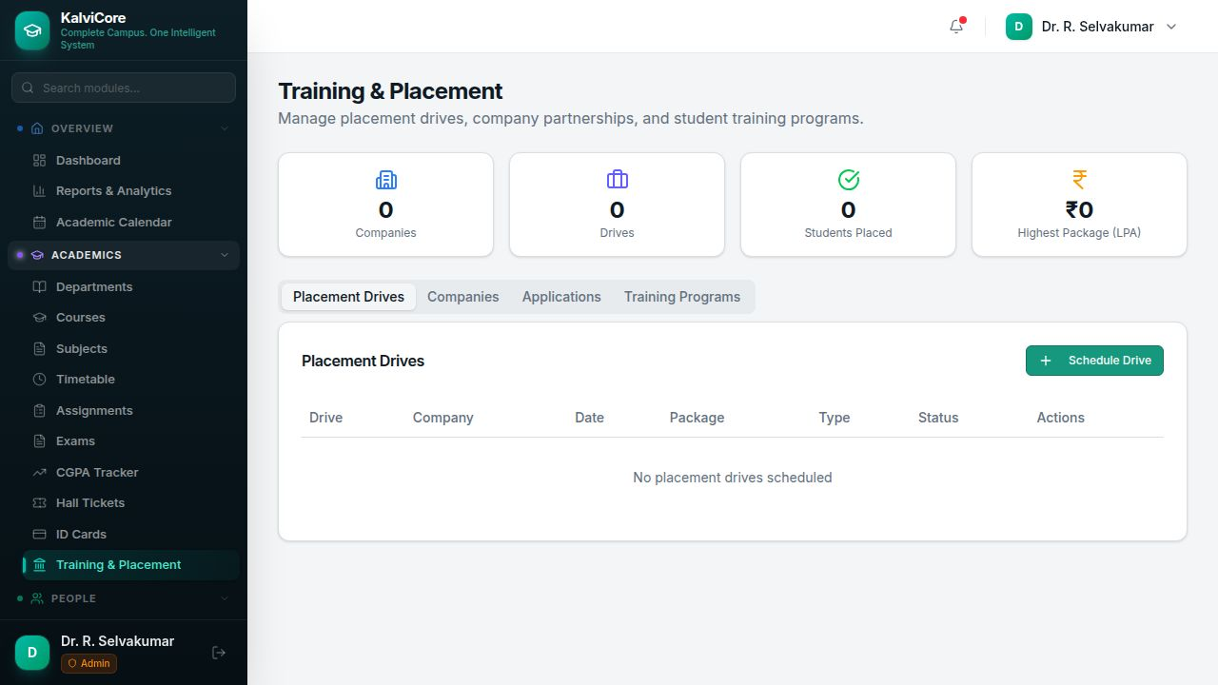
Campus placement and training management. Dashboard cards show Companies, Drives, Students Placed, and Highest Package (LPA). Four tabs cover Placement Drives (Drive, Company, Date, Package, Type, Status), Companies, Applications, and Training Programs. Schedule new placement drives and track student applications.
Key Features:
- Placement drive scheduling
- Company partnership management
- Student application tracking
- Training program management

39. Fundraising & Donations
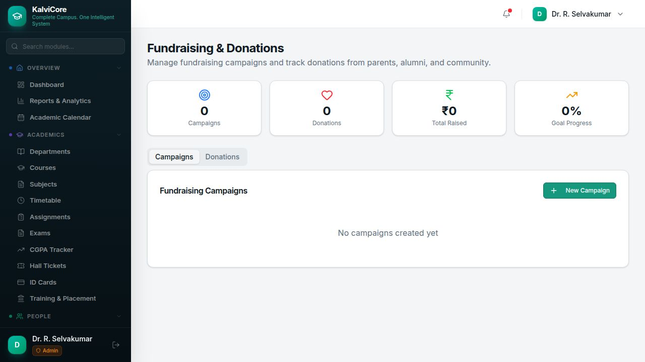
Institutional fundraising campaign management. Dashboard cards show Campaigns, Donations, Total Raised (INR), and Goal Progress percentage. Two tabs cover Campaigns (create and track fundraising campaigns) and Donations (record individual donations from parents, alumni, and community).
Key Features:
- Fundraising campaign creation
- Donation recording and tracking
- Goal progress tracking
- Target: parents, alumni, community

40. Visitor Management
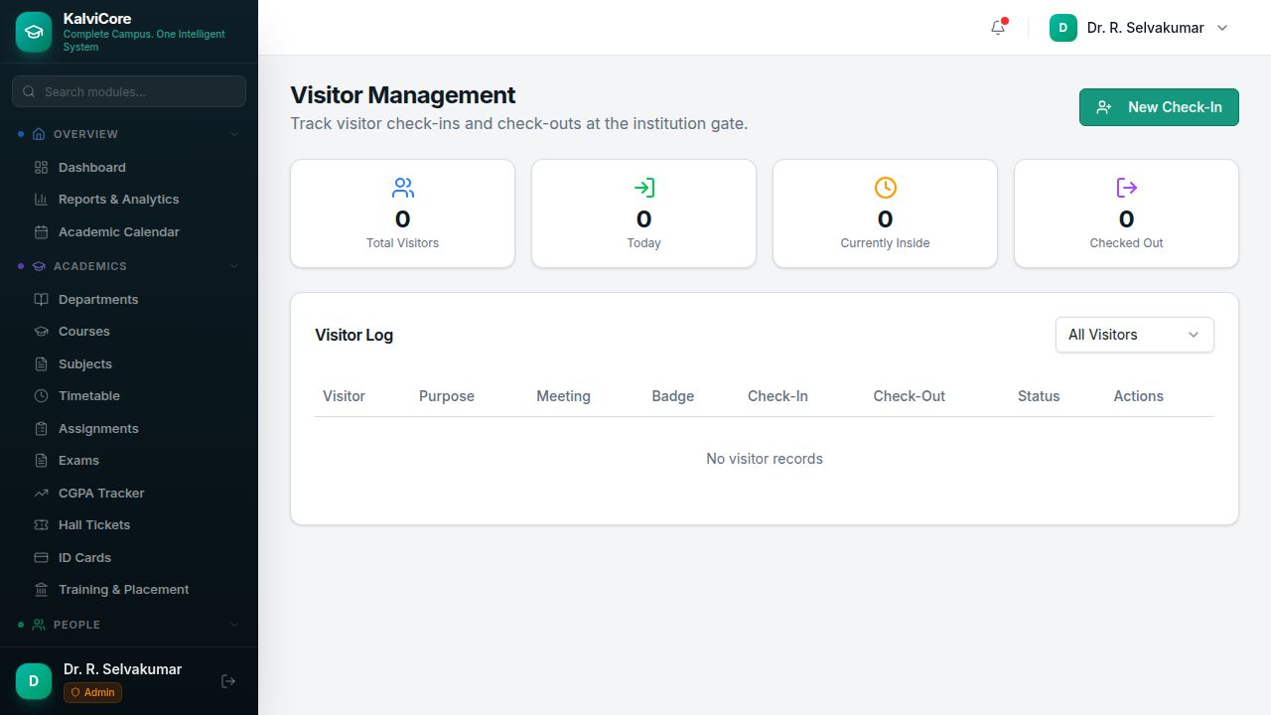
Gate and visitor tracking system. Dashboard cards show Total Visitors, Today, Currently Inside, and Checked Out counts. The Visitor Log table lists Visitor name, Purpose, Meeting with, Badge number, Check-In/Check-Out times, Status, and Actions. Supports new check-ins with auto-generated badge numbers.
Key Features:
- Visitor check-in/check-out tracking
- Badge number generation
- Purpose and meeting tracking
- Real-time inside/checked-out counts

41. Access Management
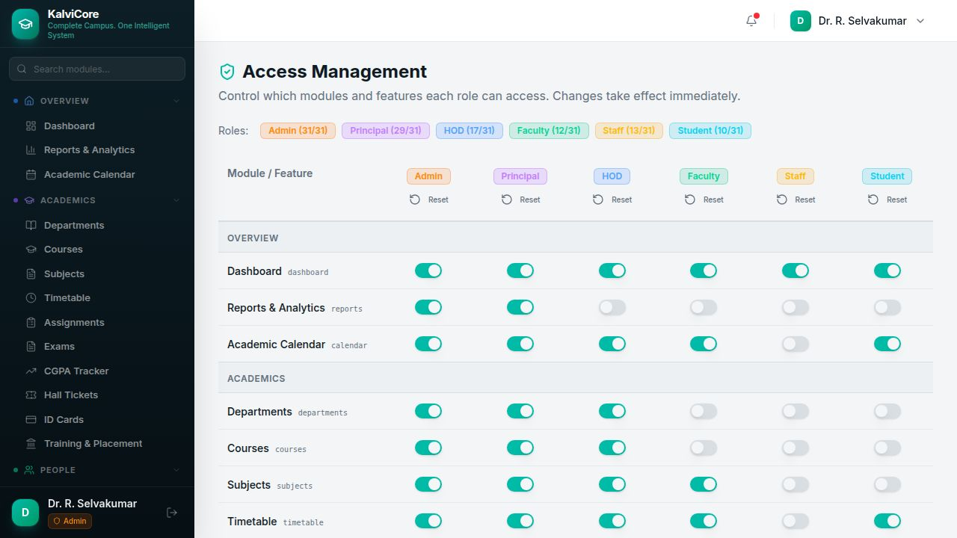
Granular role-based permission control. Shows permission counts per role: Admin (31/31), Principal (29/31), HOD (17/31), Faculty (12/31), Staff (13/31), Student (10/31). A toggle-switch matrix allows enabling/disabling each of the 31 modules per role. Modules are organized under Overview, Academics, People, Finance, Campus, and Administration categories. Changes take effect immediately.
Key Features:
- Permission matrix with toggle switches
- 6 roles x 31 modules
- Instant permission changes
- Reset per role capability

System Architecture
Frontend: React 18 + Vite + TypeScript
UI Library: ShadCN UI + Tailwind CSS
Backend: Express.js + Node.js
Database: PostgreSQL
ORM: Drizzle ORM
API: RESTful with OpenAPI specification
Authentication: JWT token-based with role permissions
Theme: Teal/Emerald enterprise palette

Role-Based Access Summary
KalviCore supports 6 user roles with granular module-level permissions. The Access Management screen allows administrators to toggle access for each of the 31+ modules per role. Admin has full access (31/31), Principal has near-full access (29/31), while Student access is limited to 10/31 modules.
- Admin (31/31) - Full system access to all modules and settings
- Principal (29/31) - Institution-wide access, cannot manage users or access control
- HOD (17/31) - Department-scoped access to academics, students, and attendance
- Faculty (12/31) - Teaching-focused access: subjects, attendance, exams, assignments
- Staff (13/31) - Office operations: fees, inventory, visitors, certificates
- Student (10/31) - Self-service: dashboard, calendar, timetable, student portal

Document generated on April 16, 2026
KalviCore v1.0 - AutoMystics

