**Market basket insight**

**Innovation Abstract:**

**Title: Unlocking Market Basket Insight: A Paradigm Shift in Consumer Analytics**

**Abstract:**

**In the dynamic landscape of modern commerce, understanding consumer behavior has never been more critical. Market Basket Analysis, a fundamental component of retail analytics, enables businesses to uncover hidden patterns in customer purchasing habits. This abstract presents a revolutionary approach to Market Basket Insight, leveraging cutting-edge technology and advanced analytics techniques to provide actionable business intelligence. Our innovation promises to reshape the way businesses understand their customers and make data-driven decisions.**

**This groundbreaking module combines the power of artificial intelligence, machine learning, and big data analytics to extract invaluable insights from transactional data. By delving deep into customer preferences, it enables businesses to optimize product assortments, boost cross-selling opportunities, and enhance the overall shopping experience.**

**Module Overview:**



**Module Title: Market Basket Insight Pro 2.0**

**Module Description:**

**Market Basket Insight Pro 2.0 is a transformative module designed to empower businesses with an unprecedented level of understanding of their customers' shopping behaviors. Leveraging state-of-the-art algorithms and advanced data**

**processing capabilities, this module goes beyond traditional Market Basket Analysis to provide actionable insights that drive growth and profitability.**

**Key Features:**

**Real-time Analytics: Market Basket Insight Pro 2.0 operates in real-time, allowing businesses to adapt quickly to changing consumer trends and preferences.**

**AI-Powered Recommendations: The module employs machine learning to generate personalized product recommendations, increasing cross-sell and upsell opportunities.**

**Predictive Analytics: By forecasting future purchase patterns, businesses can proactively plan inventory, marketing campaigns, and promotions.**

**Customer Segmentation: Market Basket Insight Pro 2.0 classifies customers into segments based on their purchasing behaviors, enabling tailored marketing strategies.**

**Anomaly Detection: Detect and mitigate fraudulent activities or unusual purchase patterns swiftly, safeguarding the integrity of your business.**

**Visualization Tools: Intuitive data visualization tools help businesses explore insights effortlessly and make informed decisions.**

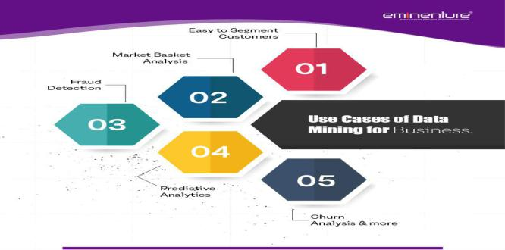

**Benefits**

**Increase in sales through personalized marketing and product recommendations. Improved inventory management, reducing carrying costs and out-of-stock incidents.**

**Enhanced customer satisfaction through a more tailored shopping experience.**

**Identification of new product opportunities and potential market niches.**

**Better fraud prevention and security measures.**

**Conclusion:**

**Market Basket Insight Pro 2.0 represents a significant leap forward in consumer analytics. By harnessing the power of cutting-edge technology and advanced analytics, businesses can gain a deeper understanding of their customers and optimize their operations to thrive in today's competitive market. This innovative module is poised to revolutionize how businesses analyze consumer behavior and drive success in the retail industry.**