Ex.No : 11

Date : 18/11/20

**Aim:**

To write a python program to find the greatest common divisor (gcd) of two integers using recursion.

**Program:**

def gcd(a,b):

if(a==0):

return a

if(b==0):

return b

if(a==b):

return b

if(a>b):

return(gcd(a-b,b))

else:

return gcd(a,b-a)

a=int(input("Enter first number:"))

b=int(input("Enter second number:"))

GCD=gcd(a,b)

print("GCD is:")

print(GCD)

**Link:**

<http://103.53.53.18/mod/vpl/forms/submissionview.php?id=326&userid=1635>

**Output:**

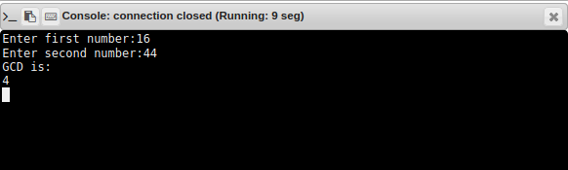

**Result:**

Thus the program to find the greatest common divisor of two integers using recursion is executed and the output is obtained.