Exercise No: 1

Date: 10/10/2020

**Aim:**

To write a python program to validate month and year and display the calendar of the given year and month if it is valid else it'll print as 'Invalid Input'.

**Program:**

import calendar as cal

year=int(input())

month=int(input())

if((year>999 and year<10000):

if(month>=1 and month<=12):

print(cal.month(year,month))

else:

print("Invalid Input")

else:

print("Invalid Input")

**Output:**

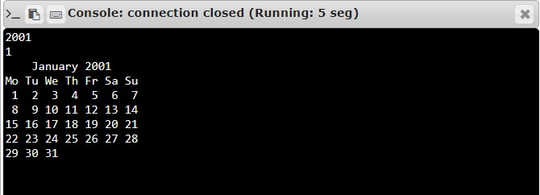

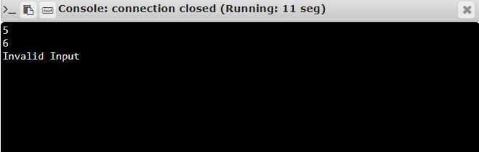

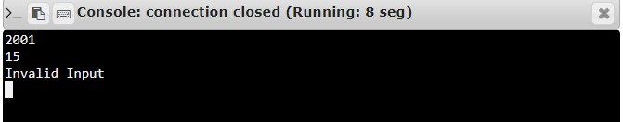

**Result:**

Thus, the program is executed, and required output is obtained.