Ex.No : 10

Date : 18/11/20

**Aim:**

To write a python program that accepts a string and calculate the number of upper case letters and lower case letters.

**Program:**

def string_test(s):

d={"UPPER_CASE":0, "LOWER_CASE":0}

for i in range(len(s)):

if(s[i].isupper()):

d["UPPER_CASE"]+=1

elif(s[i].islower()):

d["LOWER_CASE"]+=1

print("No. of Upper case characters:",d["UPPER_CASE"])

print("No. of Lower case characters:",d["LOWER_CASE"])

s=input()

p=string_test(s)

**Output:**

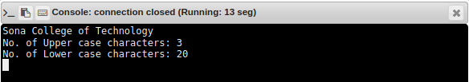

**Result:**

Thus theprogram to accept a string and calculate the number of upper case letters and lower case letters is executed and output is obtained.