Exercise No: 3

Date: 10/10/2020

**Aim:**

To write a python program to eliminate and print every 2nd number from the list and to display them in the order of elimination.

**Program:**

def removeThirdNumber(lst):

lst1=[]

pos=1

s=0

for i in range(0,len(lst)):

s=(pos+s)%len(lst)

e1=lst.pop(s)

lst1.append(e1)

return lst1

n=int(input())

int_list=[]

for i in range(0,n):

e=int(input())

int_list.append(e)

p=removeThirdNumber(int_list)

print(p)

**Output:**

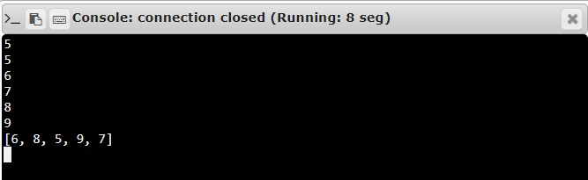

**Result:**

Thus, the program for removing and printing every 2nd number from the list is successfully executed and required output is obtained.