Inspecting Elements for XCUI.

My Desired Capabilities are
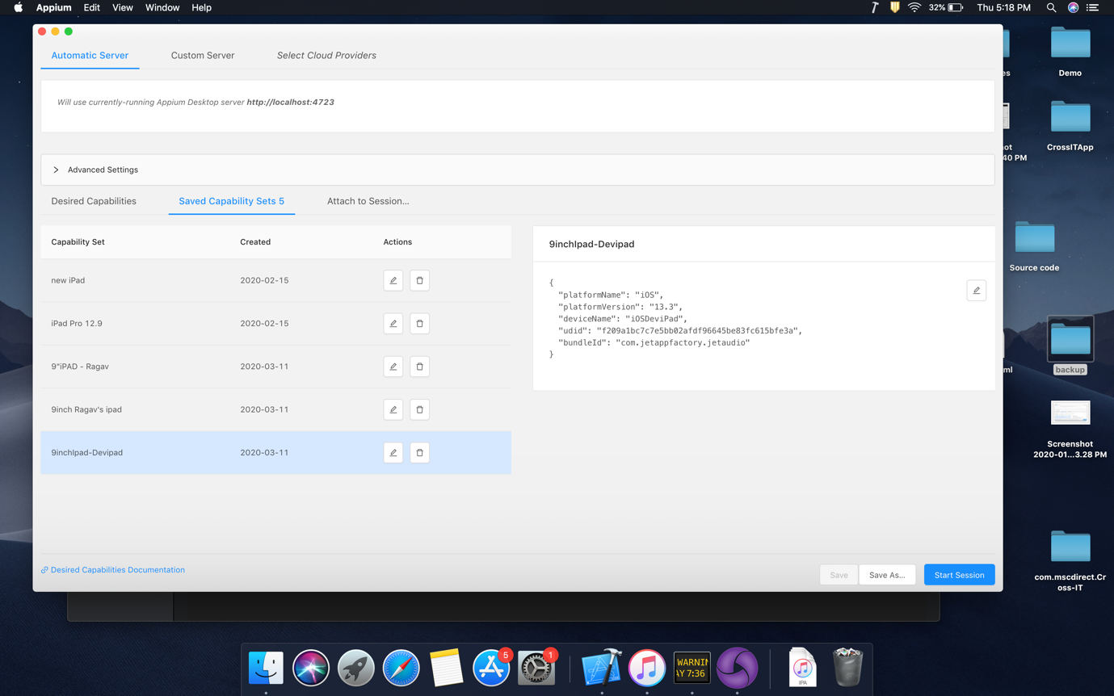

There is an option called “

