Appium set up for MAC(CCF)

$
- 1: Overview :
- 2: Objective :
  - Table 1: Supported Configurations
- 3: Setup Mode:
- 4: Proxy network configuration :
  - Figure 1: Proxy details
  - Figure 2: Export the proxy
- 5: Intalling Dependency Softwares.
  - Table 2: Appium dependeny libraries
- Version management:
  - Figure 3: Finding available versions and commands.
  - Figure 4: Searching for brew component carthage.
- 5.1: Install Homebrew :
  - Figure 5: Installing Homebrew
- 5.2: Install NPM :
  - Figure 6: Installing NPM
  - Figure 7: NPM setup check
- 5.3: If using corporate proxy:
- 5.4 Install NPM componenets:
- 5.4.1: Install ios-deploy :
  - Figure 8 : Installing iOS-deploy
- 5.4.2: Install device console :
  - Figure 9: Installing deviceconsole
- 5.5 Install BREW componenets:
- 5.5.1: Install ideviceinstaller :
  - Figure 10: Installing ideviceinstaller
- 5.5.2: Install Carthage :
  - Figure 11: Installing Carthage
- 5.5.3: Install libimobiledevice :
  - Figure 12: Installing libimobiledevice
  - Figure 13: Installing libimobiledevice --HEAD
  - Figure 14: Unlinking libimobiledevice
  - Figure 15: Error on installing libimobiledevice HEAD.
  - Figure 16: Linking libimobiledevice
- 6: Install XCPretty :
  - Figure 17: Installing xcpretty
- 7: Validation
  - Figure 18: Dependency componenets examination
- 8: Installing Appium
  - Figure 19: Installing Appium
  - Figure 20: Installing NPM http-server
  - Figure 21: Starting NPM http-server
  - Figure 22: Connecting to localhost
  - Figure 23: Setting localhost path for Chromedriver
  - Figure 24: Locating .npmrc file

  - Figure 25: Adding localhost URL to CDNURL(Chrome driver URL)
  - Figure 26: Deleting/Cleaning NPM cache
  - Figure 27: Verifing NPM cache

  - Figure 28: Installing appium with local CDURL path
  - Figure 29: Appium installation output
- 9: Setting up xcode
- 10: Install xcode command line tools.
  - Figure 30: Installing xcode command line tools
- 11: Installing Appium Doctor
  - Figure 31: Installing Appium Doctor
  - Figure 32: Checking appium setup using Appium Doctor
- 12: Starting Appium Server
  - Figure 33: Starting appium server in command prompt
- 13: Stopping Appium Server
  - Figure 34: Stopping appium server in command prompt
  - Figure 35: Appium server shutting down
- 14: Setting up iOS Web driver
  - Figure 36: Web driver agent xcode project
  - Figure 37: bootstrap and build sh files
  - Figure 38: bootstraping Webdriver agent
  - Figure 39: Signing for WebDriverAgentLib target

1: Overview :
Appium is an open source test automation framework for use with native, hybrid and mobile web apps. It drives iOS, Android, and Windows apps using the WebDriver protocol.

2: Objective :
Setting up Appium Configuration in MAC machine so we can accomplish the below requirements..

a > Run Application Automation in Android
b > Run Application Automation in iOS.

Platform | Device | Simulator/Emulator
iOS | YES | YES
Android | YES | YES

Table 1: Supported Configurations

3: Setup Mode:
In order to run appium automation in MAC setup
requires several dependency software which is explained
in later part of this document, the network configuration
plays a key role in setting up Appium.

1> Open Network.
2> Corporate Proxy Enabled.

During Appium setup the command line connects to multiple web service requests, Corporate proxy might block connecting to the web services and
Hence we need to route through correct proxy address.

This document covers both approaches for certain configurations but for few components open network is required.
Preferred : Open network is preferred as corporate proxy has lot of loop holes and extra stuff requires in setting up appium and it’s dependency libraries.

4: Proxy network configuration :
In case if we are using corporate proxy do the below step else skip this step if open network is used.

Step 1 : Get the IP proxy and port number and note down.
System Preferences -> Network - > Advanced -> Proxies ->Web Proxy(HTTP) (Ref Figure 1)

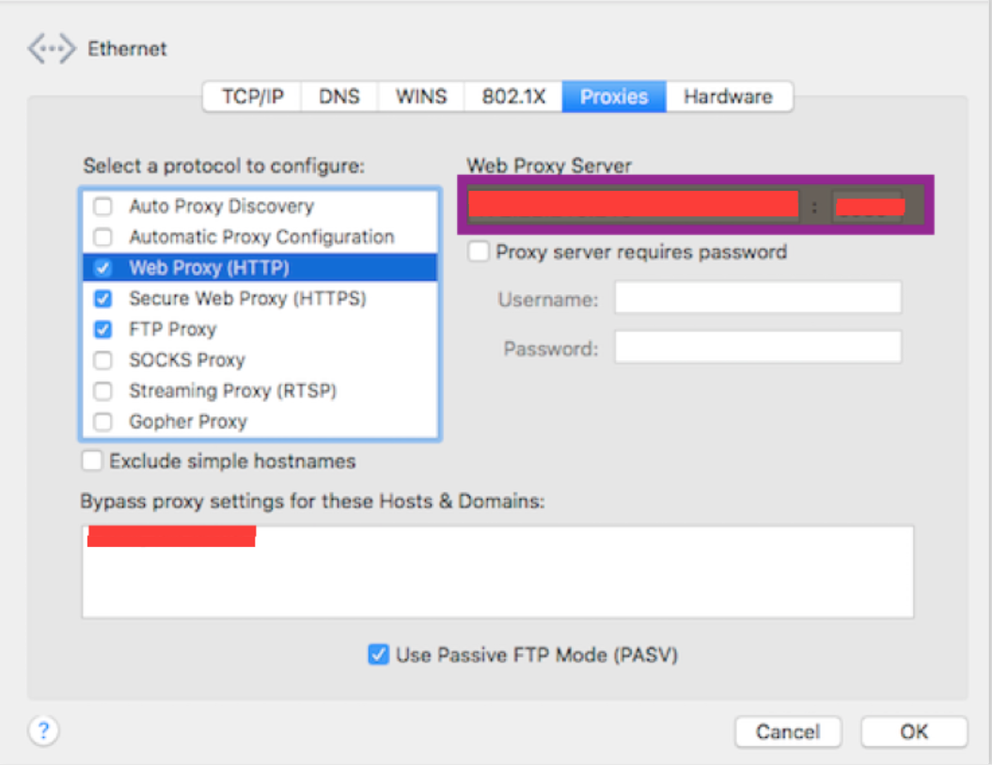

Figure 1: Proxy details

Note the Proxy xxx.xx.xxx.xxx xxxx
Export the proxy so we can use to route(Ref Figure 2).
Open terminal : Type command
export ALL_PROXY= xxx.xx.xxx.xxx xxxx

Figure 2: Export the proxy

5: Intalling Dependency Softwares.
Before installing actual Appium, we need to install all dependency softwares and
Below are the details and we will install one by one(Refer Figure 3)

MAC Dependency Libraries
NPM | Node Package Manager (packaging tool for Java Script).  Version : NPM 5.0.3  Licence Info:  The npm application  Copyright (c) npm, Inc. and Contributors  Licensed on the terms of The Artistic License 2.0
HOME BREW | Free and open-source software package management system that simplifies  the installation of software on Apple's macOS operating system.  Version : Homebrew 1.2.3  Licence Info :  BSD 2-Clause License  Copyright (c) 2009-present, Homebrew contributors
NPM Components
ios-deploy | Install and launch iOS Application.  Version : 1.9.1  Licence Info:  ios-deploy is available under the provisions of the GNU General Public License,  version 3 (or later), available here: http://www.gnu.org/licenses/gpl-3.0.html
deviceconsole | Used to get console logs  Version 1.0.1  The MIT License (MIT)  Copyright (c) 2015 xdf
Brew Components
ideviceinstaller | Manage apps on iOS devices.  Version : stable 1.1.0 (bottled), HEAD  Licence Info :  It makes use of the fabulous libimobiledevice library that allows communication  with iOS devices.
Carthage | Used to add dependency frameworks for Cocoa Application.  Version : stable 0.24.0 (bottled), HEAD  Licence Info:  The MIT License (MIT)  Copyright (c) 2014 Carthage contributors
libimobiledevice | Install and launch iOS Application  Version : 1.2.0  Licence Info:  Apple, iPhone, iPod, and iPod Touch are trademarks of Apple Inc.  libimobiledevice is an independent software library and has not been  authorized, sponsored or otherwise approved by Apple Inc.
Gem components
Xcpretty | Fast and flexible formatter for xcodebuild.  Version : 0.2.8  Licence Info :  MIT License

Table 2: Appium dependeny libraries

Version management:

Brew provides an alternative to determine what all versions can be downloaded.

to install node we can first detect what versions are available.

use command $ brew search node(Refer Figure 4)

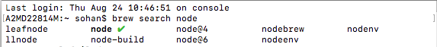

Figure 3: Finding available versions and commands.

$ brew search carthage

Figure 4: Searching for brew component carthage.

Returns only carthage which specifies that there is no such command to install specific version of carthage.

NPM doesn't provide a command to detect the available versions of NPM componenets

But from available sources it has been found that specific version of appium can be downloaded using command
npm install -g appium@version
But the same is not supported for other NPM components

Dependency componenets such as libimobiledevice, carthage, ideviceinstaller, deviceconsole and ios-deploy are all used to deploy iOS buids in a device and simulator, launch the application and capture the application logs, hence it's always recommended to use the latest version.

5.1: Install Homebrew :

Open terminal and type command

ruby -e "$(curl -fsSL https://raw.githubusercontent.com/Homebrew/install/master/install)" . (Refer Figure 5)

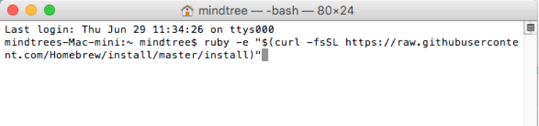

Figure 5: Installing Homebrew

Finally to check successful installation setup in terminal type

brew -v.
Expected output :
Homebrew 1.2.4 Homebrew/homebrew-core (git revision 57ed; last commit 2017-07-03)
Note : The version number could be different as per latest version.

Negative Scenarios:
In case if no open network is used or certificate validation fails then the following issues might arise.
1 > curl: (60) SSL certificate problem: Invalid certificate chain More details here: http://curl.haxx.se/docs/sslcerts.html
Fix : By pass curl’s SSL check.
change -fsSL to -k
Finally type the command : ruby -e "$(curl -k https:// raw.githubusercontent.com/Homebrew/install/master/install)"
And recheck with following command brew –v.

5.2: Install NPM :

Open terminal and type
brew install node (Refer Figure 6)
(Donʼt add . at the end)
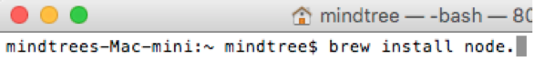

Figure 6: Installing NPM

Note : This will install Node and NPM and will always install latest version.
To install older version of node use command
brew install node@<version>
For Ex : To install node version 6.11.0 rather than current version 8.1.4 use command
brew install node@6.11.0

After installing another version of Node we have 2 versions but only one can be used at a time as node is linked to particular version.

so we need to unlink the current version and link the required version

To unlink from current version
brew unlink node
Install any version e.g. 6
brew install node@6.11.0
To link installed version
brew link node@6.11.0
In case of linking error occurs and error says use force then use the command
brew link node@6.11.0 --force

If you have a older version of NPM and wanted to update to latest version rather than installing and linking the latest one
use command
brew upgrade node

To check for successful installation use command npm --version

Expected output should be version of NPM (Refer Figure 7)

Figure 7: NPM setup check

5.3: If using corporate proxy:
In order to install libraries using NPM we need to set it’s proxy configuration by providing our web proxy noted in Figure 1.

Set NPM proxy by entering the following commands.
1 >$ npm config set proxy http://xxx.xx.xxx.xxx:xxxx
2 >$ npm config set https-proxy http://xxx.xx.xxx.xxx:xxxx

Note : use the proxy noted down at Figure 1
Don't add https in URL for https-proxy

If SSL security is established then NPM might fail.

In terminal set strict-ssl error to false which avoids SSL errors.
$ npm set strict-ssl false

To see all npm settings such as proxy configuration, SSL settings
$ npm config list

Now we have Homebrew , NPM and Node successfully installed.

5.4 Install NPM componenets:

Note: If corporate proxy is used make sure you configure proxy as described in section 5.3

5.4.1: Install ios-deploy :
open terminal and type
npm install -g ios-deploy (Refer Figure 8)

Figure 8 : Installing iOS-deploy

5.4.2: Install device console :
open terminal and type
npm install -g deviceconsole . (Refer Figure 9)
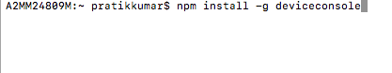

Figure 9: Installing deviceconsole

5.5 Install BREW componenets:

Note: If corporate proxy is used make sure you configure proxy as described below, re run the command
export ALL_PROXY=xxx.xx.xx.xx:xxxx

5.5.1: Install ideviceinstaller :
open terminal and type
brew install ideviceinstaller (Refer Figure 10)

Figure 10: Installing ideviceinstaller

Negeative scenario :In case curl error 443 occurs then run the command once
export ALL_PROXY=xxx.xx.xx.xx:xxxx

5.5.2: Install Carthage :
open terminal and type
brew install Carthage (Refer Figure 11)

Figure 11: Installing Carthage

Negeative scenario :In case curl error 443 occurs then run the command once
export ALL_PROXY=xxx.xx.xx.xx:xxxx

5.5.3: Install libimobiledevice :

open terminal and type

brew install libimobiledevice (Refer Figure 12)

Figure 12: Installing libimobiledevice

install libimobile HEAD for latest iOS version
In terminal type
brew install libimobiledevice --HEAD (Refer Figure 13)

Figure 13: Installing libimobiledevice --HEAD

Negeative scenario :In case curl error 443 occurs then run the command once
export ALL_PROXY=xxx.xx.xx.xx:xxxx

Note : This might
Error: libimobiledevice 1.2.0_2 is already installed
To install HEAD_2, first run `brew unlink libimobiledevice`

Run command brew unlink (Refer Figure 14)



Figure 14: Unlinking libimobiledevice

In case below error occurs (Refer Figure 15)

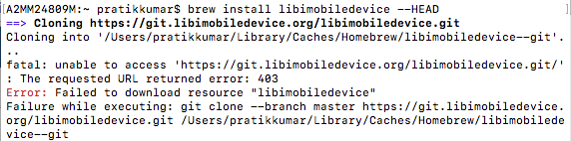

Figure 15: Error on installing libimobiledevice HEAD.

The above error occurs as currently libimobiledevice --HEAD has been removed and it's unsupported.

Then run following command to relink libimobiledevice(Refer Figure 16)

Figure 16: Linking libimobiledevice

6: Install XCPretty :

open terminal and type
sudo gem install xcpretty . (Refer Figure 17)
A password in prompted, enter the system password

Figure 17: Installing xcpretty

In case of corporate proxy use command..
sudo gem install --http-proxy http://xxx.xx.xx.xx:xxxx xcpretty
Note : use the proxy noted down at Figure 1

7: Validation
Examine the existance of all libraries as shown in figure below (Refer Figure 18)

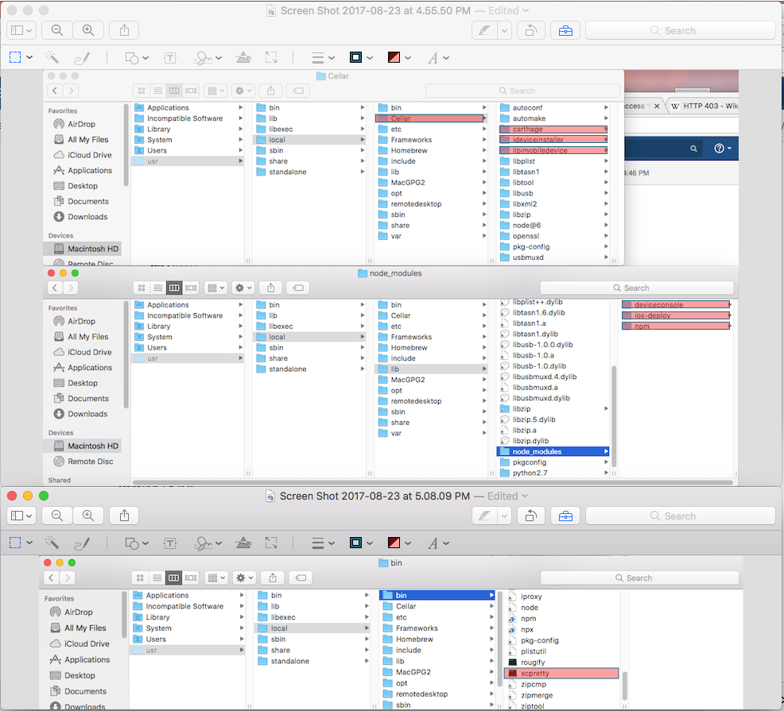

Figure 18: Dependency componenets examination

8: Installing Appium

Now we have all dependency libraries setup, now lets install appium.

Open terminal,
Type command
npm install -g appium (Refer Figure 19)

Figure 19: Installing Appium

Negeative scenario:
If using corporate proxy :
Chrome driver error occurs so corporate proxy will not work for appium installation as
Chrome driver fails behind proxy while installing appium as there will be a issue while
accessing chrome driver URL.

Need to follow additional steps so chrome driver will be stored locally and a local URL will be provided.

Step 1: Install npm http-server

Open terminal and type (Refer Figure 20)
$ npm install -g http-server

Figure 20: Installing NPM http-server

Step 2: Start npm http server
In terminal change current directory to folder where http-server is located which is
/usr/local/lib/node_modules/http-server

Checkout the repository by command
$ npm i
and finally start server by command
$ node bin/http-server (Refer Figure 21)

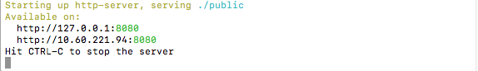

Figure 21: Starting NPM http-server

Now open browser and enter URL http://127.0.0.1:8080 or http://localhost:8080
you must see the npm server page (Refer Figure 22)

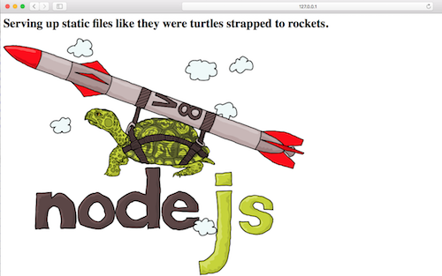

Figure 22: Connecting to localhost

Step 3: Now download the latest chrome driver , use the below URL

https://chromedriver.storage.googleapis.com/“2.21”/chromedriver_mac64.zip
Note : The URL will be updated, search for latest chrome driver under
https://appium.readthedocs.io/en/stable/en/advanced-concepts/chromedriver/

Now create a folder named 2.21 under public folder of http-server located under
/usr/local/lib/node_modules/http-server

and paste the downloaded chrome driver zip under this folder. (Refer Figure 23)

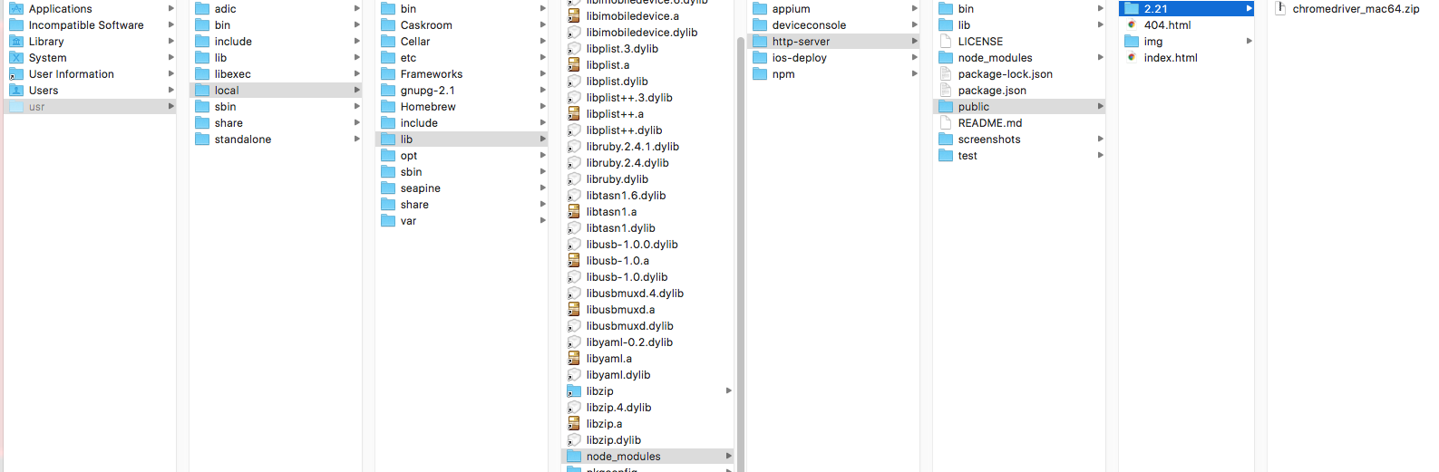

Figure 23: Setting localhost path for Chromedriver

Set CDURL path under .npmrc file
Note : This can also be done using command line

Select current user and locate .npmrc file under /Users/(User name)
The .npmrc file is hidden so to view all hidden files press CMD + SHIFT + . (Refer Figure 24)
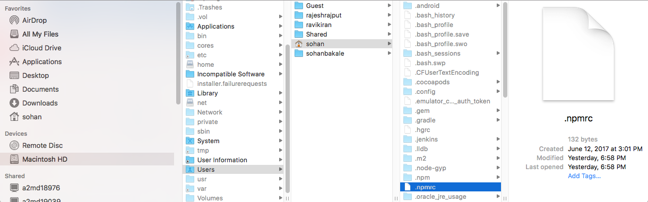

Figure 24: Locating .npmrc file

Step 4: Set CDURL path. Open .npmrc file and add CDURL path to our localhost path (Refer Figure 25)

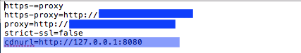

Figure 25: Adding localhost URL to CDNURL(Chrome driver URL)

Step 5:Delete .npm cache. (Refer Figure 26)

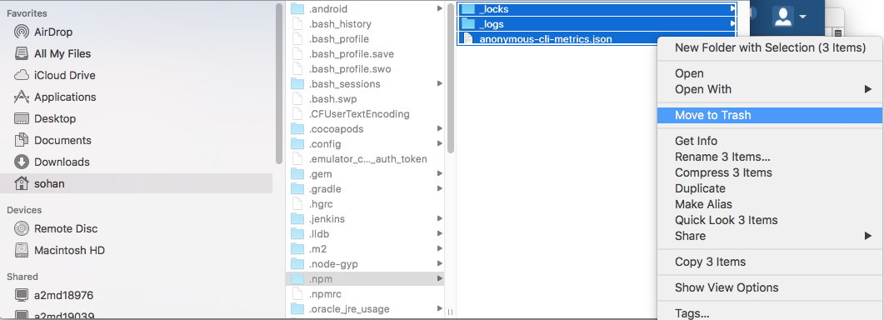

Figure 26: Deleting/Cleaning NPM cache

In the same directory, there is .npm directory, delete all files under it.
This step is equivalent to command npm cache clean --force, but this is recommended rather than command.

Verify NPM cache.

Open terminal and type

$ npm cache verify

The expected output is shown in Figure 27. (Refer Figure 27)
The figure displays 2 verifications of npm cache one is before cleaning as per Step 5 and one after cleaning.

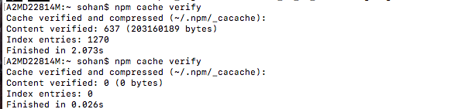

Figure 27: Verifing NPM cache

Now we have done with all configurations for Chrome driver and we can install appium behind proxy.

Open terminal, as NPM server is running in current terminal so open New Window of terminal.
Type command

$ npm install -g appium --chromedriver-cdnurl=http://127.0.0.1:8080 (Refer Figure 28)

Figure 28: Installing appium with local CDURL path

Negative Scenario : In case the following error occurs.
npm ERR! code Z_BUF_ERROR npm ERR! errno -5

then use command
$ npm cache clean --force
and reinstall appium using command in Figure 26.

Appium version : The command npm install -g appium installs current latest version of appium which is currently 1.6.5. To install required version ex 1.6.4 use command
$ npm install -g appium@1.6.4
or if usinf local CDURL path
$ npm install -g appium@1.6.4 --chromedriver-cdnurl=http://127.0.0.1:8080

The expected output is as per Figure 29. (Refer Figure 29)

Note : We get Downloading Selendroid standalone process which will loop for long time, so wait for few minutes as it will break itself, do not
stop or close the process.

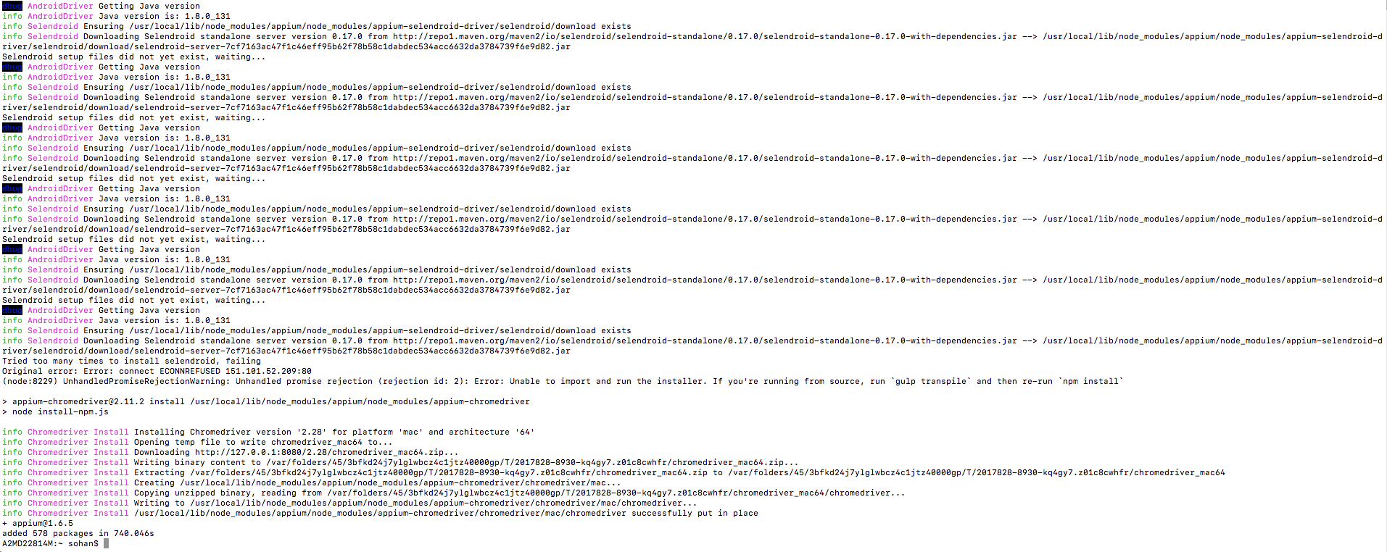

Figure 29: Appium installation output

9: Setting up xcode
Install xcode from MAC app store

In case if any older version of xcode exists then switch to point to latest xcode.
Set the xcode in command line
Open terminal and type
sudo xcode-select -s /Applications/Xcode.app

10: Install xcode command line tools.

Open terminal and type

xcode-select --install(Refer Figure 30)

Figure 30: Installing xcode command line tools

11: Installing Appium Doctor
Appium doctor is used to examine appium setup, this is optional but required to check the setup.
Open terminal,
Type command
npm install -g appium (Refer Figure 31)

Figure 31: Installing Appium Doctor
After installing appium doctor lets check if we have appium and all it’s dependency libraries set up
properly.
Open command prompt and type
appium-doctor --ios
and expected output should be as shown in Figure 32.
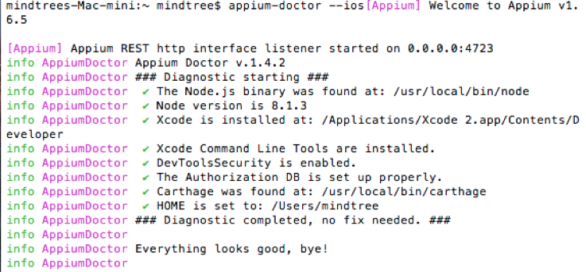

Figure 32: Checking appium setup using Appium Doctor

12: Starting Appium Server

Appium server can be started in command prompt
Open command prompt and type
appium &

Appium process starts and terminal displays it’s process id(Refer Figure 33)
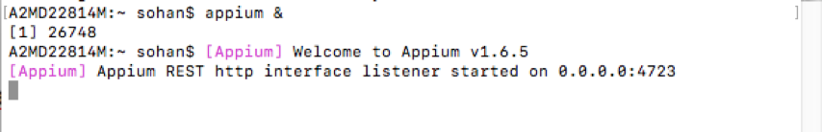

Figure 33: Starting appium server in command prompt

13: Stopping Appium Server
Get the appium process id using grep command..
Open terminal and type
(Note: Launch new terminal window as we cannot do this in existing terminal window)

ps -x|grep appium

it will return the appium process id
and use command kill pid(Refer Figure 34)

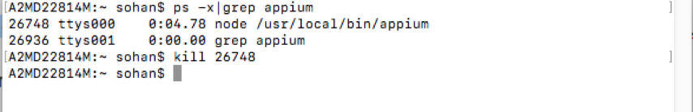

Figure 34: Stopping appium server in command prompt

And in existing appium started terminal window the process should stop and display
Shutting down(Refer Fig 35)
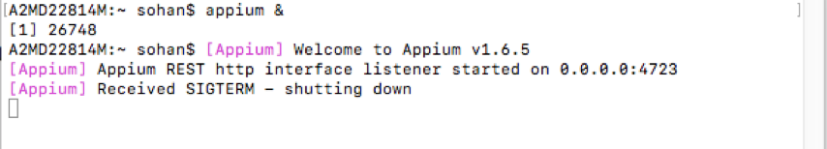

Figure 35: Appium server shutting down

By default appium launches at 0.0.0.0:4723, to launch appium at another IP and port
For example : To launch appium at 127.0.0.1 :4725 use command
appium -a 127.0.0.1 -p 4725

14: Setting up iOS Web driver

Step 1 : Open webdriver project for installed appium which is located at path
/usr/local/lib/node_modules/appium/node_modules/appium-xcuitest-driver/WebDriverAgent xcodeproject
and do the code sign.
Without code sign we will be able to run only on Simulator but for device we need to code sign WebDriverAgent project.

To do the code sign.

Note the following.

A bundle identifier.
A development team ID.

When a test case is run on real device for the first time we will get the following error

[Xcode] 2017-09-29 15:01:14.109 xcodebuild[12768:101129] Error Domain=NSCocoaErrorDomain Code=260 "The file “WebDriverAgentRunner-Runner.app” couldn’t be opened because there is no such file." UserInfo={NSFilePath=/Users/sohan/Library/Developer/Xcode/DerivedData/WebDriverAgent-brdadhpuduowllgivnnvuygpwhzy/Build/Products/Debug-iphoneos/WebDriverAgentRunner-Runner.app, NSUnderlyingError=0x7fa74e043730 {Error Domain=NSPOSIXErrorDomain Code=2 "No such file or directory"}}
[Xcode]
[Xcode] 2017-09-29 15:01:14.109 xcodebuild[12768:101129] Error Domain=IDETestOperationsObserverErrorDomain Code=6 "Early unexpected exit, operation never finished bootstrapping - no restart will be attempted" UserInfo={NSLocalizedDescription=Early unexpected exit, operation never finished bootstrapping - no restart will be attempted}
[Xcode]
[Xcode] ** TEST EXECUTE FAILED **
[Xcode]
[Xcode]
[XCUITest] xcodebuild exited with code '65' and signal 'null'

Open xcode and current set up looks like this (Refer Figure 36).

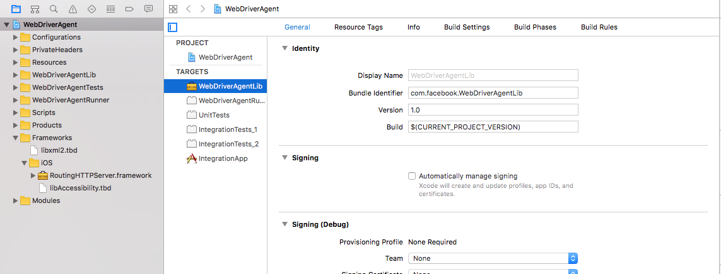

Figure 36: Web driver agent xcode project

Negeative scenario : The RoutingHHTPServer.framework error might occur as the framework might not be available so the reference will
highlight in red.

To fix this change current directory to WebDriverAgent folder and run bootstrap.sh and build.sh and it will create the missing frameworks (Refer Figure 37).
and framework error should be resolved in xcode, it also performs bootstraping which is mandatory for loading required resources.

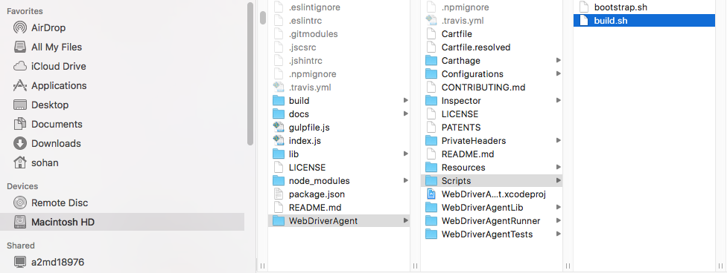

Figure 37: bootstrap and build sh files

Open terminal and type
$ cd /usr/local/lib/node_modules/appium/node_modules/appium-xcuitest-driver/WebDriverAgent

Run bootstrap.sh
$ /bin/bash Scripts/bootstrap.sh -d

The expected output should be as shown below (Refer Figure 38)

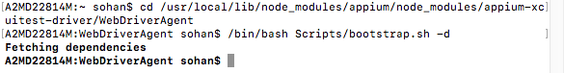

Figure 38: bootstraping Webdriver agent

Step 2 : Set up signing and set a valid bundle identifier that xcode will accept, any existing bundle identifier.

Figure 39: Signing for WebDriverAgentLib target

Set valid bundle identifier for WebdriverAgentLib,WebDriverAgentRunner and Unit tests.
Set provision profile and code signing identity for WebDriverAgentRunner.

NOTE :If Apple ID is present in xcode preferences then Automatically manage signing can work, else
provide manually.

Note : Don't do any modification for IntegrationTests and IntegrationApp.
Build the project with WebDriverAgentRunner scheme and should be succesful.

Now when a test case is Run, appium should launch

Negeative Scenario:
"Early unexpected exit, operation never finished bootstrapping - no restart will be attempted" error can occur.
Hence
You need to run bootstrap and download third party modules to compile it.
Make sure bootstrapping performed as per Figure 38, else do the same.

For Running and configuring test cases it has been mentioned in a separate document.

