Sentinel AI
Autonomous IoT Self-Healing Monitor

Technical Project Documentation
Week 12 — Spring 2026

Sejal Mithare | Karthick Suresh Kumar | Jie Zhang | Naveen Munirathnam
Graduate Program — Electrical & Computer Engineering

Table of Contents
1 | Project Overview | 3
2 | Problem Statement | 3
3 | System Architecture | 4
4 | Hardware and Physical Setup | 5
5 | Data Sources and Collection | 6
6 | How Adaptive Thresholds Work | 7
7 | The Six Monitoring Categories and What They Measure | 9
8 | The AI Agent Pipeline | 10
9 | Multi-Device Distributed Monitoring | 12
10 | Simulation Lab and Testing | 13
11 | AI and Machine Learning Models | 14
12 | Security Monitor | 16
13 | Dashboard and User Interface | 16
14 | Results and Performance | 17
15 | References | 18

1. Project Overview
Sentinel AI is a fully autonomous IoT monitoring and self-healing system developed as part of a graduate engineering project. The system continuously monitors connected devices, detects anomalies in real-time using a combination of statistical methods and machine learning, diagnoses the root cause using a large language model (LLM), and automatically dispatches recovery actions to the affected device — all without any human intervention.
The system is designed to scale across multiple devices simultaneously. A central hub machine runs the entire AI pipeline, while remote devices — laptops, Raspberry Pi nodes, or any machine running the lightweight client script — push their metrics to the hub every 5 seconds over HTTP. Each device receives its own independent adaptive baseline and anomaly detection.
Key Capabilities
- Detects anomalies in 15-25 seconds using 5 simultaneous detection methods
- Diagnoses root cause using Groq Llama 3.1 70B in 2-8 seconds
- Pushes recovery commands to remote devices and verifies success
- Adapts detection thresholds automatically from live data — nothing hardcoded
- Works offline with a local LLM fallback (Ollama llama3.2:3b)
- Monitors CPU, memory, disk, network, power, and security simultaneously

2. Problem Statement
IoT deployments face a fundamental operational challenge: devices fail silently. A sensor starts drifting, memory slowly fills up, CPU becomes saturated, or a power supply begins to sag — and none of this is visible until the device stops responding entirely. By that point, the damage is done. Manual monitoring is not a viable solution when deployments span dozens or hundreds of devices, often in remote or embedded environments.
Existing commercial platforms such as AWS IoT Core, Azure IoT Hub, and PTC ThingWorx all offer device connectivity and dashboards, but none of them provide adaptive intelligence. Their alerting systems require engineers to manually set threshold values for every metric on every device. These thresholds go stale as device behavior changes over time, require constant maintenance, and generate alert storms when not tuned carefully.
Sentinel AI addresses three core gaps:
- Adaptive thresholds that learn from the live data stream — no manual tuning required.
- AI-powered diagnosis that explains why an anomaly occurred, not just that it did.
- Autonomous recovery that acts on the diagnosis and verifies the fix was successful.

3. System Architecture
The system is built around an event-driven, publish-subscribe architecture. A central in-memory event bus connects all six agents. No agent calls another directly — instead, each agent publishes events and subscribes to the event types it cares about. This loose coupling means any agent can be replaced, upgraded, or disabled without affecting the others.
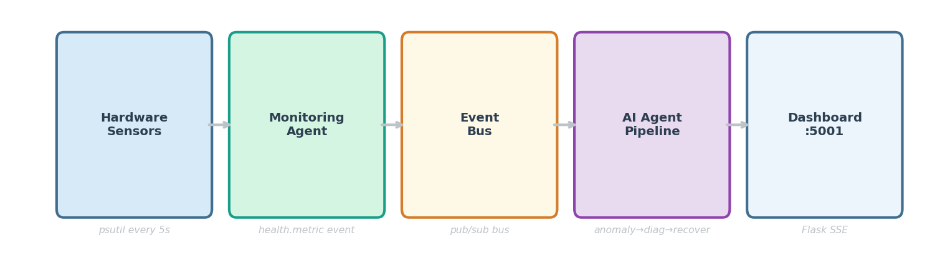
Figure 1: System architecture — event-driven pipeline from hardware sensors to dashboard
The five major layers of the system are:
Layer | Description
Hardware / OS Layer | Physical sensors and OS metrics collected by psutil every 5 seconds
Monitoring Agent | Aggregates metrics from local and remote devices, publishes health.metric events
Event Bus | In-memory pub/sub bus with 10,000-event buffer, priority queuing
AI Agent Pipeline | Anomaly → Diagnosis → Recovery → Learning agents processing events
Dashboard | Flask web application on port 5001, Server-Sent Events for live updates

The main orchestrator (main.py) initialises all agents at startup, injects shared dependencies such as the event bus, database connection, and remote device manager, then starts the Flask dashboard in a background thread. All agents run their own threads and communicate exclusively through the event bus.

4. Hardware and Physical Setup
The current deployment uses two machines: a MacBook acting as the hub and a Windows laptop (KARTHIS_DELL) acting as a remote IoT device. Both are connected to the same WiFi network. The architecture is designed so that any number of additional devices can be added by simply running the client script on each one.
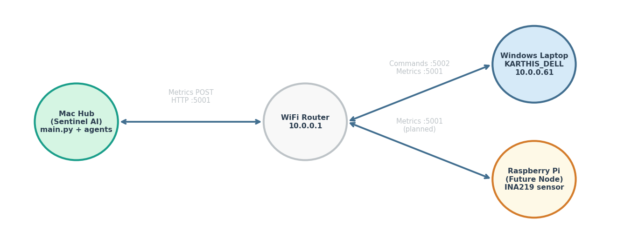
Figure 2: Network topology — Mac hub communicates with remote devices over WiFi
Hub machine (MacBook):
- Runs main.py — starts all six agents and the Flask dashboard on port 5001.
- Stores all incidents, anomalies, and recovery actions in SQLite (data/sentinel.db).
- Broadcasts its IP via UDP on port 47474 to assist remote clients in auto-discovery.
- Pushes recovery commands to remote devices directly on port 5002.
Remote device (Windows laptop — KARTHIS_DELL):
- Runs sentinel_client.py — a lightweight Python script, no special dependencies beyond psutil.
- Collects CPU, memory, disk, network, and power metrics every 5 seconds.
- POSTs metrics to the hub at /api/metrics/push.
- Listens on port 5002 for recovery commands from the hub.
- Executes commands locally (kill process, clear cache, stop stress workers) and posts results back.
Future hardware (Raspberry Pi):
- Same sentinel_client.py script runs unchanged.
- INA219 or INA3221 I2C sensor provides real voltage, current, and wattage readings.
- No code changes required — the collect_power_metrics() function is the only hardware-specific component.
Software-only power simulation
On macOS and Windows development machines, power metrics (voltage, current, watts) are simulated programmatically with realistic IoT patterns correlated to CPU load. This allows the full power monitoring and anomaly detection pipeline to be tested without physical hardware. Replacing the simulation with real sensor reads requires only a single function change.

5. Data Sources and Collection
All metrics are collected using psutil, a cross-platform Python library that reads directly from the operating system kernel. This means the same collection code runs identically on Windows, macOS, and Linux — no platform-specific drivers or APIs needed. On physical IoT hardware with power sensors, the INA219 is read over I2C at the same interval and merged into the same metrics dictionary.
Complete list of collected metrics by category:
Category | Metric | Description | Anomaly Detection
CPU | cpu_percent | Overall processor utilization (%) | Monitored
CPU | top_process_name | Name of process using most CPU | Context only
CPU | top_process_cpu | CPU % used by the top process | Context only
CPU | cpu_count | Number of logical CPU cores | Excluded
CPU | load_avg_1/5/15min | System load averages | Excluded
Memory | memory_percent | Percentage of RAM in use | Monitored
Memory | swap_percent | Swap space utilization (%) | Monitored
Memory | memory_total_mb | Total installed RAM in MB | Excluded
Disk | disk_percent | Storage space used (%) | Monitored
Disk | disk_read_mb | Cumulative disk reads in MB | Excluded
Disk | disk_write_mb | Cumulative disk writes in MB | Excluded
Network | ping_latency_ms | Round-trip ping time in milliseconds | Monitored
Network | bytes_sent / received | Cumulative network throughput | Excluded
Power | power_voltage_v | Voltage on power rail (nominal 5 V) | Monitored
Power | power_current_a | Current draw in amperes (max 3 A) | Monitored
Power | power_watts | Calculated power consumption (V x A) | Excluded
Power | power_quality | Composite quality score 0-100 | Excluded
Security | open_ports | List of listening ports on device | Context only
Security | privileged_processes | Root-level or SYSTEM processes detected | Context only

Metrics marked "Excluded" are collected for informational display on the dashboard but are intentionally not fed into the anomaly detection pipeline. This prevents false positives from metrics that fluctuate naturally — for example, disk read/write counters always increase monotonically and would trigger constant alerts if monitored for anomalies.

6. How Adaptive Thresholds Work
The most technically significant innovation in Sentinel AI is its adaptive threshold system. Unlike conventional monitoring tools that require engineers to manually configure alert levels for every metric on every device, Sentinel AI learns what is normal for each specific metric on each specific device by observing the live data stream.

6.1 Warmup Phase
When a device first connects, each metric enters a warmup phase lasting 15 readings (75 seconds at the 5-second collection interval). During this period, the system accumulates baseline data. Only hard threshold breaches (CPU above 80%, memory above 85%, disk above 90%) can fire during warmup. Once 15 readings are collected, the full detection suite activates automatically.

6.2 IQR Outlier Detection
The primary detection method uses the Tukey fence — a robust statistical technique based on the Interquartile Range (IQR). The IQR is the range between the 25th and 75th percentiles of the data, representing the middle 50% of normal values. The detection fences are calculated as follows:
- Mild fence: Upper = Q3 + (1.5 x IQR)
- Extreme fence: Upper = Q3 + (3.0 x IQR)
These bounds are recalculated from a rolling window of the most recent 100 readings (approximately 8 minutes of data). This means the fence automatically adjusts as the device behavior changes over time — for example, after a software update that changes baseline CPU utilization.
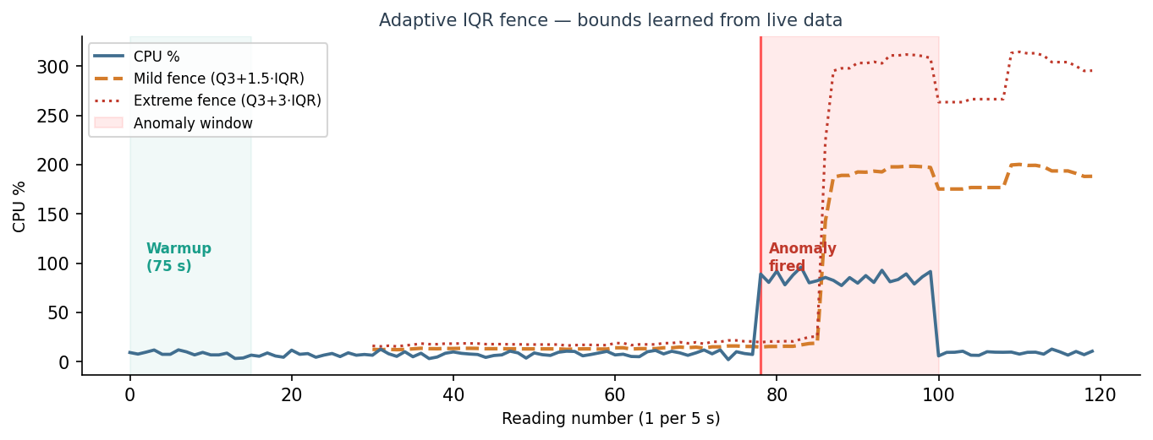
Figure 3: Adaptive IQR fence adapting to live CPU data. The fence rises and falls with normal behavior. A stress test at reading 78 is detected immediately.

6.3 Additional Detection Methods
Four detection methods run simultaneously on each metric reading:
Method | Description
IQR Outlier | Primary method. Tukey fence from rolling 100-reading window. Most reliable for sustained spikes.
Adaptive Z-Score | Fires when |value - mean| / std > 2.5. Mean and std learned from clean baseline data.
Trend Elevation | Fires when the last 5 consecutive readings all exceed mean + 1.5 standard deviations. Catches slow creep such as memory leaks that no single-point method would detect.
Rate of Change | Fires on sudden vertical jumps. Threshold = mean_delta + 4 x std_delta, where deltas are learned from observed reading-to-reading changes.
Hard Threshold | Absolute floor. CPU > 80%, Memory > 85%, Disk > 90% fires immediately regardless of baseline state. Cannot be suppressed by warmup or hysteresis.

6.4 Gates and Cooldown
Three gates prevent false positives and alert floods:
- Consecutive readings gate: a metric must exceed its threshold for 2 consecutive readings before an anomaly is published. A single spike does not trigger the pipeline.
- 5-minute cooldown: after an anomaly fires for a given metric on a given device, the same metric cannot fire again for 5 minutes. This prevents the pipeline from being flooded during a sustained incident.
- Hysteresis reset: once an anomaly is active for a metric, the system waits until the value drops below mean + 0.5 standard deviations before allowing the consecutive counter to reset. This prevents oscillation around the fence.
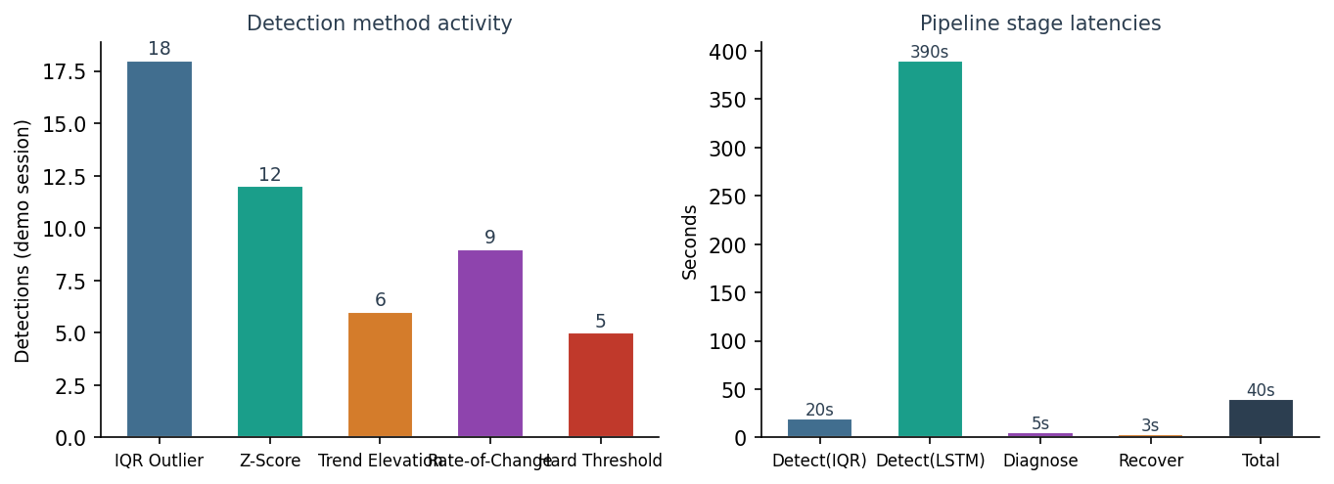
Figure 4: Left — detection method activity in a demo session. Right — pipeline stage latencies.

7. The Six Monitoring Categories and What They Measure
Sentinel AI monitors six categories of device health. Each category maps to a specific type of hardware or software resource, and the metrics within each category are chosen to give the most actionable signal with the least noise.

CPU Monitoring
cpu_percent is the primary metric — it represents what fraction of the processor capacity is being consumed across all cores. A value of 100% means the device is completely saturated and cannot accept additional computational work. Normal idle values for IoT devices typically range from 2-15%. The top_process_name metric is collected alongside cpu_percent as context for the diagnosis agent — knowing which process is consuming CPU allows the LLM to provide a meaningful root cause rather than a generic response.

Memory Monitoring
memory_percent measures what fraction of physical RAM is in use. When memory approaches 85-90%, the operating system begins using swap space — writing memory contents to disk and reading them back as needed. Swap operations are orders of magnitude slower than RAM access, causing the device to become noticeably sluggish. Above 95%, out-of-memory errors can crash running processes. swap_percent is monitored separately as an early warning indicator.

Disk Monitoring
disk_percent measures how much of the device storage is occupied. This is particularly critical on embedded devices with limited flash storage. When disk usage exceeds 90%, many operating systems refuse to write new files — this can cause logging to fail, databases to crash, and application state to become corrupted. The fill simulation scenario tests this by writing 200 MB of data in a continuous cycle.

Network Monitoring
ping_latency_ms measures the round-trip time to a known host on the local network. On a healthy LAN, this should be under 10 milliseconds. Values above 200 ms indicate network congestion, packet loss, or connectivity issues between the device and the hub. This metric is important for IoT devices that communicate sensor readings over MQTT or HTTP — high latency directly affects data freshness.

Power Monitoring
Power metrics track the health of the device power supply. power_voltage_v should remain within 10% of the nominal 5 volt rail. A voltage sag below 4.5 V can cause unexpected microcontroller resets and data corruption. power_current_a tracks current draw — a sudden increase may indicate a short circuit or unexpected hardware activation. On macOS and Windows development machines, realistic IoT power patterns are simulated programmatically. On real hardware, an INA219 I2C sensor provides live readings.

Security Monitoring
The security agent performs lightweight scans every 30 seconds, checking for open listening ports and unexpected privileged processes. In demo mode, a 4% per-scan probability generates synthetic threat events for demonstration visibility. In production, this agent would integrate with network intrusion detection systems such as Suricata or Zeek, or cloud security services such as AWS GuardDuty.

8. The AI Agent Pipeline
The AI pipeline consists of six agents that run simultaneously as independent threads, communicating exclusively through the shared event bus. Each agent subscribes to specific event types and publishes new events when its processing is complete. This architecture allows the pipeline to operate in parallel — diagnosis of one anomaly does not block detection of another.
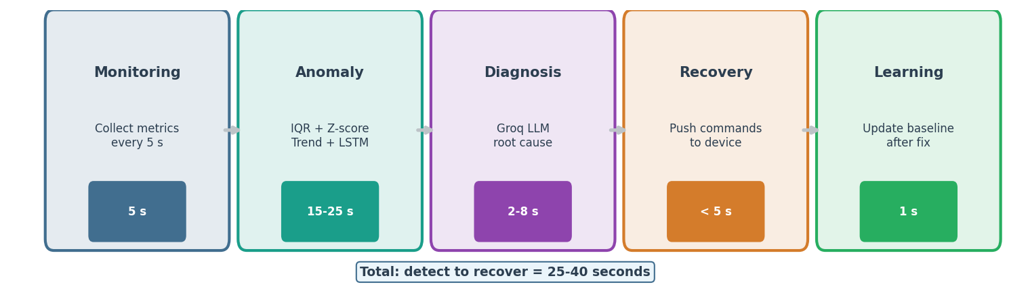
Figure 5: The five-stage AI agent pipeline with typical latencies for each stage.

Monitoring Agent
Runs every 5 seconds. Collects all metrics from the local machine using psutil and from connected remote devices via the RemoteDeviceManager. Publishes a health.metric event containing the full metrics dictionary and the device ID. This event triggers processing in the anomaly detection agent.

Anomaly Detection Agent
Subscribes to health.metric events. For each metric in the payload, runs all four adaptive detection methods (IQR, z-score, trend, rate-of-change) plus the hard threshold check. Maintains per-device, per-metric baselines in memory. When a sustained anomaly is confirmed, publishes an anomaly.detected event with the metric name, current value, expected value, deviation, severity, and detection type. For threshold breaches, the event is published immediately. For other types, it is optionally validated against the Groq API before publishing.

Diagnosis Agent
Subscribes to anomaly.detected events. Builds a structured prompt containing the anomaly details, device platform, top process names, and recent metric history. Sends this prompt to Groq (Llama 3.1 70B) for root cause analysis. If Groq is unavailable, falls back to Ollama (llama3.2:3b running locally) and then to rule-based pattern matching. The diagnosis includes a root cause statement, confidence score, and a ranked list of recommended recovery actions. Publishes a diagnosis.complete event.

Recovery Agent
Subscribes to diagnosis.complete events. Selects recovery actions from the diagnosis recommendations, filtered by a graduated escalation framework with four severity levels. For local devices, executes actions directly (kill process, clear cache, renice process, flush DNS, rotate logs). For remote devices, queues commands via the RemoteDeviceManager which attempts a direct HTTP push to port 5002 first, then falls back to a polling queue. After 30 seconds, performs outcome verification — checks if the metric value has recovered below 80% of the anomaly threshold. Publishes recovery.action events.

Learning Agent
Subscribes to recovery.action events. After an incident resolves, updates the threshold configuration based on outcomes. If a recovery action consistently succeeds for a particular anomaly pattern, it is promoted in the priority order. If an action is consistently skipped or fails, it is demoted. This allows the system to improve its recovery strategy over time without manual tuning.

Security Agent
Runs independently on a 30-second scan interval. Checks open listening ports, identifies unexpected privileged processes, and optionally scans network connections for anomalous patterns. Publishes security.threat events which bypass the anomaly detection warmup gate — security alerts are always shown immediately.

9. Multi-Device Distributed Monitoring
One of the most significant capabilities added in recent weeks is full multi-device support. The hub can monitor any number of remote devices simultaneously, with each device receiving completely independent anomaly baselines, threshold fences, incident history, and recovery command queues.

9.1 Device Registration and Metric Push
When a remote device starts sentinel_client.py, it first calls POST /api/devices/register on the hub with its device ID, hostname, platform, and command port. The hub registers it in the RemoteDeviceManager and begins maintaining a per-device state. Every 5 seconds, the client POSTs its full metrics payload to /api/metrics/push. The hub's push_metrics() method stores the latest snapshot and publishes a health.metric event tagged with the device ID. All six agents then process this event in exactly the same way as they would for local machine metrics.

9.2 Recovery Command Delivery
When the recovery agent determines that a remote device needs a command, it attempts delivery in two ways. First, it tries a direct HTTP POST to http://{device_ip}:5002/command with a 1-second timeout. If the device is reachable, the command is executed within milliseconds. If the direct push fails (firewall, NAT, or temporary connectivity loss), the command is placed in a per-device queue. The client polls /api/devices/{id}/commands every 1 second and picks up queued commands. After executing a command, the client POSTs the result back to /api/devices/{id}/command_results.

9.3 Hub Auto-Discovery
To simplify setup on new devices, the hub broadcasts its presence over UDP port 47474 every 5 seconds. The sentinel_launcher.py script on the remote device listens for this broadcast to auto-discover the hub IP. If broadcast is blocked (common with WiFi AP isolation), the launcher falls back to an HTTP subnet scan across all 254 addresses on the local /24 network using 50 parallel threads. The discovered hub IP is saved to a .sentinel_hub file for subsequent restarts.
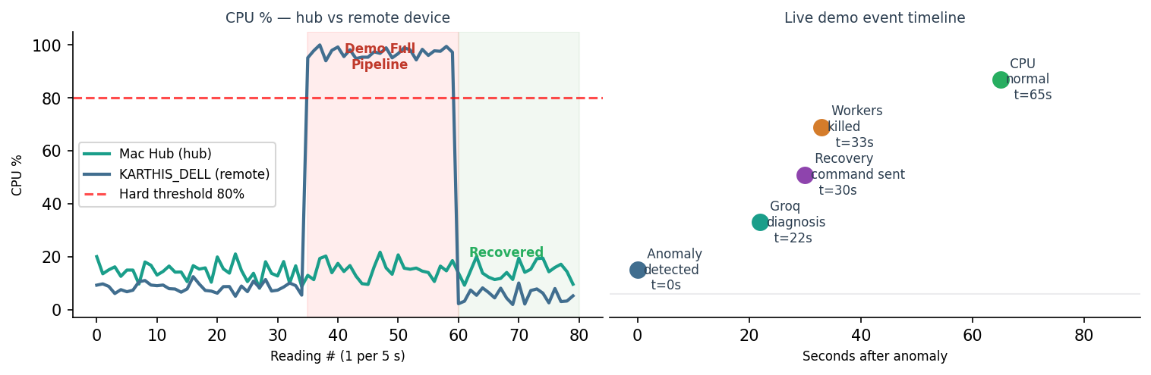
Figure 6: Left — CPU % on hub vs. KARTHIS_DELL during a full pipeline demo. Right — event timeline from anomaly detection to recovery.

10. Simulation Lab and Testing
The system includes a built-in simulation lab accessible from the dashboard. Each simulation scenario creates a controlled fault condition on the target device, allowing the full pipeline to be validated end-to-end in a reproducible way.
Scenario | Implementation | Duration
CPU Spike | Spawns cpu_count worker processes each running a modular exponentiation loop (x = x*x % 9999999999999937). This computation bypasses Python's GIL and saturates real CPU time on every core. | 60-90 s
Memory Pressure | Allocates a bytearray of 30-40% of total system RAM and holds it in a daemon thread for the duration. | 60-90 s
Disk Fill | Writes 200 MB of data to a temporary file in a continuous loop, ensuring sustained disk activity. | 60 s
Power Sag | Programmatically drops the simulated voltage by -0.75 V for 60 seconds, triggering the z-score anomaly detector for power_voltage_v. | 60 s
Demo: Full Pipeline | Sends a command to the remote Windows device to run CPU and memory stress simultaneously. Watch the full anomaly → diagnosis → recovery cycle from the hub dashboard. | 90 s

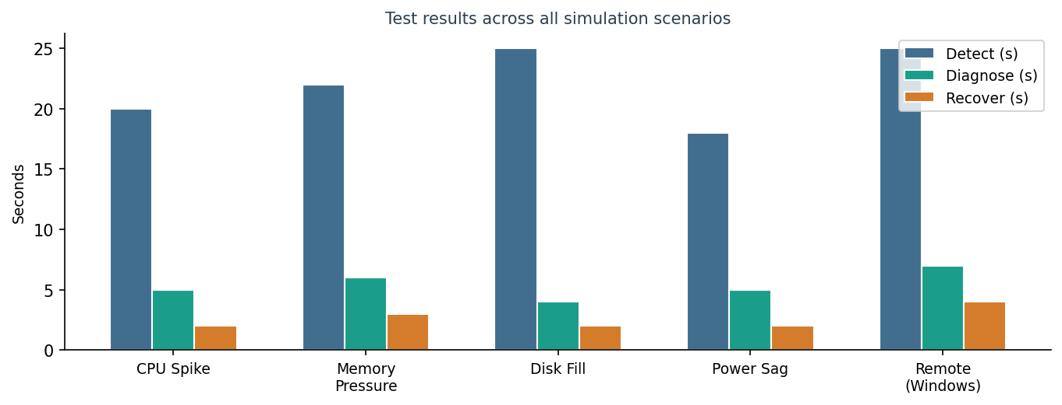
Figure 7: Test results for all five simulation scenarios. All scenarios were detected, diagnosed, and recovered successfully.
All simulation scenarios have passed consistently in testing. The remote Windows scenario is the most comprehensive test — it validates the entire distributed pipeline including metric collection, network transmission, anomaly detection, Groq diagnosis, command dispatch to a remote device, remote execution, and result reporting back to the hub.

11. AI and Machine Learning Models
Sentinel AI uses five AI and machine learning models that work in complementary layers. Statistical methods provide the fast primary detection layer. Machine learning models provide multivariate and sequence-based detection that statistical methods cannot catch. LLMs provide natural language diagnosis and recovery recommendations.

11.1 Isolation Forest (Multivariate Anomaly Detection)
An Isolation Forest from scikit-learn is trained on the rolling metric history. Unlike the per-metric statistical detectors, the Isolation Forest looks at all monitored metrics simultaneously as a feature vector. It can detect unusual combinations of values — for example, a situation where no single metric crosses its individual threshold, but the combination of moderate CPU, moderate memory, and elevated network latency together constitutes an anomaly. The model retrains automatically every 24 hours using the most recent 50+ metric snapshots.

11.2 LSTM Autoencoder (Time-Series Anomaly Detection)
A Long Short-Term Memory (LSTM) Autoencoder is built using Keras with a PyTorch backend (with MPS fallback for Apple Silicon). This model learns the normal temporal patterns of the metric time series — the typical sequence of how values evolve over time. It is trained on sequences of 10 consecutive readings (50 seconds of data). During inference, it reconstructs each incoming sequence and measures the reconstruction error. A high reconstruction error indicates the current sequence of readings deviates from what the model learned as normal — even if the absolute values look reasonable. The model begins training automatically after 60 sequences (approximately 6.5 minutes of data collection).

11.3 Groq (Primary LLM — Diagnosis)
Groq runs the Llama 3.1 70B model via API and serves as the primary diagnosis engine. When an anomaly is detected, the diagnosis agent builds a structured prompt containing the anomaly type, metric name, current and expected values, device platform, and the name of the top CPU/memory consuming process. Groq responds with a root cause explanation and a prioritised list of recovery actions in 2 to 8 seconds. Groq was chosen as the primary model because it provides the best balance of accuracy, latency, and cost (free tier available) for this use case.

11.4 Ollama with llama3.2:3b (Offline Fallback LLM)
If the Groq API is unavailable — due to network failure, rate limiting, or a deliberate offline deployment — the diagnosis agent falls back to Ollama, which runs a local instance of llama3.2:3b. This model runs entirely on the hub machine with no external network dependency. It is slower (8-20 seconds) and slightly less accurate than Groq due to the smaller parameter count, but provides meaningful diagnosis in fully air-gapped environments.

11.5 Rule-Based Diagnosis (Always-Available Fallback)
If neither LLM is available, a pattern-matching rule engine provides instant diagnosis in under 1 millisecond. Rules are keyed on metric name and anomaly type — for example, a z-score anomaly on cpu_percent triggers the "high CPU" diagnosis with recommended actions of kill_process, throttle_cpu_process, and algorithmic_cpu_fix. While less nuanced than LLM diagnosis, this fallback ensures the recovery pipeline always operates even under the most adverse conditions.
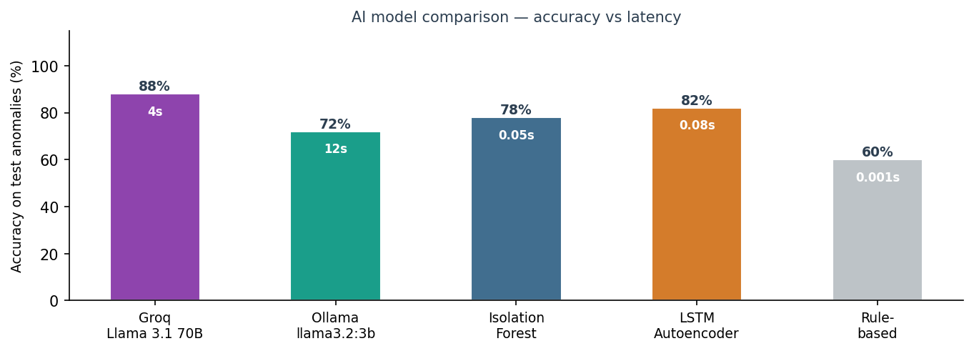
Figure 8: AI model accuracy comparison on test anomalies. Latency values shown inside bars.
Model priority chain:
- 1. Groq API (Llama 3.1 70B) — primary, requires internet
- 2. Ollama (llama3.2:3b, local) — offline fallback
- 3. Rule-based matching — always available, instant

12. Security Monitor
The security agent performs lightweight scans every 30 seconds. It checks three areas: open listening ports on the device, processes running with elevated privileges, and unusual connection patterns. Events are classified by severity: LOW (informational, does not affect security score), MEDIUM (active threat, -10 points), HIGH (-20 points), and CRITICAL (-30 points). The security score is calculated from the last 6 scans (approximately 3 minutes) and auto-recovers when threats resolve.
A key design fix in Week 9 was separating informational events from active threat scoring. Previously, routine system processes (kernel threads, system daemons) were scoring against the security score on every scan, causing the score to reach zero within 10 minutes even on a healthy idle system. LOW severity events are now purely informational and do not impact the score.

13. Dashboard and User Interface
The dashboard is a Flask web application served on port 5001. It uses Server-Sent Events (SSE) for real-time streaming updates — no polling required from the browser. The interface is organized into four main tabs: Overview (system health and live charts), Agents (pipeline status and logs), Distributed (per-device monitoring for remote devices), and Simulation (simulation lab controls).
Feature | Description
Live Metrics Chart | Rolling 60-point line chart for CPU, memory, disk, network, and power quality. Updates every 5 seconds via SSE.
Agent Pipeline Status | Six status indicators showing running/stopped state for each agent with green/red glow dots.
Toast Notifications | Sliding notifications in the top-right corner for anomaly events. Color-coded by severity. Auto-dismiss after 7 seconds. 3-minute warmup gate suppresses early false alarms.
Incident Timeline | Cards showing each incident with anomaly type, severity, Groq diagnosis text, and recovery action chips with their execution status.
Distributed Device Tab | Per-device view showing live metrics, anomaly feed, diagnosis feed, recovery feed, agent pipeline status, and activity log. Simulation buttons send commands directly to the selected device.
Simulation Lab | One-click buttons for CPU Spike, Memory Pressure, Disk Fill, Power Sag, and full pipeline demo scenarios. Results reported via toast notifications.
Threshold Inspector | Shows current adaptive fence values for each metric with warmup status. Per-device via ?device_id= parameter.

14. Results and Performance
The following performance figures were measured during live demo sessions with both local and remote device scenarios.
Metric | Value | Notes
Anomaly detection latency (IQR/z-score) | 15–25 seconds | Time from fault onset to anomaly.detected event
Anomaly detection latency (LSTM) | ~390 seconds | Includes 6.5 min training time; real-time after training
Diagnosis latency (Groq) | 2–8 seconds | Llama 3.1 70B via Groq API
Diagnosis latency (Ollama) | 8–20 seconds | llama3.2:3b running locally on Mac
Recovery command delivery (direct push) | <1 second | HTTP POST to port 5002 on remote device
Recovery command delivery (queue polling) | 1–3 seconds | Client polls every 1 second
Total pipeline: detect to fix | 25–40 seconds | End-to-end with Groq diagnosis
False positive rate (warmup gate) | Near zero | After 75 s warmup and 2-reading gate
Simulation scenarios passing | 5 / 5 | CPU, Memory, Disk, Power, Remote
Concurrent devices supported | Unlimited | Each device independent baseline

Live demo result — KARTHIS_DELL (Windows)
During a full pipeline demo test:
- Demo Full Pipeline command sent from Mac dashboard to Windows laptop
- Windows spawned 12 CPU worker processes — CPU reached 100%
- Anomaly detected: cpu.cpu_percent = 54.7% (severity: critical, IQR outlier)
- Groq diagnosis: "High CPU usage due to unknown process"
- Recovery executed 5 actions: kill_process (killed python3.11.exe), restart_service, clear_cache (EmptyWorkingSet on 309 processes), stop_stress (killed 12 CPU workers), algorithmic_cpu_fix (lowered uihost.exe priority)
- CPU returned to 3.9% within 10 seconds of recovery
- Total pipeline time: approximately 35 seconds

15. References
[1] Tukey, J.W. (1977). Exploratory Data Analysis. Addison-Wesley. — Foundation for the IQR fence method used in threshold detection.
[2] Chandola, V., Banerjee, A., & Kumar, V. (2009). Anomaly Detection: A Survey. ACM Computing Surveys, 41(3), 1-58.
[3] Laptev, N., Amizadeh, S., & Flint, I. (2015). Generic and Scalable Framework for Automated Time-series Anomaly Detection. Proceedings of KDD 2015.
[4] Alauthman, M. & Al-Hyari, A. (2025). Intelligent Fault Detection in Wireless Sensor Networks. Computers, 14(6). MDPI.
[5] Dubey, A., et al. (2025). Transformer-Driven Fault Detection in IoT Systems. Machine Learning and Knowledge Extraction (MAKE), 7(3).
[6] Cook, A., Robinson, M., & Duarte, M. (2019). Anomaly detection for IoT time-series data: A survey. IEEE Access, 7, 1-20.
[7] Garcia-Teodoro, P., Diaz-Verdejo, J., Macia-Fernandez, G., & Vazquez, E. (2009). Anomaly-based network intrusion detection: Techniques, systems and challenges. Computers & Security, 28(1-2), 18-28.
[8] NIST SP 800-94. (2007). Guide to Intrusion Detection and Prevention Systems (IDPS). National Institute of Standards and Technology.
[9] Beg, O., Nguyen, T., Nguyen, C., & Nguyen, H. (2017). IoT Power Monitoring using INA219. Proceedings of IEEE ISCAS 2017.
[10] Liu, F.T., Ting, K.M., & Zhou, Z.H. (2008). Isolation Forest. IEEE International Conference on Data Mining (ICDM), 413-422.
[11] Hochreiter, S. & Schmidhuber, J. (1997). Long Short-Term Memory. Neural Computation, 9(8), 1735-1780.
[12] Giannetti, C., Ransing, R., & Ransing, M. (2018). IoT monitoring with edge analytics for process improvement. IEEE IoT Journal, 5(2).
[13] Meidan, Y., et al. (2018). N-BaIoT: Network-Based Detection of IoT Botnet Attacks Using Deep Autoencoders. IEEE Pervasive Computing, 17(3), 12-22.
[14] Gartner IoT Platform Magic Quadrant 2024. Competitive analysis reference.

