CODE:
Employee Dao.java
package com.hcl.dao;

import org.apache.log4j.Logger;
import org.hibernate.Session;
import org.hibernate.Transaction;

import com.hcl.model.Employee;
import com.hcl.util.HibernateUtil;

public class EmployeeDao {
static Logger log = Logger.getLogger(EmployeeDao.class.getName());
public boolean saveUser(Employee employee) {
Transaction transaction = null;
try (Session session = HibernateUtil.getSessionFactory().openSession()) {
transaction = session.beginTransaction();
session.save(employee);
//hibernate insert query to save user details in DB
transaction.commit();
log.info("Data is saved");
return true;
} catch (Exception e) {
e.printStackTrace();
return false;
}
}

public String validate(String username, String password) {
Transaction transaction = null;
Employee user = null;
try (Session session = HibernateUtil.getSessionFactory().openSession()) {
transaction = session.beginTransaction();
//To find if employee exists in DB
user = findIfEmployeeExists(username);
//If user exist, go to login page
if (user != null) {
if (user.getPassword().equals(password)) {
log.info("Pass");
return "Pass";
} else {
//If user exist but gave wrong password, ask again to give correct password
log.info("Exists");
return "Exists";
}
} else {
//If user doesn't exist, ask to register
log.info("NotExists");
return "NotExists";
}
} catch (Exception e) {
e.printStackTrace();
}
log.info("TryAgain");
return "TryAgain";
}
//To find if employee exists in DB
public Employee findIfEmployeeExists(String username) {
Transaction transaction = null;
Employee employee = null;
try (Session session = HibernateUtil.getSessionFactory().openSession()) {
transaction = session.beginTransaction();
//hibernate select query to find if user exists in DB
employee = (Employee) session.createQuery("FROM Employee U WHERE U.username = :username")
.setParameter("username", username).uniqueResult();
log.info("Finding if data exists");
} catch (Exception e) {
e.printStackTrace();
}
return employee;
}
}
Employee.java
package com.hcl.model;

import java.io.Serializable;

import javax.persistence.Column;
import javax.persistence.Entity;
import javax.persistence.GeneratedValue;
import javax.persistence.GenerationType;
import javax.persistence.Id;
import javax.persistence.Table;

@Entity
@Table(name = "employees")
public class Employee implements Serializable {
private static final long serialVersionUID = 1L;

@Id
@GeneratedValue(strategy = GenerationType.IDENTITY)
private int id;

@Column(name = "first_name")
private String firstName;

@Column(name = "last_name")
private String lastName;

@Column(name = "user_name")
private String username;

@Column(name = "password")
private String password;

@Column(name = "email")
private String email;

@Column(name = "contactNumber")
private String contactNumber;

/**
* @return the email
*/
public String getEmail() {
return email;
}

/**
* @param email the email to set
*/
public void setEmail(String email) {
this.email = email;
}

/**
* @return the contactNumber
*/
public String getContactNumber() {
return contactNumber;
}

/**
* @param contactNumber the contactNumber to set
*/
public void setContactNumber(String contactNumber) {
this.contactNumber = contactNumber;
}

public String getFirstName() {
return firstName;
}

public void setFirstName(String firstName) {
this.firstName = firstName;
}

public String getLastName() {
return lastName;
}

public void setLastName(String lastName) {
this.lastName = lastName;
}

public String getUsername() {
return username;
}

public void setUsername(String username) {
this.username = username;
}

public String getPassword() {
return password;
}

public void setPassword(String password) {
this.password = password;
}
}
HibernateUtil.java
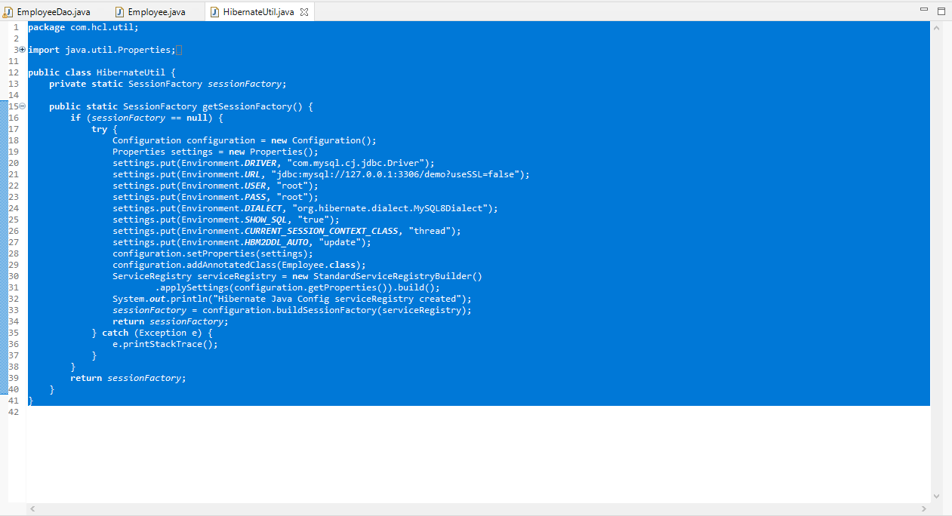

EmployeeLoginServlet.java
package com.hcl.web;

import java.io.IOException;

import javax.servlet.RequestDispatcher;
import javax.servlet.ServletException;
import javax.servlet.annotation.WebServlet;
import javax.servlet.http.HttpServlet;
import javax.servlet.http.HttpServletRequest;
import javax.servlet.http.HttpServletResponse;

import org.apache.log4j.Logger;

import com.hcl.dao.EmployeeDao;

@WebServlet("/login")
public class EmployeeLoginServlet extends HttpServlet {
static Logger log = Logger.getLogger(EmployeeDao.class.getName());
private static final long serialVersionUID = 1L;
private EmployeeDao loginDao;

public EmployeeLoginServlet() {
super();
loginDao = new EmployeeDao();
}

protected void doPost(HttpServletRequest request, HttpServletResponse response)
throws ServletException, IOException {
String message = null;
try {
authenticate(request, response);
} catch (Exception e) {
//If unexpected error occured, ask to login again
RequestDispatcher dispatcher = request.getRequestDispatcher("login.jsp");
message = "Unexpected Error Occured! Try again!";
//sending message to user
log.info("Unexpected Error Occured! Try again!");
request.setAttribute("message", message);
dispatcher.forward(request, response);
}
}

private void authenticate(HttpServletRequest request, HttpServletResponse response) throws Exception {
String username = request.getParameter("username");
String password = request.getParameter("password");
String message = null;
String check = loginDao.validate(username, password);
if (check.equals("Pass")) {
//If user exist, Successfull login
System.out.println("LoginSuccess");
log.info("LoginSuccess");
RequestDispatcher dispatcher = request.getRequestDispatcher("SuccessLogin.jsp");
dispatcher.forward(request, response);
} else if (check.equals("Exists")) {
//If user exist but gave wrong password, ask again to give correct password
System.out.println("Exists");
log.info("Exists");
RequestDispatcher dispatcher = request.getRequestDispatcher("login.jsp");
message = "Wrong Password! Try Again!";
//sending message to user
request.setAttribute("message", message);
dispatcher.forward(request, response);
} else if (check.equals("NotExists")) {
//If user doesn't exist, ask to register
System.out.println("NotExists");
log.info("NotExists");
RequestDispatcher dispatcher = request.getRequestDispatcher("register.jsp");
message = "Are you a New Employee? Please Register!";
//sending message to user
request.setAttribute("message", message);
dispatcher.forward(request, response);
} else {
//If unexpected error occured, ask to login again
System.out.println("Unexpected");
log.info("Unexpected Error Occured! Try again!");
RequestDispatcher dispatcher = request.getRequestDispatcher("login.jsp");
message = "Unexpected Error Occured! Try again!";
//sending message to user
request.setAttribute("message", message);
dispatcher.forward(request, response);
}
}
}
EmployeeRegistrationServlet.java
package com.hcl.web;

import java.io.IOException;

import javax.servlet.RequestDispatcher;
import javax.servlet.ServletException;
import javax.servlet.annotation.WebServlet;
import javax.servlet.http.HttpServlet;
import javax.servlet.http.HttpServletRequest;
import javax.servlet.http.HttpServletResponse;

import org.apache.log4j.Logger;

import com.hcl.dao.EmployeeDao;
import com.hcl.model.Employee;

@WebServlet("/register")
public class EmployeeRegistrationServlet extends HttpServlet {
static Logger log = Logger.getLogger(EmployeeDao.class.getName());
private static final long serialVersionUID = 1L;
private EmployeeDao employeeDao;

protected void doPost(HttpServletRequest request, HttpServletResponse response)
throws ServletException, IOException {
register(request, response);
}

private void register(HttpServletRequest request, HttpServletResponse response)
throws IOException, ServletException {
String message = null;
Employee ifEmployeeExists = employeeDao.findIfEmployeeExists(request.getParameter("username"));
if (ifEmployeeExists == null) {
System.out.println("Saved");
//get all values entered by the user
String firstName = request.getParameter("firstName");
String lastName = request.getParameter("lastName");
String username = request.getParameter("username");
String password = request.getParameter("password");
String email = request.getParameter("email");
String contactNumber = request.getParameter("contactNumber");
Employee employee = new Employee();
//store the values in employee
employee.setFirstName(firstName);
employee.setLastName(lastName);
employee.setUsername(username);
employee.setPassword(password);
employee.setEmail(email);
employee.setContactNumber(contactNumber);
if (employeeDao.saveUser(employee)) {
RequestDispatcher dispatcher = request.getRequestDispatcher("login.jsp");
dispatcher.forward(request, response);
} else {
RequestDispatcher dispatcher = request.getRequestDispatcher("register.jsp");
message = "Enter correct values in the fields!";
//sending message to user
request.setAttribute("message", message);
log.info(message);
dispatcher.forward(request, response);
}
} else {
System.out.println("Same User");
RequestDispatcher dispatcher = request.getRequestDispatcher("register.jsp");
//sending message to user
message = "Please use different Username!";
request.setAttribute("message", message);
log.info(message);
dispatcher.forward(request, response);
}
}

public EmployeeRegistrationServlet() {
super();
employeeDao = new EmployeeDao();
}
}
FrontPageServlet.java
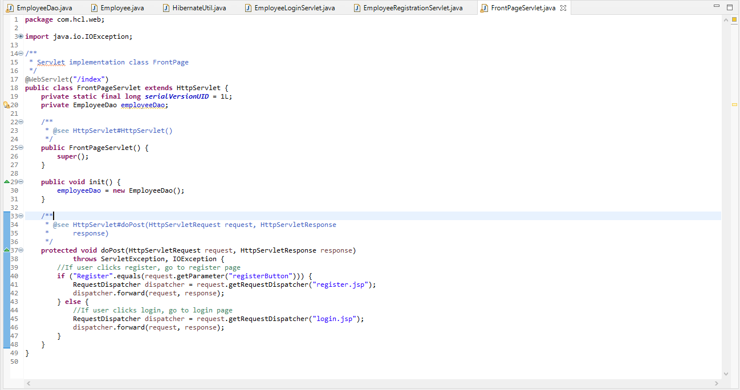
Log4j.properties
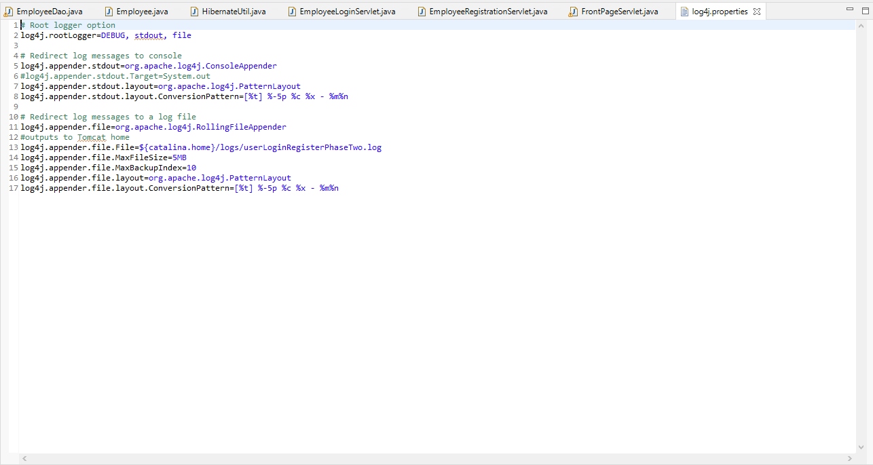
Web-xml
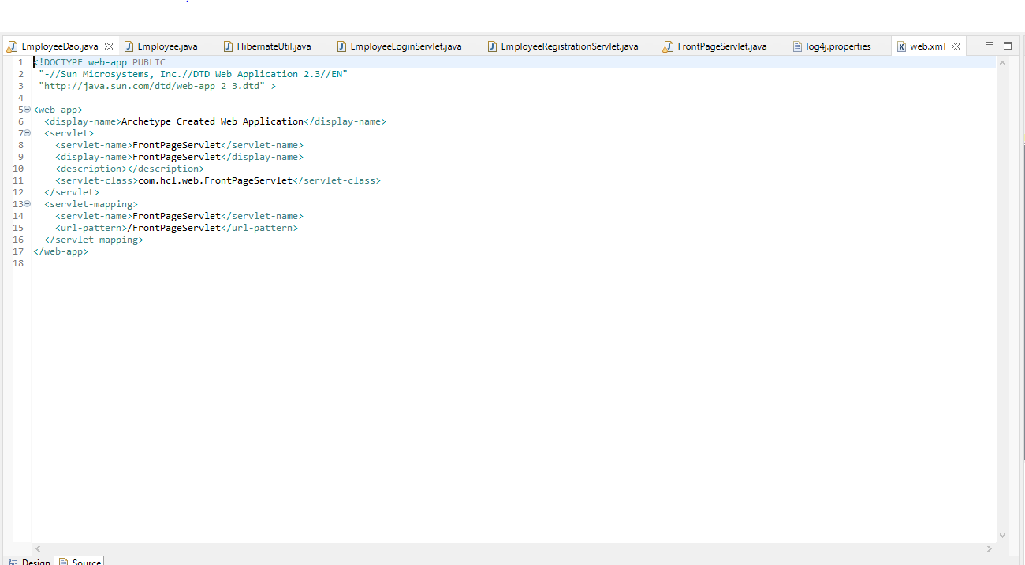
Index.jsp
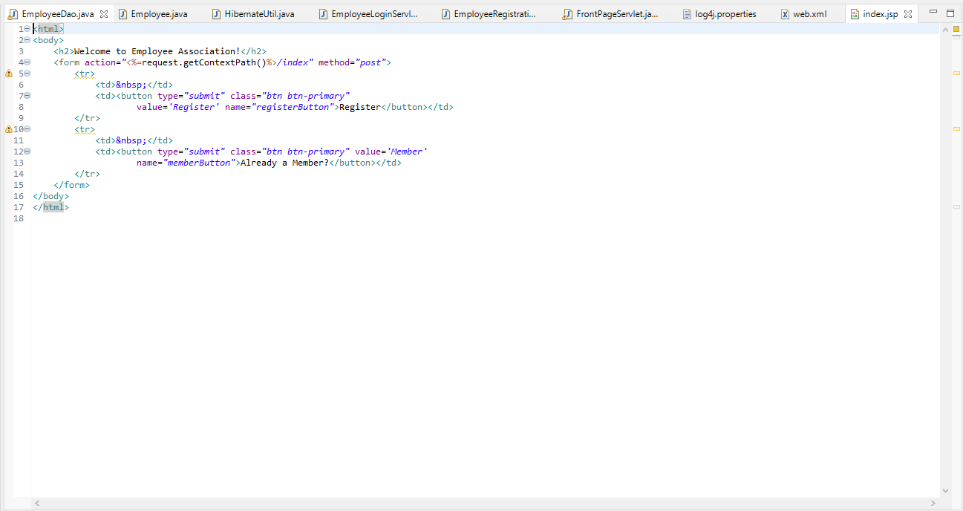
Login.jsp
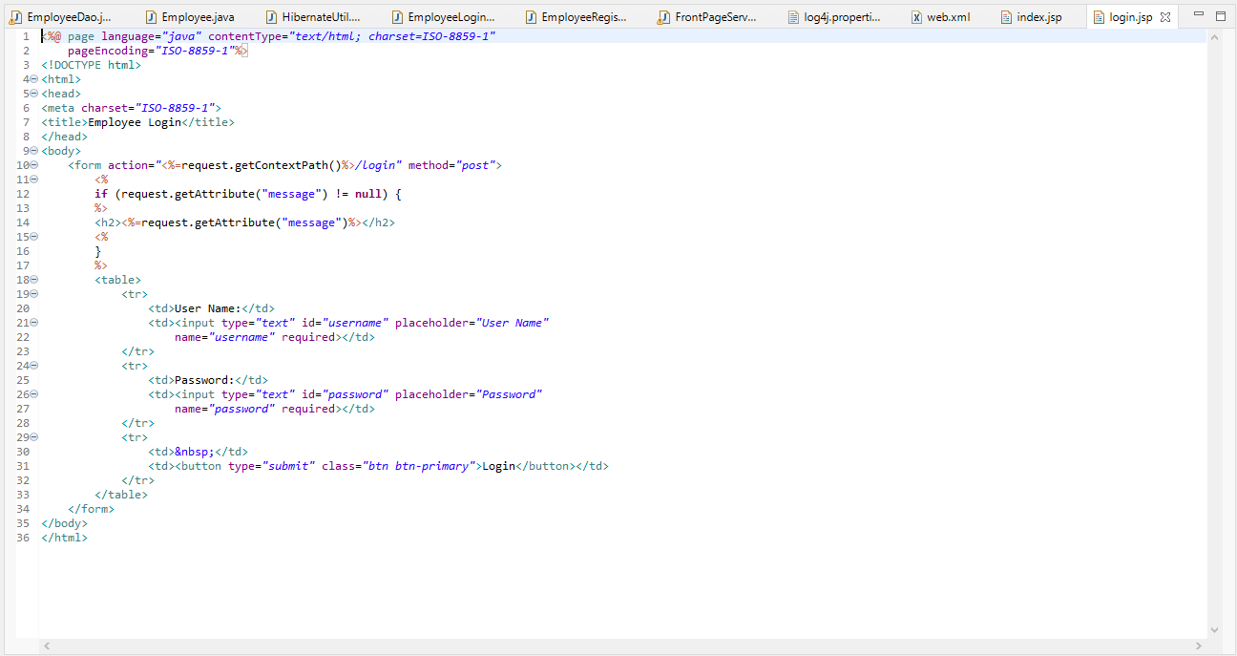
Register.jsp
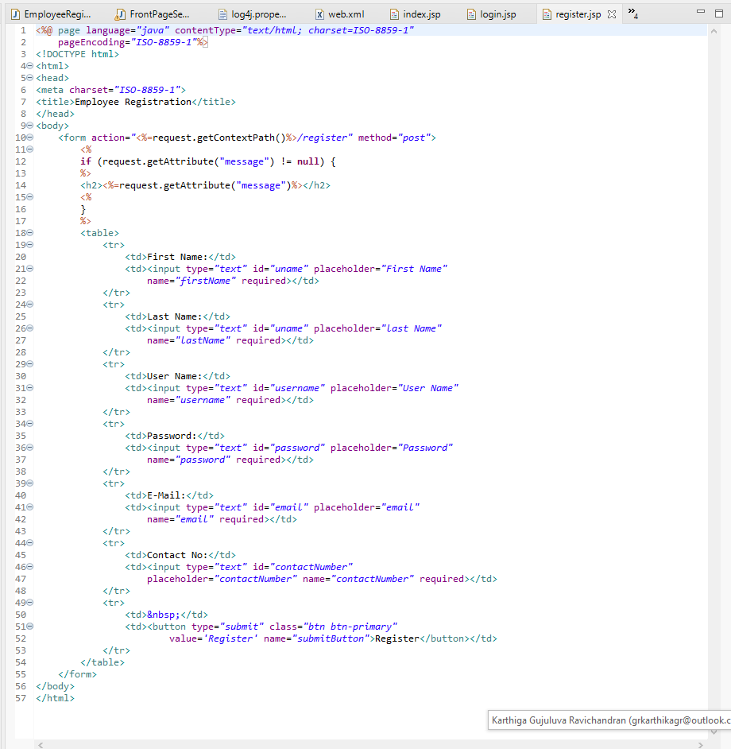
SuccessLogin.jsp
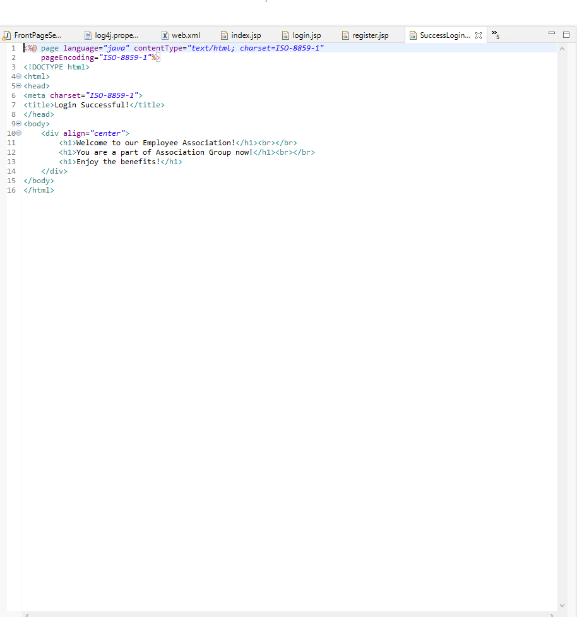
Pom.xml
<?xml version="1.0" encoding="UTF-8"?>

<project xmlns="http://maven.apache.org/POM/4.0.0"
xmlns:xsi="http://www.w3.org/2001/XMLSchema-instance"
xsi:schemaLocation="http://maven.apache.org/POM/4.0.0 http://maven.apache.org/maven-v4_0_0.xsd">

<modelVersion>4.0.0</modelVersion>

<groupId>com.hcl</groupId>
<artifactId>userLoginRegisterPhaseTwo</artifactId>
<version>0.0.1-SNAPSHOT</version>
<packaging>war</packaging>

<name>userLoginRegisterPhaseTwo Maven Webapp</name>

<properties>
<project.build.sourceEncoding>UTF-8</project.build.sourceEncoding>
<maven.compiler.source>1.8</maven.compiler.source>
<maven.compiler.target>1.8</maven.compiler.target>
</properties>

<dependencies>
<dependency>
<groupId>javax.servlet</groupId>
<artifactId>javax.servlet-api</artifactId>
<version>4.0.1</version>
<scope>provided</scope>
</dependency>
<dependency>
<groupId>javax.servlet.jsp</groupId>
<artifactId>javax.servlet.jsp-api</artifactId>
<version>2.3.3</version>
<scope>provided</scope>
</dependency>
<dependency>
<groupId>org.hibernate</groupId>
<artifactId>hibernate-core</artifactId>
<version>5.4.27.Final</version>
</dependency>
<dependency>
<groupId>mysql</groupId>
<artifactId>mysql-connector-java</artifactId>
<version>8.0.19</version>
</dependency>
<dependency>
<groupId>org.projectlombok</groupId>
<artifactId>lombok</artifactId>
<version>1.18.16</version>
<scope>provided</scope>
</dependency>
<dependency>
<groupId>log4j</groupId>
<artifactId>log4j</artifactId>
<version>1.2.15</version>
<exclusions>
<exclusion>
<groupId>com.sun.jmx</groupId>
<artifactId>jmxri</artifactId>
</exclusion>
<exclusion>
<groupId>com.sun.jdmk</groupId>
<artifactId>jmxtools</artifactId>
</exclusion>
<exclusion>
<groupId>javax.jms</groupId>
<artifactId>jms</artifactId>
</exclusion>
</exclusions>
</dependency>
<dependency>
<groupId>junit</groupId>
<artifactId>junit</artifactId>
<version>4.11</version>
<scope>test</scope>
</dependency>
</dependencies>

<build>
<finalName>userLoginRegisterPhaseTwo</finalName>
<pluginManagement>
<plugins>
<plugin>
<artifactId>maven-clean-plugin</artifactId>
<version>3.1.0</version>
</plugin>
<plugin>
<artifactId>maven-resources-plugin</artifactId>
<version>3.0.2</version>
</plugin>
<plugin>
<artifactId>maven-surefire-plugin</artifactId>
<version>2.22.1</version>
</plugin>
<plugin>
<artifactId>maven-install-plugin</artifactId>
<version>2.5.2</version>
</plugin>
<plugin>
<artifactId>maven-deploy-plugin</artifactId>
<version>2.8.2</version>
</plugin>
<plugin>
<groupId>org.apache.maven.plugins</groupId>
<artifactId>maven-compiler-plugin</artifactId>
<configuration>
<source>1.8</source>
<target>1.8</target>
</configuration>
</plugin>
<plugin>
<groupId>org.apache.maven.plugins</groupId>
<artifactId>maven-war-plugin</artifactId>
<version>3.3.1</version>
<configuration>
<warName>user</warName>
<warSourceDirectory>src/main/webapp</warSourceDirectory>
</configuration>
</plugin>
</plugins>
</pluginManagement>
</build>
</project>

