K.Dilani
ukistu05
Mongodb+Nodejs
Exercise2
1)Create a Database called ​ student

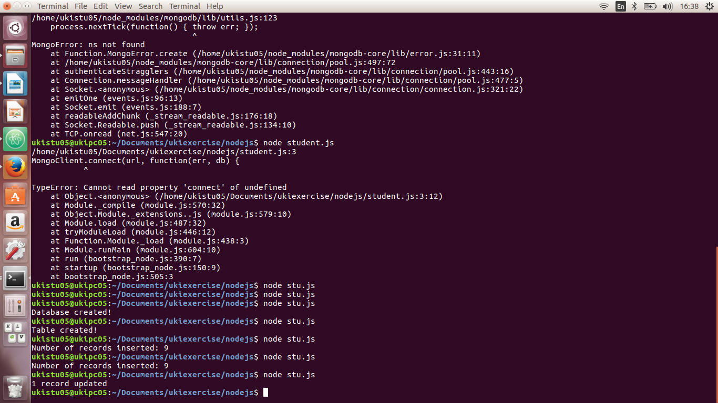
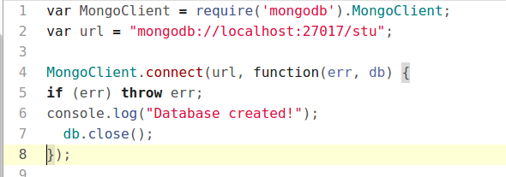

2) Create a collection called ​ studentmarks

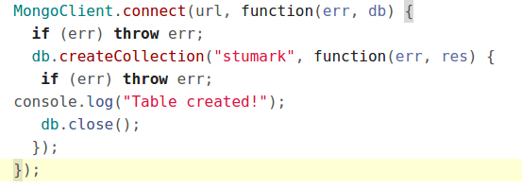

3)Create the documents listed in above table.
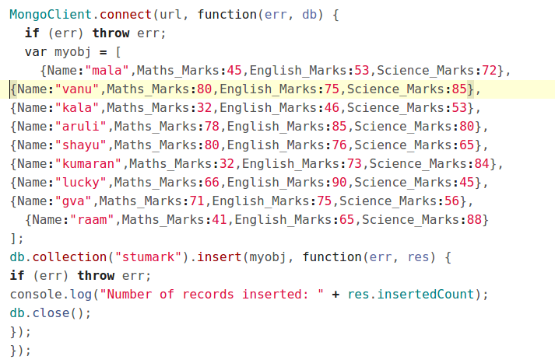

4)Increase the maths marks of Mala by 6 marks

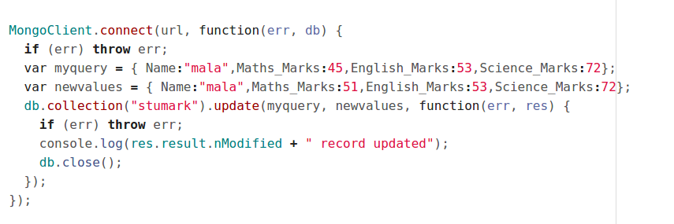
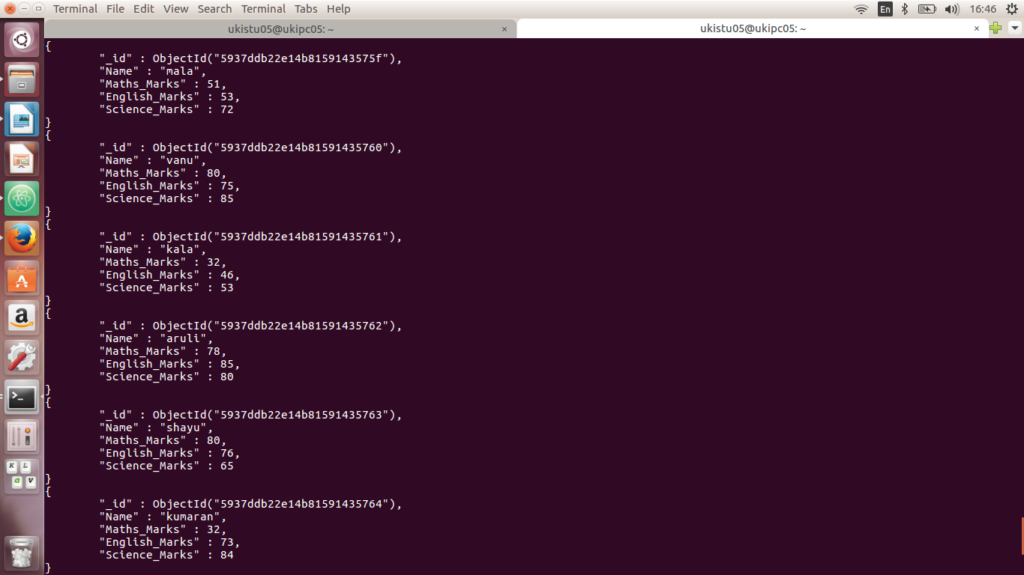
5)List the names of students who got more than 50 marks in Maths Subject.
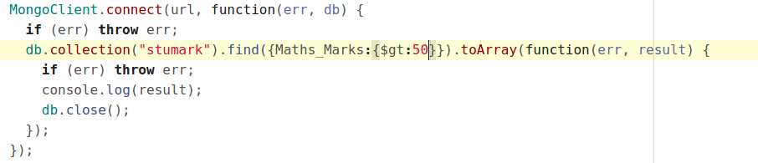
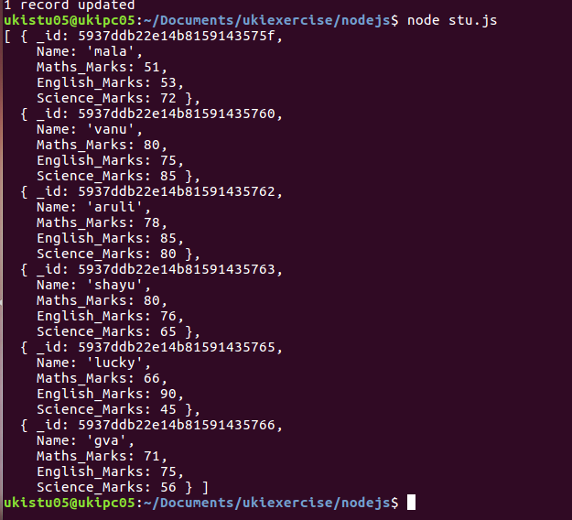

6)Add a new column(field) for Average for all students.

7)Update Marks_Science=75 to Lucky .
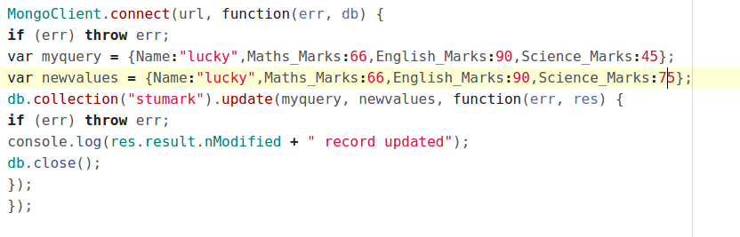
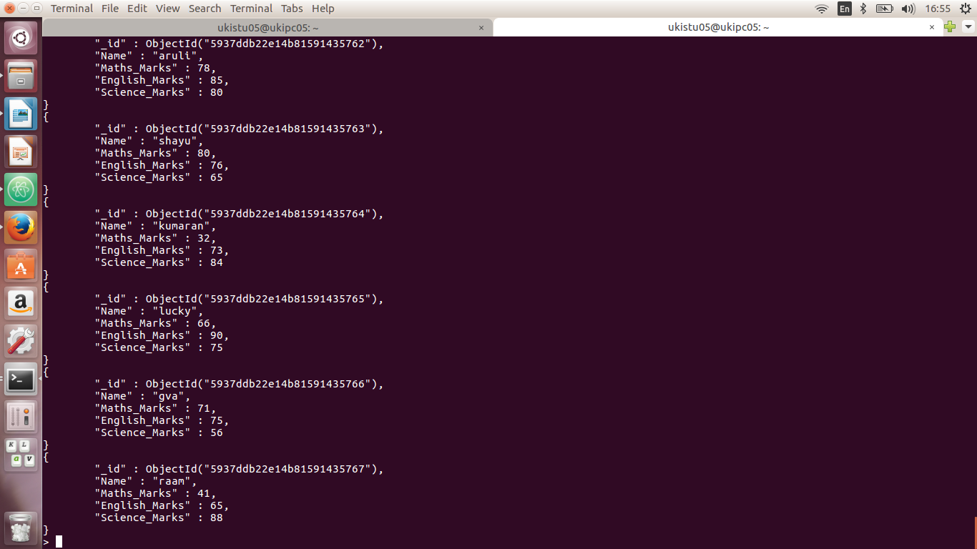


8) List the names who got more than 50 marks in all subjects.
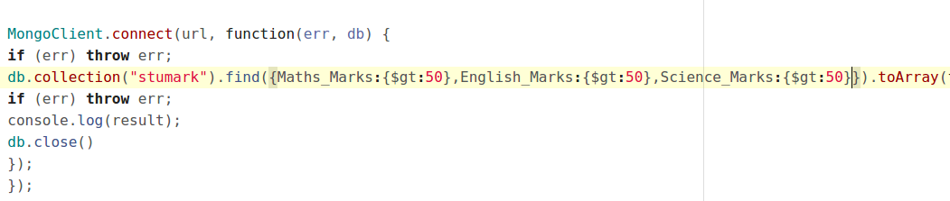
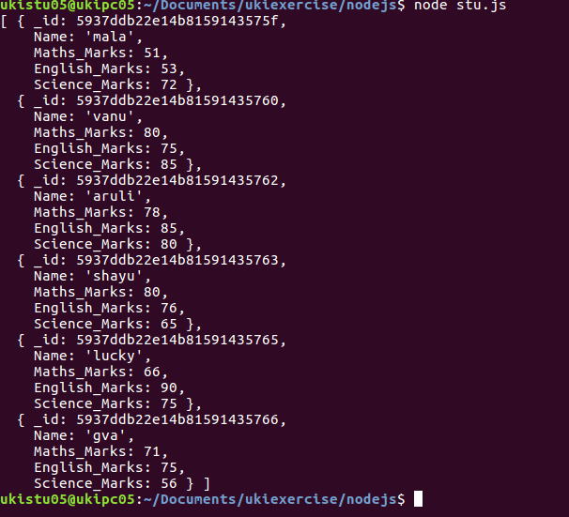

9)List the names who got less than 50 marks in Maths subject and more than 50 marks in English

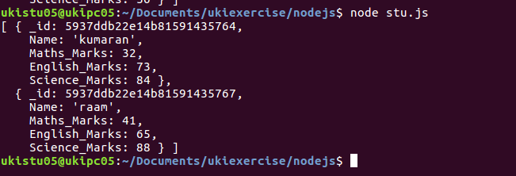
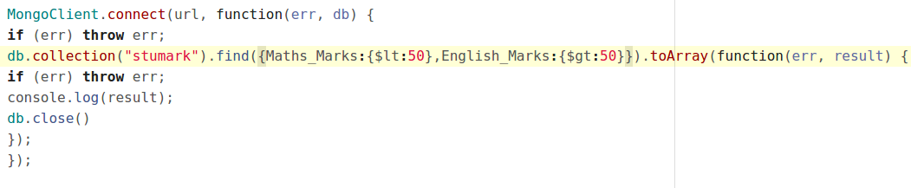
10)List the names who got less than 40 in both Maths and Science.

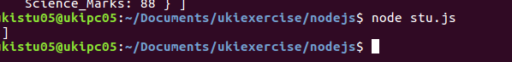
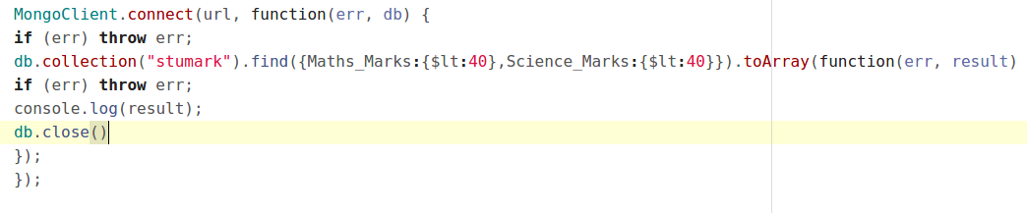

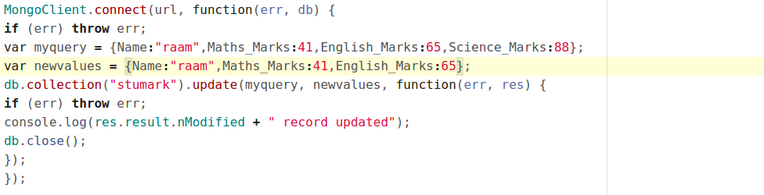
11)Remove Science column/field for Raam
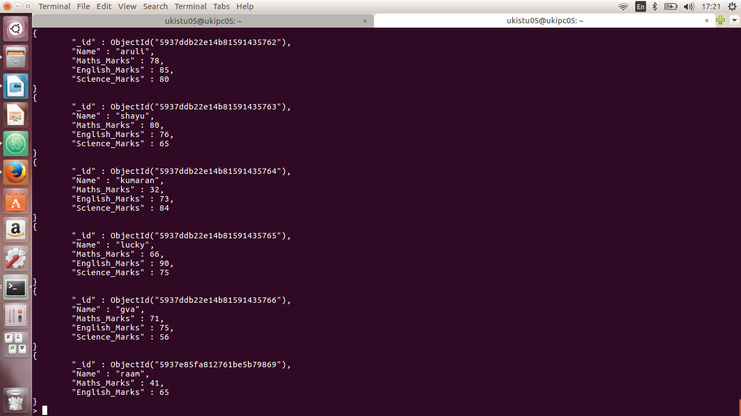
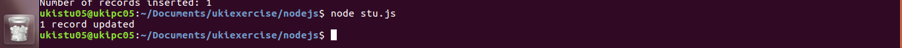

12)Update John’s Math mark as 87 and English mark as 23, if john not available upsert.

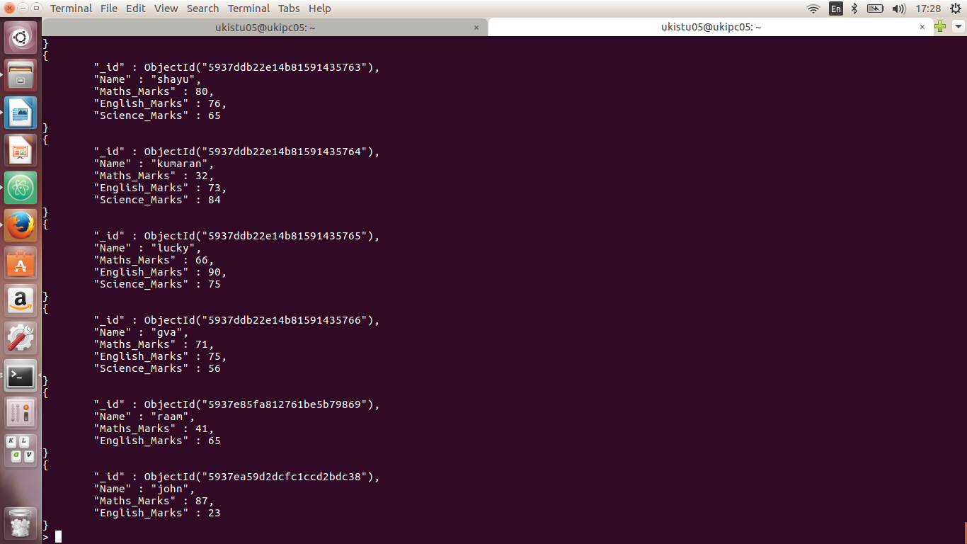
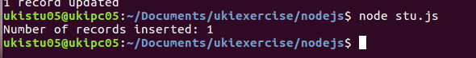
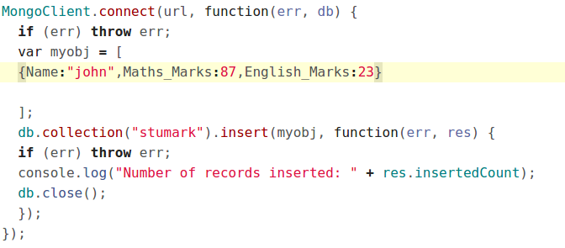
13)Rename the english_marks column/field for John to science_marks

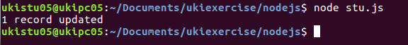
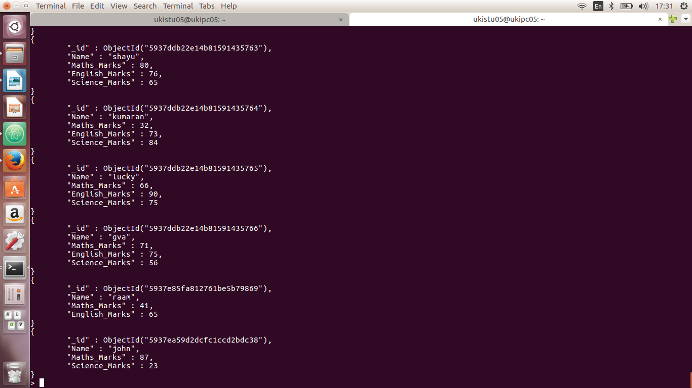
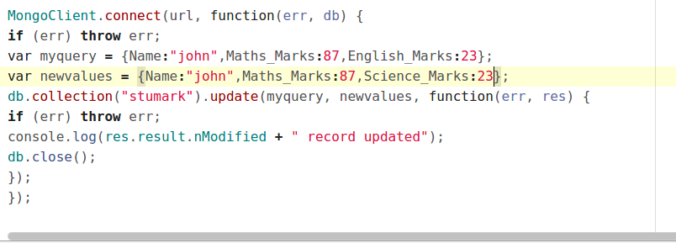

14)Remove Kumaran’s document from collection

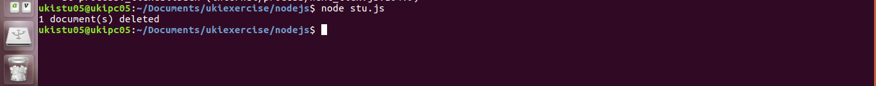

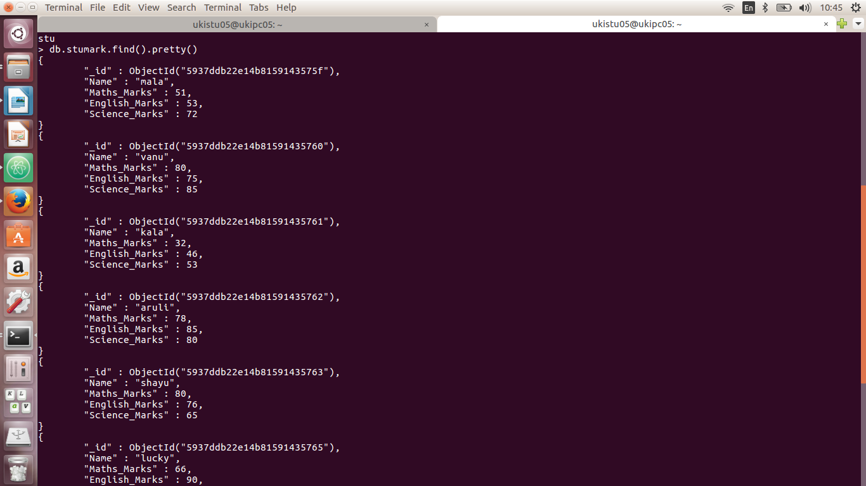
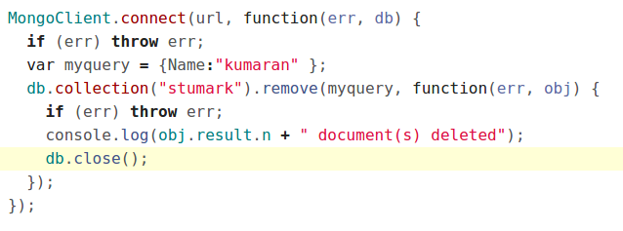

15)Find Kala’s or Aruli’s math_marks and science_marks
