Student Name:Dilani
Date 24.05.2017
MongoDB Exercise 2
1)

use student
switched to db student
> db
student

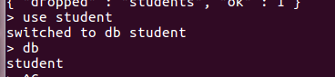

2)db.createCollection("studentmarks")
{ "ok" : 1 }

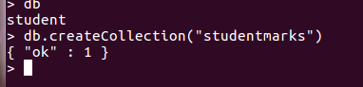

3)
db.studentmarks.insert({"Name":"Mala","Maths_marks":45,"English_Marks":53,"Science_Marks":72})
WriteResult({ "nInserted" : 1 })
> db.studentmarks.insert({"Name":"Vanu","Maths_marks":80,"English_Marks":75,"Science_Marks":85})
WriteResult({ "nInserted" : 1 })
> db.studentmarks.insert({"Name":"Kala","Maths_marks":32,"English_Marks":46,"Science_Marks":53})
WriteResult({ "nInserted" : 1 })
> db.studentmarks.insert({"Name":"Aruli","Maths_marks":78,"English_Marks":85,"Science_Marks":80})
WriteResult({ "nInserted" : 1 })
> db.studentmarks.insert({"Name":"Shayu","Maths_marks":80,"English_Marks":76,"Science_Marks":65})
WriteResult({ "nInserted" : 1 })
> db.studentmarks.insert({"Name":"Kumaran","Maths_marks":32,"English_Marks":73,"Science_Marks":84})
WriteResult({ "nInserted" : 1 })
> db.studentmarks.insert({"Name":"Lucky","Maths_marks":66,"English_Marks":90,"Science_Marks":45})
WriteResult({ "nInserted" : 1 })
> db.studentmarks.insert({"Name":"Gva","Maths_marks":71,"English_Marks":75,"Science_Marks":56})
WriteResult({ "nInserted" : 1 })
> db.studentmarks.insert({"Name":"Raam","Maths_marks":41,"English_Marks":65,"Science_Marks":88})
WriteResult({ "nInserted" : 1 })

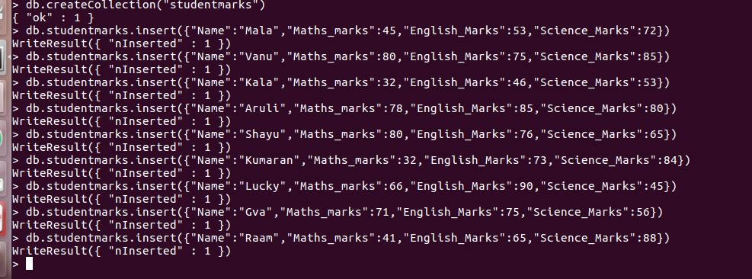
4)

db.studentmarks.update({"_id": ObjectId("592555428290bc9226dadad4")},{$set:{"Maths_marks":51}})
WriteResult({ "nMatched" : 1, "nUpserted" : 0, "nModified" : 1 })
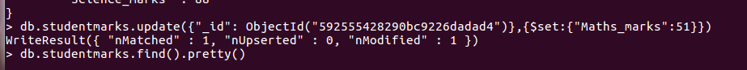

5)

db.studentmarks.find({"Maths_marks":{$gt:50}}).pretty()
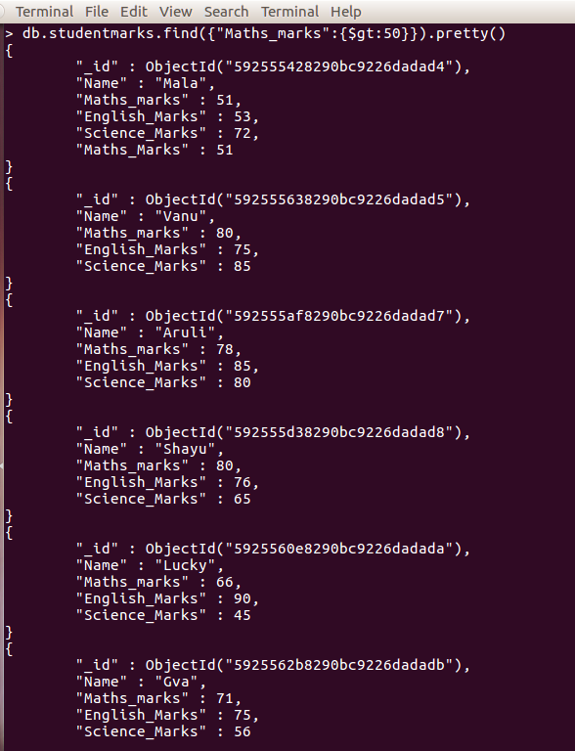

6)

db.studentmarks.aggregate([{$project:{_id:"$Name",Marksavg:{$avg:["$Maths_marks","$English_Marks","$Science_Marks"]}}}])
{ "_id" : "Vanu", "Marksavg" : 80 }
{ "_id" : "Kala", "Marksavg" : 43.666666666666664 }
{ "_id" : "Aruli", "Marksavg" : 81 }
{ "_id" : "Shayu", "Marksavg" : 73.66666666666667 }
{ "_id" : "Lucky", "Marksavg" : 67 }
{ "_id" : "Gva", "Marksavg" : 67.33333333333333 }
{ "_id" : "John", "Marksavg" : 55 }

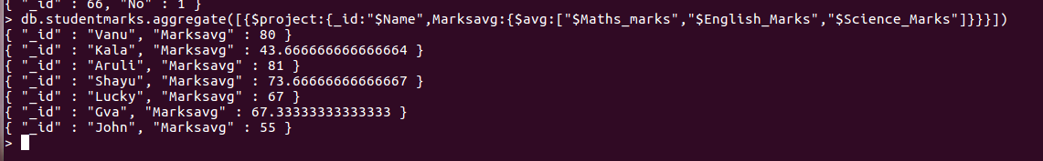

7)

db.studentmarks.update({"_id": ObjectId("5925560e8290bc9226dadada")},{$set:{"Science_marks":75}})

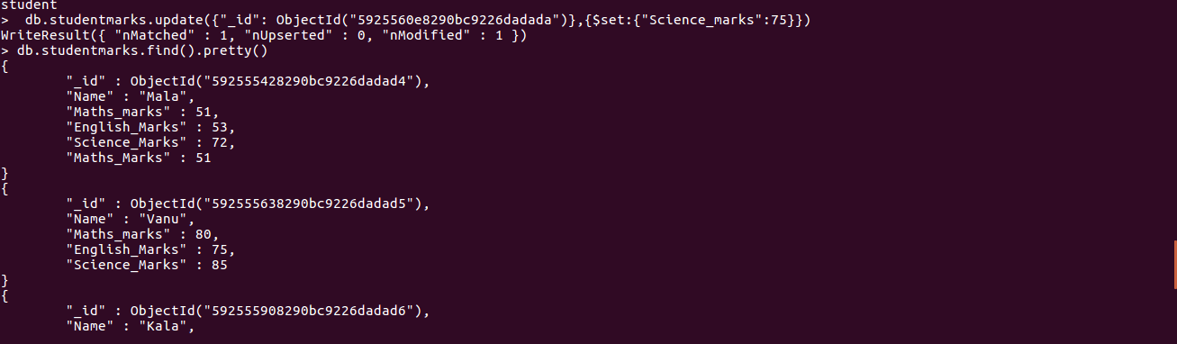
8)

db.studentmarks.find({$or:[{"Maths_marks":{$gt:50}},{"English_Marks":{$gt:50}},{"Science_Marks":{$gt:50}}]},{"Name":1,_id:0}).pretty()
{ "Name" : "Vanu" }
{ "Name" : "Kala" }
{ "Name" : "Aruli" }
{ "Name" : "Shayu" }
{ "Name" : "Lucky" }
{ "Name" : "Gva" }

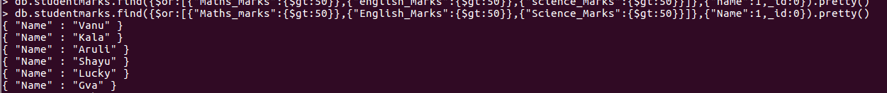
9)

db.studentmarks.find({$or:[{"Maths_marks":{$lt:50}},{"English_Marks":{$gt:50}}]},{"Name":1,_id:0}).pretty()
{ "Name" : "Vanu" }
{ "Name" : "Kala" }
{ "Name" : "Aruli" }
{ "Name" : "Shayu" }
{ "Name" : "Lucky" }
{ "Name" : "Gva" }

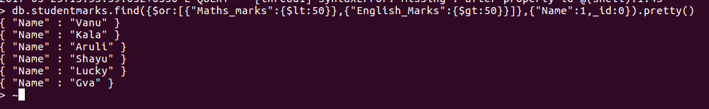

10)

db.studentmarks.find({$or:[{"Maths_marks":{$gt:40}},{"Science_Marks":{$gt:40}}]},{"Name":1,_id:0}).pretty()
{ "Name" : "Vanu" }
{ "Name" : "Kala" }
{ "Name" : "Aruli" }
{ "Name" : "Shayu" }
{ "Name" : "Lucky" }
{ "Name" : "Gva" }

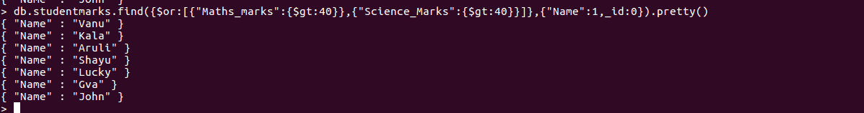
11)

db.studentmarks.remove({"_id" : ObjectId("592556498290bc9226dadadc")},{"Science_Marks":88})
WriteResult({ "nRemoved" : 0 })

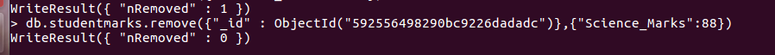
12)

db.studentmarks.insert({"Name":"John","Maths_marks":87,"English_Marks":23})
WriteResult({ "nInserted" : 1 })

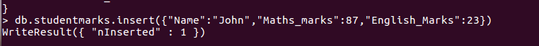
13)

db.studentmarks.update({"_id" : ObjectId("59256f62990b38c70c46d781")},{$rename:{"English_Marks":"Science_Marks"}})
WriteResult({ "nMatched" : 1, "nUpserted" : 0, "nModified" : 1 })

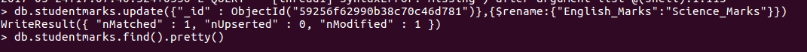

14)

db.studentmarks.remove({"_id" : ObjectId("592555f08290bc9226dadad9")})
WriteResult({ "nRemoved" : 1 })

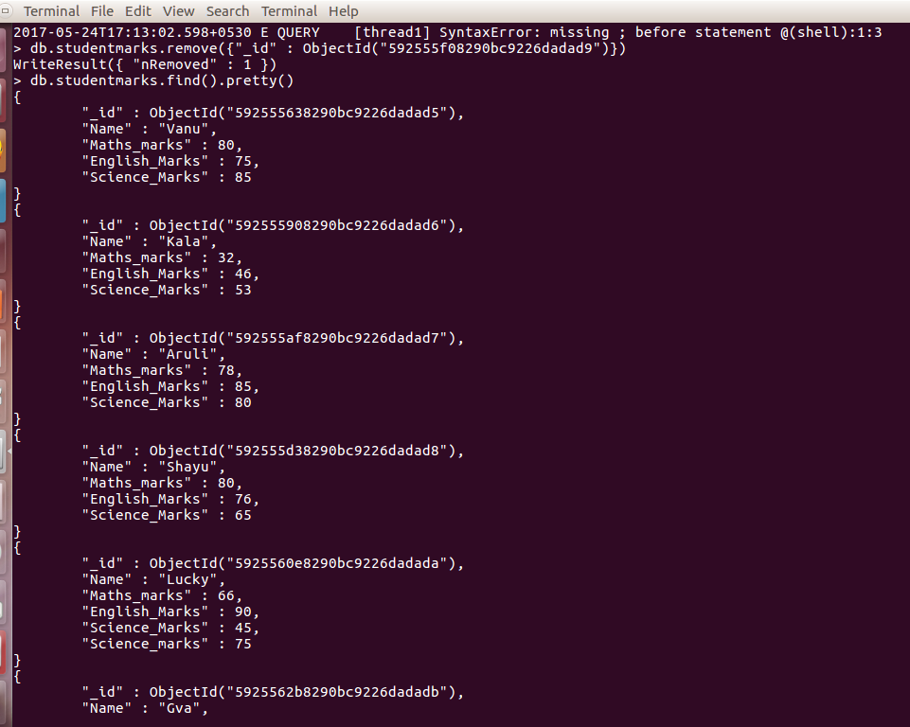

15)

db.studentmarks.find({$or:[{"Name":"Kala"},{"Name":"Aruli"}]},{"Maths_marks":1,"Science_Marks":1,_id:0,"Name":1})
{ "Name" : "Kala", "Maths_marks" : 32, "Science_Marks" : 53 }
{ "Name" : "Aruli", "Maths_marks" : 78, "Science_Marks" : 80 }

