Karthigesu Dilani
Mondodb
Exercise 01

1)
use music
switched to db music
> db
music

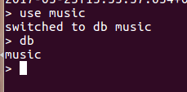

2)&3)

db.songdetails.insert({"Song Name":"Thaniye Thananthaniye","Film":"Rhythm","Music Director":"A.R.Rahman","Singer":"Shankar mahadevn"})
WriteResult({ "nInserted" : 1 })
> db.songdetails.insert({"Song Name":"Evano Oruvan","Film":"Alai Payuthey","Music Director":"A.R.Rahman","Singer":"Swarnalatha"})
WriteResult({ "nInserted" : 1 })
> db.songdetails.insert({"Song Name":"Roja Poonthottam","Film":"Kannukul Nilavu","Music Director":"Ilaiyaraala","Singer":"Unnikrishnan Anurandha Sriram"})
WriteResult({ "nInserted" : 1 })
> db.songdetails.insert({"Song Name":"Vennilavae Vennilavae Vinnaihaandi","Film":"Minsara Kanavu","Music Director":"A.R.Rahman","Singer":"Hariharan, Sadhana Sargam"})
WriteResult({ "nInserted" : 1 })
> db.songdetails.insert({"Song Name":"Sollamal Thottu Chellum Thendral","Film":"Dheena","Music Director":"Yuvan Shankar Raja","Singer":"Hariharan"})
WriteResult({ "nInserted" : 1 })

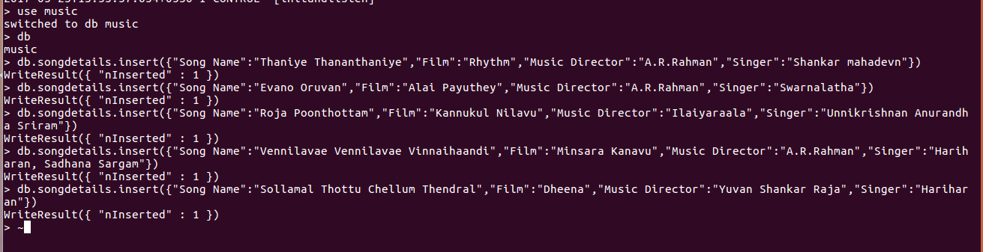

4)

db.songdetails.find()
{ "_id" : ObjectId("5924100a1bdbe951a8f21060"), "Song Name" : "Thaniye Thananthaniye", "Film" : "Rhythm", "Music Director" : "A.R.Rahman", "Singer" : "Shankar mahadevn" }
{ "_id" : ObjectId("592410421bdbe951a8f21061"), "Song Name" : "Evano Oruvan", "Film" : "Alai Payuthey", "Music Director" : "A.R.Rahman", "Singer" : "Swarnalatha" }
{ "_id" : ObjectId("592410971bdbe951a8f21062"), "Song Name" : "Roja Poonthottam", "Film" : "Kannukul Nilavu", "Music Director" : "Ilaiyaraala", "Singer" : "Unnikrishnan Anurandha Sriram" }
{ "_id" : ObjectId("592411091bdbe951a8f21063"), "Song Name" : "Vennilavae Vennilavae Vinnaihaandi", "Film" : "Minsara Kanavu", "Music Director" : "A.R.Rahman", "Singer" : "Hariharan, Sadhana Sargam" }
{ "_id" : ObjectId("5924114e1bdbe951a8f21064"), "Song Name" : "Sollamal Thottu Chellum Thendral", "Film" : "Dheena", "Music Director" : "Yuvan Shankar Raja", "Singer" : "Hariharan" }

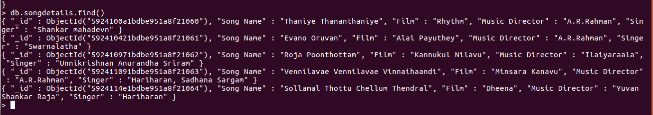
5)

db.songdetails.find({"Music Director":"A.R.Rahman"},{"Song Name":1,_id:0})
{ "Song Name" : "Thaniye Thananthaniye" }
{ "Song Name" : "Evano Oruvan" }
{ "Song Name" : "Vennilavae Vennilavae Vinnaihaandi" }
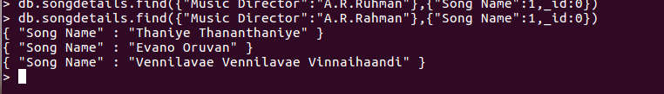

6)

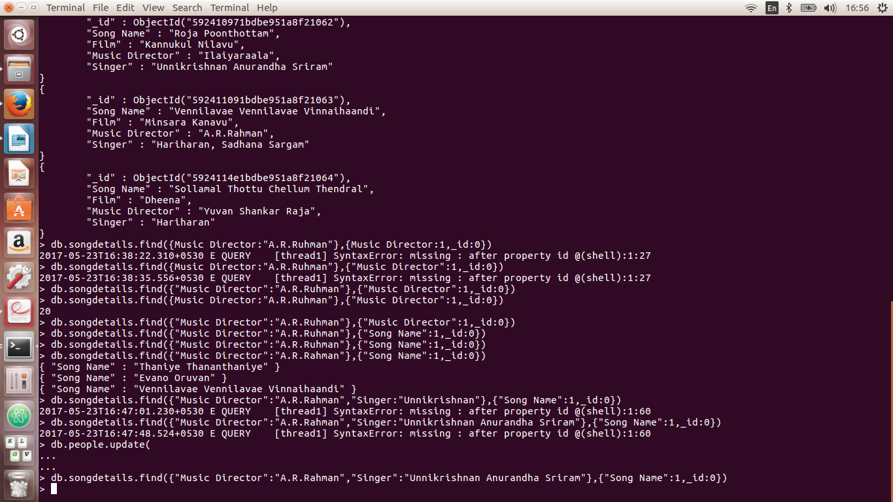
db.songdetails.find({"Music Director":"A.R.Rahman","Singer":"Unnikrishnan Anurandha Sriram"},{"Song Name":1,_id:0})

7)

db.songdetails.remove( {"Song Name" : "Roja Poonthottam"})
WriteResult({ "nRemoved" : 1 })
> db.songdetails.find()
{ "_id" : ObjectId("5924100a1bdbe951a8f21060"), "Song Name" : "Thaniye Thananthaniye", "Film" : "Rhythm", "Music Director" : "A.R.Rahman", "Singer" : "Shankar mahadevn" }
{ "_id" : ObjectId("592410421bdbe951a8f21061"), "Song Name" : "Evano Oruvan", "Film" : "Alai Payuthey", "Music Director" : "A.R.Rahman", "Singer" : "Swarnalatha" }
{ "_id" : ObjectId("592411091bdbe951a8f21063"), "Song Name" : "Vennilavae Vennilavae Vinnaihaandi", "Film" : "Minsara Kanavu", "Music Director" : "A.R.Rahman", "Singer" : "Hariharan, Sadhana Sargam" }
{ "_id" : ObjectId("5924114e1bdbe951a8f21064"), "Song Name" : "Sollamal Thottu Chellum Thendral", "Film" : "Dheena", "Music Director" : "Yuvan Shankar Raja", "Singer" : "Hariharan" }

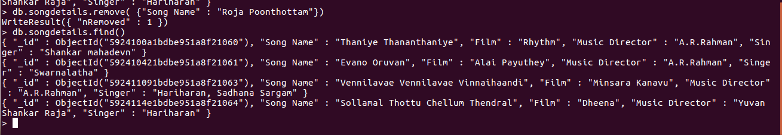
8)

db.songdetails.insert({"Song Name":"Atho thechcha othukkadi","Film":"anjan","Music Director":"Yuvan Shankar Raja","Singer":"Uuunikirishnan"})

WriteResult({ "nInserted" : 1 })
> db.songdetails.find()
{ "_id" : ObjectId("5924100a1bdbe951a8f21060"), "Song Name" : "Thaniye Thananthaniye", "Film" : "Rhythm", "Music Director" : "A.R.Rahman", "Singer" : "Shankar mahadevn" }
{ "_id" : ObjectId("592410421bdbe951a8f21061"), "Song Name" : "Evano Oruvan", "Film" : "Alai Payuthey", "Music Director" : "A.R.Rahman", "Singer" : "Swarnalatha" }
{ "_id" : ObjectId("592411091bdbe951a8f21063"), "Song Name" : "Vennilavae Vennilavae Vinnaihaandi", "Film" : "Minsara Kanavu", "Music Director" : "A.R.Rahman", "Singer" : "Hariharan, Sadhana Sargam" }
{ "_id" : ObjectId("5924114e1bdbe951a8f21064"), "Song Name" : "Sollamal Thottu Chellum Thendral", "Film" : "Dheena", "Music Director" : "Yuvan Shankar Raja", "Singer" : "Hariharan" }
{ "_id" : ObjectId("59241f54dba6720798d9c0c2"), "Song Name" : "Atho thechcha othukkadi", "Film" : "anjan", "Music Director" : "Yuvan Shankar Raja", "Singer" : "Uuunikirishnan" }

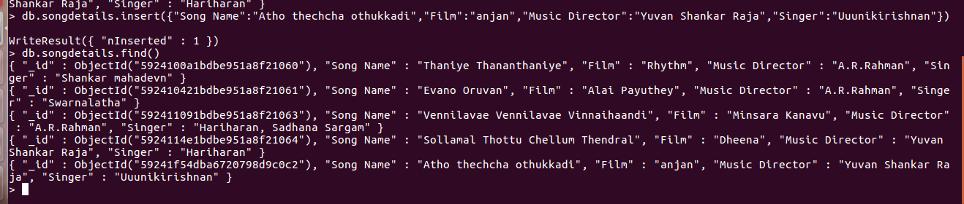

9)

db.songdetails.find({"Singer":"Hariharan, Sadhana Sargam","Film":"Minsara Kanavu"},{"Song Name":1,_id:0})
{ "Song Name" : "Vennilavae Vennilavae Vinnaihaandi" }

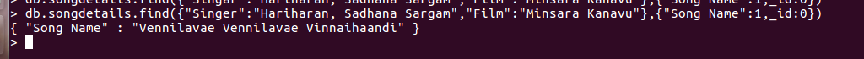

10)

db.songdetails.find({},{"Singer":1,_id:0})
{ "Singer" : "Shankar mahadevn" }
{ "Singer" : "Swarnalatha" }
{ "Singer" : "Hariharan, Sadhana Sargam" }
{ "Singer" : "Hariharan" }
{ "Singer" : "Uuunikirishnan" }
