TCP (TRANSMISSION CONTROL PROTOCOL):
- It is highly reliable and connection oriented communication protocol (since it does handshaking and reliability control)
- It ensures reliability in terms of congestion control ,error control ,flow control and connection control techniques.

TCP 3 Way handshaking :
- Client sends SYN enabled packet to server port with ISN = x and ack = 0
- Server responds with SYN-ACK with seq=y and ack=x+1 (acknowledging client’s syn)
- Client acknowledges by ACK to server to synchronize by sending packet with seq=x+1 and ack=y+1
TCP 4 Way handshaking :
- Client initiates termination by sending FIN and ACK with seq=x and ack=y
- Server responds by sending ACK with seq=y and ack = x+1
- After completing, server sends FIN and ACK with seq=y and ack=x+1
- Then, client responds by sending FIN with seq=x+1 and ack=y+1 (now, client waits for 2* maximum segment lifetime before termination)

DNS (DOMAIN NAME SYSTEM):
- The Domain Name System (DNS) is a hierarchical and decentralized system used to resolve human-readable domain names into IP addresses so that computers can communicate over networks like the internet.
- Whenever, client wants to have communication using hostname, if first checks its local cache for mapping, if no mapping found, it proceeds next.
- It requests recursive configured DNS resolver (ISP provided or Google DNS) for help. If it has records, it provides mapping. If not so, proceeds next.

UDP (USER DATAGRAM PROTOCOL):
- The User Datagram Protocol (UDP) is a connectionless, lightweight transport-layer protocol .
- It is widely used for real-time applications, DNS, VoIP, streaming, and other latency-sensitive communication. Eg. DNS , DHCP, TFTP, VOIP etc.
- It doesn’t provide reliability and congestion control as like TCP.

Wireshark packet capture of DNS:
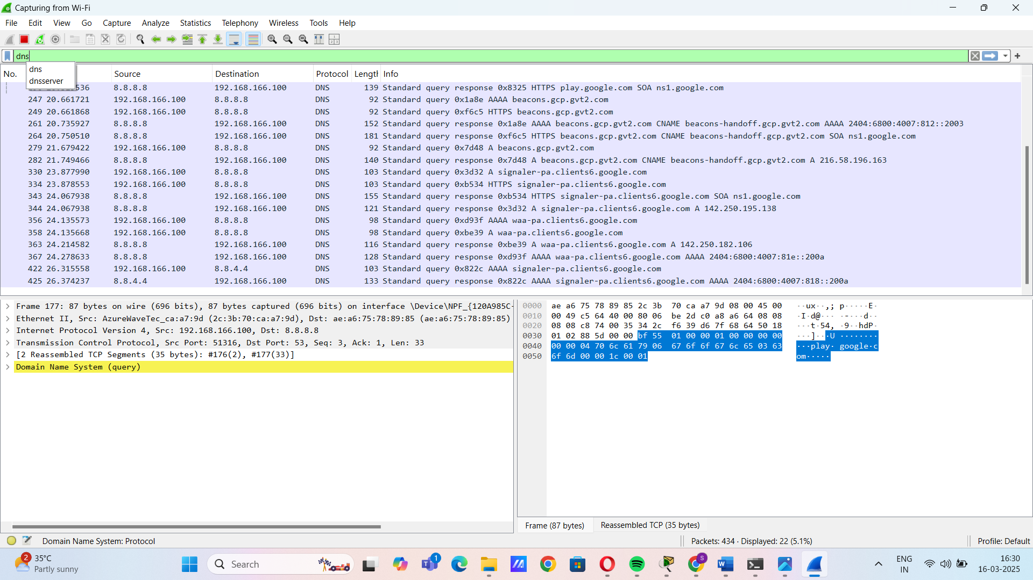

Wireshark packet capture of TCP:
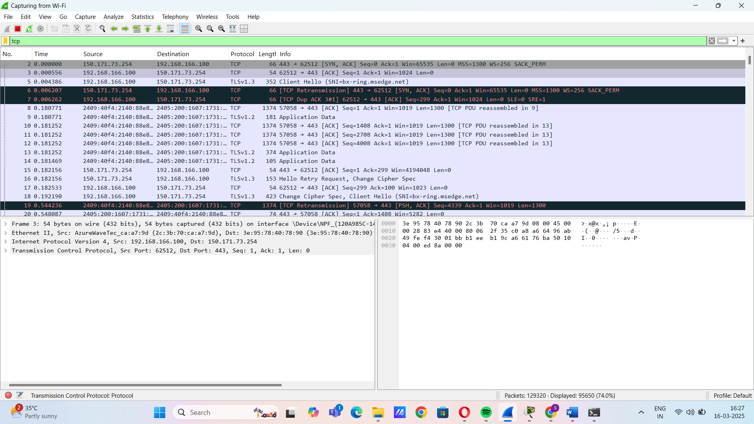

Wireshark packet capture of UDP:

