3.Using various Trace route commands:
Basic Tracert command:
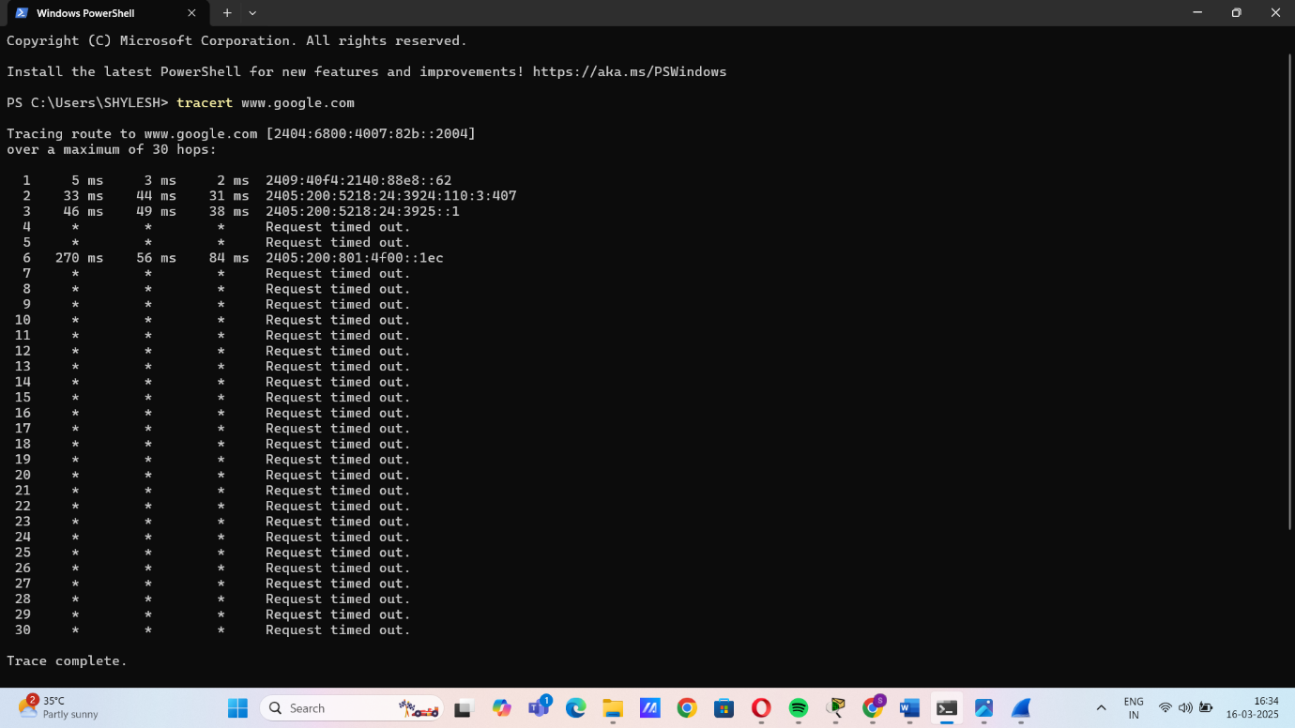

Disable DNS Name Resolution:
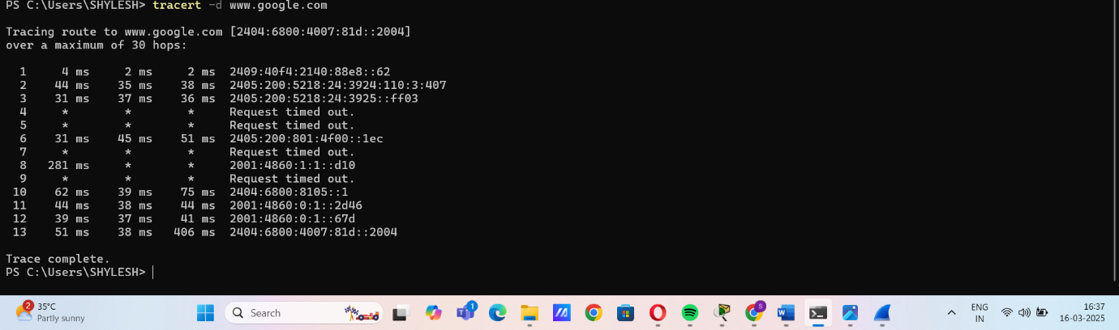

Set Maximum Hops:
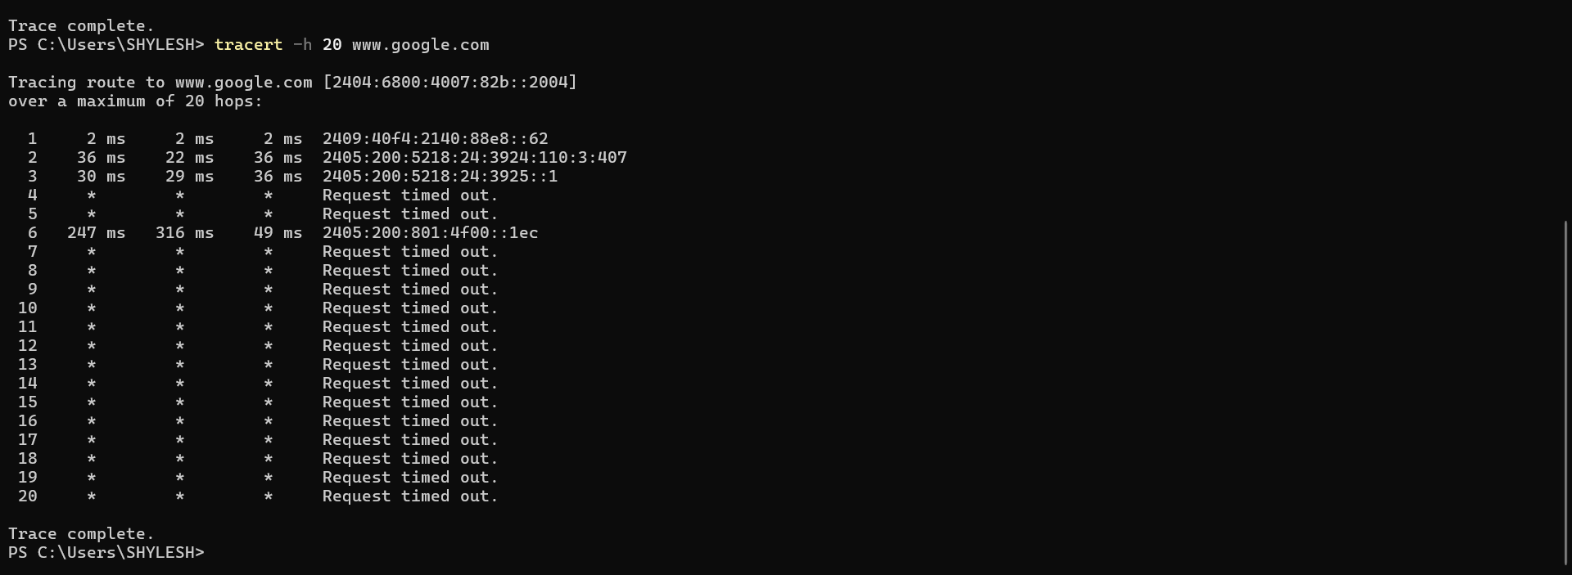

Set Timeout for Each Reply:
