Given an IP address range of 192.168.1.0/24, divide the network into 4 subnets.
Task: Manually calculate the new subnet mask and the range of valid IP addresses for each subnet.
Assign IP addresses from these subnets to devices in Cisco Packet Tracer and verify connectivity using ping between them.

We need 4 subnets, since 2 squared is 4, I'll borrow 2 bits from the host portion of the original /24 network.
The original /24 means 24 bits were for the network. By adding the 2 borrowed bits, I get a new /26 network. The new subnet mask is 255.255.255.192.
I subtract the last octet of the new subnet mask (192) from 256.

256 – 192 = 64
Subnet | Network Address | Valid IP Range | Broadcast Address
Subnet 1 | 192.168.1.0/26 | 192.168.1.1 - 192.168.1.62 | 192.168.1.63
Subnet 2 | 192.168.1.64/26 | 192.168.1.65 - 192.168.1.126 | 192.168.1.127
Subnet 3 | 192.168.1.128/26 | 192.168.1.129 - 192.168.1.190 | 192.168.1.191
Subnet 4 | 192.168.1.192/26 | 192.168.1.193 - 192.168.1.254 | 192.168.1.255

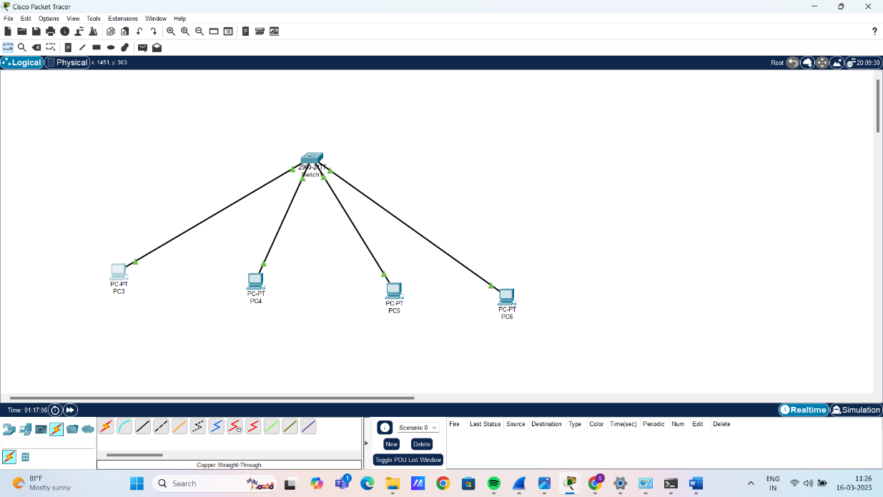

From PC 1 tracing other PC’S:
