2. Manually configure static routes on a router to direct packets to different subnets.
Use the ip route command and verify connectivity using ping and traceroute.
Setup in Cisco packet tracer:

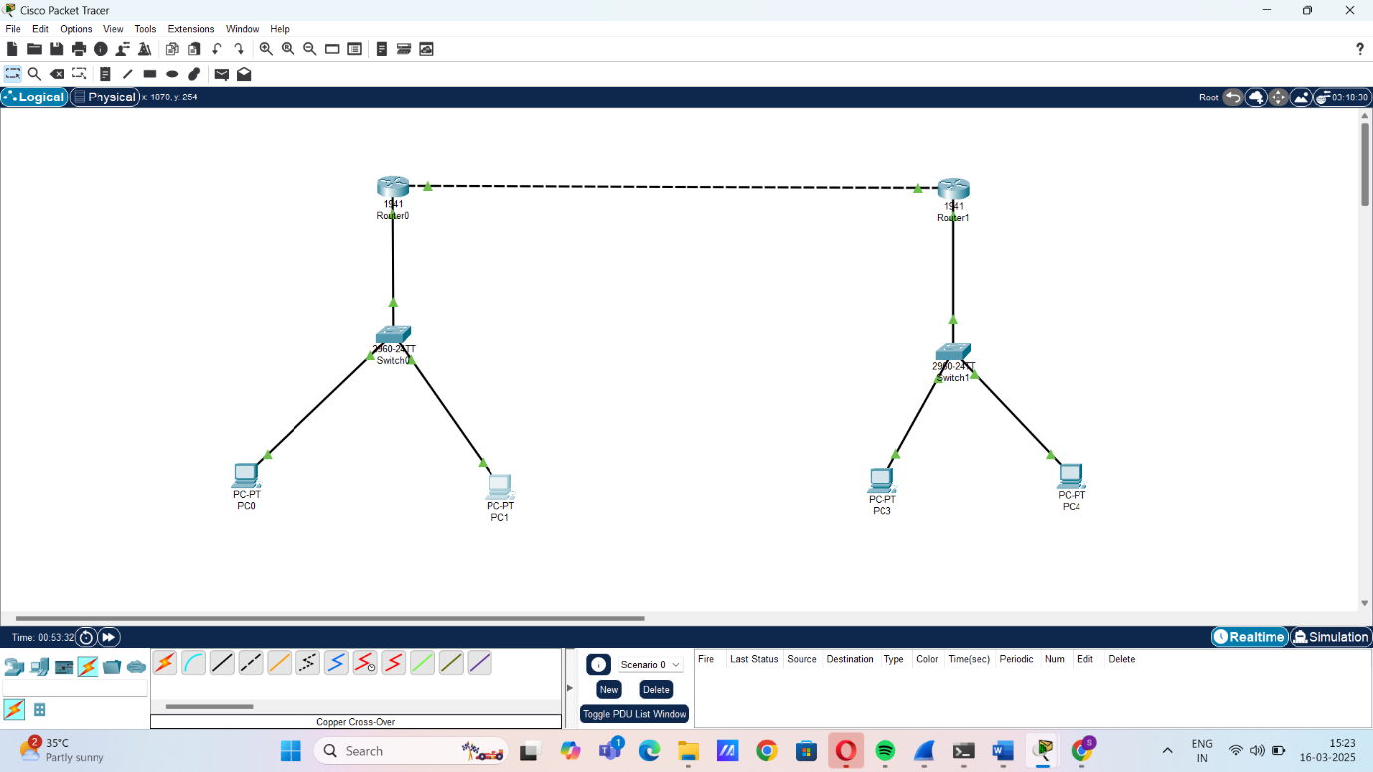

Using Tracert command in router0:
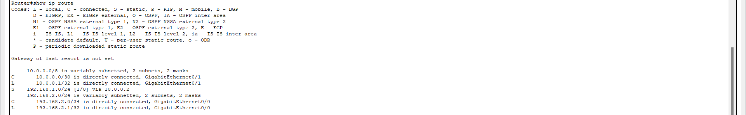

Using Tracert command in router1:
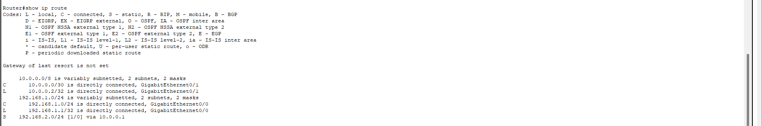

Pinging PC of router 0 from PC of router1:
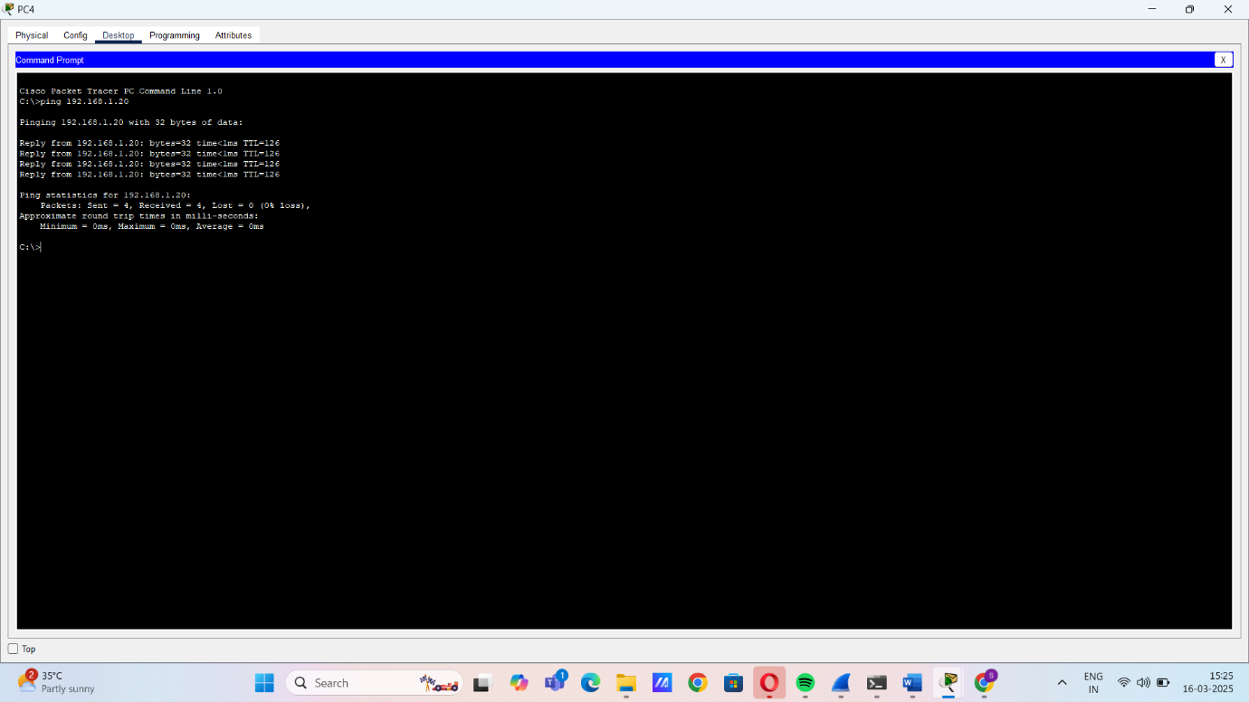

Pinging PC of router 1 from PC of router0:
