3. Given a network address of 10.0.0.0/24, divide it into 4 equal subnets.
Calculate the new subnet mask.
Determine the valid host range for each subnet.
Assign IP addresses to devices in Packet Tracer and verify connectivity.

Given Network Information
- Network Address: 10.0.0.0/24
- Default Subnet Mask: 255.255.255.0
- Total Hosts in /24: 2(32−24)=28=2562^{(32-24)} = 2^8 = 2562(32−24)=28=256 (Includes network and broadcast addresses)
Determine the New Subnet Mask
We need 4 subnets, so we borrow bits from the host portion.
- To calculate required subnet bits:
Number of required subnets 22=42^2 = 422=4
Thus, we borrow 2 bits from the host portion.
- New subnet mask:
24+2=26

Calculate Subnet Ranges
total addresses = 2^(32−26)=2^6=64 total addresses
- Usable hosts per subnet: 64−2=62 (excluding network and broadcast addresses).

Subnet Breakdown:
Subnet | Network Address | First Usable Host | Last Usable Host | Broadcast Address
1 | 10.0.0.0/26 | 10.0.0.1 | 10.0.0.62 | 10.0.0.63
2 | 10.0.0.64/26 | 10.0.0.65 | 10.0.0.126 | 10.0.0.127
3 | 10.0.0.128/26 | 10.0.0.129 | 10.0.0.190 | 10.0.0.191
4 | 10.0.0.192/26 | 10.0.0.193 | 10.0.0.254 | 10.0.0.255

Setup:
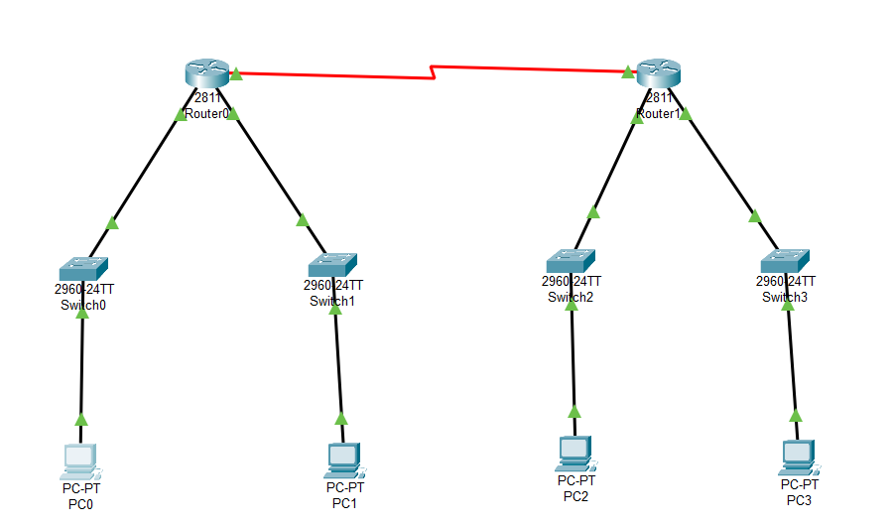

Ping from PC0 (10.0.0.2) to PC3 (10.0.0.194):
