- Simulate a small network with switches and multiple devices. Use ping to generate traffic and observe the MAC address table of the switch. Capture packets using Wireshark to analyse Ethernet frames and MAC addressing.

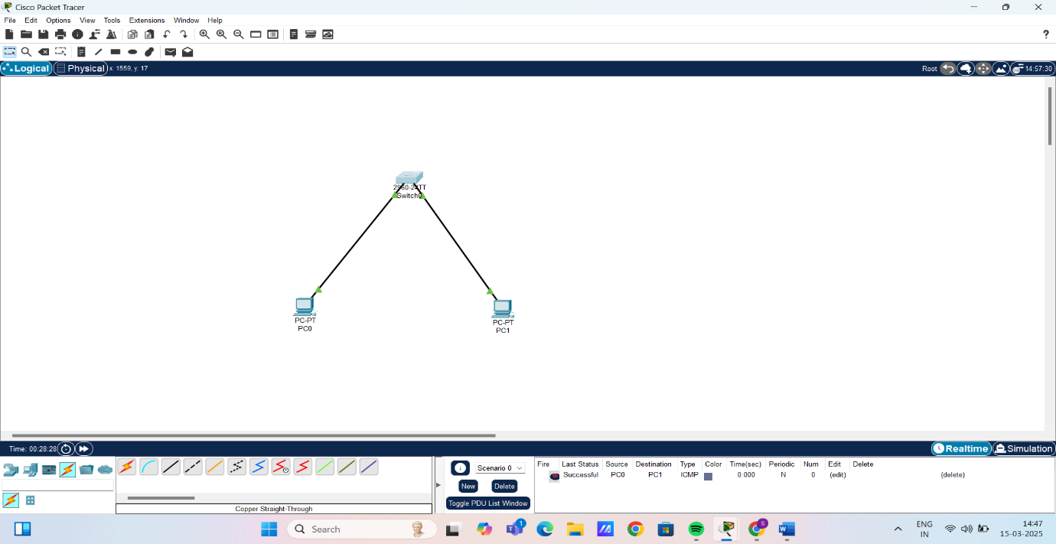

Pinging PC1 from PC0:

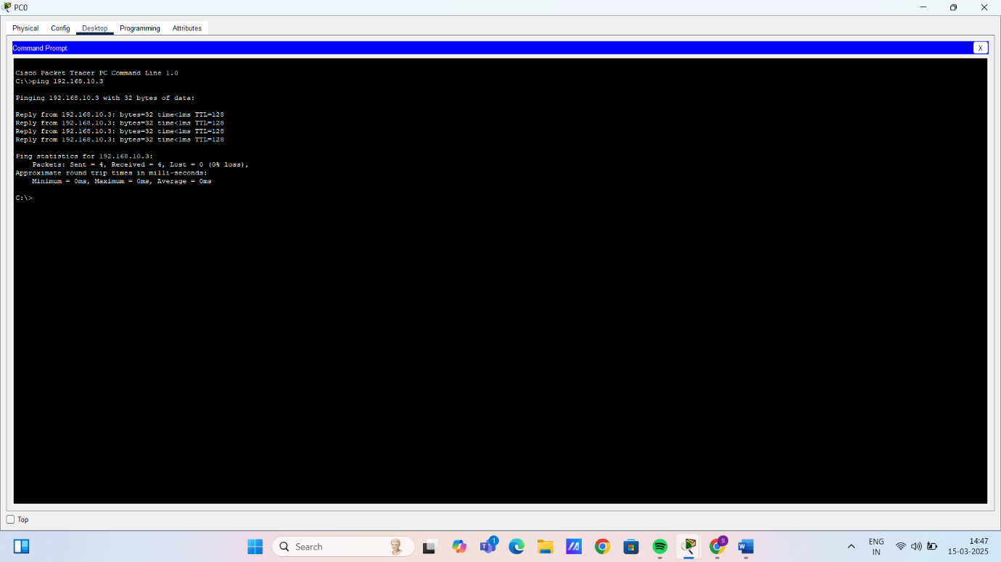

Pinging PC0 from PC1:

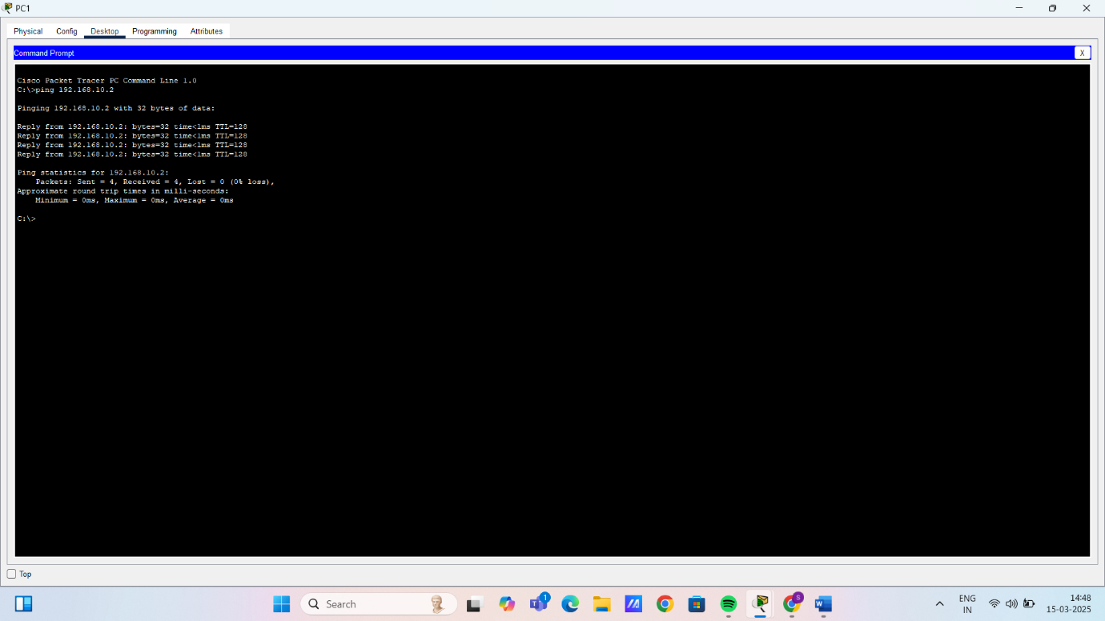

MAC address table of the switch:
