2.Capture and analyse Ethernet frames using Wireshark. Inspect the structure of the frame, including destination and source MAC addresses, Ethertype, payload, and FCS Use GNS3 or Packet Tracer to simulate network traffic.

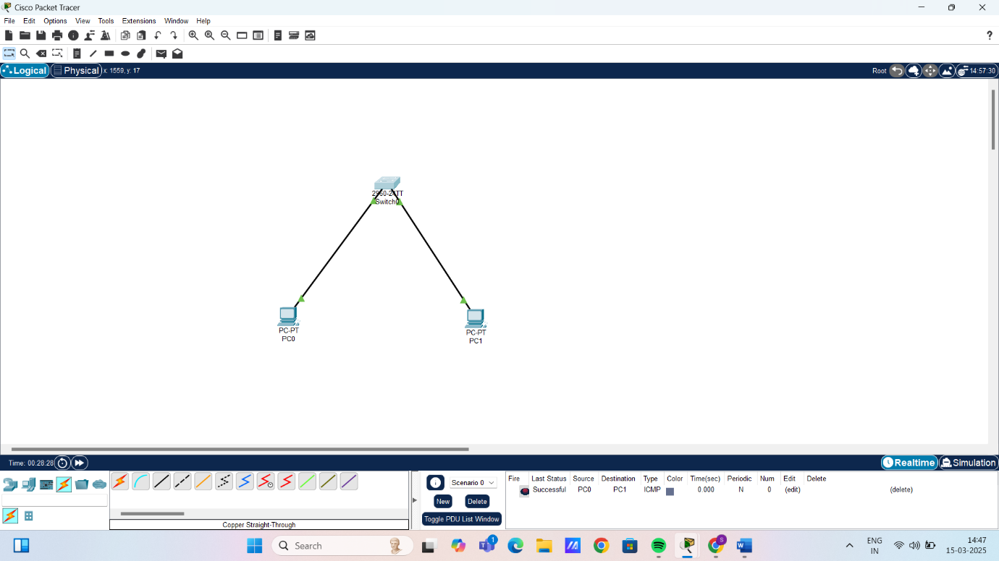

PDU information Table of PC0:
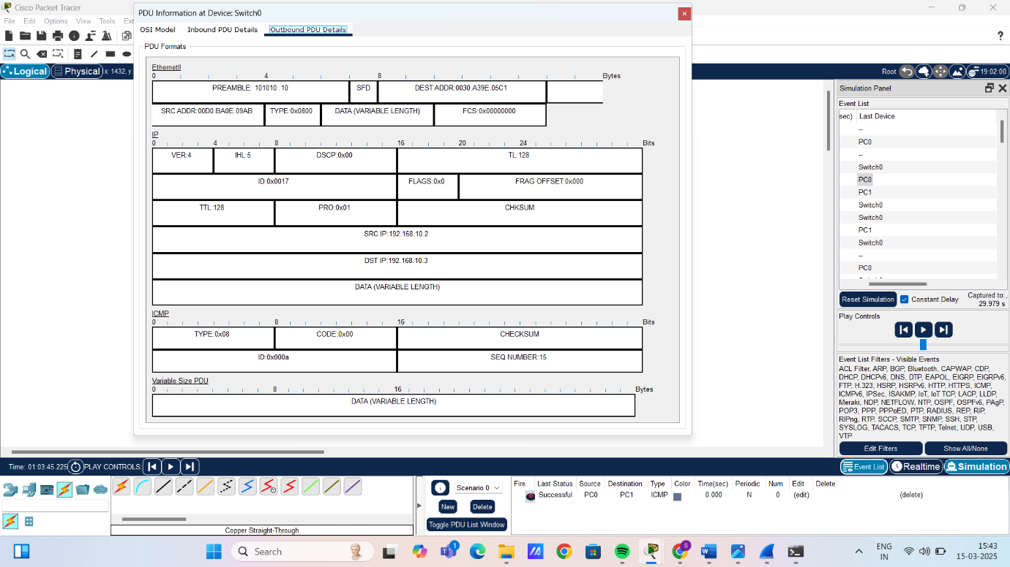

PDU information Table of PC1:
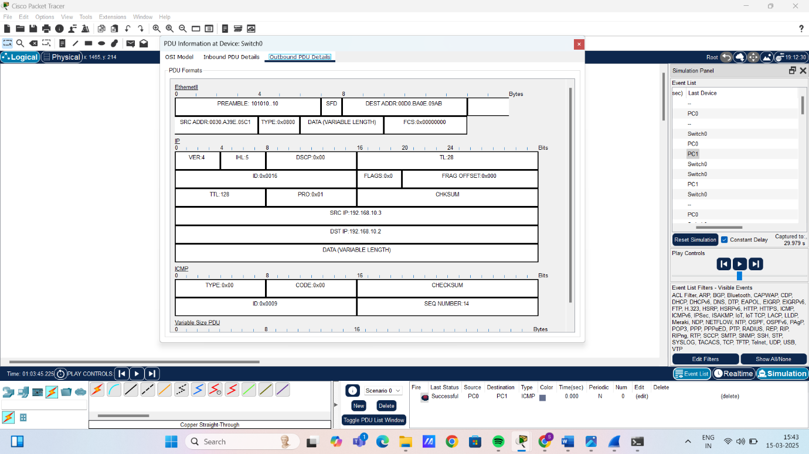

Captured packet from wireshark:
