Create a simple LAN setup with two Linux machines connected via a switch.
Adding both the Linux machines to GNS3:
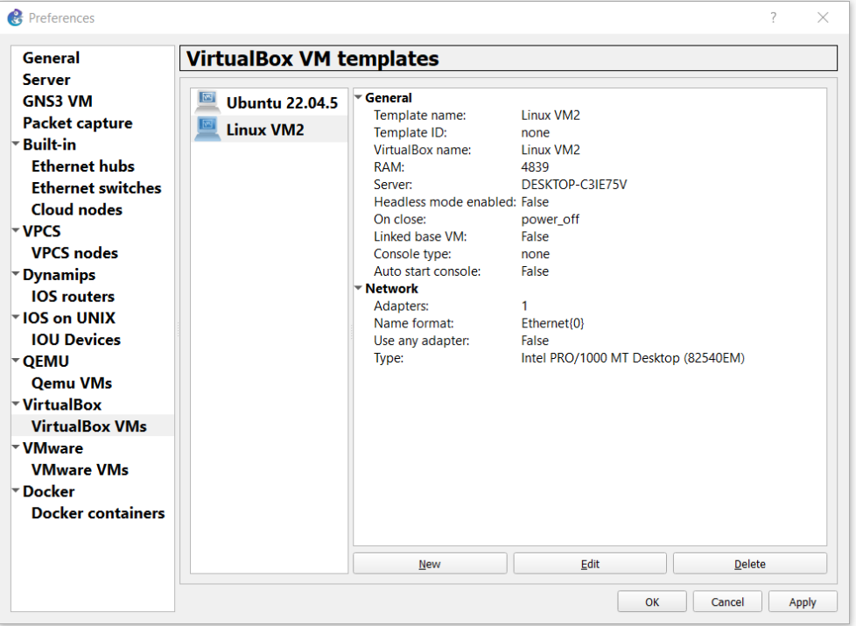
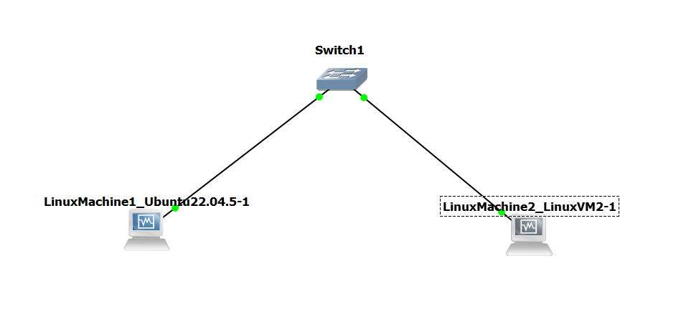

Pinging Machine1 from Machine2:
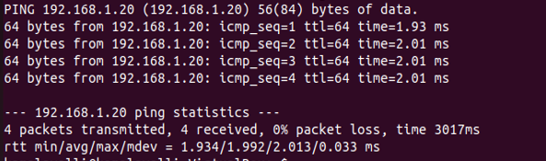

Pinging Machine2 from Machine1:


