Ping from one machine to the other. If it fails, use ifconfig to ensure the IP addresses are configured correctly.

Machine 1: Windows
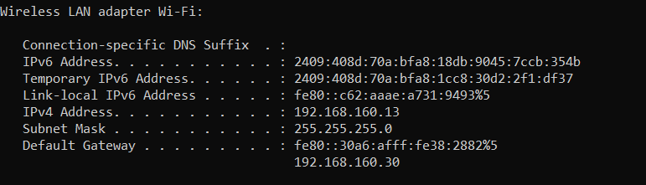

Machine 2: Linux
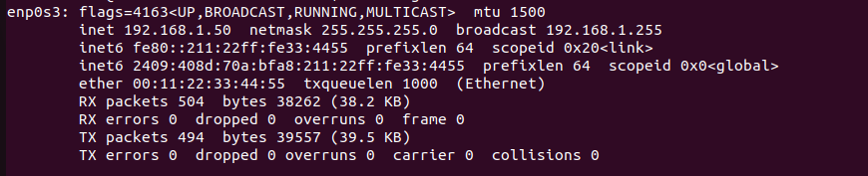

Pinging Machine1 Machine 2 Fails:
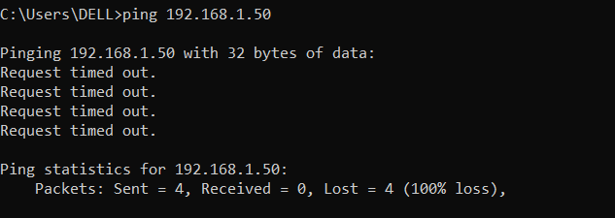

Fixing Configuration:
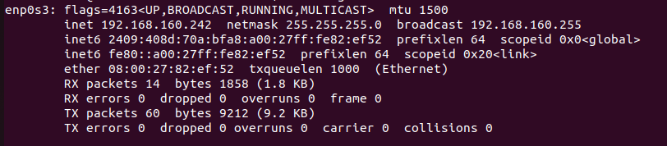

Pinging is Successful:
Machine1 Machine2
