1. Movie class.

class movie {

constructor(title,studio,rating="PG"){

this.title = title;

this.studio = studio;

this.rating = rating;

}

getPG(arr){

var result = arr.filter(array =>array.includes(this.rating));

return result;

}

}

const movie1 = new movie("Casino Royale","Eon Productions","PG13");

console.log(movie1);

Output:

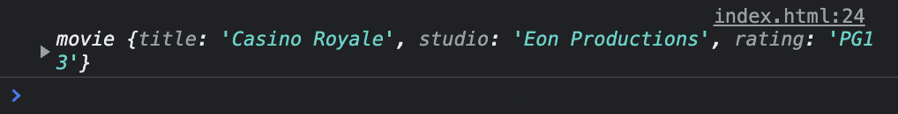

2.

class Circle {

constructor(radius, color) {

this.radius = radius;

this.color = color;

}

getRadius() {

return this.radius

}

getColor() {

return this.color

}

getArea() {

return Math.PI \* Math.pow(this.radius,2);

}

getCircumference() {

return Math.PI \* this.radius\*2;

}

}

const circle = new Circle(5,"Blue");

console.log(circle.getRadius());

console.log(circle.getColor());

console.log(circle.getArea());

console.log(circle.getCircumference());

Output:



3.Write a “person” class to hold all the details.

class Person{

constructor(name,profession,experience,age,location){

this.name = name;

this.profession = profession;

this.experience=experience;

this.age = age;

this.location = location;

}

biodata(){

let info =` Name : ${this.name}

Profession : ${this.profession}

Experience : ${this.experience}

Age : ${this.age}

Location : ${this.location}`;

return info;

}

}

let information = new Person("Abinaya","front-end developer","2 years",23,"trichy");

console.log(information.biodata());

Output:



4.write a class to calculate uber price.

class Uber {

constructor(kilometer,priceperkm) {

this.kilometer = kilometer;

this.priceperkm = priceperkm;

}

getPrice() {

var totalcost = this.kilometer \* this.priceperkm;

return `Fare is ${totalcost}`;

}

}

const user= new Uber(15,4);

console.log(user.getPrice());

Output:

