NEURODEGENERATIVE DISEASE CLASSIFICATION
A Project Report
Submitted in the partial fulfillment of the
requirements for the award of the degree of

BACHELOR OF TECHNOLOGY

In
DEPARTMENT OF ELECTRONICS AND COMMUNICATION ENGINNERING
By
K.V. SAI SRIHARI-2320040033
P. KARTHIK-2320040019
R. VINAY VARDHAN NAIDU-2320040117

Under the Esteemed Guidance of

Siripuri Divya




K L (Deemed to be) University

DEPARTMENT OF ELECTRONICS AND COUMMINCATION ENGINEERING



Declaration

The Project Report entitled “NEURODEGENERATIVE DISEASE CLASSIFICATION
“is a record of Bonafide work of Siri Puri Divya- 457788, K V Sai Sri Hari-2320040033,
P. Karthik-2320040019, R. Vinay Vardhan Naidu-2320040117 submitted in partial fulfillment for the award of B. Tech in Electronics and Communication to the K L University. The results embodied in this report have not been copied from any other departments/University/Institute.

Siripuri Divya - 457788
K.V. Sai Sri Hari - 2320040033
P. Karthik – 2320040019
R. Vinay Vardhan Naidu-2320040117

K L (Deemed to be) University
DEPARTMENT OF ELECTRONICS AND COMMUNICATION ENGINEERING

Certificate

This is to certify that the project based report entitled “Neurodegenerative disease classification” is a Bonafide work done and submitted by S. Divya (458999), team members K.V. Sai Sri Hari-2320040033,
P. Karthik-2320040019, R. Vinay Vardhan-2320040033 in partial fulfillment of the requirements for the award of the degree of BACHELOR OF TECHNOLOGY in Department of Computer Science Engineering, K L (Deemed to be University), during the academic year 2024-2025.

Signature of the Supervisor

Signature of the HOD Signature of the External Examiner

ACKNOWLEDGEMENT

The success in this project would not have been possible but for the timely help and guidance rendered by many people. Our wish to express my sincere thanks to all those who has assisted us in one way or the other for the completion of my project.

Our greatest appreciation to my guide, Siripuri Divya mam, Department of Computer Science which cannot be expressed in words for his tremendous support, encouragement and guidance for this project.

We express our gratitude to Dr. Sunkara Srinivas Rao sir, Head of the Department for Electronics and Communication Engineering, for providing us with adequate facilities, ways and means by which we can complete this project-based Lab.

We thank all the members of the teaching and non-teaching staff members, and those who have assisted me directly or indirectly for successful completion of this project. Finally, I sincerely thank my parents, friends and classmates for their kind help and cooperation during my work.

S. Divya - 4567889

TABLE OF CONTENTS

S.No | Contents | Page no
1 | Abstract | 6
2 | Introduction | 7
3 | Literature survey | 9
4 | Client meetings | 12
5 | Hardware and Software requirements | 14
6 | Implementation | 15
7 | Experimentation and Code | 20
8 | Results | 22
9 | Conclusion | 24
10 | References | 25

ABSTRACT
Title: Neurodegenerative disease classification

Problem Statement: This project aims to develop an AI/ML model to accurately identify individuals suffering from Lewy body dementia. The goal is to process and analyze diverse data sources to distinguish patients with Lewy Body Dementia from those with other conditions.
Explanation: Lewy body dementia is a brain disorder caused by abnormal proteins called Lewy bodies. These proteins disrupt brain function, leading to symptoms like memory problems, confusion, visual hallucinations, and movement difficulties like Parkinson's disease. It affects thinking, movement, and behavior.
For our project, we’re working on an AI/ML model that will analyze raw patient data to identify individuals with Lewy body dementia. The model will provide a classification indicating whether a patient is likely to have LBD or not, based on the patterns in the data. This will help in early diagnosis and better management of the disease.
Algorithm:
Data Collection: Gathering raw data that includes relevant features, such as cognitive assessments, medical history, motor function metrics, and behavioral observations.
Data Cleaning: Handle missing values and outliers.
Choosing an Algorithm:
Logistic Regression: A basic yet effective algorithm for binary classification problems.
Decision Tree: Provides a clear decision-making process and is easy to interpret.
Train and Evaluate the Model: Divide the data into training and testing sets (e.g., 80% training, 20% testing). Applying the chosen algorithm to the training data. Evaluate Performance using metrics like accuracy, precision, and recall on the test data to assess how well the model performs.
Deploy Model: Implement the model in a basic application or tool for making predictions.
INTRODUCTION

Neurodegenerative diseases refer to conditions in which the progressive degradation or loss of neurons takes place. A neuron is a type of cell responsible for cell formation in the brain and spinal cord. Such disorders are pathologically marked by gradual neuronal degeneration, causing the structure and functions to degenerate into severe physical and cognitive disability. The most common neurodegenerative diseases include Alzheimer's disease, which primarily impacts the memory and cognition centers in the brain; Parkinson's disease, which affects movement control; Huntington's disease, which comprises motor, cognitive, and psychiatric symptoms; amyotrophic lateral sclerosis (ALS), which results in muscle weakening and paralysis; and prion diseases, where rapid and fatal neurodegeneration is achieved. These typically end with severe impairments in cognition, motion, and sensation, culminating sometimes with fatal outcomes.
Neurodegeneration is a multifaceted and complex disorder that involves a wide array of genetic, environmental, and lifestyle factors. Many neurodegenerative diseases share key pathological features, such as the abnormal accumulation of proteins within neurons. Such proteins may be beta-amyloid and tau proteins in Alzheimer's disease or alpha-synuclein in Parkinson's disease. This protein aggregation causes disruption of normal cellular functions, leading to inflammation, oxidative stress, and dysfunction in mitochondria. These lead to neuron death, which further lowers the brain's capability to act normally in cognitive and motor functions. Except for genetics, the environmental factors include toxin exposure, head trauma, and lifestyle habits like diet and exercise contribute to susceptibility to neurodegenerative diseases.
The major reason why neurodegenerative diseases are highly prevalent is because of the aged population worldwide. As the population lives longer, the prevalence of such diseases increases significantly, hence becoming a big public health problem in almost all countries. Neurodegenerative diseases not only affect the patient but also caregivers and healthcare systems regarding long-term care and economic costs associated with chronic management. This impact underscores the urgent need for effective treatments and interventions to slow down disease progression or prevent onset altogether.
Most neurodegenerative diseases have no cure at present though many treatments control symptoms and improve the quality of life for patients. For instance, medications manage symptoms such as memory loss in Alzheimer's, dopamine therapies decrease motor symptoms in Parkinson's, and physical therapy maintains mobility and strength in ALS patients. Nonetheless, treatments available are largely symptomatic, improving quality of life but by no means curative or effective at preventing the progression of this disease. There remains a search for better ways to intervene, including promising areas of gene therapy and stem cell research, and some pharmacological approaches aimed either at preventing protein misfolding or reducing oxidative stress.
Another area that neurodegenerative disease research has tackled is biomarkers—biological indicators that can point to the presence or progression of disease. The ability of biomarkers could lead to earlier diagnosis and intervention before significant neuron damage occurs. For instance, in Alzheimer's disease, cerebrospinal fluid biomarkers such as amyloid-beta and tau proteins are being studied to predict years before the onset of any symptoms. Advanced imaging techniques, such as PET and MRI scans, are also proving increasingly useful in monitoring the progression of a disease, as well as the efficacy of experimental therapies.
Many areas of emerging research are showing promise: from the personalized medicine approach, tailoring treatments to an individual's specific genetic profile, to therapies directly aimed at addressing the root causes of neurodegeneration. Advances in genetic research, such as CRISPR gene editing technology, may hold promise for correcting the genetic mutations responsible for a subset of neurodegenerative diseases, particularly those with a strong genetic basis, like Huntington's disease. Stem cell technology has also provided unprecedented insights into mechanisms that underline the disease process and promises hope for regeneration of damaged neurons soon.
Such diseases are considered a tough challenge for modern medicine: Their effects on patients are progressive, often irreversible, and deadly. With the aging population, there can be predictions of growing dimensions as such diseases become more common. Current treatments for neurodegenerative diseases are often symptom-based, leaving research as hopeful at such a time. This would lead to finding some causation, efficient biomarkers, and other innovative approaches to treatments, whereby one day it will be possible to retard, or stop such devastating diseases altogether, and offer the hope of a cure for millions around the world.

LITERATURE SURVEY

Parkinson’s disease:

Parkinson's disease is a movement disorder of the nervous system that worsens over time. The nervous system is a network of nerve cells that controls many parts of the body, including movement.
Symptoms start slowly. The first symptom may be a barely noticeable tremor in just one hand or sometimes a foot or the jaw. Tremor is common in Parkinson's disease. But the disorder also may cause stiffness, slowing movement and trouble with balance that raises the risk of falls.
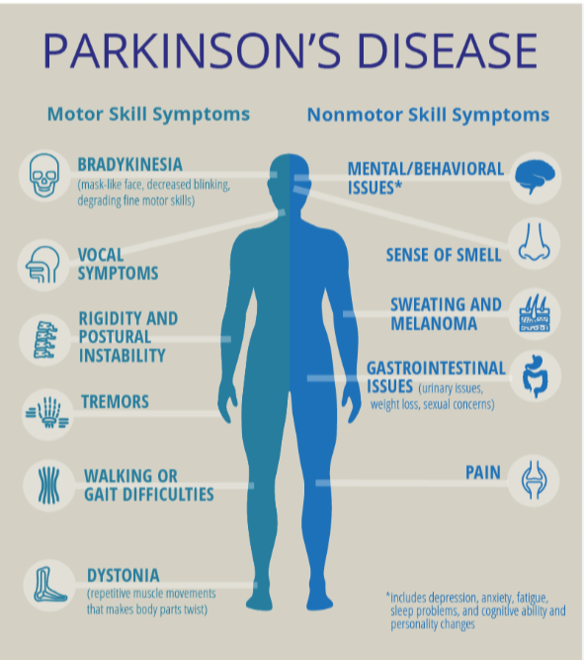
In the early stages of Parkinson's disease, your face may show little or no expression. Your arms may not swing when you walk. Your speech may become soft or slurred. Symptoms get worse over time.
Although Parkinson's disease can't be cured, medicines may help symptoms get better. Sometimes a healthcare professional may suggest surgery to help control parts of the brain. This surgery may help lessen symptoms.
Risk factors:
- Age: Age is one of the most significant risk factors for neurodegenerative diseases, as the likelihood of developing these conditions increases with advancing age. Age-related cellular changes, such as reduced protein homeostasis, mitochondrial dysfunction, and oxidative stress, make neurons more vulnerable to damage. Additionally, the cumulative effects of environmental exposures over time contribute to age-related degeneration of neurons.
- Family History: Family history is a key risk factor, especially for neurodegenerative diseases with known genetic components, even without known mutations, may increase risk due to shared genetic predispositions or environmental factors.
Parkinson’s has four main symptoms:
- Tremor in hands, arms, legs, jaw, or head
- Muscle stiffness, where muscle remains contracted for a long time
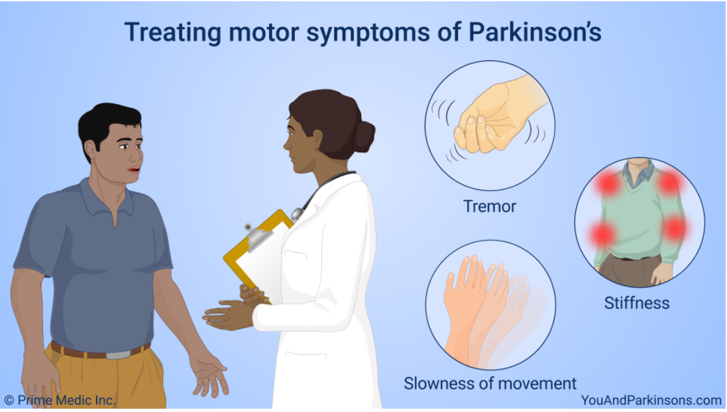
- Slowness of movement
- Impaired balance and coordination, sometimes leading to falls

Some people with Parkinson’s may experience changes in their cognitive function, including problems with memory, attention, and the ability to plan and accomplish tasks. Stress, depression, and some medications may also contribute to these changes in cognition.

Although there is no cure for Parkinson’s disease, medicines, surgical treatment, and other therapies can often relieve some symptoms.

Types of Parkinson’s disease:

1. Motor Symptoms of Parkinson's Disease
Motor symptoms are the hallmark of Parkinson's disease and are primarily caused by the loss of dopamine-producing neurons in the brain. These symptoms typically emerge in the early stages and can progress over time.
- Tremors: One of the most recognizable symptoms, tremors often begin in the hands or fingers and are most noticeable when the muscles are at rest. This symptom, known as a "resting tremor," can spread to other parts of the body as the disease progresses.
- Bradykinesia (Slowness of Movement): Bradykinesia, or slowed movements, can make simple tasks take much longer. This symptom can lead to difficulty with everyday activities like walking, writing, or dressing. Patients may experience a "shuffling" gait or have trouble initiating movement.
- Rigidity (Muscle Stiffness): Stiff muscles or resistance to movement, known as rigidity, can occur in any part of the body, causing discomfort and limiting the range of motion. Muscle stiffness can also contribute to a stooped posture.
- Postural Instability (Balance Problems): As Parkinson's advances, postural instability becomes more pronounced, leading to balance problems and an increased risk of falls. This symptom is often associated with later stages of the disease and can make walking and standing without assistance challenging.
- Freezing Episodes: Freezing occurs when a person suddenly becomes unable to initiate movement, often while walking. This can be triggered by certain obstacles, tight spaces, or stress, leading to a temporary inability to move forward
2. Non-Motor Symptoms of Parkinson's Disease
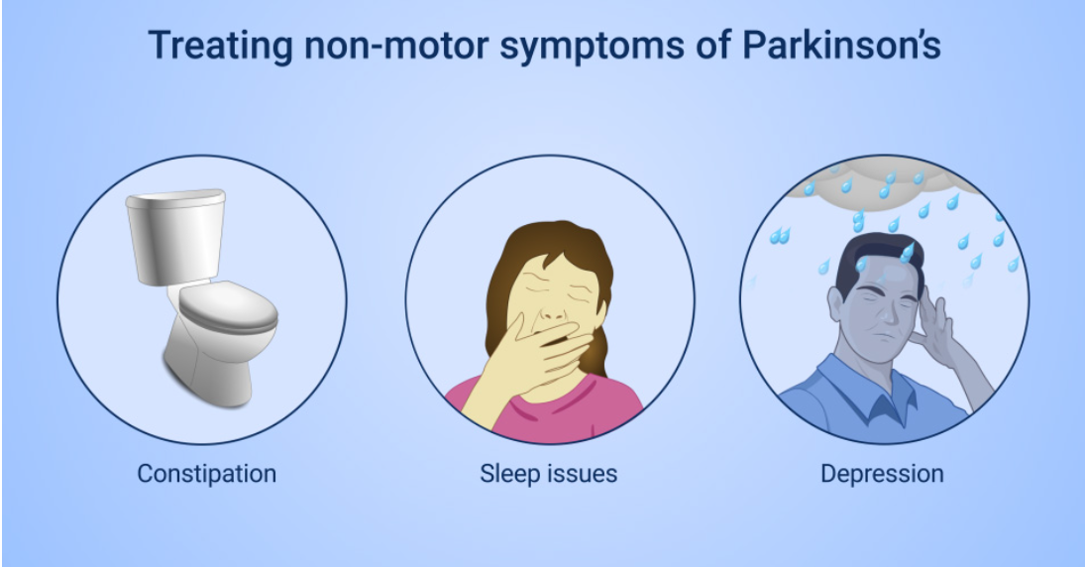
Non-motor symptoms are often underrecognized but can be equally disabling. These symptoms are varied and may affect mood, cognition, sleep, and autonomic functions. They can sometimes appear before motor symptoms and worsen as the disease progresses.
- Cognitive Impairment: Many people with Parkinson's experience some degree of cognitive decline, especially as the disease progresses. This can range from mild memory issues to more severe problems with executive functions, attention, and reasoning. In some cases, Parkinson's can lead to Parkinson’s disease dementia, characterized by significant cognitive impairment and behavioural changes.
- Mood Disorders: Depression and anxiety are common in Parkinson’s patients, sometimes resulting from changes in brain chemistry. These conditions can exacerbate motor symptoms and negatively impact overall quality of life.
- Sleep Disorders: Sleep disturbances are prevalent in Parkinson's and include issues like insomnia, REM sleep behaviour disorder (where people act out dreams), and excessive daytime sleepiness. These disruptions can affect the body’s ability to rest and repair, impacting physical and mental health.
- Autonomic Dysfunction: Parkinson's can impair autonomic nervous system functions, leading to issues like constipation, orthostatic hypotension (a sudden drop in blood pressure when standing), and bladder control problems. These symptoms often require separate treatments.
- Sensory Symptoms: Some patients experience sensory symptoms, such as a decreased sense of smell (hyposmia), which can occur early in the disease. Pain, tingling, and burning sensations are also possible, sometimes affecting specific areas like the neck and shoulders.
- Fatigue: Chronic fatigue is common and can be debilitating. Fatigue in Parkinson's disease may result from physical effort needed to manage motor symptoms or as a direct effect of the disease on brain chemistry.
- Speech and Swallowing Issues: Many individuals experience changes in their voice, such as a softer or monotone speech, and have trouble with articulation. Additionally, difficulty swallowing (dysphagia) can become a serious concern, particularly in later stages, as it increases the risk of aspiration and pneumonia.

Client meetings

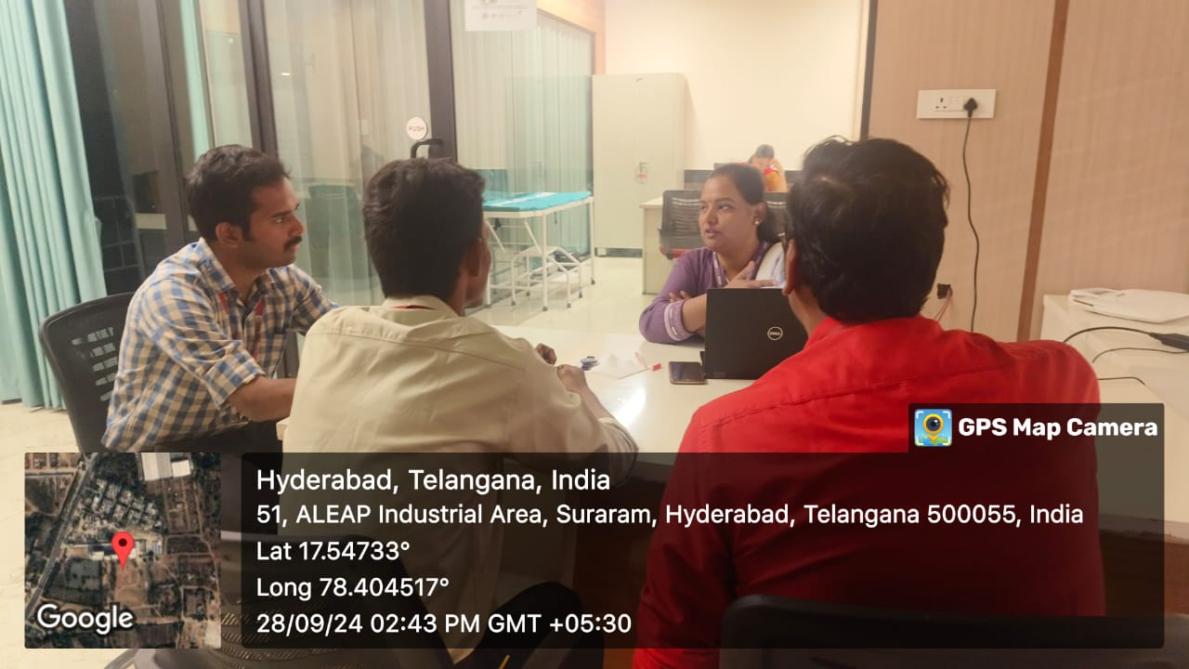


Project Title: Neurodegenerative Disease Classification and Analysis
Client: Asha Suhasini, Psychology Counsellor at KLH University
Consultation Duration: Four days of meetings
Objective: To gather expert insights on neurodegenerative diseases, patient behaviour, and relevant psychological indicators to enhance our project on Parkinson’s Disease classification.

As part of our project on neurodegenerative disease classification using machine learning, we identified the importance of understanding the psychological aspects of patients affected by such conditions. To gain a well-rounded perspective, we consulted with our college's psychology counselor, who provided us with insights on patient behavior, common symptoms, and the psychological challenges associated with neurodegenerative diseases like Parkinson’s. Our objective was to ensure that our technical approach aligns with real-world observations and to integrate any additional factors that could improve the accuracy and sensitivity of our model.
Our interactions with the counsellor yielded several valuable insights:
- Data Relevance: The counsellor highlighted the importance of focusing on voice measurements and other subtle behavioural markers, as these are often early indicators of Parkinson’s. This feedback validated our choice of dataset features.
- Feature Selection: The meetings helped us refine our feature selection by incorporating aspects that are psychologically relevant, not only physiologically. This could improve our model’s predictive power and make it more aligned with patient experiences.
- User-Focused Design: The counsellor’s perspective reinforced the need for a user-friendly interface, especially for non-technical users, which led us to use Streamlit to present our results in an accessible way.

Meeting with our client, the psychology counsellor, was instrumental in shaping our approach to this project. The sessions helped us understand Parkinson's disease beyond its physical symptoms, highlighting the psychological aspects that impact patient lives. This comprehensive understanding has informed our model selection, feature engineering, and interface design, ensuring that our project is both scientifically accurate and empathetically aligned with real patient needs.

By combining technical tools with insights from psychology, we are confident that our project will serve as a meaningful step toward better understanding and potentially improving the diagnosis of neurodegenerative diseases.

HARDWARE AND SOFTWARE REQUIREMENTS

HARDWARE REQUIREMENTS: To run this project effectively, the following hardware components are recommended:
- Processor: Intel Core i5 or higher for smooth processing and fast model training.
- RAM: Minimum of 8 GB, ideally 16 GB or more, to handle data loading and processing without lag.
- Storage: At least 256 GB of free disk space for dataset storage, model files, and necessary libraries.
- Operating System: Compatible with Windows, macOS, or Linux operating systems.

SOFTWARE REQUIREMENTS: This project requires several software tools and libraries to ensure seamless data analysis and user interface development. Below is a list of essential software components:
- Python 3.7 or higher: The programming language used for data processing, model training, and interface development.
- Streamlit: A Python library used for creating the interactive user interface. It enables the deployment of machine learning models in a web-based format.
- Jupyter Notebook or an IDE (like VS Code or PyCharm): Recommended for writing and testing the code before deployment.
- pip: The package manager for installing required Python libraries.

Required Python Libraries:

- Streamlit
- Pandas
- Seaborn
- Matplotlib
- scikit-learn
- Pickle
- OS

IMPLEMENTATION

Code execution using google colab:

- Open Google colab and create a new file



- Include all the necessary programs and libraries for the implementation of the code


- Upload the document into the colab and copy the path of the document

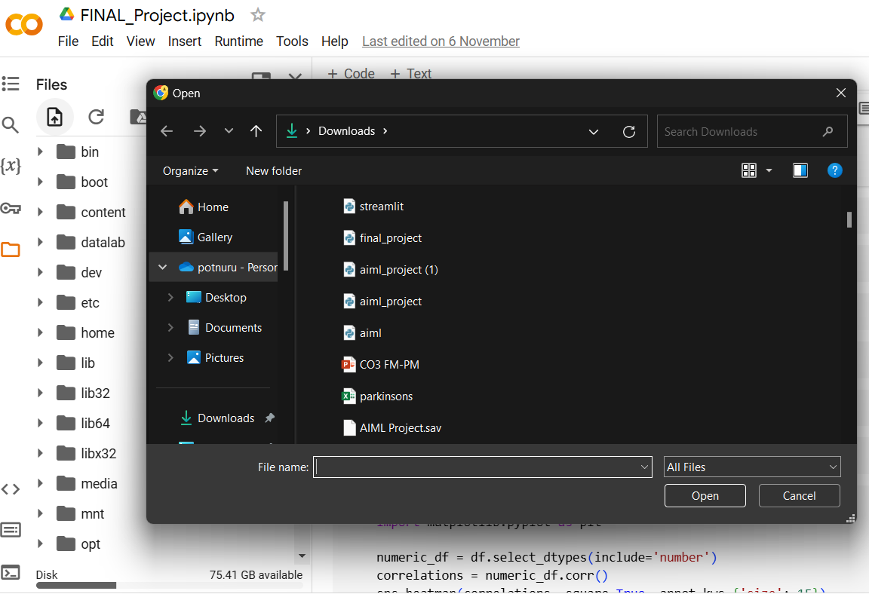

- Write your remaining code in the cell line by line

- Correlation Heat Map
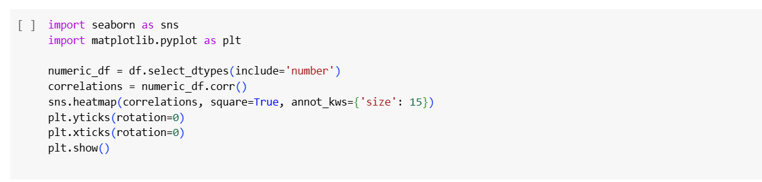

- Random Forest classification
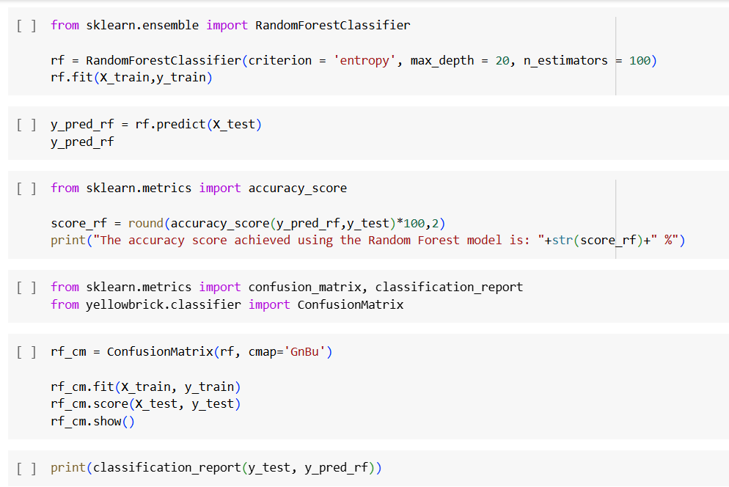

- KNN Algorithm
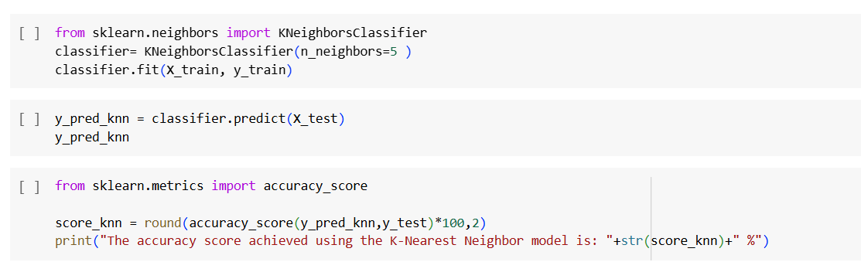

- SVM Algorithm

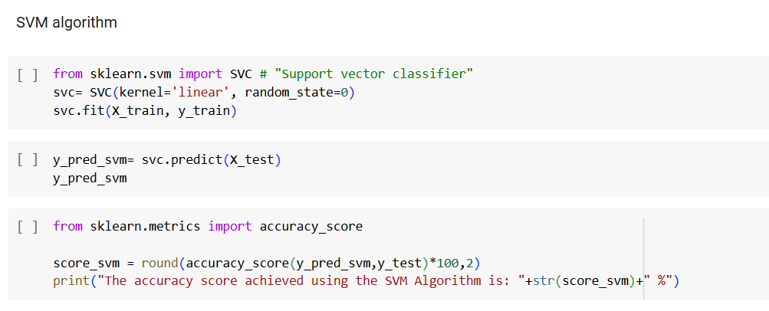

- Implement the pickle module in Python to save (serialize) and load (deserialize) an object
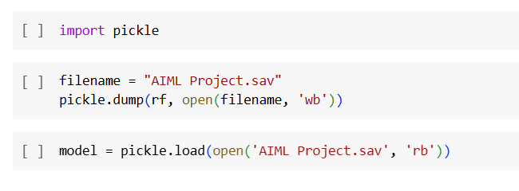

Implementation of the UI interface

"Streamlit is an open-source Python library that allows you to create interactive web applications for machine learning projects with minimal coding. In my neurodegenerative disease classification project, I used Streamlit to build a user-friendly interface where users can easily upload medical data, view classification results, and explore model predictions. Streamlit supports interactive elements like sliders, file uploaders, and buttons, making it simple to visualize results in real-time. This allows users to interact with the model without needing any programming knowledge, providing a seamless experience."

- The code snippet in the image installs the streamlit library using Python's subprocess module.

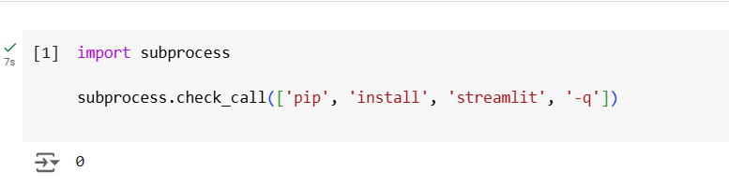

- The code snippet in the image checks the version of streamlit installed in the environment.

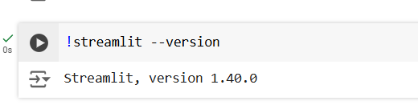

- Cell 1: Retrieve the public IP address
Cell 2: Installs local tunnel globally
Cell 3: Provides help with information using local tunnel

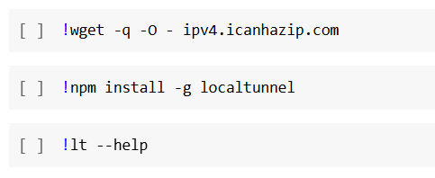

- This part runs a Streamlit application by executing the Python file final_project.py and this uses localtunnel to expose the Streamlit app (running on port 8501) to the internet, creating a public URL that others can access.

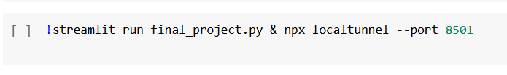

EXECUTION AND CODE

Source Code images:

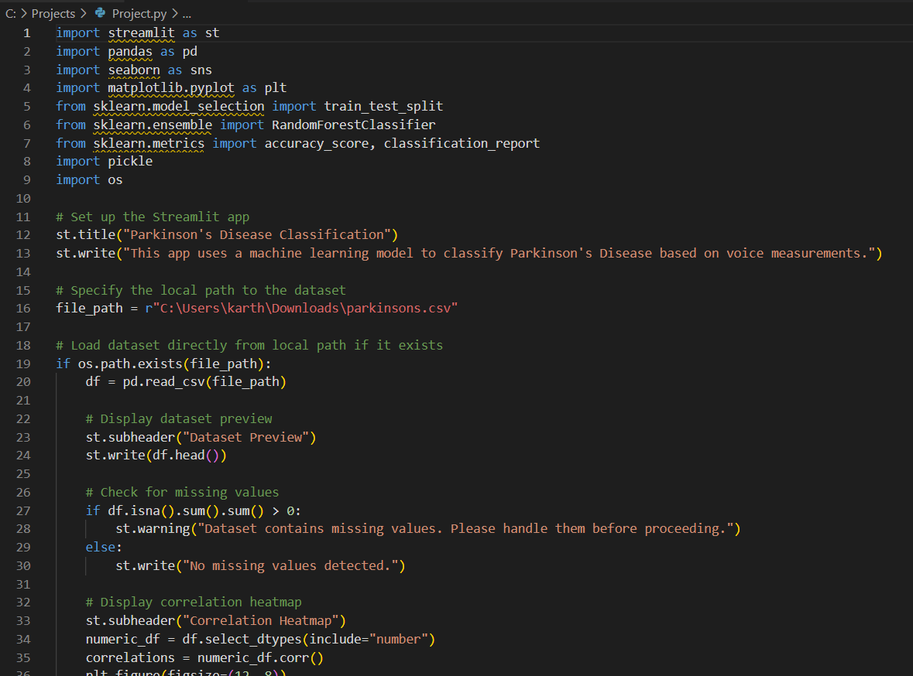

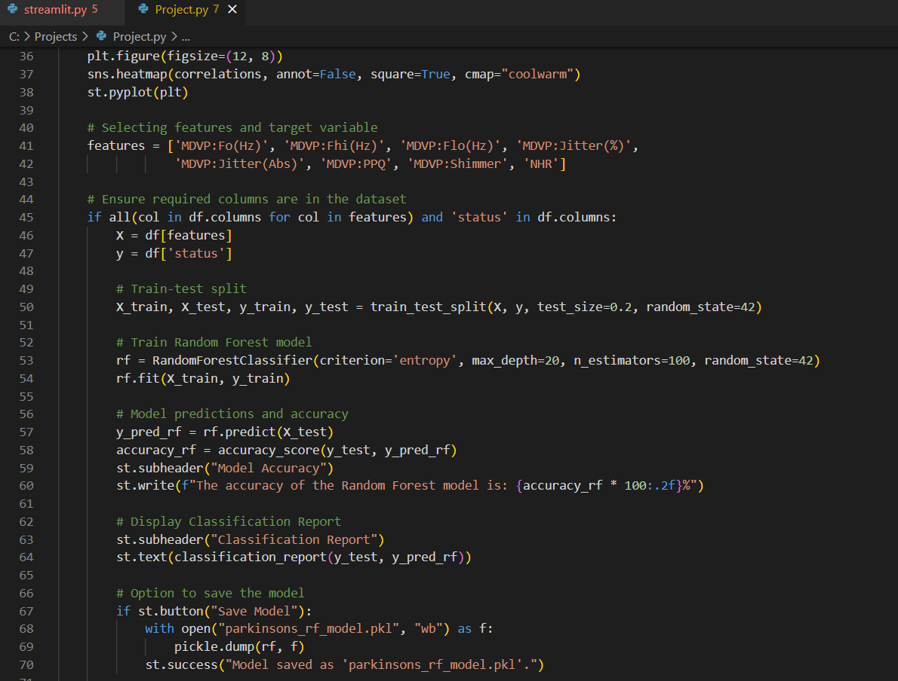

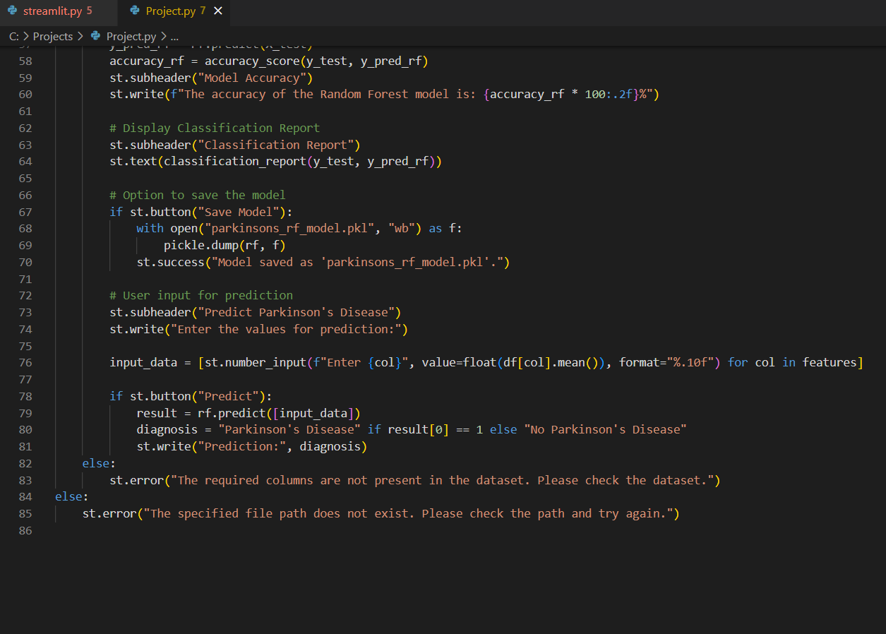

The above code creates a Streamlit app for classifying Parkinson's Disease based on voice measurements

Execution in Command Prompt:

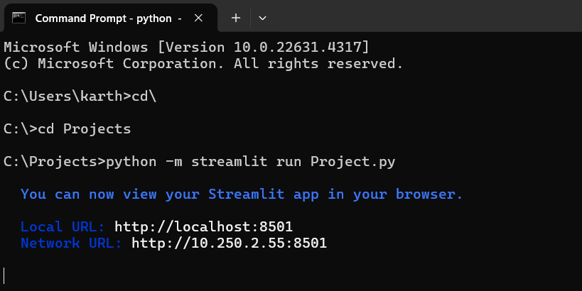

Results:

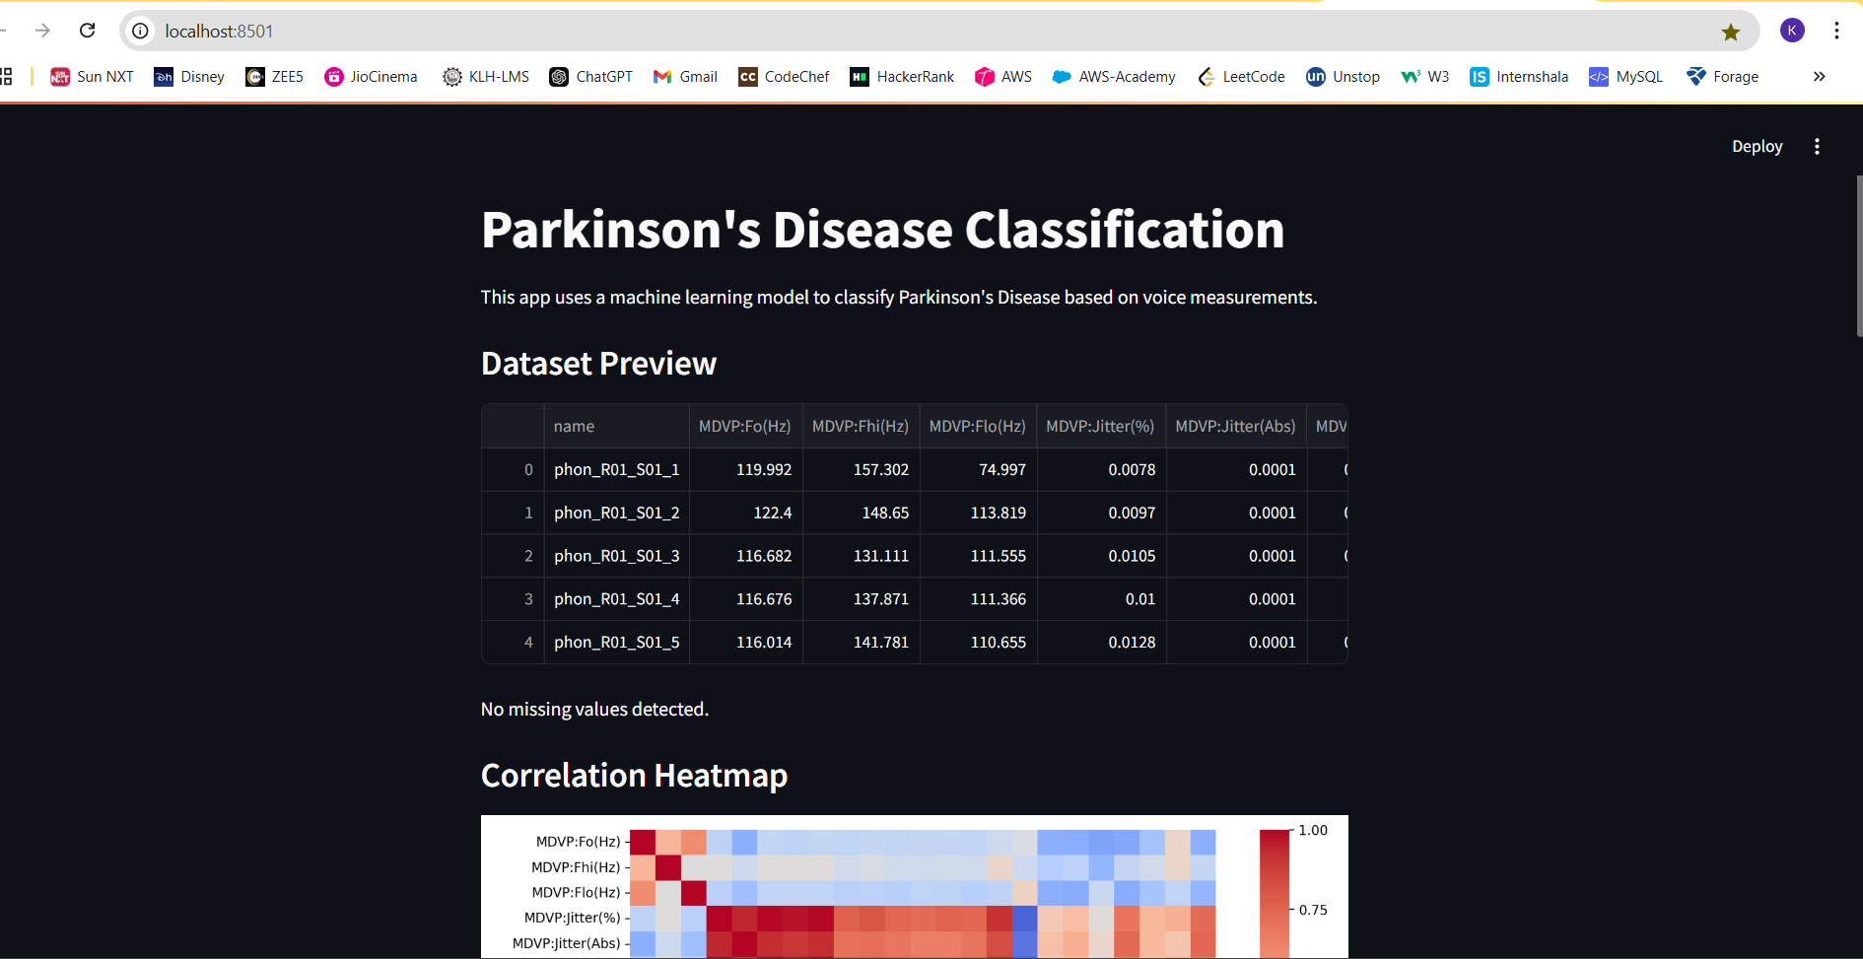

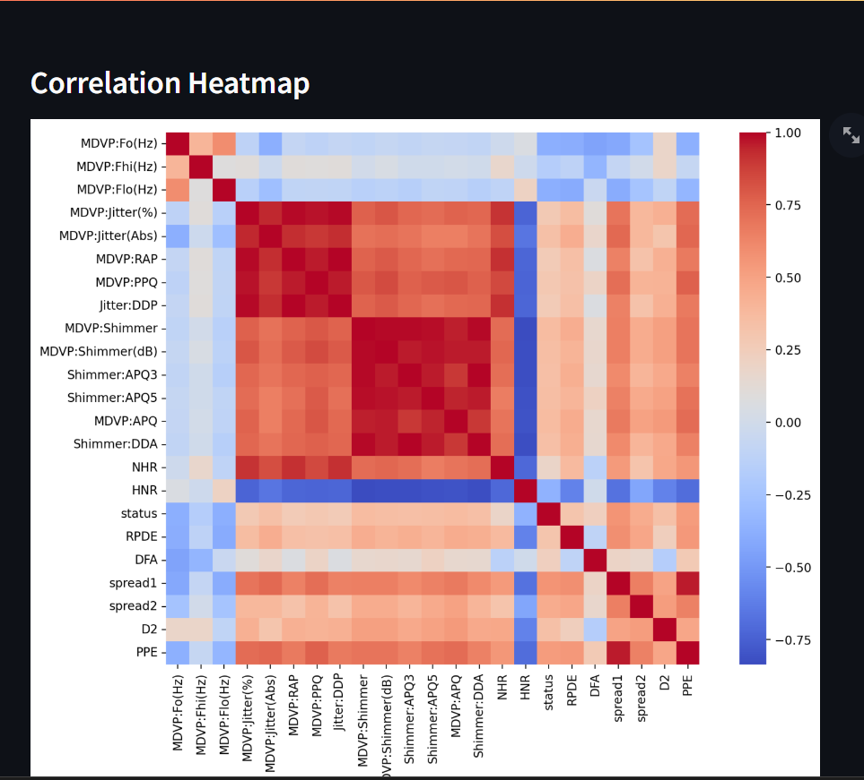

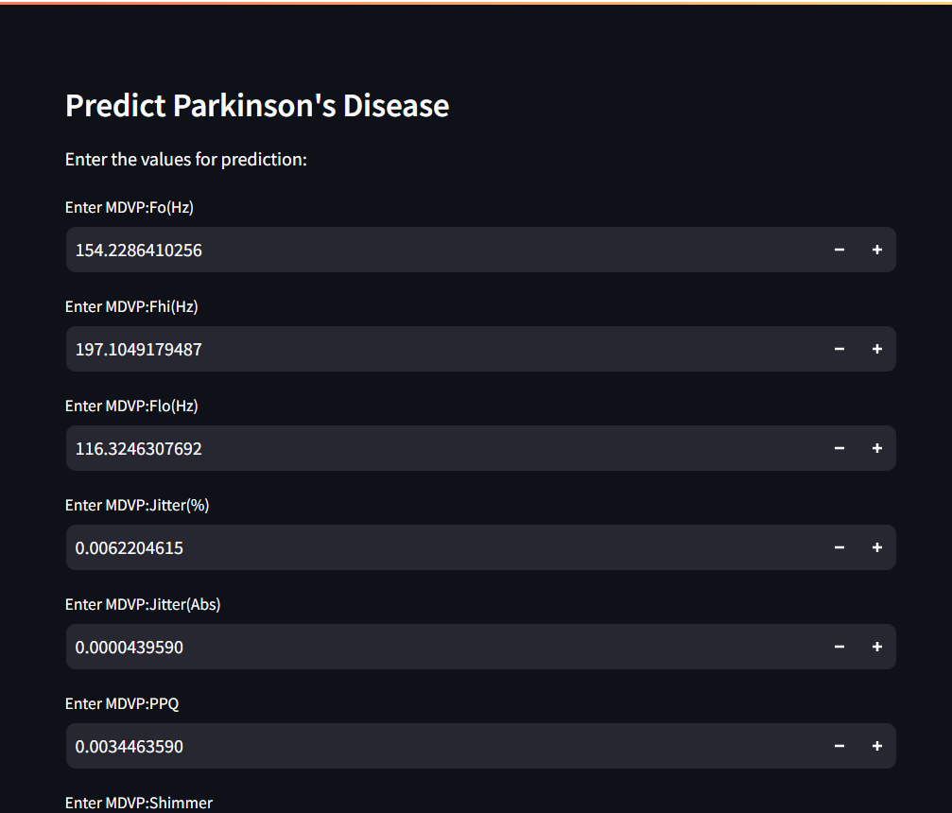
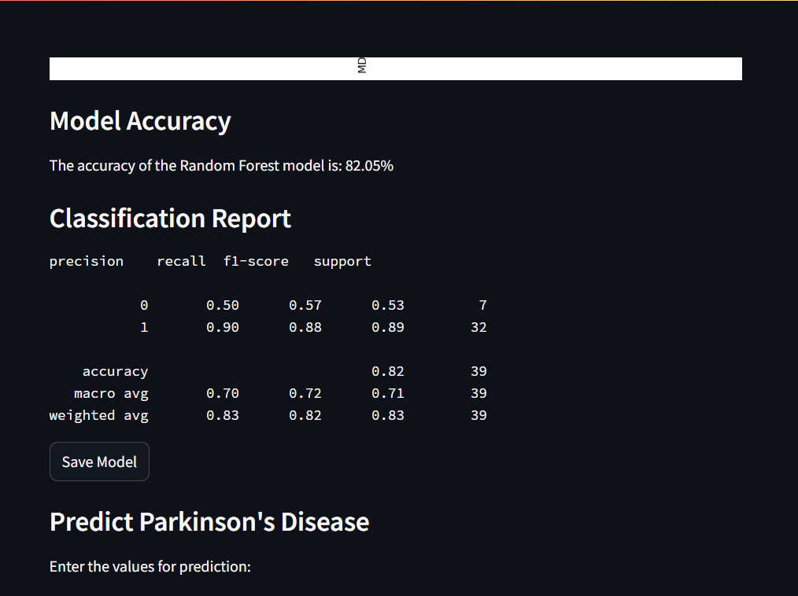

Predictions in Two cases:

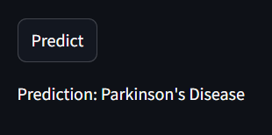

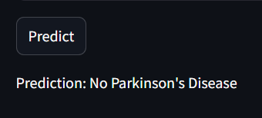

Conclusion:

In this project, we developed a machine learning-based approach to classify Parkinson's disease using various algorithms, including Random Forest, Support Vector Machine (SVM), and K-Nearest Neighbours (KNN). The use of these models allowed us to compare their effectiveness in predicting Parkinson’s disease based on voice measurements, revealing valuable insights into each algorithm’s strengths and limitations in handling neurodegenerative disease data.

The Random Forest classifier demonstrated robust performance with high accuracy, likely due to its ensemble nature, which reduces overfitting. SVM and KNN also showed promising results, each with unique advantages depending on data distribution and feature importance. By deploying the results on a Streamlit interface, we were able to present a user-friendly visualization and interactive analysis, making the model outputs accessible and interpretable.

Overall, this project highlights the potential of machine learning in aiding early diagnosis of Parkinson's disease, which can be crucial in managing and slowing disease progression. Future work may include incorporating more diverse datasets, testing additional algorithms, or refining feature selection to improve predictive accuracy further. This project serves as a foundational step towards leveraging AI/ML for practical and impactful healthcare solutions.

References:

https://my.clevelandclinic.org/health/discases/24976-neurodegenerative-disease

https://pdbp.ninds.nih.gov/lewy-body-data

https://www.thelaneet.com/article/81474-4422(19)30153-X/abstract

