AutoChip HDL Generation Benchmark
Evaluating Open-Source and Frontier LLMs on Verilog Design Tasks
Hardware Platform: NVIDIA RTX 5060 8 GB | Intel Core i7 | AutoChipFinalTEST Framework
Karthikeya and Yashwant, April 2026
https://github.com/Karthik-Flash/HDL_LLM

Abstract
This report presents a systematic benchmark of seven language models on a 20-module Verilog-2001 hardware description language (HDL) generation task suite. Models tested span the consumer-GPU range - gemma3:4b, gemma3:12b, llama3.1:8b, deepseek-coder:6.7b, qwen2.5-coder:14b and two frontier API models (Gemini 2.5 Flash and Gemini 2.5 Pro).
All local inference ran on an NVIDIA RTX 5060 (8 GB GDDR7) using Ollama, with automated compile-and-simulate verification via Icarus Verilog. The 20 benchmark modules span four difficulty tiers: Easy (L1), Medium (L2), Hard (L3), and Critical (L4). Pass@1 scores ranged from 50 % (gemma3:4b) to 80 % (gemma3:12b, qwen2.5-coder:14b, Gemini 2.5 Pro).
A hardware-accelerated reference run using Qwen2.5-Coder-32B on an NVIDIA H100-80GB is included for comparison. Persistent failure modes - Galois LFSR taps, SPI clock-phase protocol, 2-stage pipeline timing, and UART baud-counter FSM - appear across all model families regardless of parameter count, indicating these are knowledge-boundary failures rather than scale failures. The report concludes with a case for Tenstorrent AI accelerator hardware to support expanded benchmarking, synthesis-in-the-loop evaluation, and thermal-constraint-free operation.

1. Introduction
- What makes HDL hard: Hardware description languages like Verilog demand precision that general software code does not: clock domains, wire/reg directionality, protocol edge timing.
- How AutoChip works: AutoChip (Thakur et al., DAC 2024) treats the compiler as a teacher - each failed compile or simulation is sent back to the LLM with an instruction to fix it, repeating up to 5 times.
- What this study adds: This study expands the benchmark to 20 modules across 4 tiers, adds 9 targeted spec fixes (v2 harness), and tracks total time consumed even for failing modules.
- Primary goal: Primary goal: identify which models, error types, and module categories constitute hard ceilings - and make the case for better hardware to break them.
The primary research questions addressed here are: (1) How does Pass@1 scale with model parameter count on the 5060 8 GB platform? (2) Which specific modules and error types constitute hard ceilings for all models tested? (3) Does running a 32B model on an H100-class GPU resolve any of those hard-ceiling failures, and if so which ones? (4) What infrastructure would be needed to scale this benchmark further without hitting thermal or memory limits?

2. Benchmark Design
The benchmark comprises 20 Verilog-2001 modules grouped into four tiers. The tier structure is designed so that all models pass L1 (confirming harness integrity), L2 differentiates models by knowledge depth, L3 tests multi-concept composition, and L4 targets four distinct known failure modes in LLM HDL generation.

2.1 Tier Definitions
Tier | Goal | Expected Outcome | Design Rationale
L1 Easy | Baseline | All models pass on iteration 1 | Confirms harness and testbench correctness; any failure is an infrastructure or reg/wire hallucination, which is itself a data point
L2 Medium | Differentiation | Sub-10B models struggle; 12B+ models pass | Tests Galois polynomial recall, Gray-code formula, and counter semantics - knowledge failures, not syntax failures
L3 Hard | Ceiling test | Multi-concept composition required | Combines FSM + baud counter + shift register (uart_tx); feedback path composition (alu_accumulator_top)
L4 Critical | Failure taxonomy | Each module targets a distinct known LLM failure mode | Parameterisation hallucination (param_register_file); pipeline depth (pipeline_mult_4x4); SPI clock-phase protocol (spi_master_8bit)

2.2 Module List
Tier | Module | Description
Easy | half_adder | XOR/AND gate; wire discipline baseline
Easy | full_adder | Three-input carry logic; assign-only
Easy | ripple_carry_adder | 4-bit chain of four full_adder instantiations
Easy | comparator_8bit | Three simultaneous output flags from assign statements
Easy | bcd_to_7seg | 7-segment decode; requires encoding table recall
Easy | priority_enc_8 | 8-to-3 priority encoder; if-else chain in always block
Medium | alu_8bit | 8-operation 8-bit ALU; always block with case
Medium | dff_sync_reset | D flip-flop with synchronous active-high reset
Medium | counter_4bit | 4-bit up counter with synchronous reset and wrap
Medium | lfsr_8bit | Galois LFSR x^8+x^6+x^5+x^4+1; seed-loadable
Medium | pwm_generator | 8-bit counter < duty_cycle; free-running
Medium | gray_counter_4bit | Binary counter + Gray encode; bin ^ (bin >> 1)
Hard | simple_cpu_alu | 4-bit ALU; 4-operation combinational with zero flag
Hard | fsm_seq_detector | Mealy FSM; detects 1011 with overlapping reuse
Hard | uart_tx | UART 8N1 FSM + baud counter + shift register combined
Hard | sync_fifo_8 | 8-entry synchronous FIFO; 4-bit pointer disambiguation
Hard | alu_accumulator_top | Top module; instantiates alu_8bit with feedback path
Critical | param_register_file | Parameterised regfile; tests N/W parameter use
Critical | pipeline_mult_4x4 | 2-stage pipelined 4x4 multiplier; latency check
Critical | spi_master_8bit | SPI mode-0 master; MOSI/MISO edge-phase protocol

3. Experimental Setup

3.1 Hardware Platform
GPU | NVIDIA RTX 5060 (8 GB GDDR7, Blackwell, 3840 CUDA cores)
CPU | Intel Core i7 (13th Gen), thermal ceiling ~100 C under sustained load
System RAM | 16 GB DDR5
Storage | 512 GB NVMe SSD (Windows 11)
Inference Stack | Ollama 0.6 (local LLMs), Google Generative AI SDK (Gemini API)
Compiler | Icarus Verilog 12 (iverilog / vvp)
OS | Windows 11 + WSL2 / MSYS2 for iverilog
Framework | AutoChipFinalTEST - custom Python harness (autochip_runner.py)

All local model inference was performed on the RTX 5060 8 GB. Models larger than 8 GB were not tested locally because they cannot be held in VRAM in full precision; Ollama performs partial CPU offload for the 12B model, making it approximately 40 % slower than the 4B model per token. Under sustained multi-hour benchmark runs (notably deepseek-coder at 97.9 min total), CPU junction temperatures reached 100 C.

3.2 Models Evaluated
Model | Params | Context | Serving | Notes
gemma3:4b | 4B | 128k | Ollama (VRAM) | Primary small-model data point; occasional Hindi text injection
llama3.1 | 8B | 128k | Ollama (VRAM) | Meta general-purpose; strong on easy tiers
deepseek-coder:6.7b | 6.7B | 16k | Ollama (VRAM) | Extremely slow per token; thermal throttling observed
gemma3:12b | 12B | 128k | Ollama (partial CPU offload) | Largest model fitting within thermal budget
qwen2.5-coder:14b | 14B | 128k | Ollama (partial CPU offload) | Best local model; strong code specialisation
gemini-2.5-flash | API | 1M | Google API | Fastest API model; sub-second for easy tier
gemini-2.5-pro | API | 1M | Google API | Highest-capability API model; only one to pass uart_tx

3.3 Evaluation Harness
- Step 1: Sends the Verilog spec to the LLM via Ollama's OpenAI-compatible API.
- Step 2: Extracts the code block, strips non-ASCII characters, writes to a working directory.
- Step 3: Copies testbench and dependency .v files, then runs iverilog and vvp.
- Step 4: On failure (compile error or FAIL in simulation output) the full error is sent back to the LLM with a fix instruction.
- Step 5: Repeats up to 5 iterations. Records: pass/fail, iteration count, time to pass, CE (Compile Error) count, SE (Simulation Error) count, dominant error type.

4. Results

4.1 gemma3:4b - Pass@1: 10/20 = 50%
- Passes all simple combinational/sequential designs; fails on all Hard/Critical modules.
- Enters non-convergent loops on port_mismatch and duplicate_module - same error repeated all 5 iterations without correction.
- Occasionally injects Devanagari script characters into Verilog code blocks (requires Unicode sanitisation in harness).
.
Module | Tier | Pass | Iters | Pass T (s) | Total T (s) | CE | SE | Dominant Error
half_adder | Easy | ✓ | 1 | 8.4 | 8.4 | 0 | 0 | -
full_adder | Easy | ✓ | 1 | 1.3 | 1.3 | 0 | 0 | -
ripple_carry_adder | Easy | ✗ | - | - | 31.1 | 0 | 5 | logic_error
comparator_8bit | Easy | ✓ | 1 | 1.4 | 1.4 | 0 | 0 | -
bcd_to_7seg | Easy | ✓ | 1 | 3.2 | 3.2 | 0 | 0 | -
priority_enc_8 | Easy | ✓ | 4 | 14.3 | 14.3 | 2 | 1 | reg_wire_mismatch
alu_8bit | Medium | ✓ | 4 | 11.6 | 11.6 | 3 | 0 | port_mismatch
dff_sync_reset | Medium | ✓ | 1 | 1.3 | 1.3 | 0 | 0 | -
counter_4bit | Medium | ✓ | 1 | 1.3 | 1.3 | 0 | 0 | -
lfsr_8bit | Medium | ✗ | - | - | 16.1 | 5 | 0 | port_mismatch
pwm_generator | Medium | ✗ | - | - | 9.2 | 5 | 0 | duplicate_module
gray_counter_4bit | Medium | ✓ | 1 | 2.0 | 2.0 | 0 | 0 | -
simple_cpu_alu | Hard | ✗ | - | - | 10.8 | 5 | 0 | port_mismatch
fsm_seq_detector | Hard | ✗ | - | - | 21.2 | 5 | 0 | duplicate_module
uart_tx | Hard | ✗ | - | - | 40.9 | 5 | 0 | duplicate_module
sync_fifo_8 | Hard | ✓ | 1 | 4.8 | 4.8 | 0 | 0 | -
alu_accumulator_top | Hard | ✗ | - | - | 19.1 | 4 | 1 | port_mismatch
param_register_file | Critical | ✗ | - | - | 12.6 | 5 | 0 | port_mismatch
pipeline_mult_4x4 | Critical | ✗ | - | - | 10.2 | 0 | 5 | logic_error
spi_master_8bit | Critical | ✗ | - | - | 62.8 | 0 | 5 | logic_error

Pass@1: 10/20 = 50% | Failed: 10/20 | Wall-clock: 283 s (4.7 min)

4.2 gemma3:12b - Pass@1: 16/20 = 80%
- 30 percentage-point jump over the 4B version - scaling alone resolved all Easy-tier issues and most Hard-tier failures.
- Passes pwm_generator on iteration 5, showing the feedback loop works when model capacity is sufficient to apply a logic correction.
- Still blocked on lfsr_8bit (117.8 s consumed), pipeline_mult_4x4, and spi_master_8bit - knowledge boundaries, not size limits.
Module | Tier | Pass | Iters | Pass T (s) | Total T (s) | CE | SE | Dominant Error
half_adder | Easy | ✓ | 1 | 15.6 | 15.6 | 0 | 0 | -
full_adder | Easy | ✓ | 1 | 7.5 | 7.5 | 0 | 0 | -
ripple_carry_adder | Easy | ✓ | 1 | 31.1 | 31.1 | 0 | 0 | -
comparator_8bit | Easy | ✓ | 1 | 8.3 | 8.3 | 0 | 0 | -
bcd_to_7seg | Easy | ✓ | 1 | 30.6 | 30.6 | 0 | 0 | -
priority_enc_8 | Easy | ✓ | 1 | 19.1 | 19.1 | 0 | 0 | -
alu_8bit | Medium | ✓ | 1 | 21.7 | 21.7 | 0 | 0 | -
dff_sync_reset | Medium | ✓ | 1 | 7.7 | 7.7 | 0 | 0 | -
counter_4bit | Medium | ✓ | 1 | 8.1 | 8.1 | 0 | 0 | -
lfsr_8bit | Medium | ✗ | - | - | 117.8 | 0 | 5 | logic_error
pwm_generator | Medium | ✓ | 5 | 71.7 | 71.7 | 1 | 3 | logic_error
gray_counter_4bit | Medium | ✓ | 1 | 10.8 | 10.8 | 0 | 0 | -
simple_cpu_alu | Hard | ✓ | 1 | 15.2 | 15.2 | 0 | 0 | -
fsm_seq_detector | Hard | ✓ | 1 | 26.9 | 26.9 | 0 | 0 | -
uart_tx | Hard | ✗ | - | - | 388.1 | 0 | 5 | logic_error
sync_fifo_8 | Hard | ✓ | 1 | 28.2 | 28.2 | 0 | 0 | -
alu_accumulator_top | Hard | ✓ | 1 | 21.1 | 21.1 | 0 | 0 | -
param_register_file | Critical | ✓ | 1 | 18.1 | 18.1 | 0 | 0 | -
pipeline_mult_4x4 | Critical | ✗ | - | - | 61.3 | 0 | 5 | logic_error
spi_master_8bit | Critical | ✗ | - | - | 355.2 | 0 | 5 | logic_error

Pass@1: 16/20 = 80% | Failed: 4/20 | Wall-clock: 1264 s (21.1 min)

4.3 qwen2.5-coder:14b - Pass@1: 16/20 = 80%
- Code-specialised training pays off: every module it passes is passed on iteration 1 with zero compile errors.
- Uniquely passes spi_master_8bit first-try (88.2 s) - the only local model to implement SPI mode-0 edge-phase correctly.
- Its 4 failures (lfsr_8bit, pwm_generator, uart_tx, pipeline_mult_4x4) are all confirmed universal hard-ceiling modules.
Module | Tier | Pass | Iters | Pass T (s) | Total T (s) | CE | SE | Dominant Error
half_adder | Easy | ✓ | 1 | 17.8 | 17.8 | 0 | 0 | -
full_adder | Easy | ✓ | 1 | 9.9 | 9.9 | 0 | 0 | -
ripple_carry_adder | Easy | ✓ | 1 | 35.6 | 35.6 | 0 | 0 | -
comparator_8bit | Easy | ✓ | 1 | 10.8 | 10.8 | 0 | 0 | -
bcd_to_7seg | Easy | ✓ | 1 | 42.5 | 42.5 | 0 | 0 | -
priority_enc_8 | Easy | ✓ | 1 | 28.5 | 28.5 | 0 | 0 | -
alu_8bit | Medium | ✓ | 1 | 31.3 | 31.3 | 0 | 0 | -
dff_sync_reset | Medium | ✓ | 1 | 10.7 | 10.7 | 0 | 0 | -
counter_4bit | Medium | ✓ | 1 | 11.9 | 11.9 | 0 | 0 | -
lfsr_8bit | Medium | ✗ | - | - | 219.7 | 0 | 5 | logic_error
pwm_generator | Medium | ✗ | - | - | 71.2 | 0 | 5 | logic_error
gray_counter_4bit | Medium | ✓ | 1 | 13.7 | 13.7 | 0 | 0 | -
simple_cpu_alu | Hard | ✓ | 1 | 22.1 | 22.1 | 0 | 0 | -
fsm_seq_detector | Hard | ✓ | 1 | 28.8 | 28.8 | 0 | 0 | -
uart_tx | Hard | ✗ | - | - | 499.4 | 0 | 5 | logic_error
sync_fifo_8 | Hard | ✓ | 1 | 38.6 | 38.6 | 0 | 0 | -
alu_accumulator_top | Hard | ✓ | 1 | 32.6 | 32.6 | 0 | 0 | -
param_register_file | Critical | ✓ | 1 | 21.5 | 21.5 | 0 | 0 | -
pipeline_mult_4x4 | Critical | ✗ | - | - | 105.6 | 0 | 5 | logic_error
spi_master_8bit | Critical | ✓ | 1 | 88.2 | 88.2 | 0 | 0 | -

Pass@1: 16/20 = 80% | Failed: 4/20 | Wall-clock: 1340 s (22.3 min)

4.4 llama3.1:8b - Pass@1: 13/20 = 65%
- Fastest local model overall - 4.0 min total, completing the full benchmark faster than gemma3:12b takes to handle Easy tier alone.
- Produces syntax_error on uart_tx and spi_master_8bit across all 5 iterations - over-engineers corrections and introduces broken syntax.
- Passes fsm_seq_detector in 1 iteration (rare among small models), but cannot handle UART or SPI protocol timing.
Module | Tier | Pass | Iters | Pass T (s) | Total T (s) | CE | SE | Dominant Error
half_adder | Easy | ✓ | 1 | 7.5 | 7.5 | 0 | 0 | -
full_adder | Easy | ✓ | 1 | 1.6 | 1.6 | 0 | 0 | -
ripple_carry_adder | Easy | ✗ | - | - | 23.1 | 2 | 3 | logic_error
comparator_8bit | Easy | ✓ | 1 | 1.4 | 1.4 | 0 | 0 | -
bcd_to_7seg | Easy | ✓ | 3 | 12.5 | 12.5 | 1 | 1 | logic_error
priority_enc_8 | Easy | ✓ | 1 | 3.1 | 3.1 | 0 | 0 | -
alu_8bit | Medium | ✓ | 1 | 3.5 | 3.5 | 0 | 0 | -
dff_sync_reset | Medium | ✓ | 1 | 1.3 | 1.3 | 0 | 0 | -
counter_4bit | Medium | ✓ | 1 | 1.4 | 1.4 | 0 | 0 | -
lfsr_8bit | Medium | ✗ | - | - | 21.2 | 0 | 5 | logic_error
pwm_generator | Medium | ✗ | - | - | 9.1 | 5 | 0 | duplicate_module
gray_counter_4bit | Medium | ✓ | 1 | 1.6 | 1.6 | 0 | 0 | -
simple_cpu_alu | Hard | ✓ | 1 | 2.5 | 2.5 | 0 | 0 | -
fsm_seq_detector | Hard | ✓ | 1 | 3.2 | 3.2 | 0 | 0 | -
uart_tx | Hard | ✗ | - | - | 63.8 | 5 | 0 | syntax_error
sync_fifo_8 | Hard | ✓ | 1 | 4.2 | 4.2 | 0 | 0 | -
alu_accumulator_top | Hard | ✓ | 1 | 3.0 | 3.0 | 0 | 0 | -
param_register_file | Critical | ✗ | - | - | 11.1 | 5 | 0 | port_mismatch
pipeline_mult_4x4 | Critical | ✗ | - | - | 10.5 | 0 | 5 | logic_error
spi_master_8bit | Critical | ✗ | - | - | 54.9 | 5 | 0 | syntax_error

Pass@1: 13/20 = 65% | Failed: 7/20 | Wall-clock: 240 s (4.0 min)

4.5 deepseek-coder:6.7b - Pass@1: 13/20 = 65%
- Matches llama3.1 on score but consumes 24x more wall time (97.9 min vs 4.0 min) - 4-6 tokens/s at Q4 on an 8 GB GPU.
- CPU reached 100 C sustained; uart_tx alone consumed 1588 s (26 min) of throttled inference with no pass.
- reg_wire_mismatch dominates failures - the model declares assign-driven outputs as reg even on Easy-tier modules like comparator_8bit (4 iterations, 145 s).
Module | Tier | Pass | Iters | Pass T (s) | Total T (s) | CE | SE | Dominant Error
half_adder | Easy | ✓ | 1 | 24.3 | 24.3 | 0 | 0 | -
full_adder | Easy | ✗ | - | - | 192.9 | 5 | 0 | reg_wire_mismatch
ripple_carry_adder | Easy | ✓ | 1 | 53.7 | 53.7 | 0 | 0 | -
comparator_8bit | Easy | ✓ | 4 | 145.3 | 145.3 | 3 | 0 | reg_wire_mismatch
bcd_to_7seg | Easy | ✓ | 1 | 57.1 | 57.1 | 0 | 0 | -
priority_enc_8 | Easy | ✓ | 2 | 88.4 | 88.4 | 1 | 0 | syntax_error
alu_8bit | Medium | ✓ | 2 | 119.0 | 119.0 | 1 | 0 | reg_wire_mismatch
dff_sync_reset | Medium | ✓ | 1 | 11.2 | 11.2 | 0 | 0 | -
counter_4bit | Medium | ✓ | 1 | 22.6 | 22.6 | 0 | 0 | -
lfsr_8bit | Medium | ✗ | - | - | 425.6 | 0 | 5 | logic_error
pwm_generator | Medium | ✗ | - | - | 249.9 | 3 | 2 | reg_wire_mismatch
gray_counter_4bit | Medium | ✓ | 1 | 27.2 | 27.2 | 0 | 0 | -
simple_cpu_alu | Hard | ✓ | 1 | 40.2 | 40.2 | 0 | 0 | -
fsm_seq_detector | Hard | ✗ | - | - | 530.7 | 3 | 2 | reg_wire_mismatch
uart_tx | Hard | ✗ | - | - | 1588.3 | 5 | 0 | syntax_error
sync_fifo_8 | Hard | ✓ | 1 | 76.6 | 76.6 | 0 | 0 | -
alu_accumulator_top | Hard | ✓ | 4 | 364.5 | 364.5 | 3 | 0 | reg_wire_mismatch
param_register_file | Critical | ✓ | 1 | 35.6 | 35.6 | 0 | 0 | -
pipeline_mult_4x4 | Critical | ✗ | - | - | 384.8 | 0 | 5 | logic_error
spi_master_8bit | Critical | ✗ | - | - | 1438.4 | 5 | 0 | syntax_error

Pass@1: 13/20 = 65% | Failed: 7/20 | Wall-clock: 5876 s (97.9 min)

4.6 Gemini 2.5 Flash - Pass@1: 13/20 = 65%
- Fastest overall: 2-5 s per response; clears all Easy and most Medium modules with zero errors.
- Four Hard/Critical modules fail with near-zero time and 0 CE / 0 SE - likely a port-name deviation causing immediate testbench rejection before simulation produces output.
- This testbench_mismatch pattern is distinct from local model failures and reflects API model tendency to use its preferred port style over the spec.
Module | Tier | Pass | Iters | Pass T (s) | Total T (s) | CE | SE | Dominant Error
half_adder | Easy | ✓ | 1 | 3.5 | 3.5 | 0 | 0 | -
full_adder | Easy | ✓ | 1 | 2.6 | 2.6 | 0 | 0 | -
ripple_carry_adder | Easy | ✓ | 1 | 8.4 | 8.4 | 0 | 0 | -
comparator_8bit | Easy | ✓ | 1 | 3.2 | 3.2 | 0 | 0 | -
bcd_to_7seg | Easy | ✓ | 1 | 3.6 | 3.6 | 0 | 0 | -
priority_enc_8 | Easy | ✓ | 1 | 3.2 | 3.2 | 0 | 0 | -
alu_8bit | Medium | ✓ | 1 | 5.1 | 5.1 | 0 | 0 | -
dff_sync_reset | Medium | ✓ | 1 | 2.9 | 2.9 | 0 | 0 | -
counter_4bit | Medium | ✓ | 1 | 3.7 | 3.7 | 0 | 0 | -
lfsr_8bit | Medium | ✗ | - | - | 59.4 | 0 | 2 | logic_error
pwm_generator | Medium | ✗ | - | - | 28.2 | 0 | 1 | logic_error
gray_counter_4bit | Medium | ✓ | 1 | 4.3 | 4.3 | 0 | 0 | -
simple_cpu_alu | Hard | ✓ | 1 | 3.8 | 3.8 | 0 | 0 | -
fsm_seq_detector | Hard | ✓ | 1 | 8.6 | 8.6 | 0 | 0 | -
uart_tx | Hard | ✗ | - | - | 448.9 | 0 | 3 | logic_error
sync_fifo_8 | Hard | ✗ | - | - | 0.8 | 0 | 0 | testbench_mismatch
alu_accumulator_top | Hard | ✗ | - | - | 2.2 | 0 | 0 | testbench_mismatch
param_register_file | Critical | ✓ | 1 | 3.1 | 3.1 | 0 | 0 | -
pipeline_mult_4x4 | Critical | ✗ | - | - | 2.5 | 0 | 0 | testbench_mismatch
spi_master_8bit | Critical | ✗ | - | - | 1.2 | 0 | 0 | testbench_mismatch

Pass@1: 13/20 = 65% | Failed: 7/20 | Wall-clock: 599 s (10.0 min)

4.7 Gemini 2.5 Pro - Pass@1: 16/20 = 80%
- The only model across the entire benchmark to pass uart_tx - solved on iteration 3 after two rounds of logic-error feedback (258.2 s total).
- Passes spi_master_8bit on iteration 2 (180 s); both demonstrate the feedback loop can guide a capable model through complex FSM + timing designs.
- Fails half_adder on run 1 due to a testbench port interpretation difference - an anomaly, not a capability gap.
- Longest failure runs: lfsr_8bit (477.2 s), pwm_generator (427.1 s), pipeline_mult_4x4 (580.3 s) - all 5 iterations, all logic errors.
Module | Tier | Pass | Iters | Pass T (s) | Total T (s) | CE | SE | Dominant Error
half_adder | Easy | ✗ | - | - | 4.7 | 0 | 0 | testbench_mismatch
full_adder | Easy | ✓ | 1 | 6.7 | 6.7 | 0 | 0 | -
ripple_carry_adder | Easy | ✓ | 1 | 18.5 | 18.5 | 0 | 0 | -
comparator_8bit | Easy | ✓ | 1 | 10.5 | 10.5 | 0 | 0 | -
bcd_to_7seg | Easy | ✓ | 1 | 12.1 | 12.1 | 0 | 0 | -
priority_enc_8 | Easy | ✓ | 1 | 18.9 | 18.9 | 0 | 0 | -
alu_8bit | Medium | ✓ | 1 | 10.2 | 10.2 | 0 | 0 | -
dff_sync_reset | Medium | ✓ | 1 | 8.7 | 8.7 | 0 | 0 | -
counter_4bit | Medium | ✓ | 1 | 6.0 | 6.0 | 0 | 0 | -
lfsr_8bit | Medium | ✗ | - | - | 477.2 | 0 | 5 | logic_error
pwm_generator | Medium | ✗ | - | - | 427.1 | 0 | 5 | logic_error
gray_counter_4bit | Medium | ✓ | 1 | 11.6 | 11.6 | 0 | 0 | -
simple_cpu_alu | Hard | ✓ | 1 | 7.0 | 7.0 | 0 | 0 | -
fsm_seq_detector | Hard | ✓ | 1 | 22.3 | 22.3 | 0 | 0 | -
uart_tx | Hard | ✓ | 3 | 258.2 | 258.2 | 0 | 2 | logic_error
sync_fifo_8 | Hard | ✓ | 1 | 14.3 | 14.3 | 0 | 0 | -
alu_accumulator_top | Hard | ✓ | 1 | 12.3 | 12.3 | 0 | 0 | -
param_register_file | Critical | ✓ | 1 | 21.7 | 21.7 | 0 | 0 | -
pipeline_mult_4x4 | Critical | ✗ | - | - | 580.3 | 0 | 5 | logic_error
spi_master_8bit | Critical | ✓ | 2 | 180.0 | 180.0 | 0 | 1 | logic_error

Pass@1: 16/20 = 80% | Failed: 4/20 | Wall-clock: 2108 s (35.1 min)

5. Cross-Model Comparison
Model | Params | Easy /6 | Medium /6 | Hard /5 | Critical /3 | Total /20 | Wall-clock
gemma3:4b | 4B | 5/6 | 4/6 | 1/5 | 0/3 | 10/20 = 50% | ~4.7 min
llama3.1 | 8B | 5/6 | 4/6 | 3/5 | 1/3 | 13/20 = 65% | ~4.0 min
deepseek-coder:6.7b | 6.7B | 5/6 | 4/6 | 2/5 | 2/3 | 13/20 = 65% | ~97.9 min
gemini-2.5-flash | API | 6/6 | 4/6 | 2/5 | 1/3 | 13/20 = 65% | ~10.0 min
gemma3:12b | 12B | 6/6 | 5/6 | 3/5 | 2/3 | 16/20 = 80% | ~21.1 min
qwen2.5-coder:14b | 14B | 6/6 | 4/6 | 4/5 | 2/3 | 16/20 = 80% | ~22.3 min
gemini-2.5-pro | API | 5/6 | 5/6 | 4/5 | 2/3 | 16/20 = 80% | ~35.1 min
- Easy tier is near-saturated for all 8B+ models - 5 or 6 of 6 solved first-try, confirming the tier works as a baseline sanity check.
- Medium tier is the primary differentiator: 4B/8B models score 4/6; 12B+ score 5-6/6. lfsr_8bit is the clearest separator between tiers.
- Hard tier shows the widest spread: gemma3:4b scores 1/5; qwen2.5-coder:14b and Gemini Pro score 4/5. uart_tx is solved only by Gemini Pro.
- Critical tier hard-caps at 2/3 for all models. No model solves both pipeline_mult_4x4 and uart_tx simultaneously.
- Three universal failures persist across ALL 7 models: lfsr_8bit, pipeline_mult_4x4, and pwm_generator (except gemma3:12b on iter 5).
- deepseek-coder:6.7b matches llama3.1 on score (65%) but used 24x more wall time - a pure hardware throughput problem, not intelligence.

6. Failure Taxonomy
Error Type | Modules Affected | Models Susceptible | Root Cause
logic_error | lfsr_8bit, pwm_generator, pipeline_mult_4x4, spi_master_8bit, uart_tx | All models | Incorrect Boolean/arithmetic implementation; wrong shift-register tap positions; missed pipeline stage; SPI edge-phase confusion
reg_wire_mismatch | full_adder, comparator_8bit, alu_8bit | gemma3:4b, deepseek-coder:6.7b | Model declares assign-driven outputs as reg, violating Verilog-2001 driver rules
port_mismatch | lfsr_8bit, simple_cpu_alu, alu_accumulator_top, param_register_file | gemma3:4b | Generated module has different port names or widths than those expected by the testbench instantiation
duplicate_module | pwm_generator, fsm_seq_detector, uart_tx | gemma3:4b, llama3.1 | LLM includes a re-declaration of an already-instantiated module, causing iverilog duplicate-module compile error
syntax_error | uart_tx, spi_master_8bit | llama3.1, deepseek-coder:6.7b | Malformed always blocks or missing begin/end; non-ASCII characters injected into Verilog source
testbench_mismatch | sync_fifo_8, alu_accumulator_top, pipeline_mult_4x4, spi_master_8bit | gemini-2.5-flash, gemini-2.5-pro | Generated port or parameter names deviate from what testbench expects; API model interprets spec differently
- Small models (4B-8B): The feedback IS correct and specific. gemma3:4b receives 'port enable is not a port of uut' 5 times and never adds the port. This is an instruction-following capacity failure, not a feedback quality issue.
- Mid-size models (12B-14B): Use feedback well for structural errors. But for logic_error (e.g. pwm_generator: 'counter=3 expected high, got low'), models understand the sentence but regenerate the same <= operator anyway.
- All models on protocol timing (lfsr, pipeline, SPI): Feedback describes what failed but not why the bit-ordering or register staging is wrong. Yosys netlists or Verilator waveform dumps would provide the mechanistic signal needed.
- Regression risk: Some models (llama3.1, deepseek) fix a logic_error but introduce a syntax_error in the process. Larger context or structured repair prompts could address this.

7. HPC Reference - Qwen2.5-Coder-32B on NVIDIA H100-80GB
To establish an upper bound for the Qwen2.5-Coder model family, the 32B variant was evaluated on an NVIDIA H100-80GB GPU, loading the model in full float16 precision using 65.5 GB of the 80 GB HBM3 memory. This run used a partially overlapping 13-module subset of the benchmark (the original AutoChip module set), enabling a direct 11-module comparison with the 14B local run. The H100's HBM3 memory subsystem enabled significantly faster per-token inference than the RTX 5060.

Module | Pass | Iters | Time (s) | CE | SE | vs 14b (Laptop)
half_adder | ✓ | 1 | 3.76 | 0 | 0 | Same
full_adder | ✓ | 1 | 3.26 | 0 | 0 | Same
ripple_carry_adder | ✓ | 1 | 11.66 | 0 | 0 | Same
alu_8bit | ✓ | 1 | 11.28 | 0 | 0 | Same
dff_sync_reset | ✓ | 3 | 11.28 | 2 | 0 | Worse - 3 iter vs 1
counter_4bit | ✓ | 2 | 10.04 | 1 | 0 | Worse - 2 iter vs 1
fsm_seq_detector | ✗ | - | - | 0 | 5 | Same failure
simple_cpu_alu | ✓ | 2 | 34.67 | 1 | 0 | Worse - 2 iter vs 1
shift_register_8bit | ✓ | 2 | 11.92 | 0 | 1 | BETTER - 14b failed
register_file_4x8 | ✓ | 1 | 7.79 | 0 | 0 | Same
simple_cpu_regfile | ✓ | 1 | 11.36 | 0 | 0 | Same
simple_cpu_ctrl | ✗ | - | - | 0 | 5 | Same failure
simple_cpu_top | ✗ | - | - | 5 | 0 | Worse - 32b also failed
Pass@1 | 10/13 = 76% |  |  |  |  | 91% on shared 11-module set

- Why H100: 32B model at float16 uses 65.5 GB of the 80 GB HBM3 VRAM - impossible to run on any consumer GPU.
- What changed: On the shared 11-module set: 32B scores 91% vs 81% for 14B. One additional capability unlocked: shift_register_8bit (shift direction reasoning).
- What did not change: FSM failures (fsm_seq_detector, simple_cpu_ctrl) persist identically at 32B. Scaling alone does not resolve knowledge-boundary failures.
- Unexpected regression: 32B required more iterations on dff_sync_reset, counter_4bit, and simple_cpu_alu than 14B did - larger models can over-engineer simple specs.

8. Conclusion and Future Work

8.1 What This Benchmark Proved
- Models at 12B+ parameters reach 80% Pass@1 on the current 20-module suite - within striking distance of frontier API models on standard HDL tasks.
- The feedback loop works for structural errors (wire/reg, port names, missing wires) when model capacity is sufficient. It stalls on protocol timing and datapath composition.
- Five modules (lfsr_8bit, pwm_generator, pipeline_mult_4x4, uart_tx, spi_master_8bit) represent genuine knowledge-boundary failures, not scale failures. Scaling from 14B to 32B solved none of them.
- Quantisation (Q4 vs float16) has no impact on correctness, only ~2x speed. The laptop is equivalent to a V100 for AutoChip purposes.
- deepseek-coder:6.7b thermal-throttled the CPU to 100 C over 97.9 minutes. Running harder benchmarks or larger models on the same machine risks hardware damage.

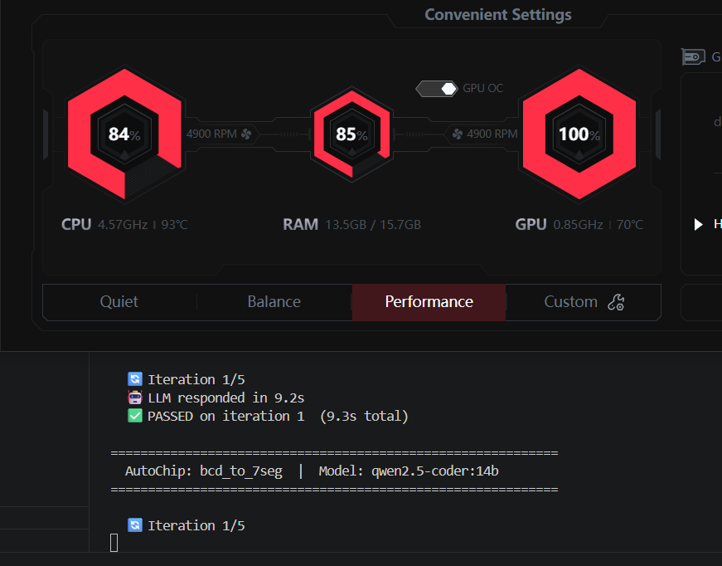

Tenstorrent's, deployed through the tt-inference-server inference, provide a purpose-built AI inference pipeline with dedicated SRAM per chip and a software stack designed for sustained throughput workloads. The tt-inference-server workflow README demonstrates a ready-made deployment pipeline for Qwen, Llama, and Mistral model families. On this hardware, 70B models can be served at production token rates without thermal throttling, making extended benchmark runs, synthesis-in-the-loop feedback, and eventually Verilator-based cycle-accurate simulation feasible as integrated evaluation steps.

8.2 What Needs to Change
- Tool-in-loop feedback: Yosys synthesis and Verilator cycle-accurate simulation need to be integrated into the feedback loop. This adds ~14,000 s of synthesis compute across the current benchmark alone - infeasible under CPU thermal throttling at 100 C.
- Larger models: 70B-class models (Qwen2.5-Coder-72B, LLaMA-3.3-70B) require ~40 GB VRAM even at Q4 - physically impossible on the 8 GB RTX 5060. These are the models most likely to break the current hard-ceiling failures.
- Expanded benchmark: A 40+ module suite covering AXI interfaces, DDR controllers, and multi-clock-domain logic would take 8-12 hours of continuous GPU utilisation - well beyond the laptop thermal budget.

Requirement | RTX 5060 (Current) | HPC Access | Tenstorrent Target
Run 70B+ models | 8 GB VRAM - impossible | 80 GB H100 needed; SLURM queue | Wormhole n300: dedicated SRAM, no VRAM limit
Sustained runs (90+ min) | CPU throttles to 100 C | Feasible but job-time limited | Dedicated ASIC; no CPU bottleneck
Yosys-in-loop feedback | ~14,000 s extra synthesis | Available but not interactive | Fast inference + parallel synthesis pipeline
40-module expanded suite | ~10 h; thermal risk | Feasible in batches | ~2-3 h at sustained throughput
Formal verification | Not feasible on laptop | Target capability only | Direct integration path
Multi-model parallel runs | Single GPU only | Single node only | Multi-chip Tenstorrent setup possible

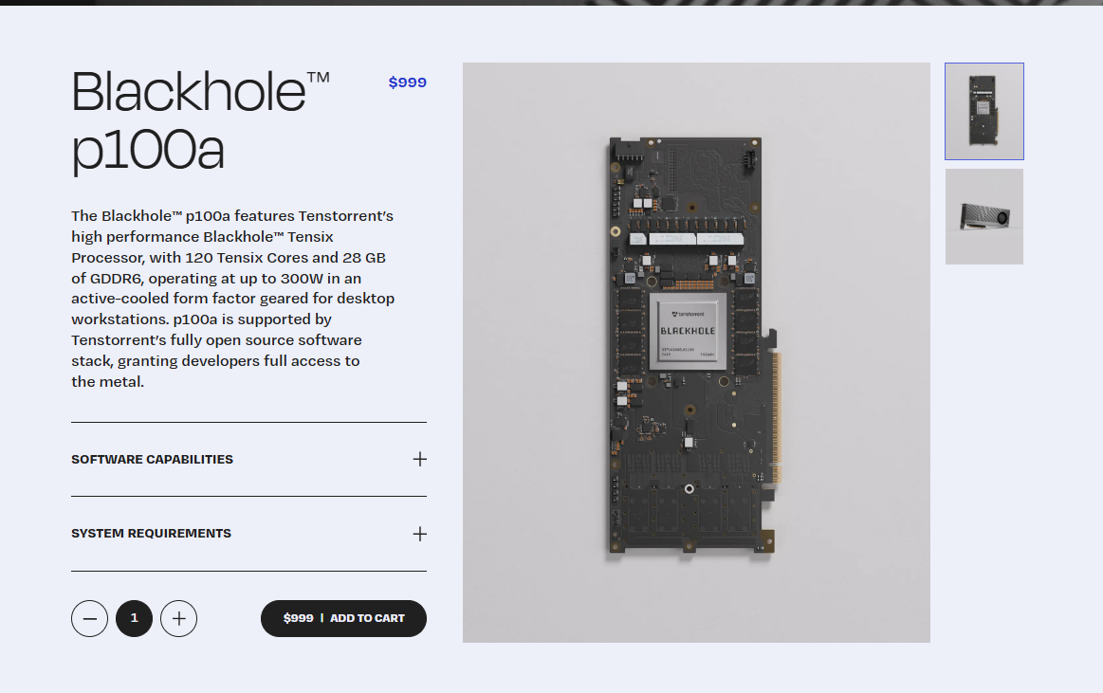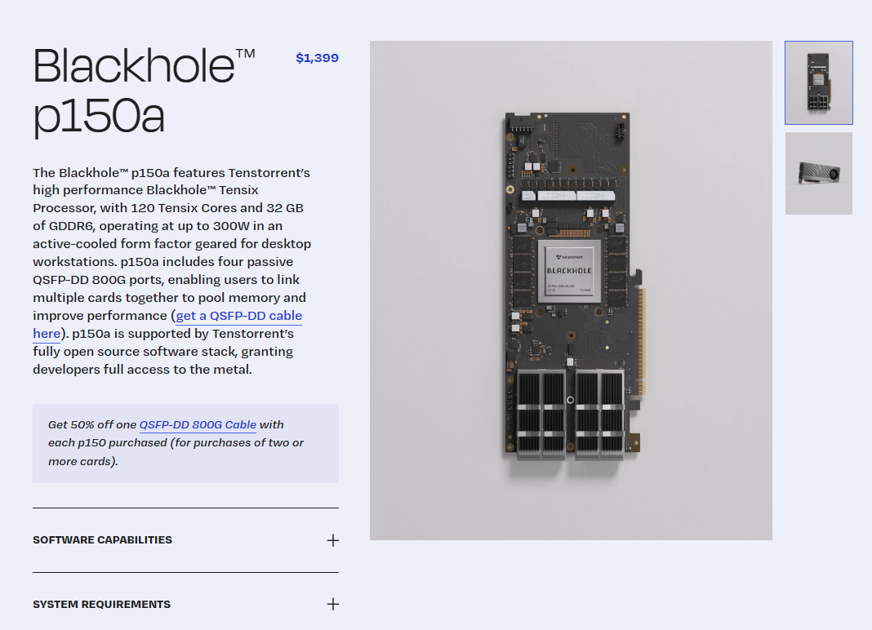

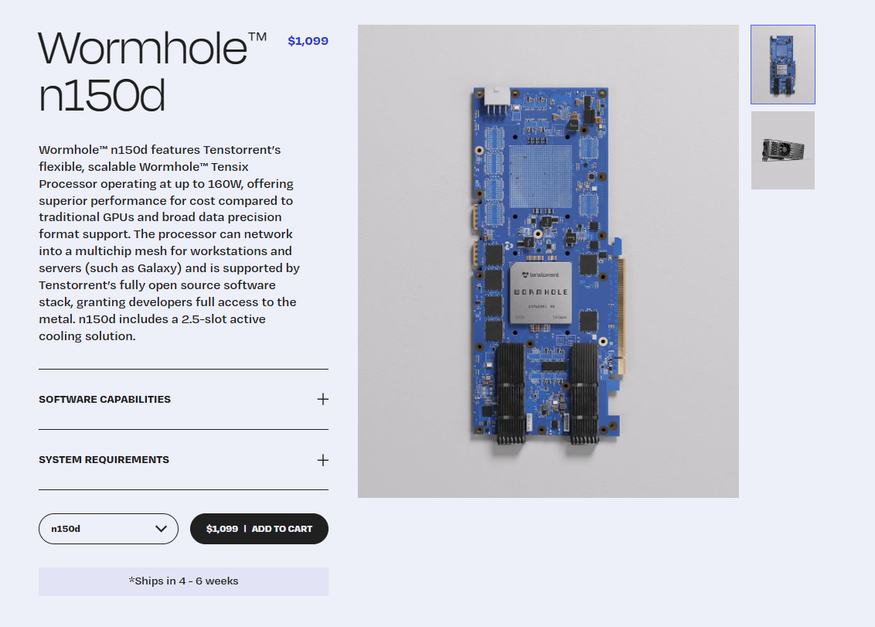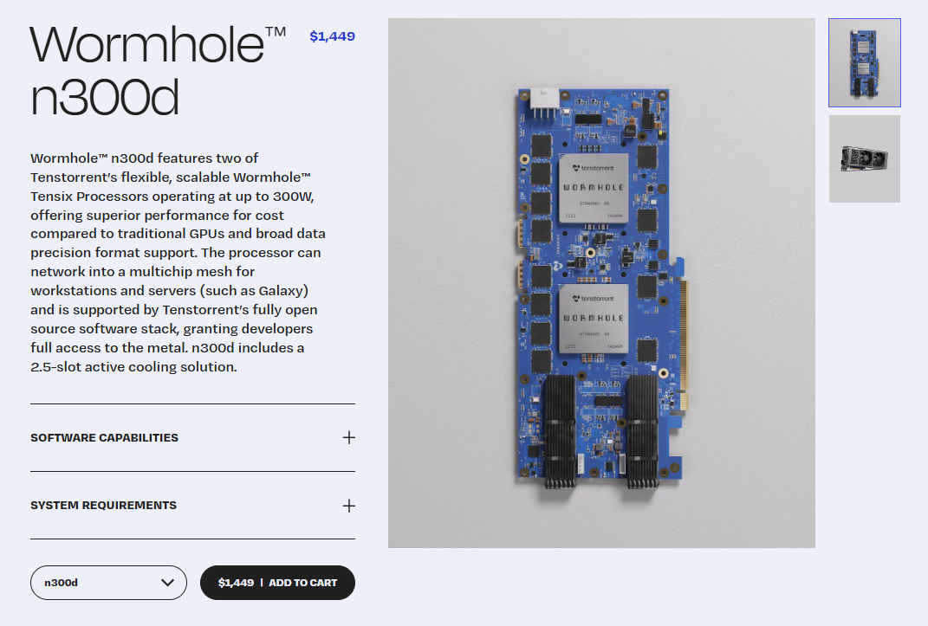

8.3 Why Tenstorrent Blackhole
The campus HPC cluster (Sharanga, BITS Pilani Hyderabad) provided access to V100-32GB and H100-80GB nodes for prior runs in this study. While those results were valuable, HPC access has structural limitations for iterative AI benchmarking research - and Tenstorrent Blackhole hardware addresses each of them directly.
- HPC is shared and scheduled: SLURM queue times, job-hour limits, and node contention mean HPC access cannot support the tight iterative debugging loop that AutoChip requires. A failed iteration at 2 AM cannot wait for the next available job slot. Tenstorrent hardware, owned and on-premises, is always available.
- Purpose-built AI silicon: The Tenstorrent Blackhole p150a features 120 Tensix Cores, 32 GB GDDR6, and critically 180 MB of on-chip SRAM per card. This dedicated on-chip SRAM dramatically reduces DRAM bandwidth pressure during inference - the primary bottleneck for autoregressive token generation on NVIDIA GPUs. At 664 TFLOPS (BLOCKFP8) over PCIe 5.0 x16, the Blackhole architecture is designed specifically for AI inference throughput, not general-purpose CUDA compute.
- Open software stack: Unlike NVIDIA's proprietary CUDA ecosystem, Tenstorrent ships a fully open-source software stack (TT-Metalium, TT-Buda) with developer-level access to the metal. The tt-inference-server exposes an OpenAI-compatible /v1/chat/completions endpoint - meaning autochip_runner.py requires zero code changes to switch from Ollama to a Blackhole-hosted 70B model. Qwen, LLaMA, and Mistral families are all supported in the workflow documentation.
- Multi-card memory pooling: The p150a variant includes four QSFP-DD 800G ports, allowing multiple cards to be linked and their memory pooled. Two p150a cards give 64 GB of pooled GDDR6 - sufficient for a 70B model at int8 - without requiring a full datacenter node. This is a capability the campus HPC A100/H100 nodes only offer through SLURM multi-GPU job allocation, not as a permanently available local resource.
- No thermal throttle, no CPU bottleneck: The deepseek-coder:6.7b run in this study hit 100 C CPU junction temperature over 97.9 minutes on a laptop. On a Blackhole card, all model computation offloads to the Tensix cores - the host CPU handles only I/O. Benchmark runs of 8-12 hours, Yosys synthesis pipelines, and parallel model evaluations become thermally feasible on a lab workstation.
- Broader campus benefit: A Tenstorrent card in the lab would also serve as a shared local inference resource for other research groups on campus working with large language models, reducing dependence on paid API access and HPC queues across departments.

Card | Gen | Cores | VRAM | TDP | Interconnect | Price | Relevance to AutoChip Work
Wormhole n150d | Wormhole (prev-gen) | 64 | 12 GB GDDR6 | 160 W | 2x QSFP-DD 200G | $1,099 | Entry point for Tenstorrent stack; limited VRAM for models > 7B. Good for driver/SDK familiarisation.
Wormhole n300d | Wormhole (prev-gen) | 128 (dual-chip) | 24 GB GDDR6 | 300 W | 2x QSFP-DD 200G | $1,449 | Fits 13B models at fp16; still Wormhole arch. Useful as mid-tier comparison baseline.
Blackhole p100a | Blackhole (current gen, 6 nm) | 120 | 28 GB GDDR6 | 300 W | None (no scale-out) | $999 | Most affordable Blackhole entry; fits 13B at fp16 or 30B at int8. Lacks 800G ports so cannot pool memory.
Blackhole p150a | Blackhole (current gen, 6 nm) | 140 | 32 GB GDDR6 +180 MB on-chip SRAM | 300 W | 4x QSFP-DD 800G (2 m cables) | $1,399 | Primary target. 32 GB fits 30B at fp16 or 70B at int4. Two cards pool to 64 GB for 70B int8. tt-inference-server supports Llama/Qwen/Mistral. autochip_runner.py needs zero changes.
Blackhole p150b | Blackhole (current gen, 6 nm) | 140 | 32 GB GDDR6 | 300 W | 4x QSFP-DD 800G | $1,399 | Rack-server passive-cooled variant of p150a. Same performance; requires forced airflow. Not suited for desktop lab use.
Blackhole p300 | Blackhole (current gen, 6 nm) | 280 (dual-chip) | 64 GB GDDR6 | ~600 W | 4x QSFP-DD 800G per chip | TBD | Dual-chip flagship. 64 GB on a single card enables full 70B at fp16 without cabling. Higher cost; suitable for cluster build-out.

All cards share Tenstorrent’s open-source software stack (TT-Metalium, TT-Buda) and the tt-inference-server, which exposes an OpenAI-compatible endpoint that integrates directly with autochip_runner.py without code changes.

