Oracle Virtual Box Manager

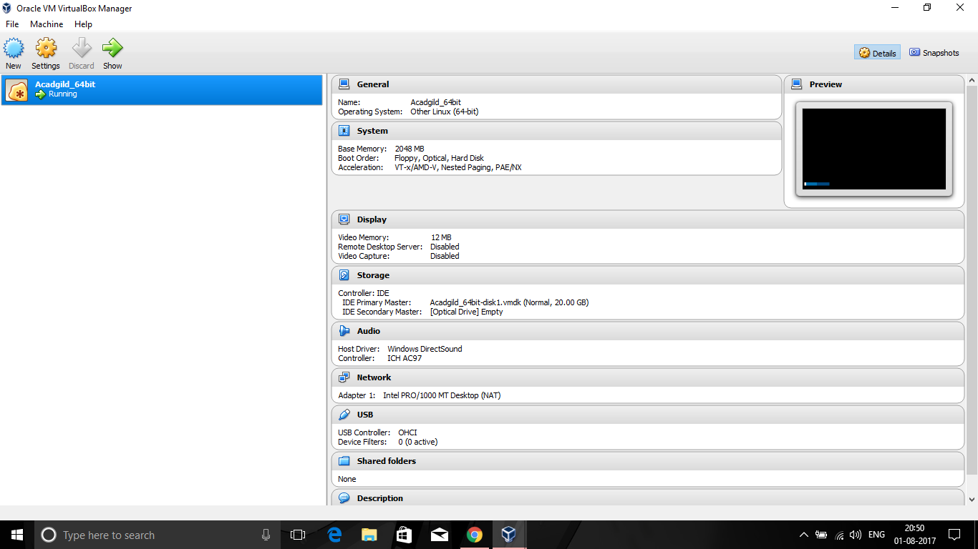

AcadGild Virtual Box

