Created a directory hadoop in hdfs

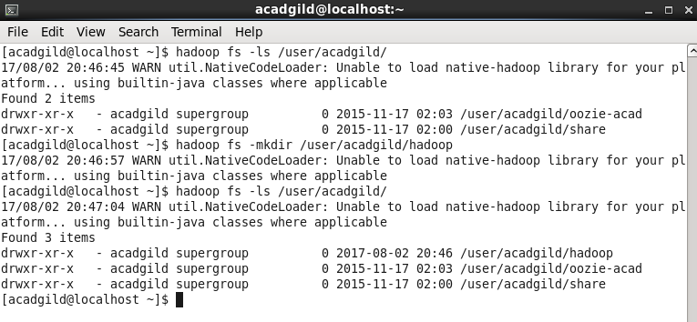Created word-count.txt file

