Created a file max-temp.txt and moved it to hdfs

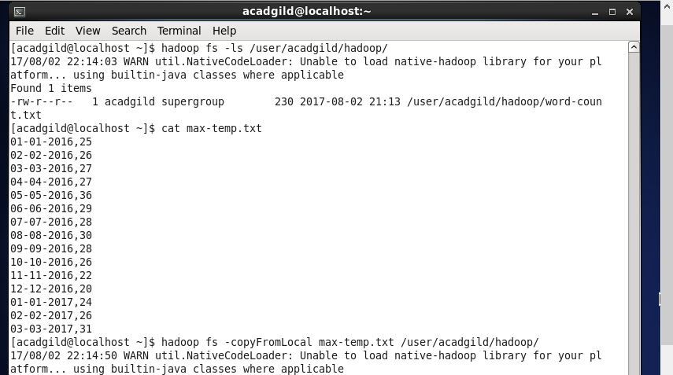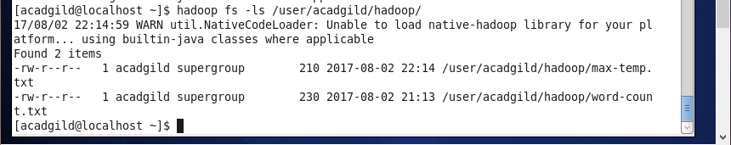

Changed the permission of the file /user/acadgild/hadoop/max-temp.txt

