PUMPGURU
Modbus Monitoring, Web Dashboard &
Report Generation System
Technical Design Document & Datasheet

Document Version: 1.0
Date: August 24, 2026
Classification: Internal / Technical Reference

Table of Contents

1. Introduction & Purpose
This document describes the complete technical design, architecture, and operating procedures for the PUMPGURU Monitoring, Web Dashboard, and Report Generation System. PUMPGURU is a pump starter and protection controller providing built-in fault detection for Dry Run, Soft Start-Off, Over/Under Voltage, Over/Under Current, Phase Detection, and related alarm conditions.
The system described here connects to a PUMPGURU device over Modbus RTU (RS485), continuously acquires all protection and measurement data, stores a complete history, presents that data through a live web dashboard accessible from any device on the local network, and generates detailed Excel-based analysis reports on demand.

1.1 Scope
This document covers:
- System and software block diagrams
- Complete technical datasheet (electrical, communication, and software specifications)
- Step-by-step installation, configuration, and commissioning process
- Full web application program structure and source code reference
- Report generation logic and output specification
- Troubleshooting and maintenance guidance

1.2 Intended Audience
This document is written for both technical/engineering personnel (electrical engineers, automation engineers, software integrators) who will install and maintain the system, and for general technical stakeholders who need to understand system capability and data flow.
Important — Register Map Dependency
PUMPGURU's Modbus register addresses are manufacturer- and firmware-specific. This document uses representative/placeholder addresses (see Section 4.4) until confirmed against the official PUMPGURU communication manual or the register scanner utility described in Section 6.5. All software described here reads addresses from a single configuration file, so the real register map can be substituted without changing any other code.

2. System Block Diagram
The diagram below shows the complete signal and data path: from the pump motor and its sensing elements, through the PUMPGURU controller, across the RS485 communication link, into the host application, and out to the web browser used for monitoring.
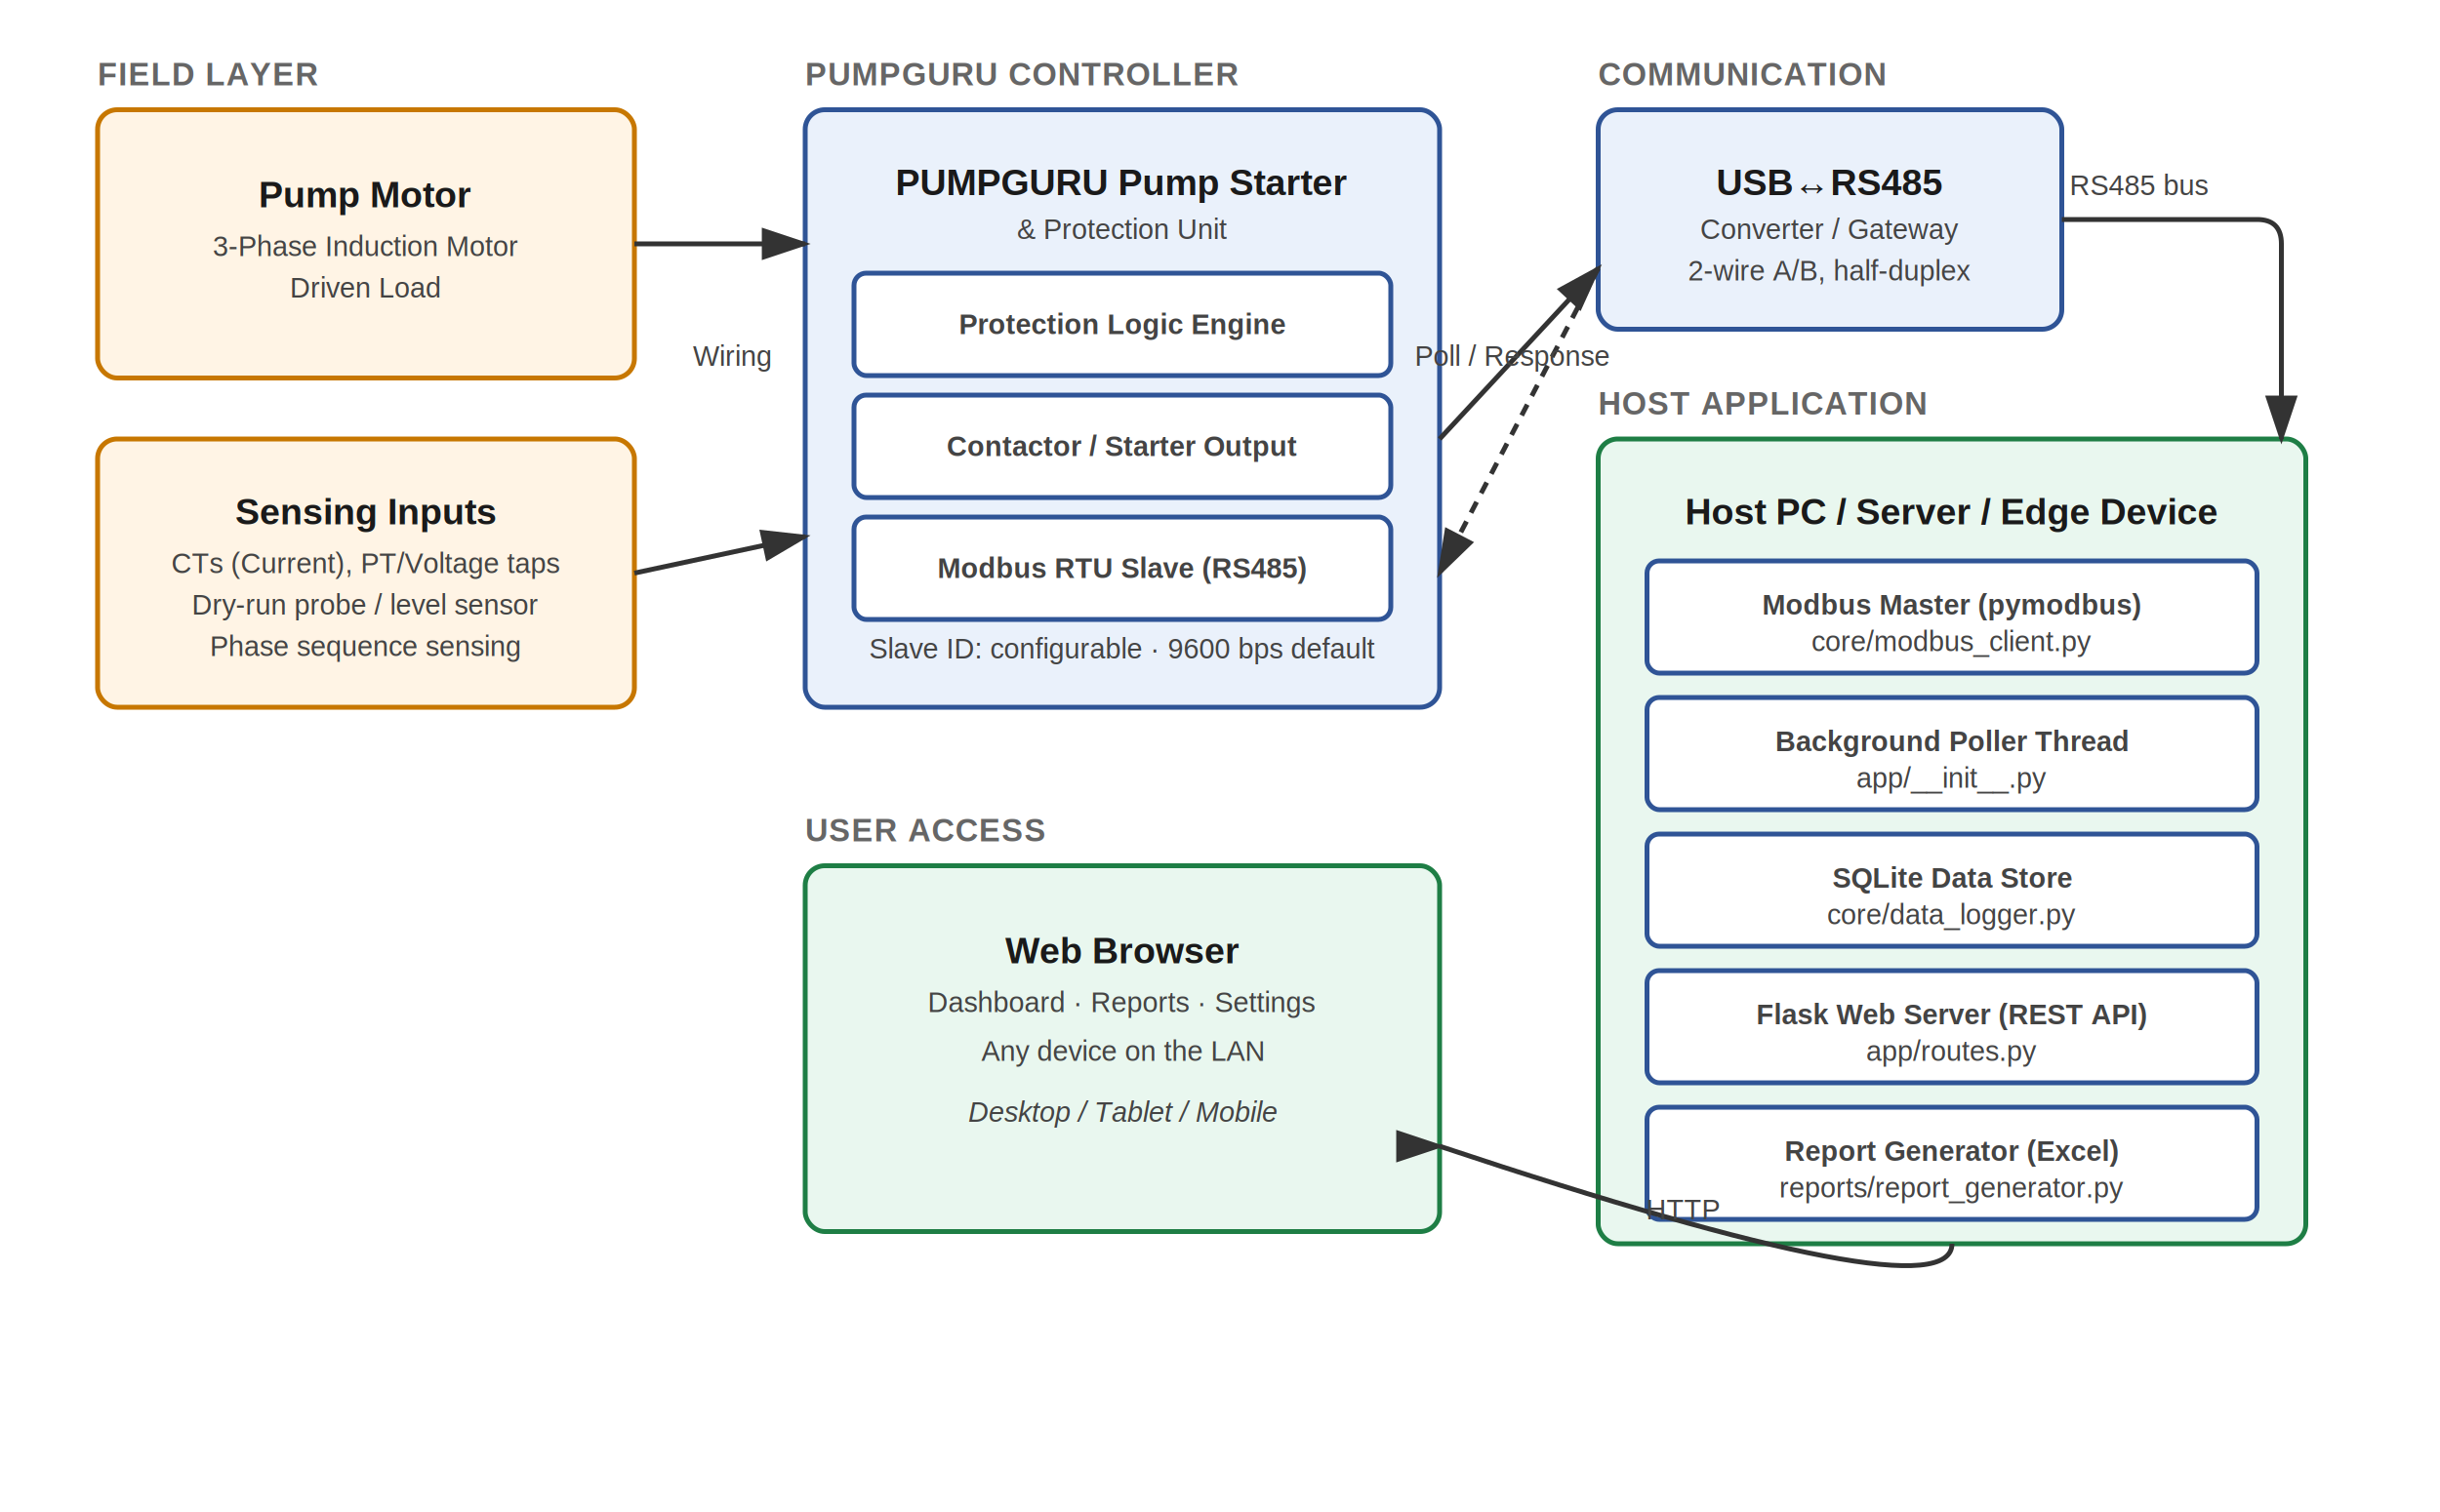
Figure 1 — Overall System Block Diagram

2.1 Layer Description
Layer | Function | Key Components
Field Layer | Physical sensing at the motor | 3-phase motor, current transformers, voltage taps, dry-run probe, phase sequence sensing
PUMPGURU Controller | Protection logic and switching | Protection logic engine, contactor/starter output, Modbus RTU slave interface
Communication | Physical link to host | USB-to-RS485 converter, 2-wire A/B differential bus
Host Application | Data acquisition, storage, serving | Modbus master, background poller, SQLite store, Flask REST API, report generator
User Access | Presentation / interaction | Web browser dashboard, reports page, settings page

3. Software Architecture
The application is organized into four layers, each with a single responsibility. This separation means the register map can change, the storage engine can be swapped, or the UI can be redesigned, without cascading changes through the rest of the codebase.
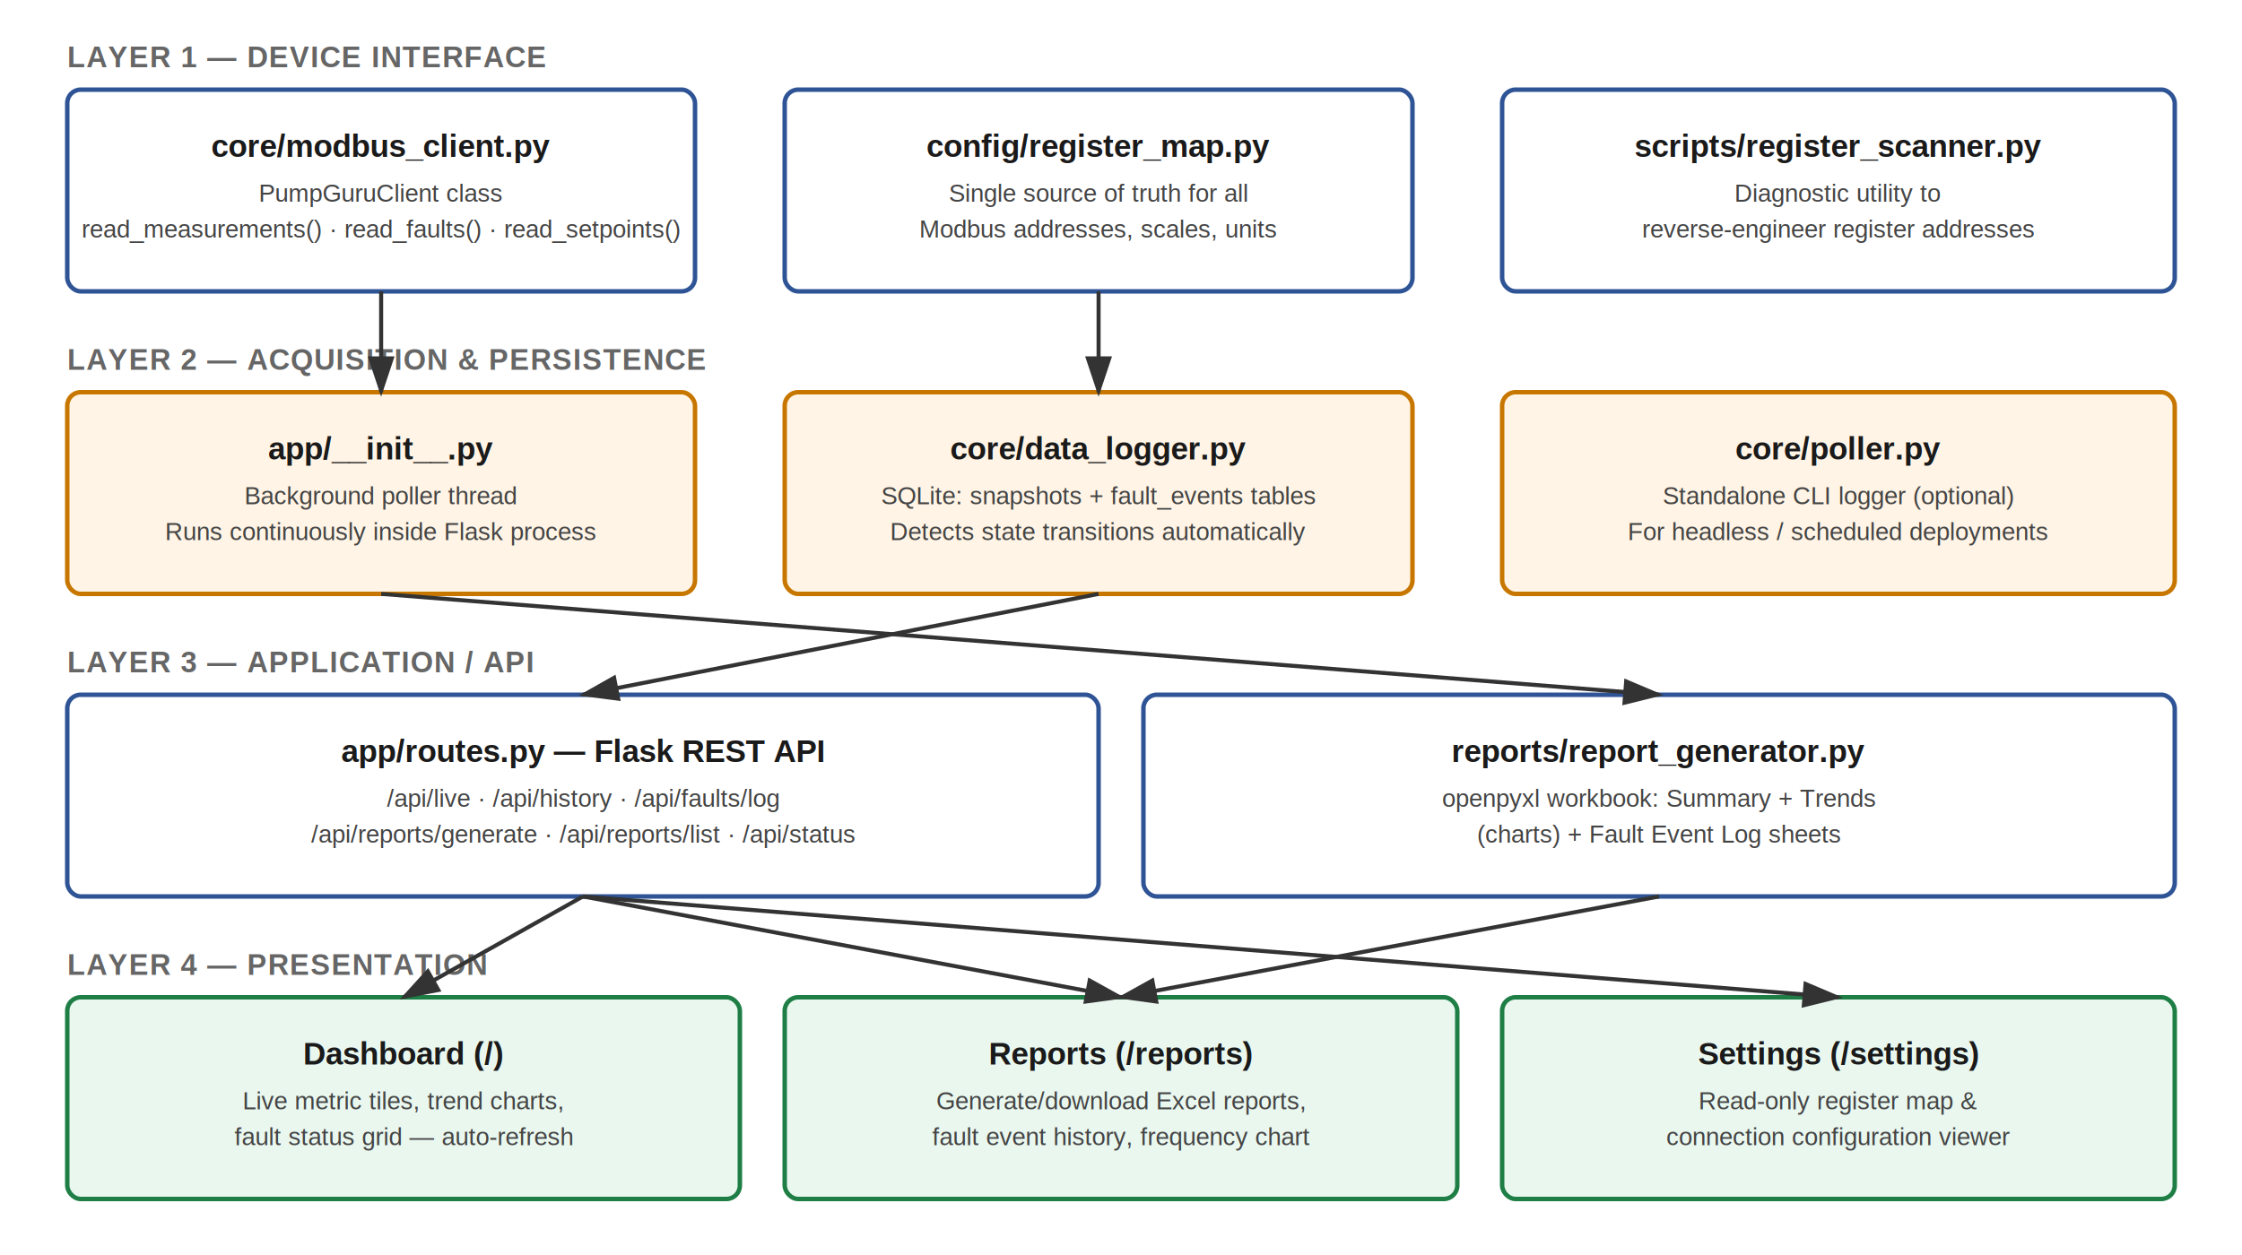
Figure 2 — Software Architecture / Module Diagram

3.1 Layer Responsibilities
Layer | Module(s) | Responsibility
1. Device Interface | modbus_client.py, register_map.py, register_scanner.py | Raw Modbus communication, register decoding, address configuration
2. Acquisition & Persistence | app/__init__.py (poller thread), data_logger.py, poller.py | Continuous polling, in-memory state, SQLite history, fault transition detection
3. Application / API | routes.py, report_generator.py | REST endpoints, business logic, Excel report generation
4. Presentation | templates/*.html, static/css, static/js | Dashboard, reports, and settings pages rendered in-browser

4. Data Flow — Sequence Diagram
The sequence diagram below traces one complete poll cycle: the background thread requests data from PUMPGURU over Modbus, decodes and stores it, and the browser independently retrieves the latest data and historical trends over HTTP.
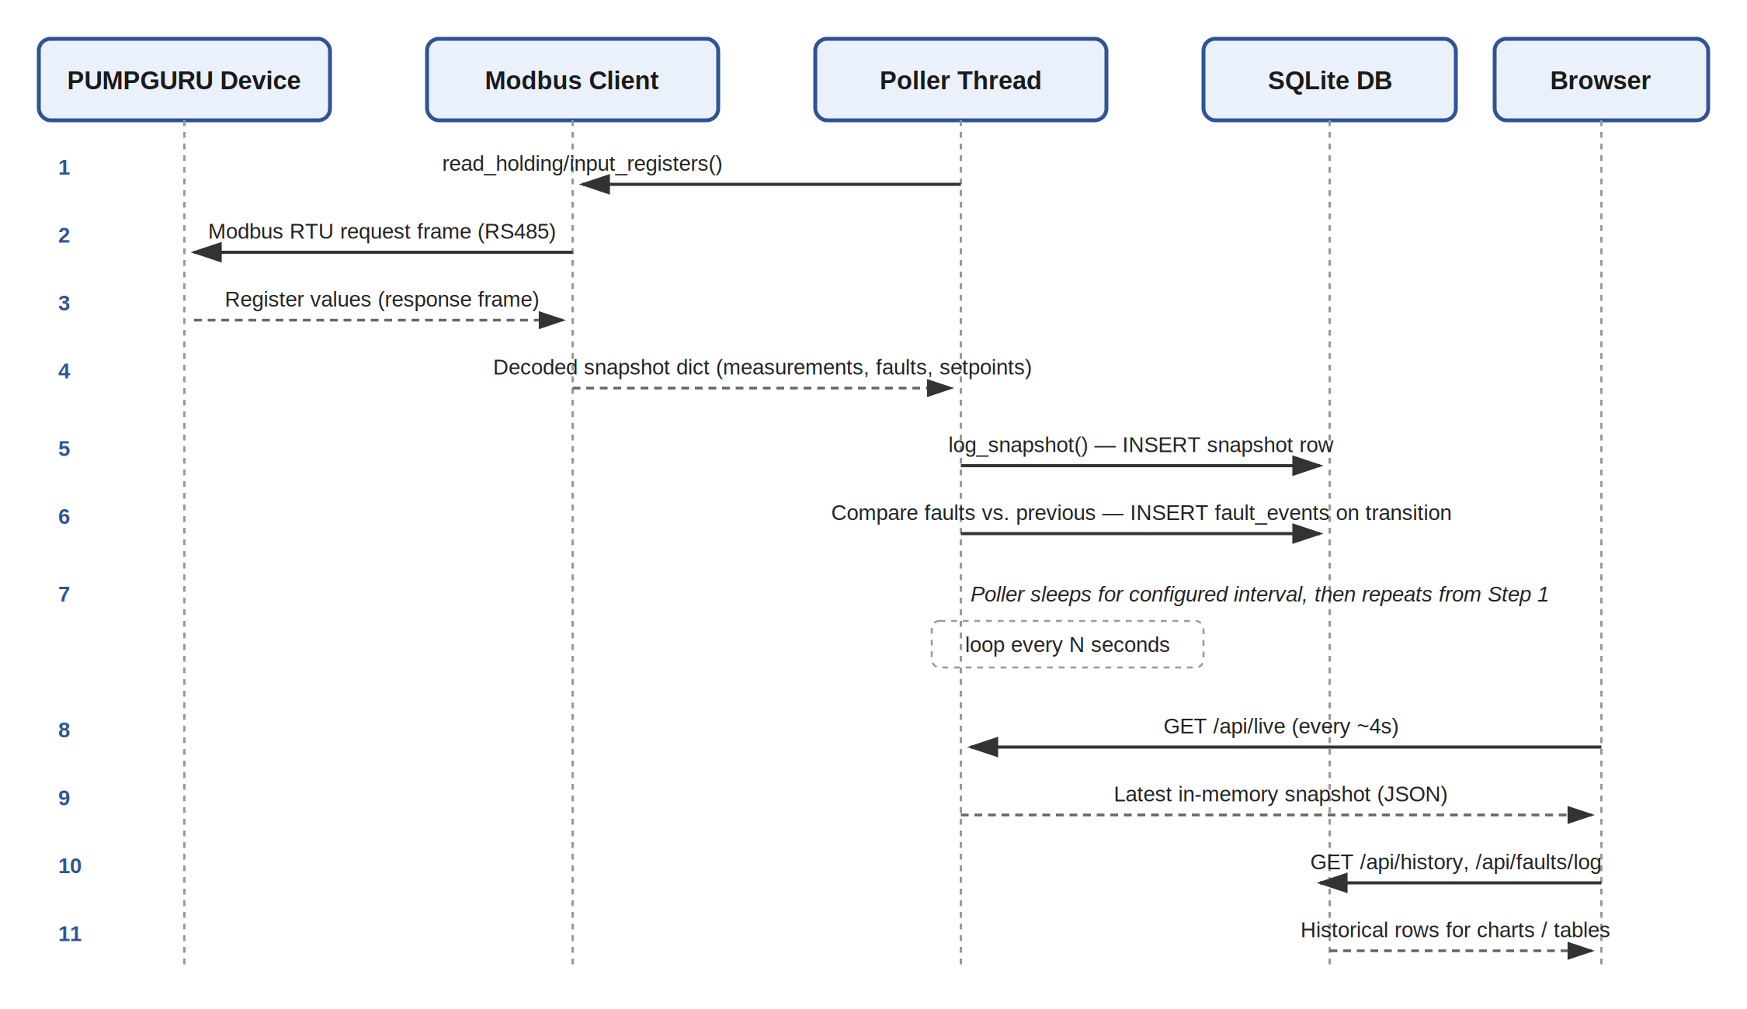
Figure 3 — Poll Cycle & Browser Data Retrieval Sequence

4.1 Sequence Notes
- The poller thread runs independently of any browser connection — data collection continues even with no dashboard open.
- The browser never talks to the PUMPGURU device directly; all access is mediated through the Flask REST API.
- Fault transitions (OK→ACTIVE or ACTIVE→OK) are detected by comparing each new snapshot's fault flags against the previous snapshot, and logged as discrete events for the fault log and report.
- Default poll interval is 5 seconds (configurable); browser dashboard refresh is 4 seconds for live tiles and 15 seconds for trend charts.

5. Technical Datasheet

5.1 Communication Interface Specification
Parameter | Specification
Protocol | Modbus RTU
Physical Layer | RS485, 2-wire half-duplex
Default Baud Rate | 9600 bps (configurable: 1200–115200 typical range)
Data Bits | 8
Parity | None (configurable: None / Even / Odd)
Stop Bits | 1
Default Slave ID | 1 (configurable 1–247)
Host Connection | USB-to-RS485 converter (FTDI/CH340-class chipset recommended)
Function Codes Used | 0x03 (Read Holding Registers), 0x04 (Read Input Registers)
Poll Timeout | 1.0 second (configurable)

5.2 Measured Parameters
Parameter | Register Type | Data Type | Unit | Typical Range
Voltage R / Y / B | Input | uint16 (÷10) | V | 0 – 500
Current R / Y / B | Input | uint16 (÷10) | A | 0 – 999.9
Frequency | Input | uint16 (÷10) | Hz | 0 – 99.9
Power Factor | Input | uint16 (÷100) | — | 0.00 – 1.00
Motor Temperature | Input | uint16 (÷10) | °C | -40 – 200
Run Hours | Input | uint32 | hrs | 0 – 4,294,967,295
Start Count | Input | uint32 | starts | 0 – 4,294,967,295

5.3 Protection / Fault Parameters
Fault | Description | Typical Trigger Condition
Dry Run | No/insufficient water flow detected | Current below threshold for set delay, or level sensor input
Soft Start-Off | Soft-start sequence not completed / bypassed | Start ramp fault or bypass contactor failure
Over Voltage | Supply voltage above safe limit | Any phase exceeds configured over-voltage setpoint
Under Voltage | Supply voltage below safe limit | Any phase falls below configured under-voltage setpoint
Over Current | Motor current above safe limit | Any phase exceeds configured over-current setpoint
Under Current | Motor current below expected running level | May indicate dry run, broken coupling, or blocked flow
Phase Reverse | Incorrect phase rotation sequence | R-Y-B sequence detected as reversed at startup
Phase Failure | Loss of one or more supply phases | Missing phase voltage/current detected
Voltage Unbalance | Excessive imbalance between phase voltages | Deviation exceeds configured unbalance %
Current Unbalance | Excessive imbalance between phase currents | Deviation exceeds configured unbalance %

5.4 Configurable Setpoints
Setpoint | Unit | Purpose
Over Voltage Set | V | Trip threshold for over-voltage protection
Under Voltage Set | V | Trip threshold for under-voltage protection
Over Current Set | A | Trip threshold for over-current protection
Under Current Set | A | Trip threshold for under-current / dry-run assist
Dry Run Delay | sec | Confirmation delay before declaring a dry-run fault
Restart Delay | sec | Cool-down delay before automatic restart after a fault clears

5.5 Host / Software Requirements
Component | Requirement
Operating System | Windows 10/11, Linux (Ubuntu 20.04+), or macOS
Python Version | 3.9 or later
Key Python Packages | Flask, Flask-CORS, pymodbus, openpyxl
Browser Support | Any modern browser (Chrome, Edge, Firefox, Safari)
Network | LAN access to host machine; no internet required
Storage | SQLite (file-based, no external DB server required)
Minimum Hardware | Any PC/edge device capable of running Python 3.9+; Raspberry Pi 4 or better is sufficient

6. Step-by-Step Installation & Commissioning Process

6.1 Physical Wiring
- Identify the PUMPGURU device's Modbus RS485 terminals (typically labeled A/+ and B/− or D1/D2).
- Connect the RS485 terminals to a USB-to-RS485 converter using twisted-pair cable. Keep A-to-A and B-to-B polarity consistent.
- For runs longer than ~10 m or in electrically noisy environments, use shielded twisted-pair cable and ground the shield at one end only.
- If multiple Modbus devices share the same bus, add a 120Ω termination resistor at each physical end of the bus line.
- Connect the USB-to-RS485 converter to the host PC/server via USB.

6.2 Software Installation
- Install Python 3.9+ on the host machine if not already present.
- Extract the provided project folder (pumpguru_web) to a working directory.
- Open a terminal in that directory and install dependencies:
pip install flask flask-cors pymodbus pyserial openpyxl
- Verify the installation by running the connection test:
python core/modbus_client.py

6.3 Configure the Register Map
- Open config/register_map.py in a text editor.
- Update SERIAL_CONFIG with the correct COM port (Windows, e.g. COM3) or device path (Linux, e.g. /dev/ttyUSB0), baud rate, and Slave ID for your PUMPGURU unit — check the device's on-panel setup menu for these values.
- If you have the official PUMPGURU Modbus communication manual, update every entry in MEASUREMENT_REGISTERS, FAULT_REGISTERS, and SETPOINT_REGISTERS with the documented addresses.
- If no manual is available, proceed to Section 6.5 (Register Scanning) before continuing.

6.4 Confirm Device Communication
- With the device powered and wired, run the connection test script again: python core/modbus_client.py
- Confirm the returned JSON shows plausible voltage/current values matching the PUMPGURU's own front-panel display.
- If the connection fails, verify: (a) correct COM port, (b) correct baud rate/parity, (c) correct Slave ID, (d) A/B wiring polarity, (e) that no other application is holding the COM port open.

6.5 Register Scanning (if no manual is available)
- Run the scanner utility while the pump operates normally:
python scripts/register_scanner.py --start 0 --end 60 --type both
- With the scanner running, safely trigger each fault condition in turn (e.g., simulate dry-run by lowering the sensed water level, briefly disconnect one phase on a test rig) and observe which register address changes value.
- Record the address, register type (holding/input), and the observed before/after values for each fault and measurement.
- Transfer these findings into config/register_map.py, replacing the placeholder addresses.

6.5b Quick-Test Utility (fastest way to start testing)
A standalone diagnostic tool, tools/modbus_quick_test.py, is included for immediate testing against real hardware without any project setup, register map, or configuration file. It is the fastest way to confirm basic communication and to discover the real register map by watching which addresses change as faults are triggered.
pip install pymodbus pyserial
REM Basic connectivity test
python modbus_quick_test.py --port COM3 --baud 9600 --slave 1
REM Continuously watch registers 0-59 and highlight changes
python modbus_quick_test.py --port COM3 --slave 1 --start 0 --count 60 --watch
REM Unsure of baud rate? Try common rates automatically
python modbus_quick_test.py --port COM3 --slave 1 --autobaud
A pre-built Windows executable can also be produced with the included tools/build_exe.bat script (double-click on a Windows machine with Python installed) — this produces a single modbus_quick_test.exe file that runs on any Windows PC with no Python installation required, useful for field technicians or commissioning engineers without a development environment.

6.6 Launch the Web Application
- From the project root, start the application:
python run.py --port 5000 --interval 5
- To evaluate the interface without hardware connected, use simulation mode instead:
python run.py --simulate --port 5000
- Open a browser to http://localhost:5000 on the host machine, or http://<host-ip>:5000 from any other device on the same network.
- Confirm the connection badge in the sidebar shows "Connected" and that live values update on the Dashboard page.

6.7 Generate a Report
- Allow the system to run and collect data for the desired reporting period (minimum ~30 minutes recommended for a meaningful first report).
- Navigate to the Reports page in the web app.
- Select the report period (24 hours / 7 days / 30 days / 90 days) and click Generate Report.
- Download the generated .xlsx file from the Generated Reports table.

6.8 Ongoing Operation
- Leave the application running continuously (as a background process, scheduled task, or system service) to build up a complete history for reporting.
- The poller automatically attempts to reconnect if the RS485 connection is interrupted.
- Periodically archive or back up data/pumpguru.db if long-term historical retention is required beyond routine reporting.

7. Web Application — Program Reference
This section documents the complete web application: file structure, each module's role, the REST API contract, and how to run it. Full source code is included in the delivered project package (pumpguru_web/).

7.1 Project Structure
pumpguru_web/
├── run.py Entry point — starts Flask app + poller
├── app/
│ ├── __init__.py App factory, background poller thread
│ ├── routes.py REST API + page routes
│ ├── templates/
│ │ ├── base.html Shared layout / navigation
│ │ ├── dashboard.html Live dashboard page
│ │ ├── reports.html Report generation page
│ │ └── settings.html Register map / config viewer
│ └── static/
│ ├── css/style.css Application styling
│ └── js/common.js Shared client-side helpers
├── config/
│ └── register_map.py EDITABLE: all Modbus addresses & serial config
├── core/
│ ├── modbus_client.py Modbus RTU client (PumpGuruClient class)
│ ├── data_logger.py SQLite persistence layer
│ └── poller.py Standalone CLI poller (optional headless use)
├── reports/
│ ├── report_generator.py Excel report builder (openpyxl)
│ └── output/ Generated .xlsx files land here
├── scripts/
│ └── register_scanner.py Register reverse-engineering utility
├── tools/
│ ├── modbus_quick_test.py Standalone Modbus test CLI (no project setup needed)
│ └── build_exe.bat Builds modbus_quick_test.exe on Windows
└── data/
└── pumpguru.db SQLite database (created automatically)

7.2 REST API Reference
Method & Path | Description | Response
GET / | Serves the live dashboard page | HTML
GET /reports | Serves the reports page | HTML
GET /settings | Serves the settings / register map viewer | HTML
GET /api/live | Latest polled snapshot (measurements + faults + setpoints) | JSON
GET /api/status | Connection status, poll count, last error | JSON
GET /api/history?hours=N | Historical measurement series for charting | JSON
GET /api/faults/log?days=N | Fault event log (ACTIVE/CLEARED transitions) | JSON
GET /api/faults/summary?days=N | Fault occurrence counts by type | JSON
POST /api/reports/generate | Generates a new Excel report; body: {"days": N} | JSON (download_url)
GET /api/reports/list | Lists previously generated reports | JSON
GET /api/reports/download/<file> | Downloads a specific report file | File (.xlsx)

7.3 Key Module: core/modbus_client.py
The PumpGuruClient class wraps pymodbus and provides three high-level read methods that return clean, decoded Python dictionaries:
- read_measurements() — reads all analog values (voltage, current, frequency, temperature, etc.)
- read_faults() — reads all protection/alarm bits, automatically handling packed status-word bit fields
- read_setpoints() — reads configured protection thresholds
- read_all() — convenience method combining all three plus a timestamp, used by the poller
All decoding (scaling, signed/unsigned, 16-bit vs. 32-bit) is driven entirely by the metadata in config/register_map.py — no decoding logic is hardcoded per-parameter.

7.4 Key Module: core/data_logger.py
Implements a two-table SQLite schema:
Table | Columns | Purpose
snapshots | id, timestamp, measurements_json, faults_json, setpoints_json | One row per poll — full historical record
fault_events | id, timestamp, fault_name, state | One row per fault state transition (ACTIVE/CLEARED) — powers the event log and report

7.5 Key Module: app/__init__.py — Background Poller
A daemon thread started at application launch continuously polls the device (or generates simulated data in demo mode), updates an in-memory "latest snapshot" for instant API responses, and writes every snapshot to the database. This design means the REST API never blocks on live Modbus I/O — browser requests are always served from memory or the database, keeping the dashboard responsive even if a Modbus read is slow or times out.

7.6 Running in Simulation / Demo Mode
For UI evaluation, training, or development without physical hardware connected, launch with the --simulate flag. This substitutes a realistic random data generator for the Modbus client while leaving every other layer (storage, API, dashboard, reporting) fully exercised.
python run.py --simulate --interval 2 --port 5000

8. Report Generation — Technical Specification
Reports are generated as native Excel (.xlsx) workbooks using openpyxl, ensuring compatibility with Microsoft Excel, Google Sheets, and LibreOffice Calc without any proprietary viewer.

8.1 Report Structure
Sheet | Contents
Summary | Report period, total data points logged, snapshots with active faults, estimated fault-free uptime %, total fault events, and a fault-frequency breakdown table
Trends | Full time-series of voltage (R/Y/B), current (R/Y/B), frequency, and motor temperature, with embedded native Excel line charts for voltage and current
Fault Event Log | Every fault ACTIVE/CLEARED transition with timestamp; active-state rows are highlighted for rapid visual scanning

8.2 Report Generation Logic
The generate_report() function accepts a lookback period in days, queries all snapshots and fault events from that window via DataLogger, and computes:
- Uptime % = 100 × (1 − snapshots_with_any_active_fault / total_snapshots)
- Fault frequency = count of ACTIVE transitions per fault type, most-frequent first
- Trend series = every measurement value in chronological order, feeding native openpyxl LineChart objects bound to worksheet cell ranges (so charts remain live/editable if the user edits data in Excel)

8.3 Generating Reports Programmatically
Reports can also be generated outside the web UI via command line, useful for scheduled/automated reporting (e.g., a nightly cron job or Windows Task Scheduler entry):
python reports/report_generator.py --days 7 --output reports/output/weekly_report.xlsx

9. Troubleshooting Guide
Symptom | Likely Cause | Resolution
Connection badge shows "Disconnected" | Wrong COM port, baud rate, or Slave ID | Verify settings in config/register_map.py against the PUMPGURU's setup menu
Dashboard shows "--" for all values | Poller not yet completed first successful read | Check terminal/log output for Modbus errors; verify wiring polarity
Fault values never change from device's real state | Register map addresses are placeholders / incorrect | Run scripts/register_scanner.py to determine correct addresses (Section 6.5)
Values look scaled incorrectly (e.g., 10x too high) | Incorrect "scale" value in register_map.py | Adjust the scale factor for that parameter and re-test
Report generation fails with "No data available" | No snapshots logged yet for the selected period | Allow the poller to run longer, or select a shorter reporting period
Web app unreachable from another device on the network | Firewall blocking the port, or app bound to localhost only | Ensure run.py uses --host 0.0.0.0 (default) and allow the port through the host firewall
Serial port "access denied" / "in use" | Another program (e.g., PUMPGURU's own configuration software) has the port open | Close other software using the port before starting the web app

10. Appendix

10.1 Glossary
Term | Definition
Modbus RTU | A serial communication protocol using binary encoding over RS485/RS232, widely used in industrial automation
Holding Register | A 16-bit Modbus register type, typically read/write, often used for setpoints and configuration
Input Register | A 16-bit Modbus register type, typically read-only, often used for live measured values
Slave ID | The address (1–247) identifying a specific device on a shared Modbus bus
RS485 | A differential serial standard supporting multi-drop bus communication over long distances
Dry Run | A fault condition indicating the pump is operating without adequate liquid, risking damage
Soft Start | A motor-starting method that ramps up voltage/current gradually to reduce mechanical and electrical stress

10.2 Revision History
Version | Date | Description
1.0 | 2026-08-24 | Initial release — full system documentation, block diagrams, datasheet, and web application program reference

— End of Document —

