**11.AMLA:**

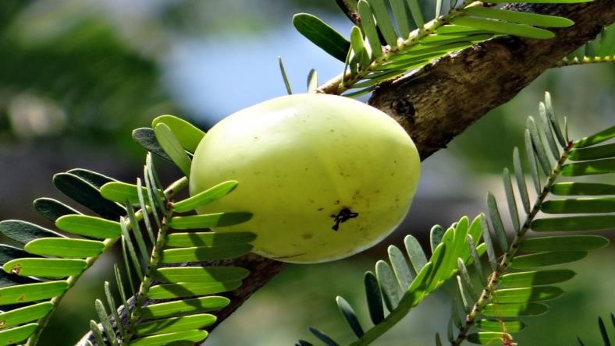

Amla fruit is often enjoyed pickled or candied. It’s also sometimes sold as a powdered supplement or consumed as a juice for a quick and convenient way to squeeze some extra nutrients into your diet.Amla juice is not only versatile and delicious but also highly nutritious and associated with a variety of health benefits

**.HEALTH BENIFTS:**

1.Promotes immune function

Amla juice is a great source of [vitamin C,](https://www.healthline.com/nutrition/vitamin-c-foods) which is a water-soluble vitamin that acts as an antioxidant .In fact, according to one review, amla is one of the richest sources of vitamin C, packing 600–700 mg of vitamin C into each fruit

1. Enhances liver health

Although research in humans is limited, some promising animal studies suggest that amla juice could help improve liver function. In one animal study, feeding amla to rats on a high fructose diet increased levels of several key proteins involved in metabolism, which could help prevent fructose-induced [fatty liver disease.](https://www.healthline.com/health/nonalcoholic-fatty-liver-disease)

1. Supports healthy digestion

Interestingly, some research shows that amla juice could offer several benefits for digestive health.

1. May increase hair growth

Amla is often used to [stimulate hair growth](https://www.healthline.com/health/what-makes-hair-grow) and protect against hair loss.