1. Exercise: Explore the relationship between the following, where x contains numbers from 1 to 100:

x and x^2

x and x^3

x + y = 101

xy = 500

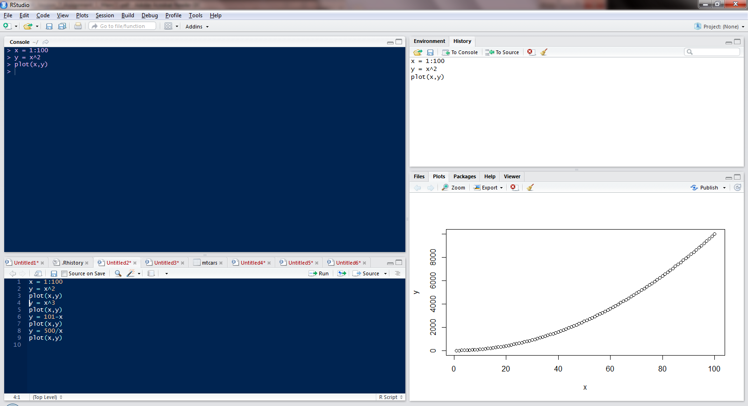

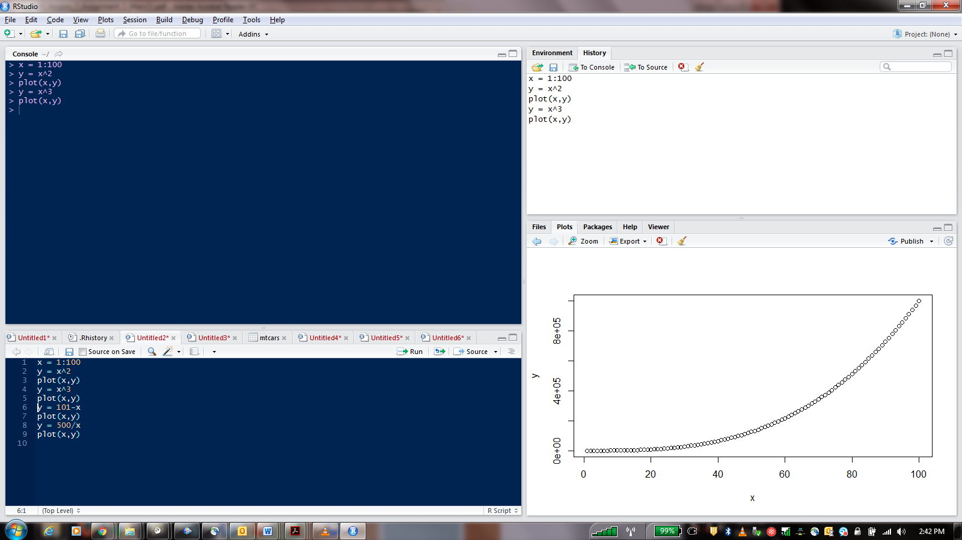 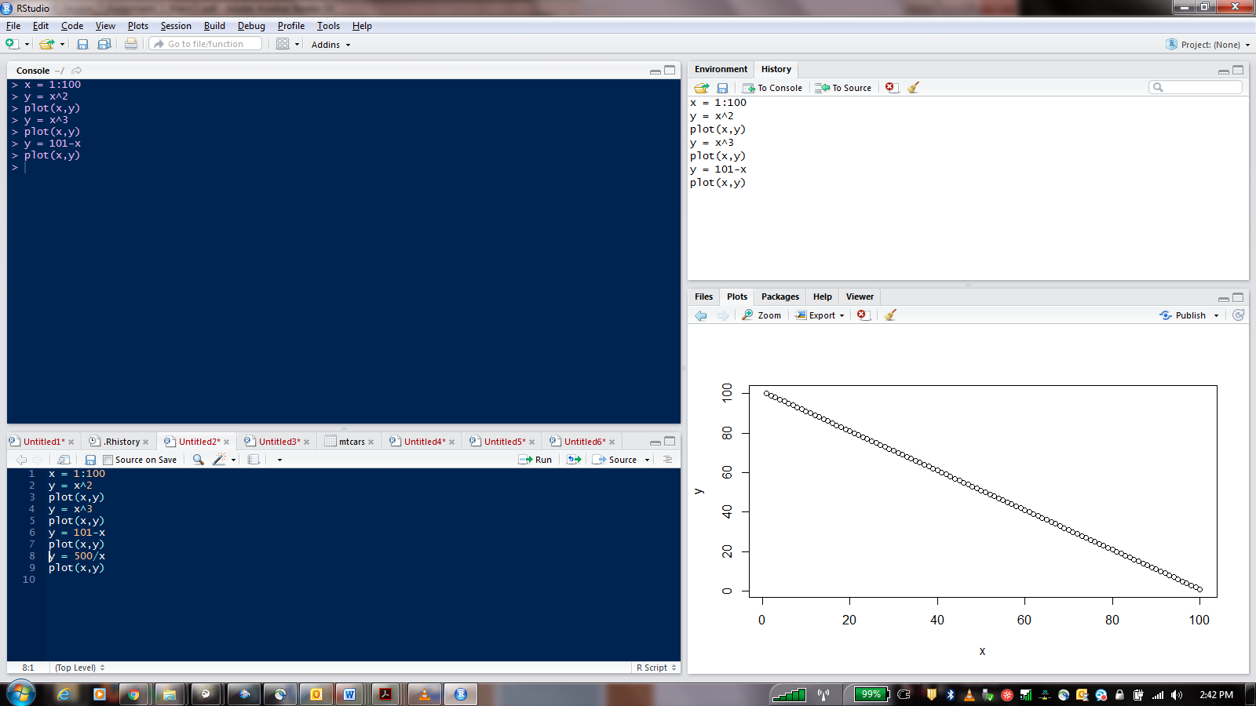 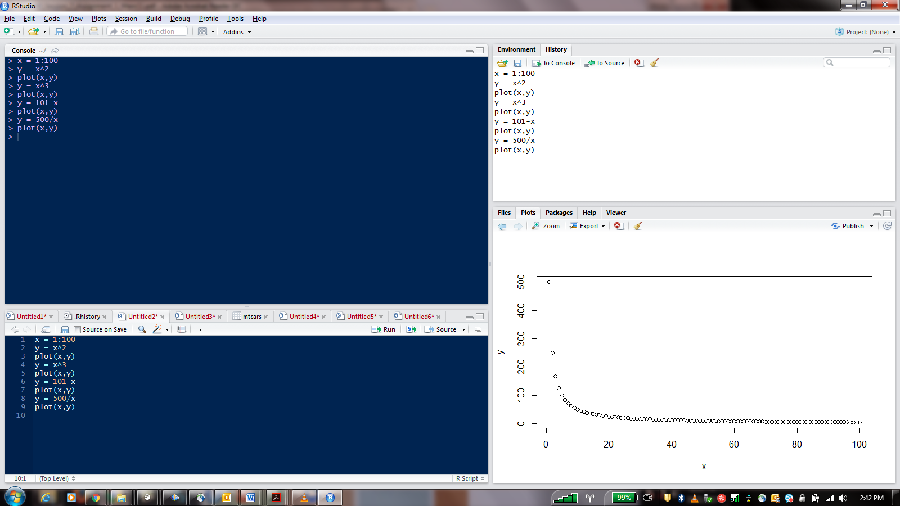

2. First we'll produce a very simple graph using the values in the car vector:

# Define the cars vector with 5 values

cars = c(1, 3, 6, 4, 9)

# Graph the cars vector with all defaults

plot(cars)

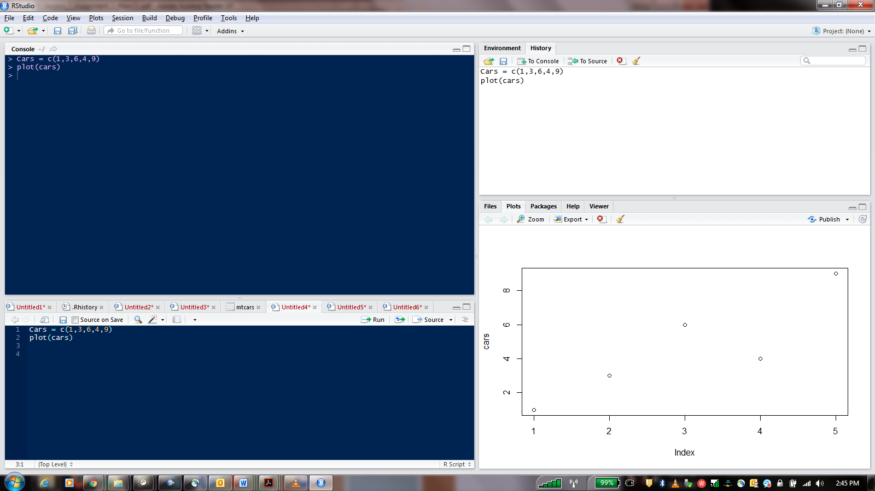

Let's add a title, a line to connect the points, and some color:

# Define the cars vector with 5 values

cars = c(1, 3, 6, 4, 9)

# Graph cars using blue points overlayed by a line

plot(cars, type="o", col="blue")

# Create a title with a red, bold/italic font

title(main="Autos", col.main="red", font.main=4)

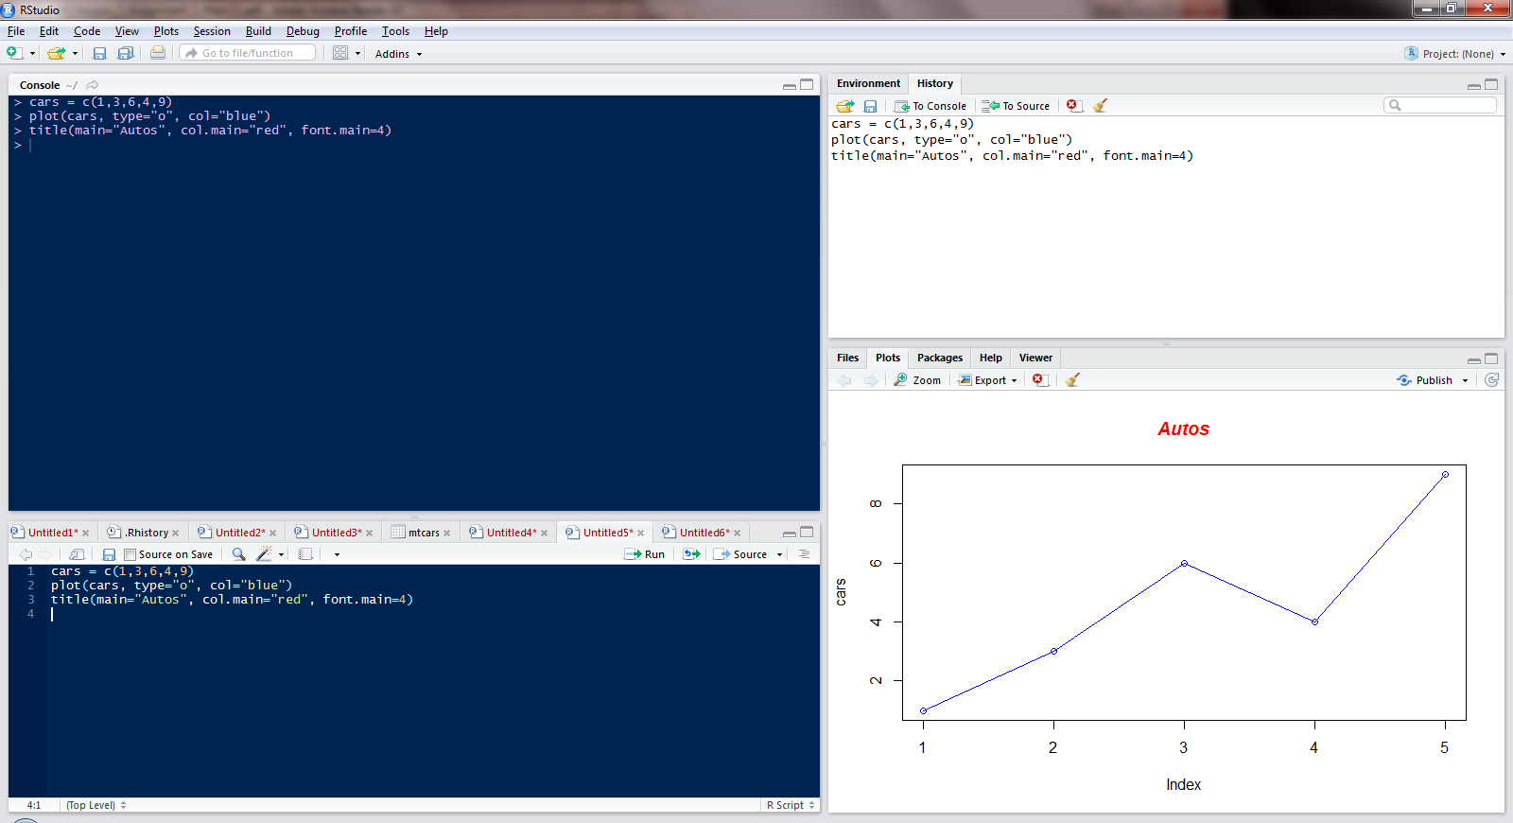

• Now let's add a red line for trucks and specify the y-axis range directly so it will be large enough to fit the truck data:

• # Define 2 vectors

cars = c(1, 3, 6, 4, 9) trucks = (2, 5, 4, 5, 12)

• # Graph cars using a y axis that ranges from 0 to 12

plot(cars, type="o", col="blue", ylim=c(0,12)

• # Graph trucks with red dashed line and square points

lines(trucks, type="o", pch=22, lty=2, col="red")

• # Create a title with a red, bold/italic font

title(main="Autos", col.main="red", font.main=4)

