1. Create a numerical vector to store the odd numbers between 1 to 100 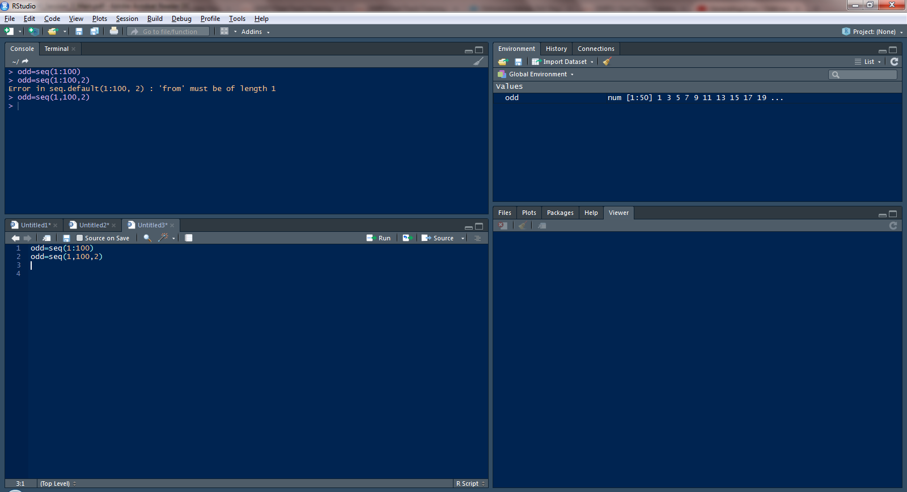

2. Create the numerical vector with following values

1,2,3,4,5,8,6,2,11

• Create 3x3 matrix from the vector

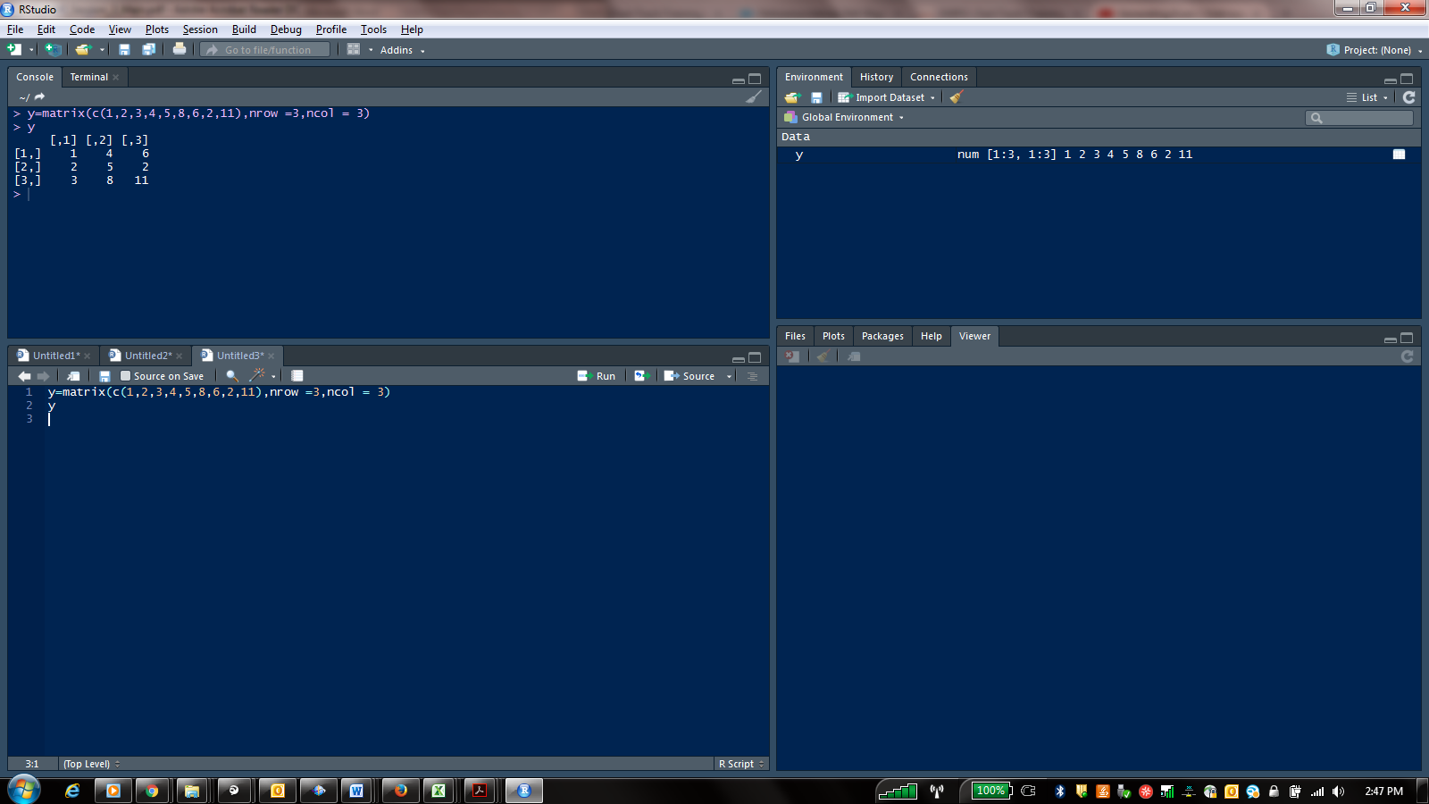

Consider the following vector a<-c(NA,11:15,NA,NA) remove all the NA and find the mean of the vector

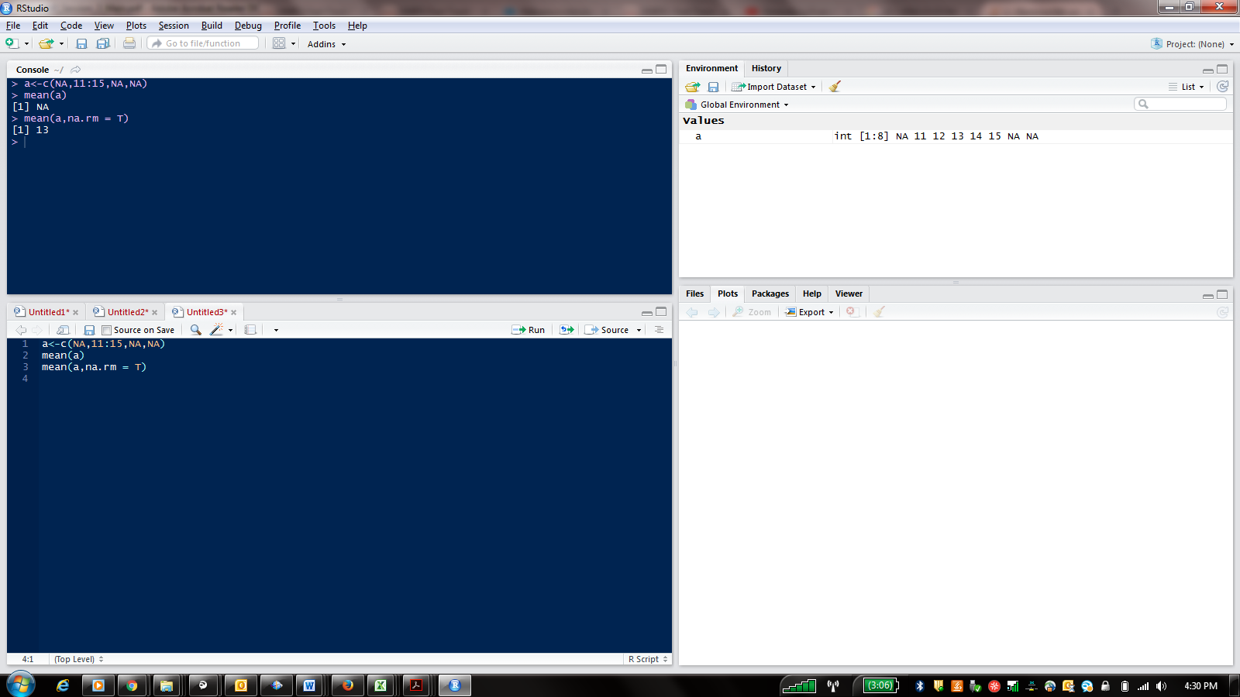

4. Consider the vector x=c(”apple”,”banana”,”grape”)

Replace the first occurrence of a with ‘$’

