1. <https://catalog.us-east-1.prod.workshops.aws/workshops/85cd2bb2-7f79-4e96-bdee-8078e469752a/en-US/introduction>

<https://www.youtube.com/watch?v=amiIcyt-J2A&ab_channel=TechTutorialswithPiyush>

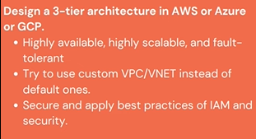

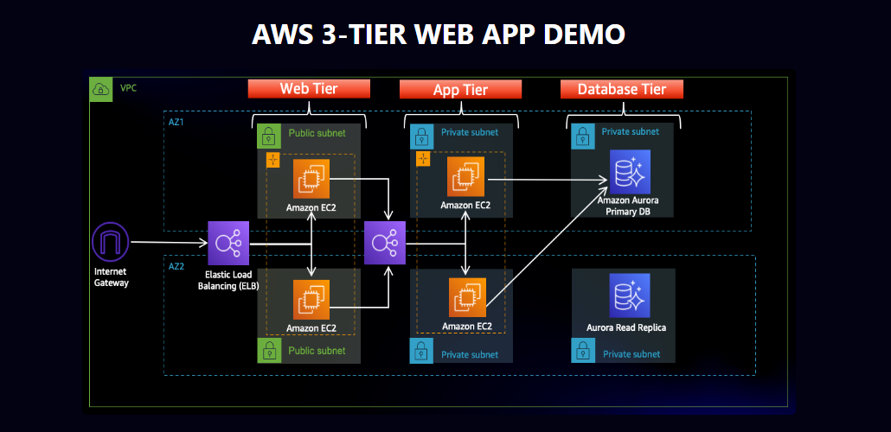

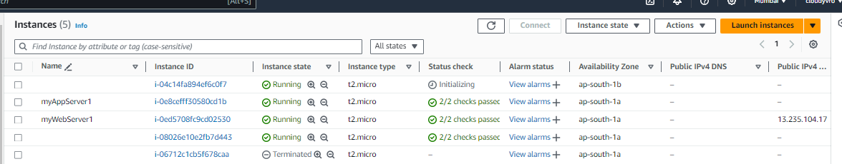

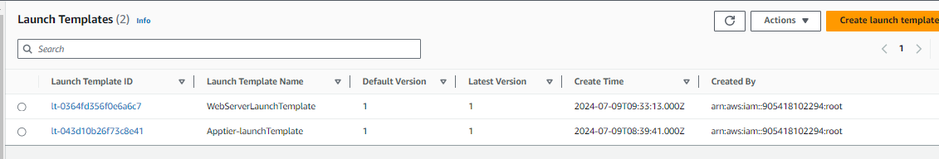

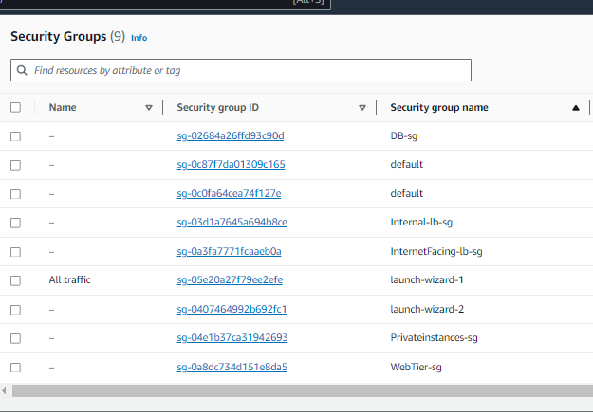

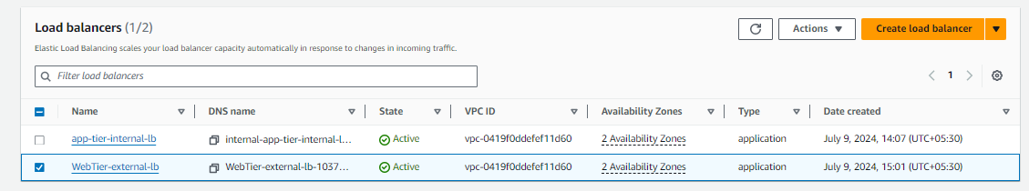

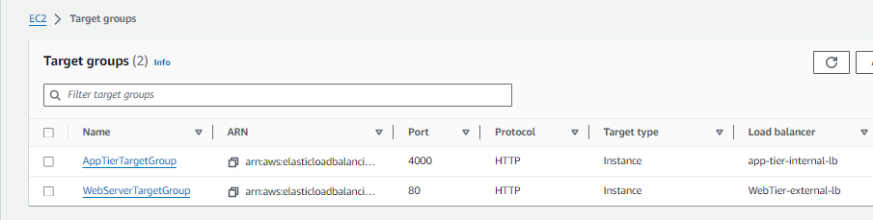

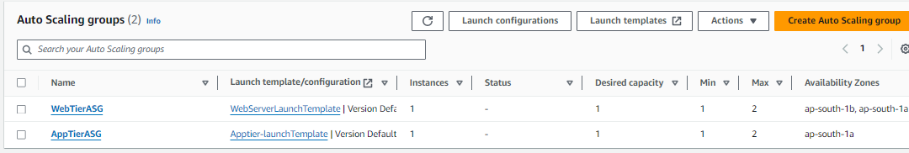

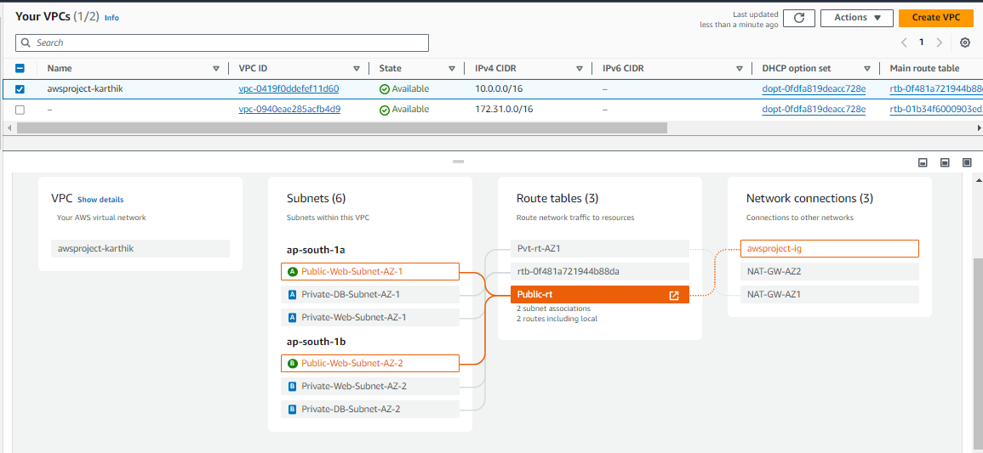

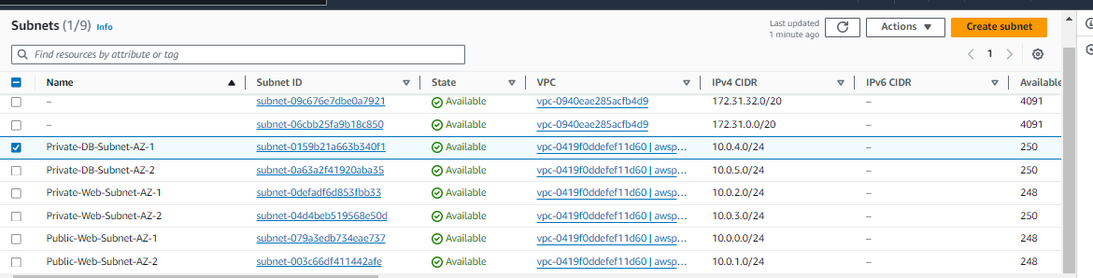

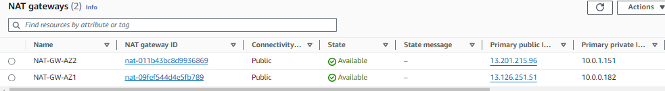

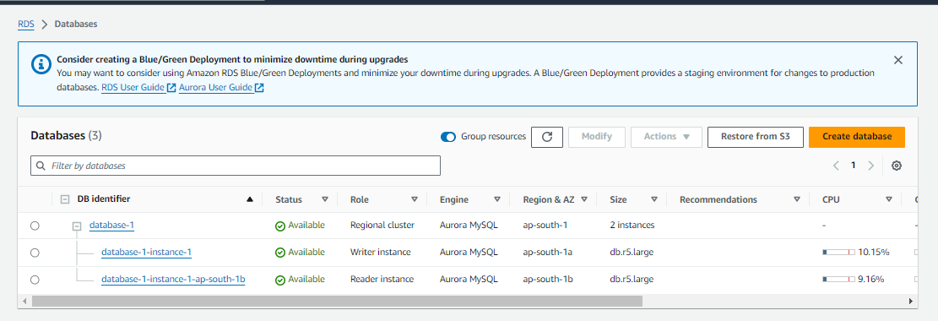

Master username

admin

Master password

OFlciTjdnz4468DM6vCA

