AWS Cloud Resume Challenge:

1. Create a bucket ‘myresume-karthik’ and upload all the folders and files of resume website

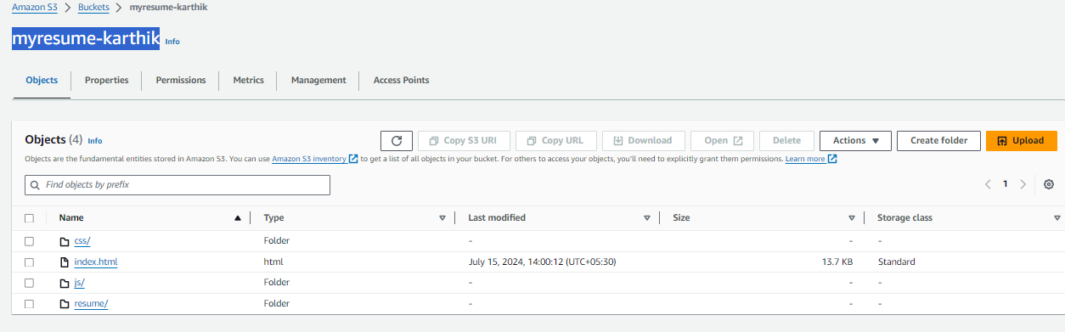

1. Create a Cloud Front distribution with the origin as S3 and update the policy provided by cloud front during distribution creation.

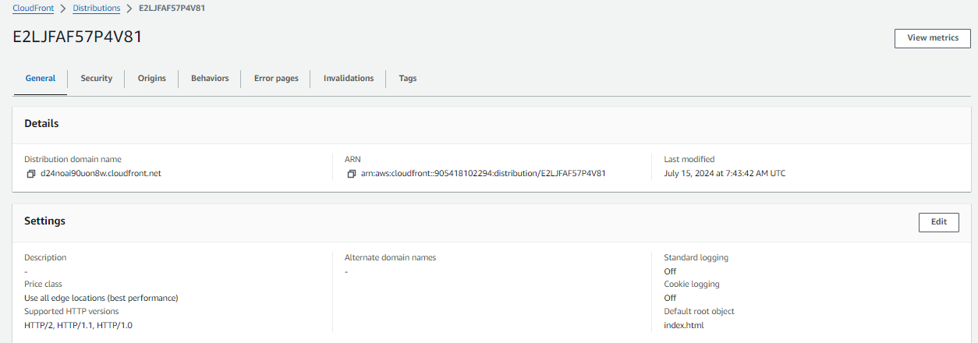

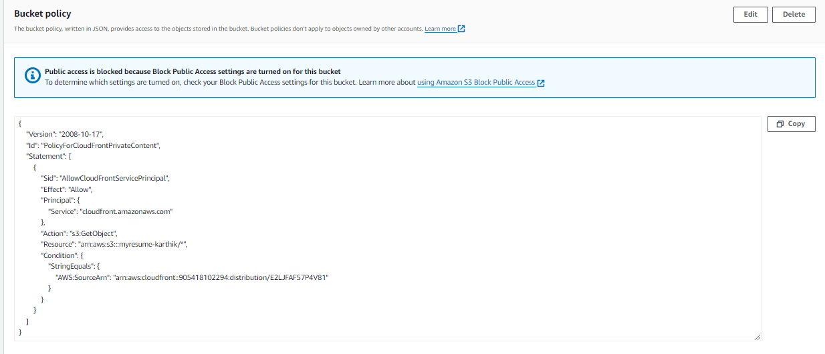

1. Create a lambda function with the code available in the “infra\lambda\lambda_function.py” and also give permission of dynamodb through role.

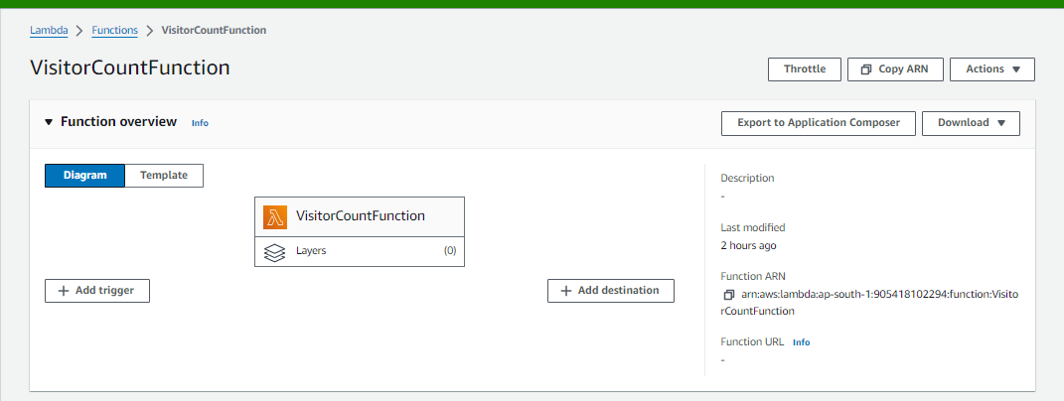

1. Test the lambda function with blank test cases

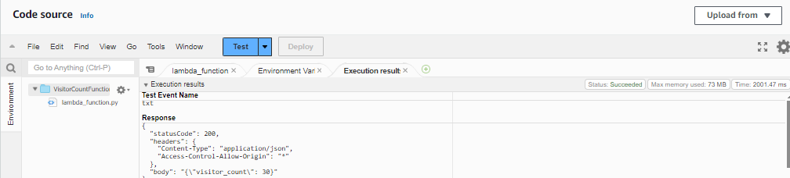

1. Create a DynamoDB table and item before testing the lambda function

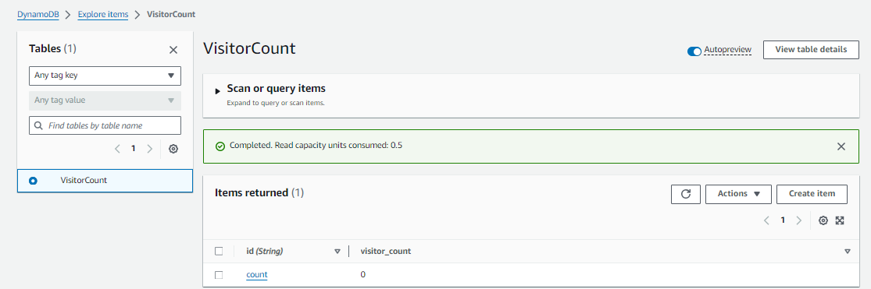

1. Create an API Gateway: <https://cfjcwlw8be.execute-api.ap-south-1.amazonaws.com/uat>

<https://cfjcwlw8be.execute-api.ap-south-1.amazonaws.com/uat/visitorcount>

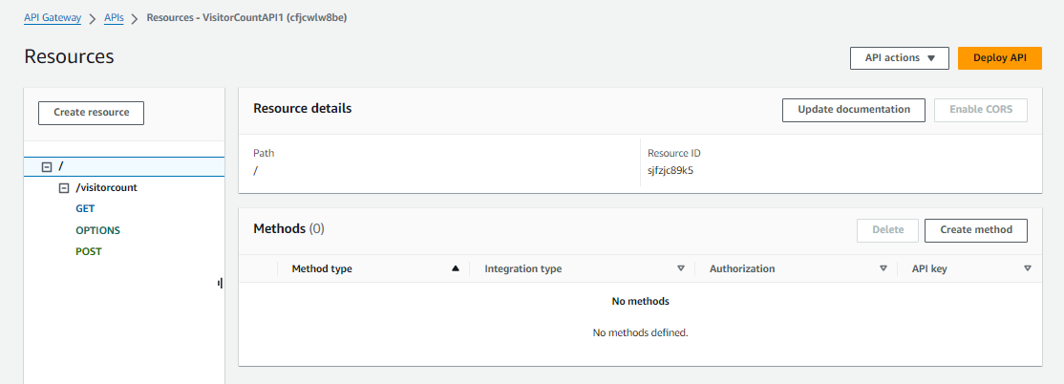

1. Add the API URL in html code as follows:  
   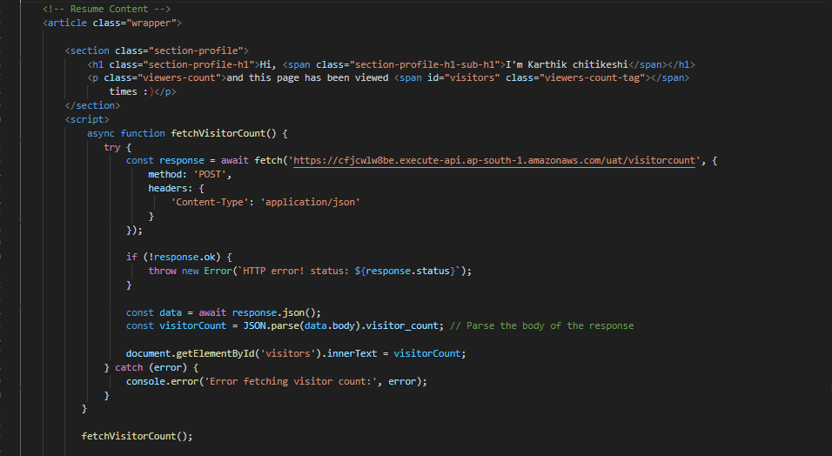
2. Now check the Cloud distribution url in the browser

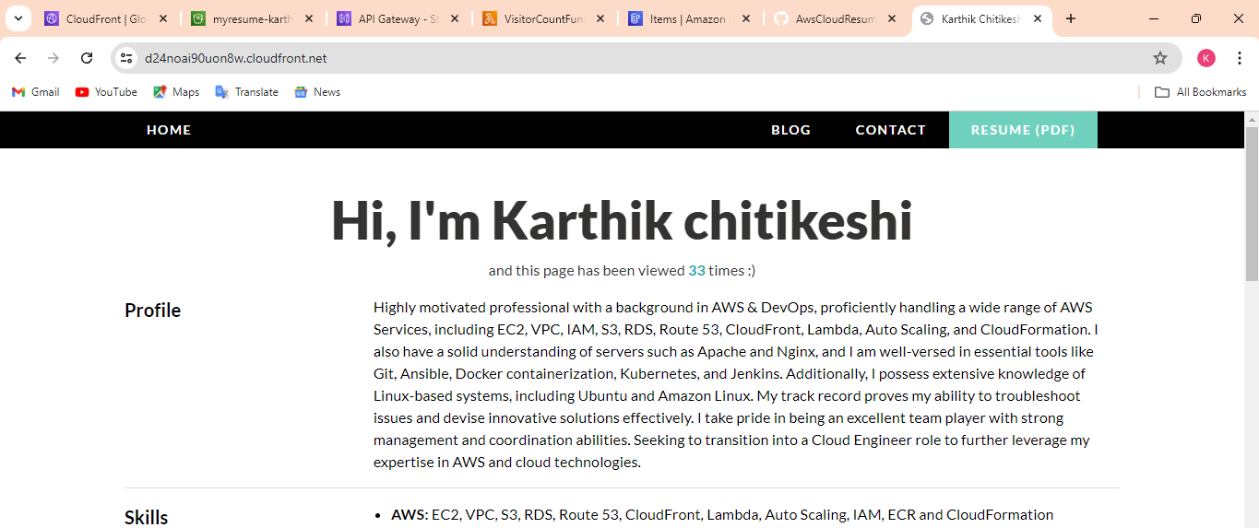

U can see the resume and the number of visites to this page.