Scaler-DSML-Tableau

[Tableau App Download Link](https://www.tableau.com/en-gb/products/public/download)

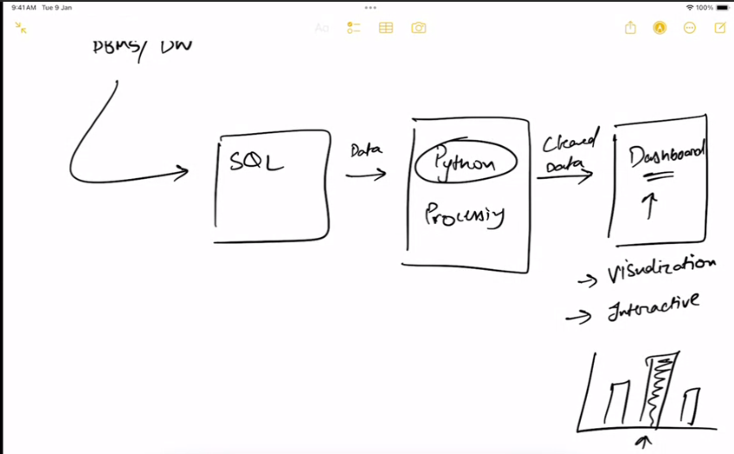Business Intelligence -> The whole above process

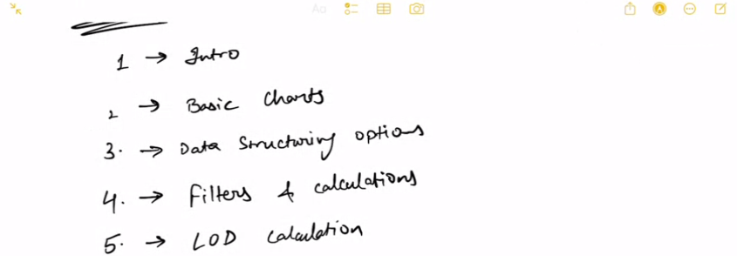



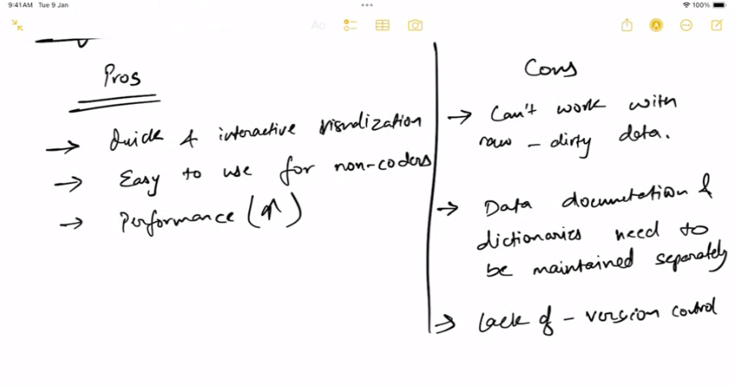

[Tableau Product Suite](https://public.tableau.com/views/TableauProductSuite/ProductSuite?:embed=y&:showVizHome=no&:display_count=y&:display_static_image=y&:bootstrapWhenNotified=true)

[Tableau Pricing](https://www.tableau.com/pricing/teams-orgs)

what is the input for tableau ? SQL or nonsql ? --> SQL

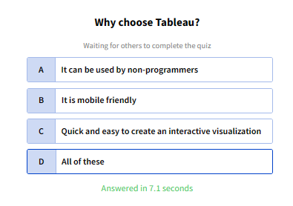

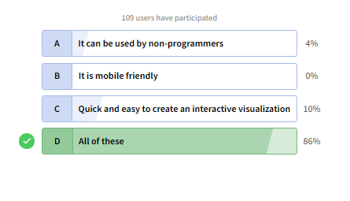

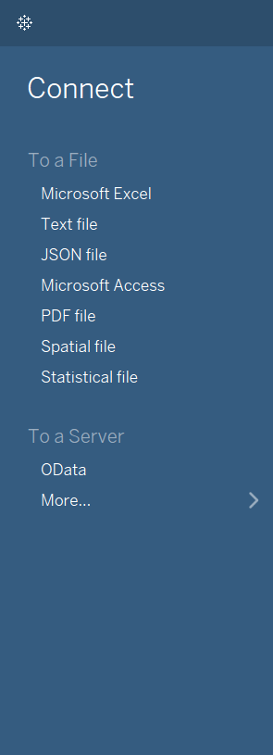

Data Source Connection

If upgraded, the data will get automatically refreshed

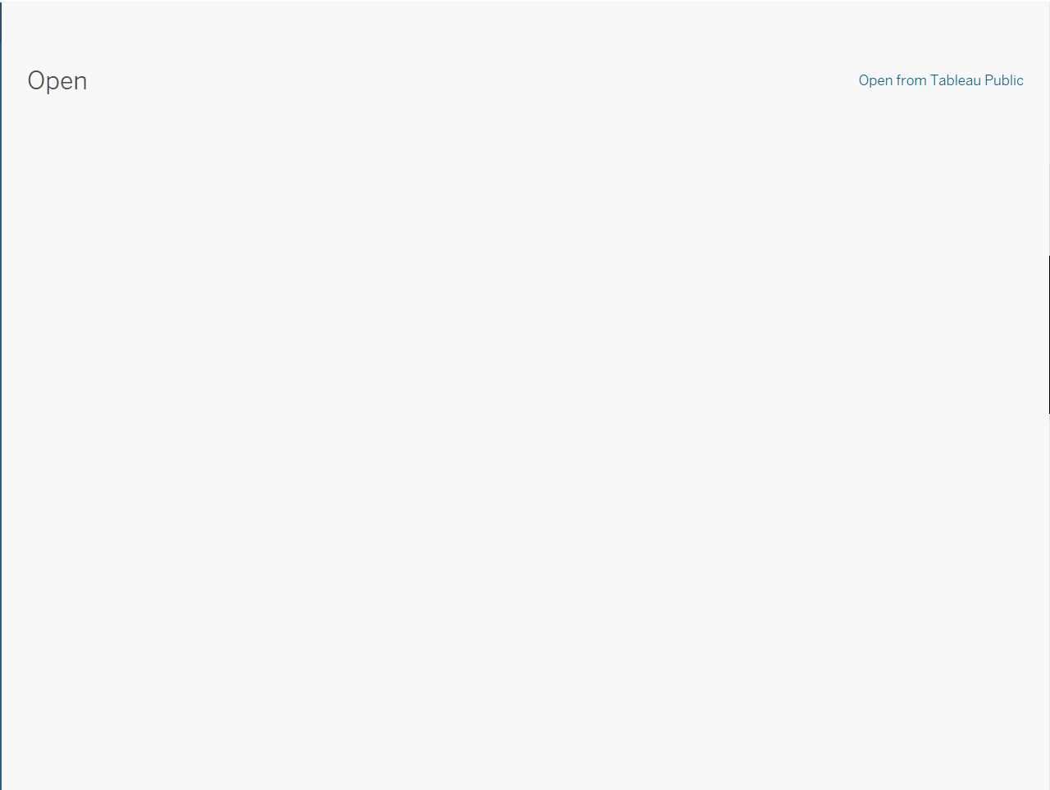

Workbooks --> The project we will prepare(analysis)

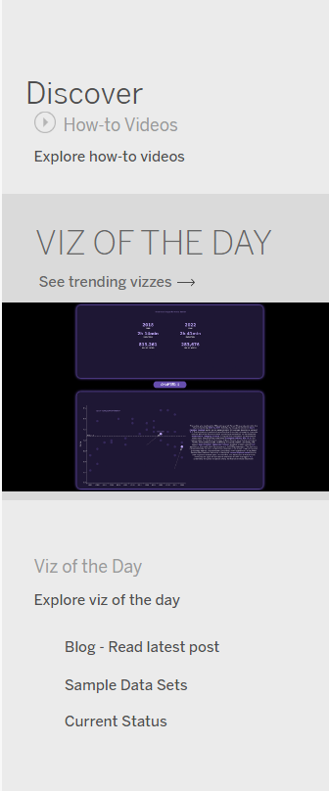

Discover --> Read blogs

We cannot keep our data private with this.

[sample_superstore_dataset](https://docs.google.com/spreadsheets/d/1yEDocbFhGgZ1BWQO8FHy1jYg4tW8YP8X/edit?usp=sharing&ouid=100286367410441414804&rtpof=true&sd=true)



Datatype

Tableau automatically auto assigns datatype

* String(text) - Abc
* Integer-#
* Date-Calendar(Any format)
* Timestamp-Calender(Any format)
* Boolean-T|F
* Geographic-Globe
* Cluster/Grouped-crown type

We can change the datatype manually

[Spatial](https://www.tableau.com/blog/guide-to-mapping-in-tableau#:~:text=Tableau%20can%20map%20three%20types,%3A%20points%2C%20lines%20and%20polygons.)

2 main types

* Dimension
* Measure

Green icons – Measures (Dependent field) - a function of 1 or more dimensions - Quantitative

Blue icons – Dimensions (Independent field) - Qualitative

Meta data info

Data preview

Physical realm where we define relationships

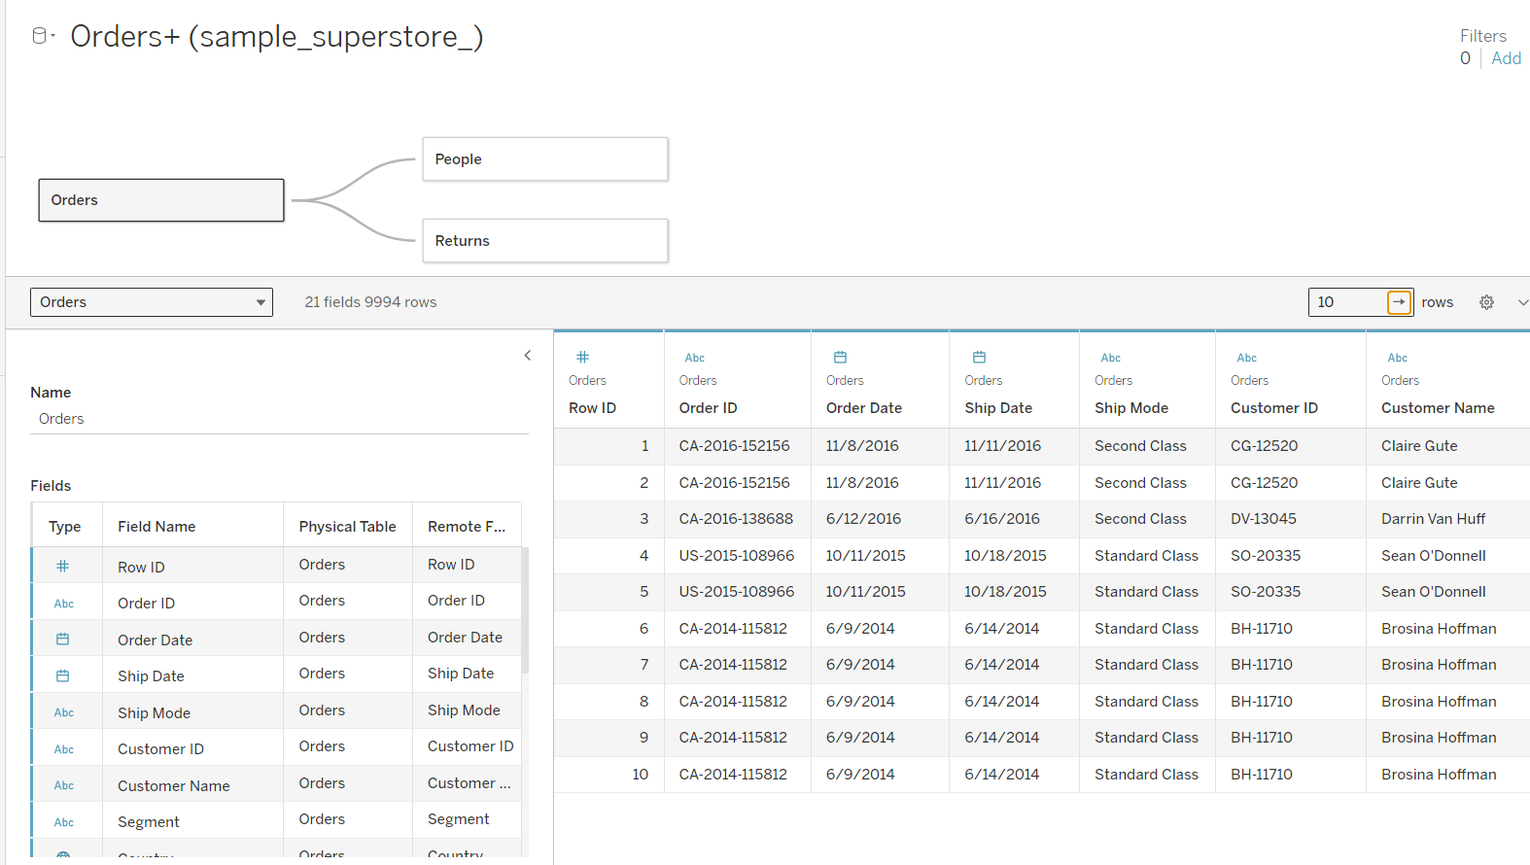

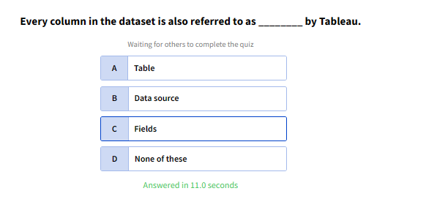

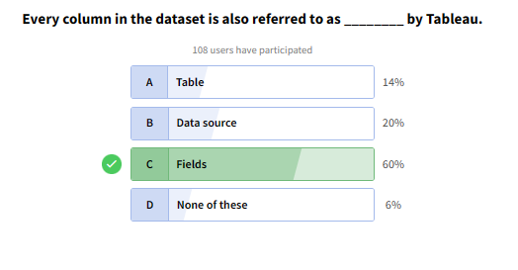

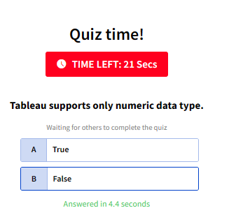

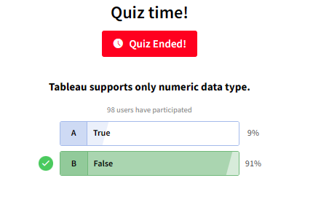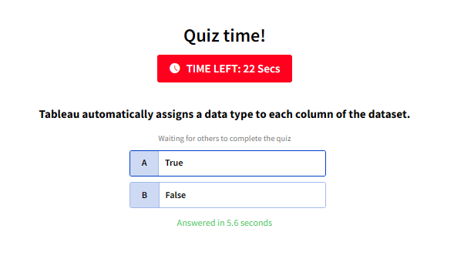

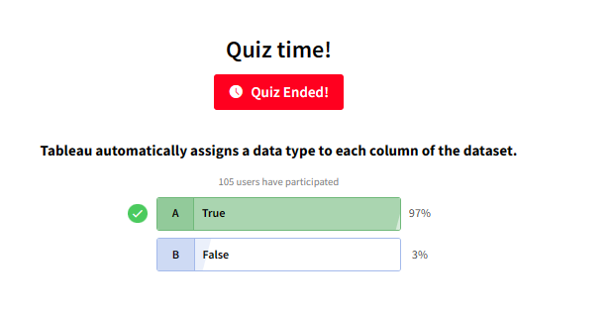

Each Worksheet works as analysis

Tableau always works on aggregated values.

We can change measures to dimensions and vice versa

Discrete vs continuous

Continuous – unbroken, something which we can’t count (Weight)

Discrete – individual separate values, something which we can count (Quantity)

Discrete -> Bar chart

Continuous -> Line chart

Q1. Determine the total sales value of each category

