# GitHub: https://github.com/Karthik-shetty-964

# LinkedIn: https://www.linkedin.com/in/karthik-shetty-7980b1223/

**Karthik Shetty**

**+91-9964300358 ||**

**karthiksshetty111@gmail.com**

**D.No.** 1-4-54 Gundibailu, Kudure-kalsanka,Udupi-576102

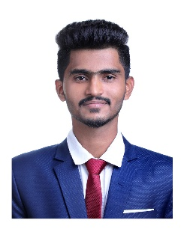

**SUMMARY**

An Information Science & Engineering student with knowledge of programming and keeping a close eye on emergent technologies, looking for a software engineering job that would help improve professional and domain skills and dedicate the skills acquired for the overall benefit of the organization.

# EDUCATION

**Bachelors of Engineering - Information Science & Engineering** 2019-2023

Mangalore Institute of Technology & Engineering CGPA:9.42

**Senior Secondary (12th)** 2018-2019

Mahatma Gandhi Memorial PU College, Udupi Percentage:73%

**Secondary School (SSLC)** 2016-2017

Govt. High School Volakadu, Udupi Percentage:83%

# SKILLS

**Languages :** C, C++, Java, JavaScript, Python.

**Database :** SQL.

**Tools :** MYSQL, Visual Studio, Eclipse, PyCharm, GitHub.

# COURSES & WORKSHOPS

* **Web-development:** Participated in a workshop on **web-development using Java** conducted by **DLithe**.
* Certified in **Crash Course on Python** authorized by **Google** and offered through Coursera.
* Completed course on **Step into Robotic Process Automation** by Guvi-UiPath, June 2020.
* **Problem Solving:** Achieved certificate in **Problem solving** test on Hacker rank.

# ACHIEVEMENTS & ACTIVITIES

* **Portfolio website**: Developed my personal portfolio website[https://karthik-shetty.netlify.app] using Html,Css and Javascript.
* **Covid Help Center**: Developed a Dbms project Covid help center which stores the details of the covid infected patients and helps people to know about the patients in their area which is developed using Java and MySql.
* Participated in **ZeCoder** coding event conducted by ZERONE MITE.
* Participated in **Reliance Quiz-a-thon 6.0** organised by **Reliance Industries Limited (RIL)**.