**DATA 230 – SEC 27**

**DATA VISUALISATION**

**TERM PROJECT**

**GUN VIOLENCE TREND ANALYSIS ACROSS USA**

**Professor: Dr. Andrew Bond**

**By**

**Name: Nimmagadda Karthik**

**Student ID: 016996148**

**Email:** [**karthik.nimmagadda@sjsu.edu**](mailto:karthik.nimmagadda@sjsu.edu)

**Introduction:**

One important problem that has generated much national concern and discussion is gun violence in the United States. With the use of cutting-edge data visualization tools, this research seeks to provide a thorough examination of the patterns in gun violence in the United States while providing lucid, perceptive insights into this intricate and multidimensional issue

My analysis includes a variety of data, such as the quantity of gun-related occurrences, deaths, and injuries throughout different time periods, as well as the geographic distributions of gun violence and the demographic characteristics of those who are impacted. The relationship between gun violence and variables like laws, socioeconomic circumstances, and gun access is also examined in the report.

This project's main goal is to offer a data-driven framework for comprehending the dynamics of gun violence.

**Objective:**

The purpose of the USA's Gun Violence Trend Analysis is

**To Provide a Complete Understanding of Gun Violence Trends**:

The main goal is to examine and illustrate the patterns in gun violence occurrences that occur in the United States over time, taking into account factors like frequency, severity, and distribution. To find trends and changes in gun-related occurrences, fatalities, and injuries, data from many years must be analysed.

**Analysing Geographical and Demographic Variations:**

One important objective is to investigate the variations in gun violence among the various states and regions in the United States of America. This entails examining how different demographic groups—including age, gender, race, and socioeconomic status—are affected by gun violence.

**To Establish a Correlation Between Gun Violence and Socio-Political elements:**

The purpose of this research is to establish a link between several socio-political elements, including social concerns, economic situations, and gun ownership restrictions, and gun violence. The goal is to comprehend the potential effects of these variables on the patterns and trends in gun violence.

**Using Sophisticated Data Visualization Techniques:**

One of the main goals is to use sophisticated data visualization tools and strategies to convey the findings in a way that is both effective and easily understood. The goal is to produce visually appealing and educational representations that make complex information easy to understand.

**To Determine Areas for Improvement and Intervention**:

The project uses analysis to pinpoint particular areas where improvements would be most successful. This entails pinpointing high-risk areas, vulnerable demographics, and peak gun violence periods to inform focused preventative and control initiatives.

**Data Source:**

Dataset is collected from Kaggle website. Below is the link for the dataset.

<https://www.kaggle.com/datasets/nidzsharma/us-mass-shootings-19822023>

**Data Cleaning:**

Cleaned the dataset using excel. Added some columns which will be useful for data visualisation in tableau.

The following are the columns in my dataset after cleaning.

* location
* date
* summary
* fatalities
* injured
* total_victims
* location.1
* age_of_shooter
* prior_signs_mental_health_issues
* mental_health_details
* weapons_obtained_legally
* where_obtained
* weapon_type
* weapon_details
* race
* gender
* latitude
* longitude
* type
* year
* quarter
* half
* month_name
* day_of_week
* age_group
* decade
* name
* current_age
* description

**Tools Used:**

1. Excel for Cleaning.
2. Tableau for Data Visualisation
3. Integrated D3.js with Tableau for Interactive Dashboards in a Browser.

**ABSTRACT**

In this study, we analyse gun violence trends across the U.S. over the course of 41 years, beginning in 1982 and ending in 2023. Using a large dataset of gun violence events, including mass shooting incidents, we look at the patterns and changes in the frequency and type of gun-related events over time. We use sophisticated time series methods to interpret these changes, with the primary goal of identifying periods of high or low gun-related events. We also look at how legislative changes, social trends, and advances in technology affect gun violence rates, as well as the seasonality and cyclical nature of these events to understand their temporal distribution. Finally, we look at how gun violence interacts with demographic variables, including age and socioeconomic status, to gain a better understanding of the communities affected by gun violence. The goal of this analysis is to inform policy discourse, providing Evidence based insights to inform targeted strategies for reducing gun violence and improving public safety. In the end, this study captures not only the statistical dimensions, but also the human costs of gun violence.

**Data Visualisation:**

**Overview:**

I have created various sheets of visualisations which includes several types of charts and graphs and created two dashboards where one is for Victims and another is for Shooters. Also, I have completed a story on Gun Violence Trend in USA. At last, I have published my project in Tableau Cloud and published graphs in html file using D3.js.

**For Victims**

**Sheet 1:**

**Title:** Time Series Analysis of Victims from 1982 to 2023.

**Axis:** Year in Columns and Total Victims in Rows.

**Chart:** Line Chart

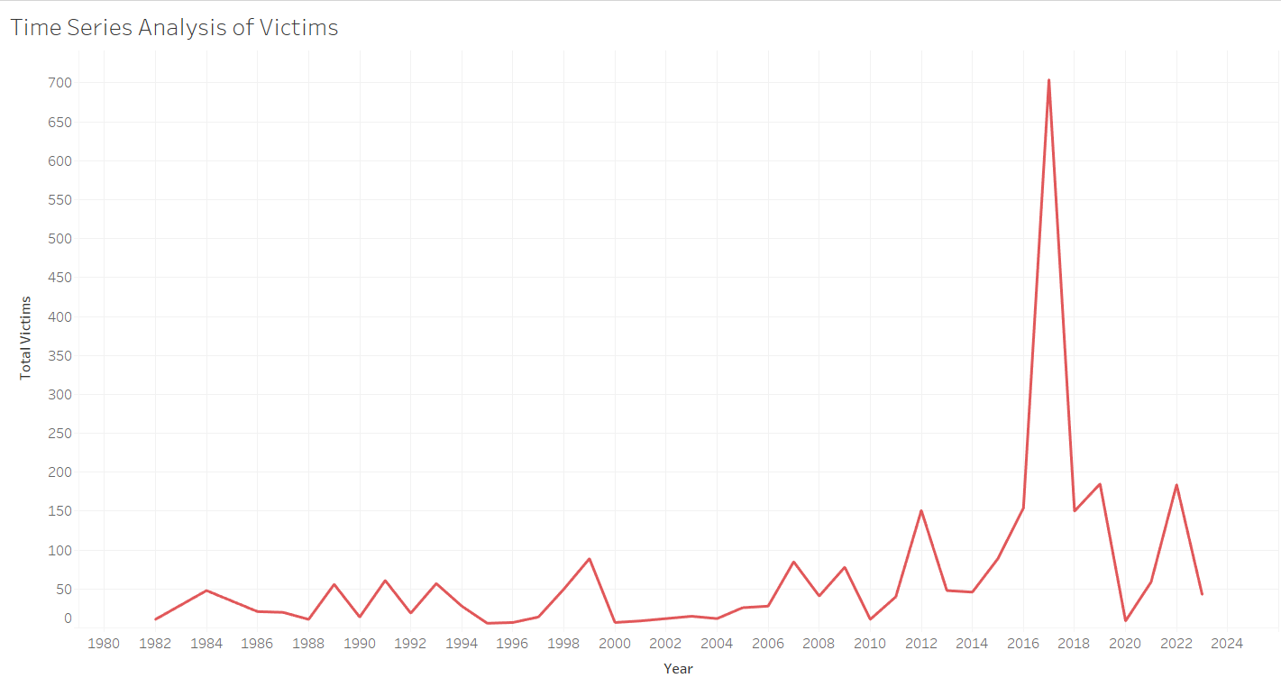

**Explanation and Analysis:**

Time series analysis is a statistical technique that deals with time series data, or data that is observed sequentially over time. We can observe that the highest number of people are affected by gun violence in USA is in the year 2017 and the lowest is in the year 1982. Around 704 victims are affected by gun violence crimes in 2017 and 11 are affected in 1982.

**Sheet 2:**

**Title:** Fatalities and Injuries Over Time

**Axis:** Year in Columns and Fatalities, Injuries are in Rows.

**Chart:** Two Line Charts

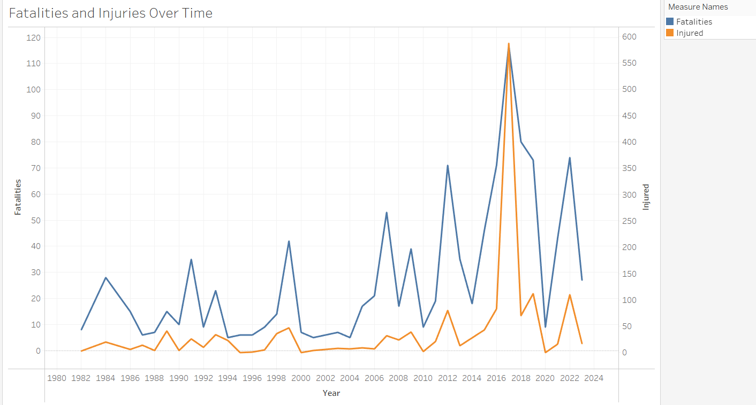

**Explanation and Analysis:**

We can observe that the highest number injuries and fatalities due to gun violence in USA is in the year 2017 and lowest in the year 1982. Around 587 injuries and 117 fatalities took place in the year 2017. Around 8 injuries and 3 fatalities took place in 1982.

**Sheet 3:**

**Title:** Total Victims affected by Weapon type

**Axis**: Weapon type in Columns and Total Victims in Rows.

**Chart:** Bar chart

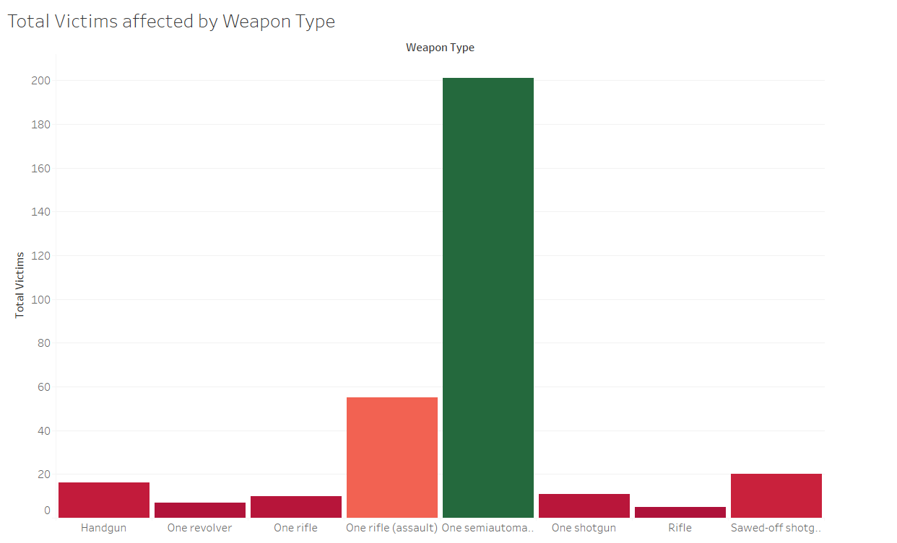

**Explanation and Analysis:**

Here we can observe that from the bar chart that most of the victims are affected by 8 weapons. Around 5 members were victims of rifle gun where 5 died and 0 injured. Around 201 members were victims of Semiautomatic hand gun where 89 died and 112 injured.

**Sheet 4:**

**Title:** Geographic Representation of Victims in USA (Cities Wise)

**Axis**: Longitude in Columns and Latitude in Rows. Location in Size.

**Chart:** Maps (Geographical Map)

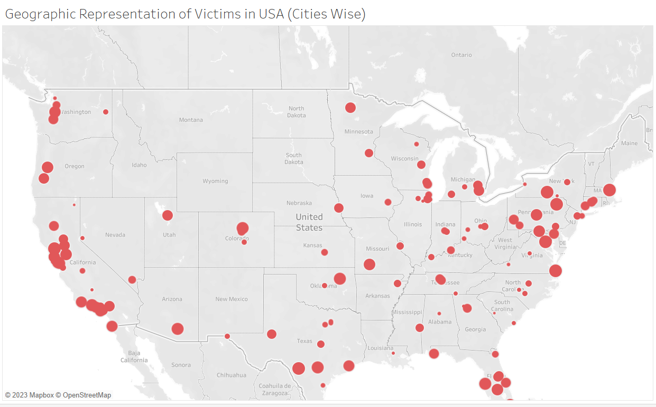

**Explanation and Analysis:**

From the geographical map we can observe that gun violence has happened in 130 cities across USA. Las Vegas stood first with 604 victims and Birmingham stood last with 3 victims.

**Sheet 5:**

**Title:** Total Victims by Race

**Axis**: Total Victims in Rows and Race in Colours.

**Chart:** Stacked Chart

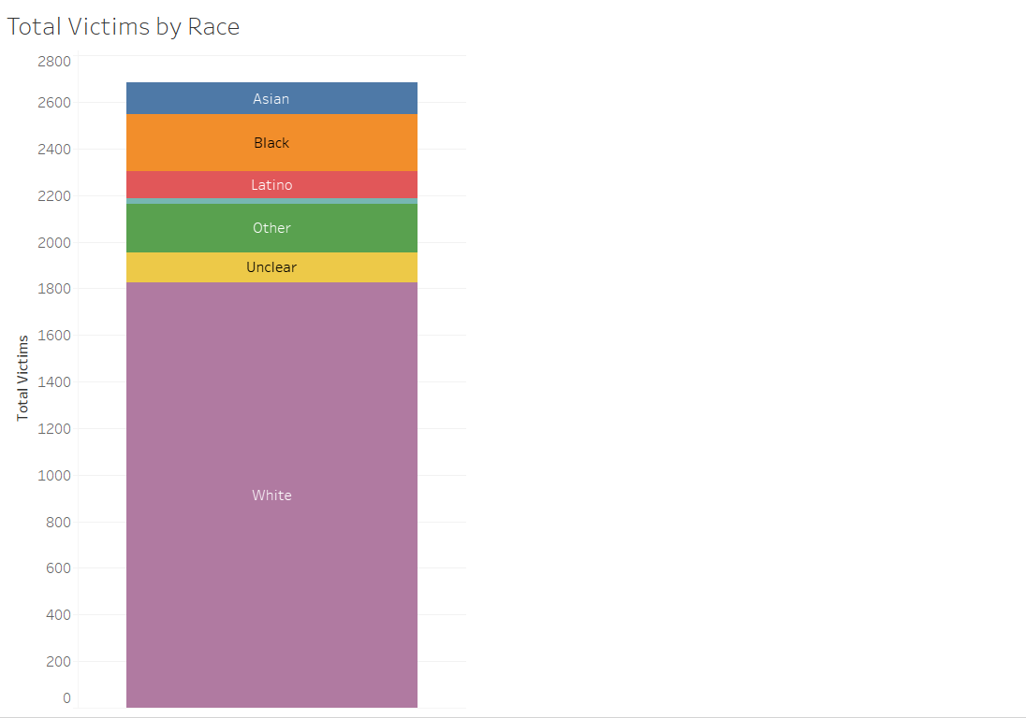 **Explanation and Analysis:**

From the Stacked Bar chart, we can observe that Whites are most affected by Gun Violence in USA and Native Americans were the least and Latino were the second least affected by Gun Violence.

**For Shooters:**

**Sheet 1:**

**Title:** Shooter's Prior Mental Health Issues

**Axis:** Prior Signs Mental Health Details

**Chart:** Circle Chart

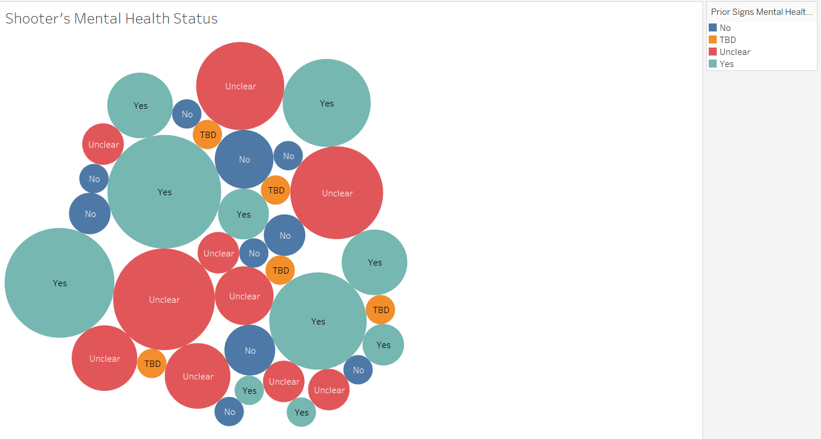 **Explanation and Analysis:**

From the Circle chart it is evident that Most of the shooters are having Mental Health Issues. Least number of shooters are not having any mental health issues. Some were Unclear and remaining are to be Discussed.

**Sheet 2:**

**Title:** Average age of Shooters vs Used Weapon type

**Axis:** Average age of Shooter in Columns and Weapon type in Rows.

**Chart:** Horizontal Bar Chart

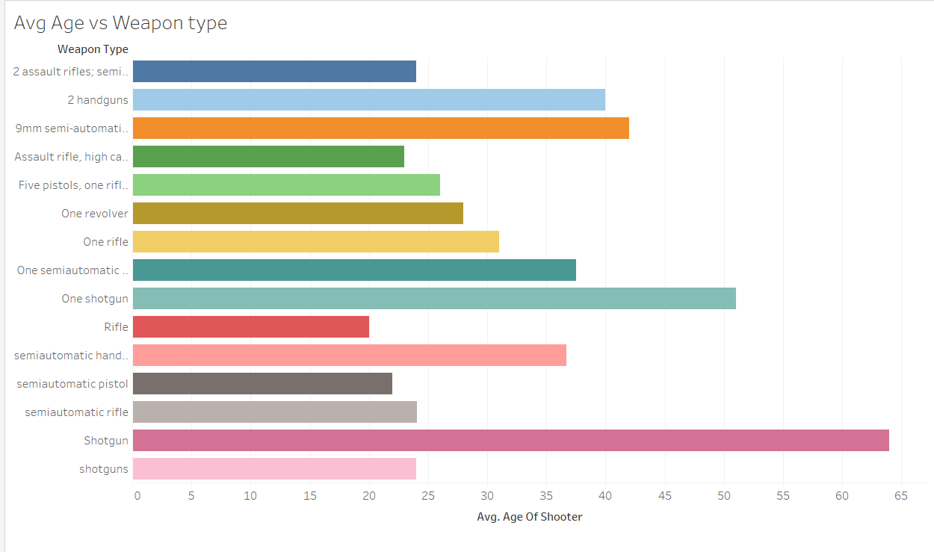 **Explanation and Analysis:**

We can observe that a bar chart is plotted between the average age of shooters and Weapon type they used. Shooters of age 20 to 40 have used pistols, assault rifles and revolvers. Shooters of age 40 to 65 have used shotguns.

**Sheet 3:**

**Title:** Shootings by Place type

**Axis:** Location.1 (Sub Location) in Colours.

**Chart:** Pie Chart

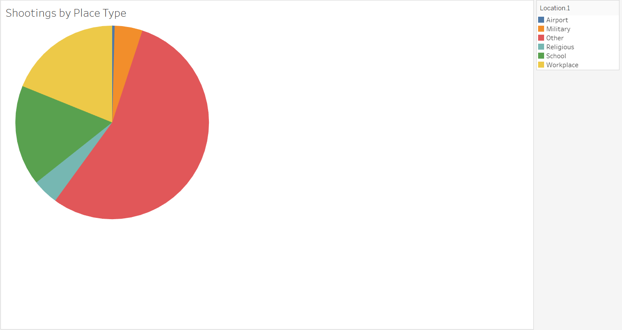

**Explanation and Analysis:**

From this Pie Chart we can observe that analysis is drawn between Shootings happened and Place type. Shootings took place at Airport, Military, Religious places, Schools, Work Places and Other. Least Shooting Incidents happened at Airports and Most incidents occurred at Other Places.

**Sheet 4:**

**Title:** Shootings by Month and Place type.

**Axis:** Month in Marks and Case in Label

**Chart:** Trees Map

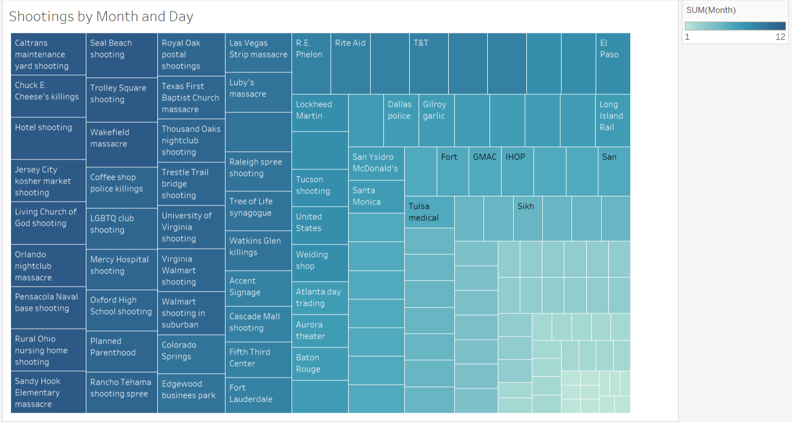

**Explanation and Analysis:**

From this tree map we can observe that most of the shootings happened in Second Half of the year. Most of the shootings happened at other places like public places like Markets, Churches, Schools, Clubs, Super stores.

**Dashboard 1 for Victims:**

For Victims Dashboard, I have included 4 sheets and added interactive elements related to Victims to better analyse the information related to Victims. They are:

* 1. Fatalities and Injuries over a period of time.
  2. Total Victims by Race.
  3. Geographic Representation of Gun Violence victims by cities wise.
  4. Total Victims affected by Weapon type.

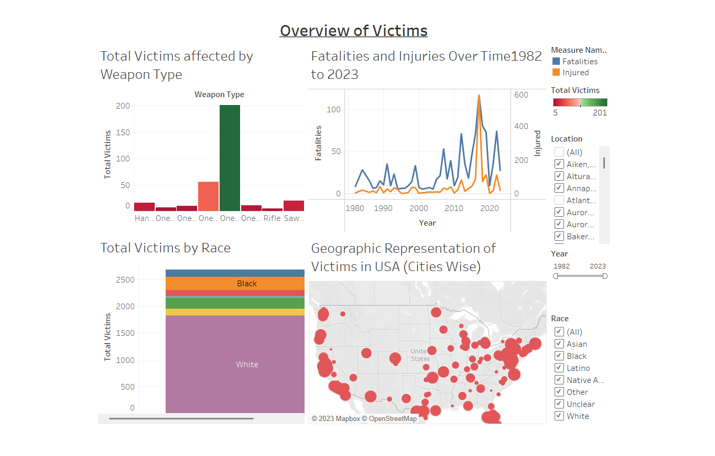

**Dashboard 2 for Shooters:**

For Shooters Dashboard, I have included 4 sheets and added interactive elements related to Shooters to better analyse the information related to Shooters. They are:

1. Shooter’s Prior Mental Health Issues
2. Shootings happened by place type.
3. Average age of shooters vs Used weapon type.
4. Shootings by month and place type.

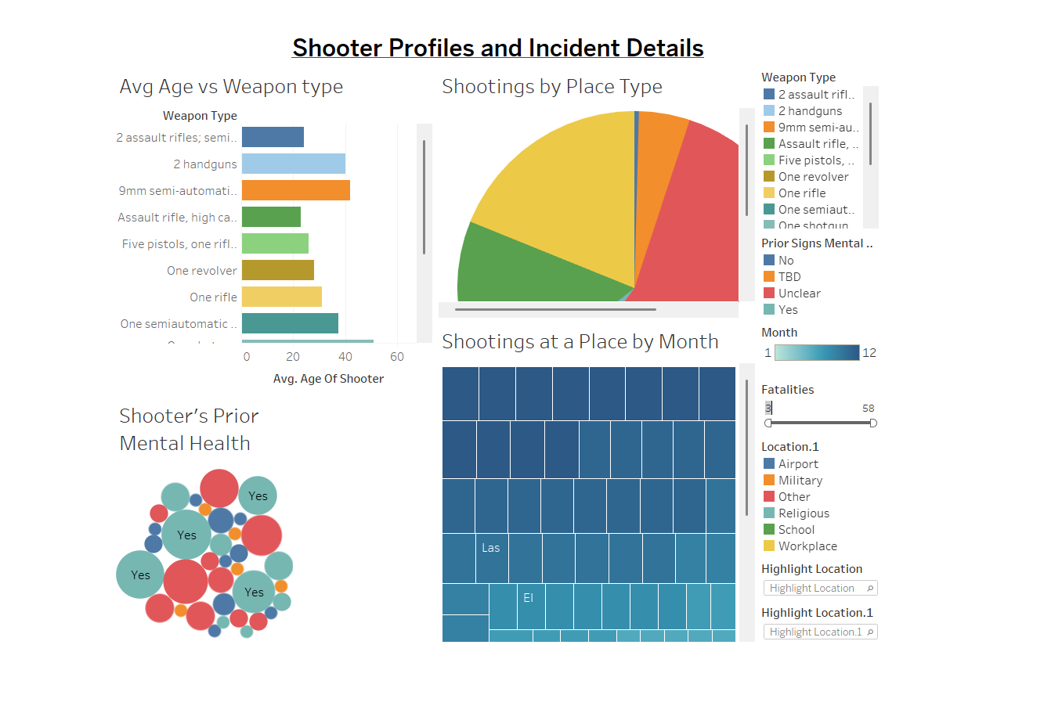

**Story:**

I have created a story by using various sheets of victims and shooters in tableau. For more info u can check my workbook.

**D3.js**

I have published my workbook in Tableau Cloud and integrated tableau with d3.js and published in localhost.

**Tableau Cloud:**

<https://us-west-2b.online.tableau.com/#/site/karthikat016996148/workbooks/896112/views>

**Code for Dashboard 1:**

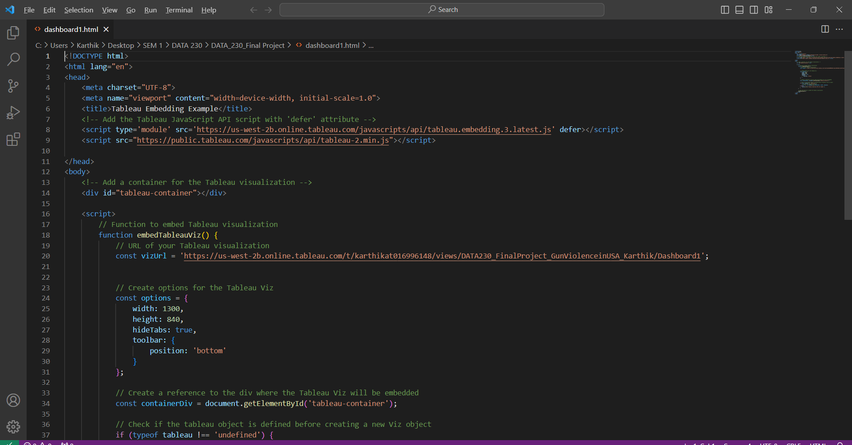

**Code for Dashboard 2:**

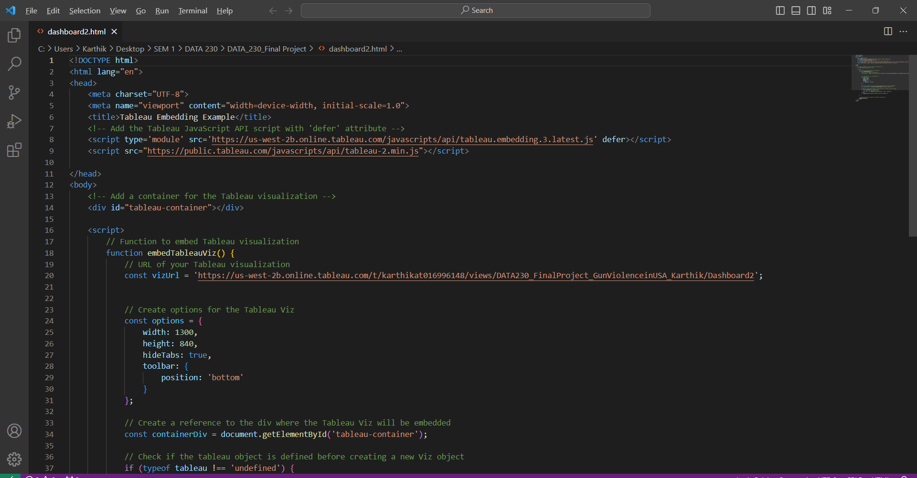

**Dashboard 1:**

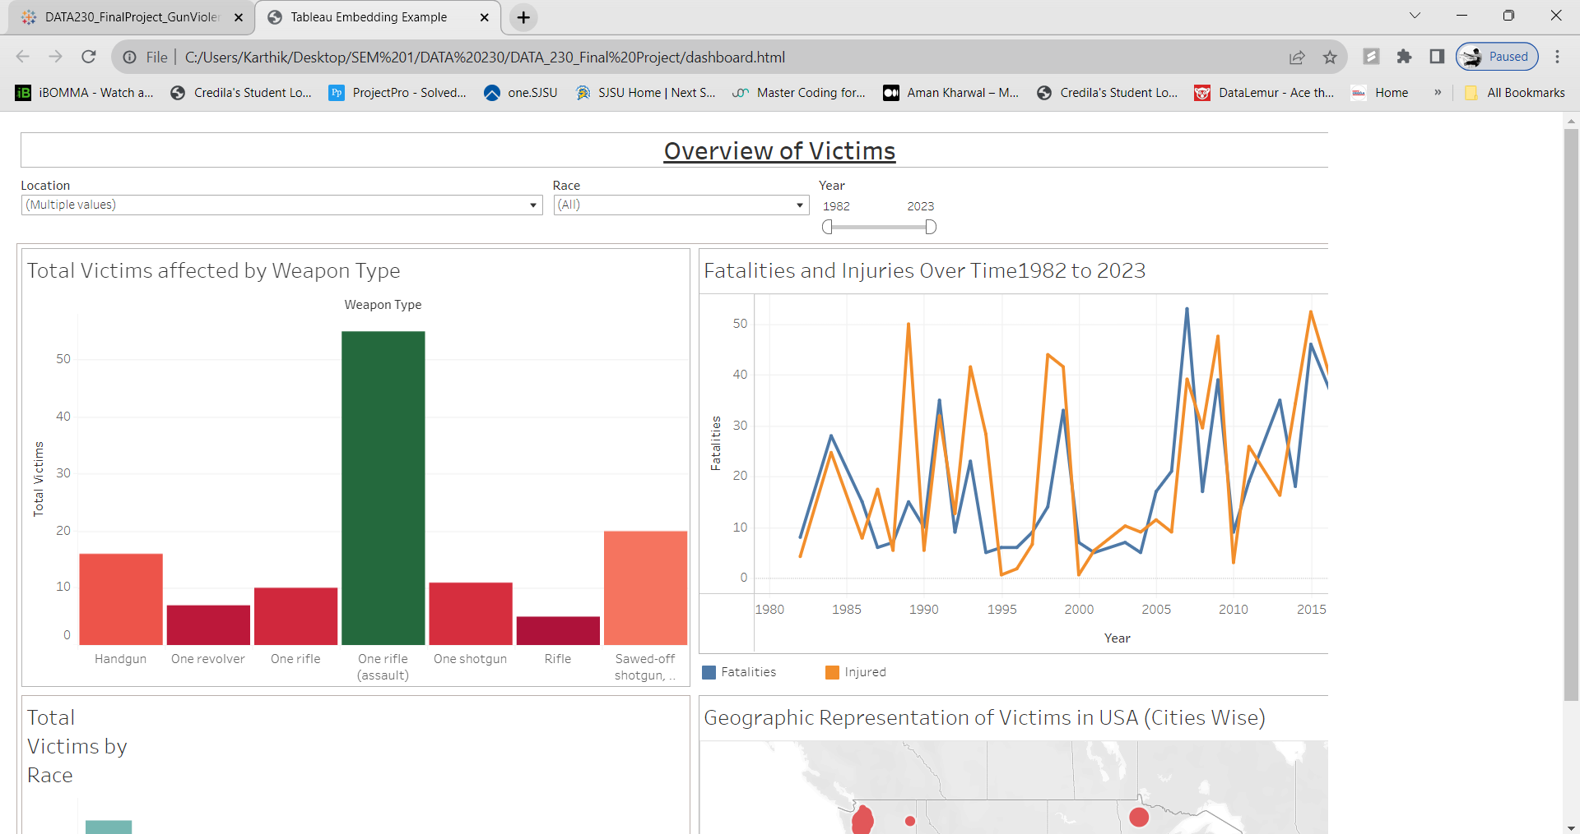**Dashboard 2:**

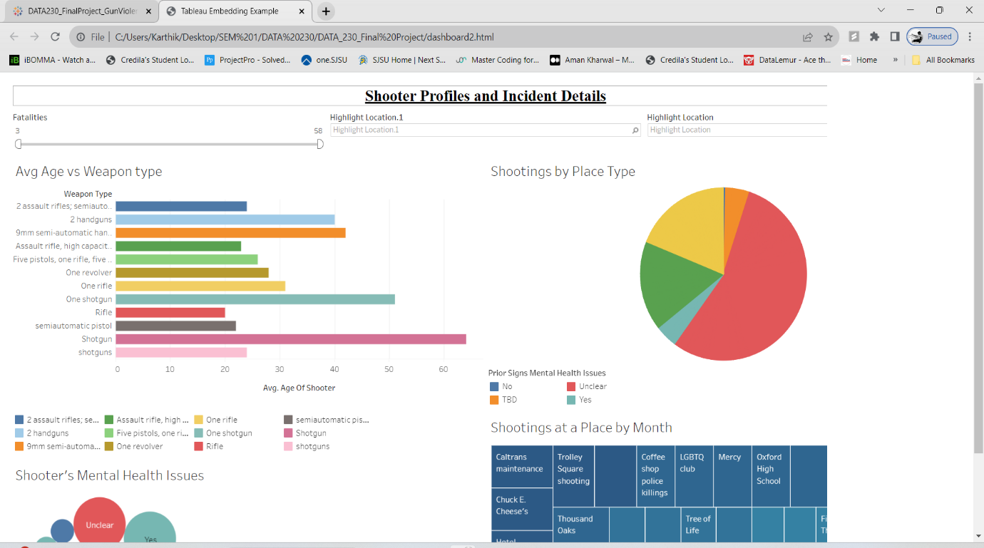

**GitHub:**

Pushed the entire report, tableau workbook, csv file into git hub repository.

<https://github.com/Karthik016996148/DATA230_Project/upload>

**Conclusion:**

* My analysis has shed light on the multifaceted nature of gun violence in the USA. The data reveals troubling trends, including a rise in the number of incidents over the years and a significant number of victims affected by certain types of firearms, particularly rifles.
* It is only through concerted efforts across policy, community engagement, and research that we can hope to see a decline in gun violence and its devastating effects on society.
* The study emphasizes how complicated gun violence is, a multidimensional problem entwined with socioeconomic, cultural, and policy-related issues. It becomes evident that the problem cannot be fully solved by a single solution. To decrease the dangers and lower the frequency of gun violence, a mix of comprehensive laws, community-based programs, mental health support, and gun safety education is needed.
* This research serves as a sobering reminder of the consequences of inaction and the pressing need for a coordinated, long-term effort to prevent gun violence as we look to the future. Because gun violence results in fatalities and traumatizes communities, it must be viewed as a serious public health concern that requires immediate and ongoing attention from decision-makers, stakeholders, and the general public.

**References:**

* Centers for Disease Control and Prevention 2001 Statistics Query and Reporting System (WISQARS). National Center for Injury Prevention and Control, Centers for Disease Control and Prevention. Available: <http://www.cdc.gov/ncipc/wisqars>.
* National Academies of Sciences, Engineering, and Medicine. 2005. Firearms and Violence: A Critical Review. Washington, DC: The National Academies Press. <https://doi.org/10.17226/1088>
* Kaplan, M.S., and O. Gelling 1998 Firearm suicides and homicides in the United States: Regional variations and patterns of gun ownership. Social Science and Medicine 45:1227-1233.