Customer Churn Prediction
Week 1 – Data Science Project Planning and Strategy Design

Project : Customer Churn Prediction for Telecom Industry
Week : Week 1 – Planning & Strategy
Prepared by : Data Science Intern
Date : September 2026

1. Introduction & Project Background
Customer churn — the phenomenon where subscribers discontinue a service — is one of the most pressing business challenges faced by telecommunications companies worldwide. Industry research consistently shows that acquiring a new customer costs five to seven times more than retaining an existing one, and even a modest 5% reduction in churn can increase profitability by 25–95% (Reichheld, F., Harvard Business Review).
This project addresses churn prediction for a hypothetical mid-sized telecom operator serving approximately 7 million subscribers. The business is experiencing an annual churn rate of 22%, costing an estimated $42 million per year in lost revenue. Despite having rich customer data across CRM, billing, usage, and support channels, the company currently relies on reactive strategies — offering discounts only after a customer files a cancellation request. A predictive, data-driven approach would allow the business to intervene proactively.

1.1 Problem Motivation
The core motivation is to transition the telecom company from reactive churn management to proactive, AI-driven customer retention. By identifying at-risk customers 30–60 days before they churn, retention teams can deploy personalised offers, service improvements, or priority support — dramatically reducing the churn rate and protecting revenue.

1.2 Why Python?
- Rich ecosystem: pandas, NumPy, scikit-learn, XGBoost, LightGBM, matplotlib, seaborn, plotly.
- Rapid prototyping and iteration through Jupyter Notebooks.
- Seamless integration with cloud services (AWS SageMaker, GCP Vertex AI, Azure ML).
- Strong community support and extensive open-source libraries for every stage of the pipeline.
- Production-readiness via Flask/FastAPI for model serving and MLflow for experiment tracking.
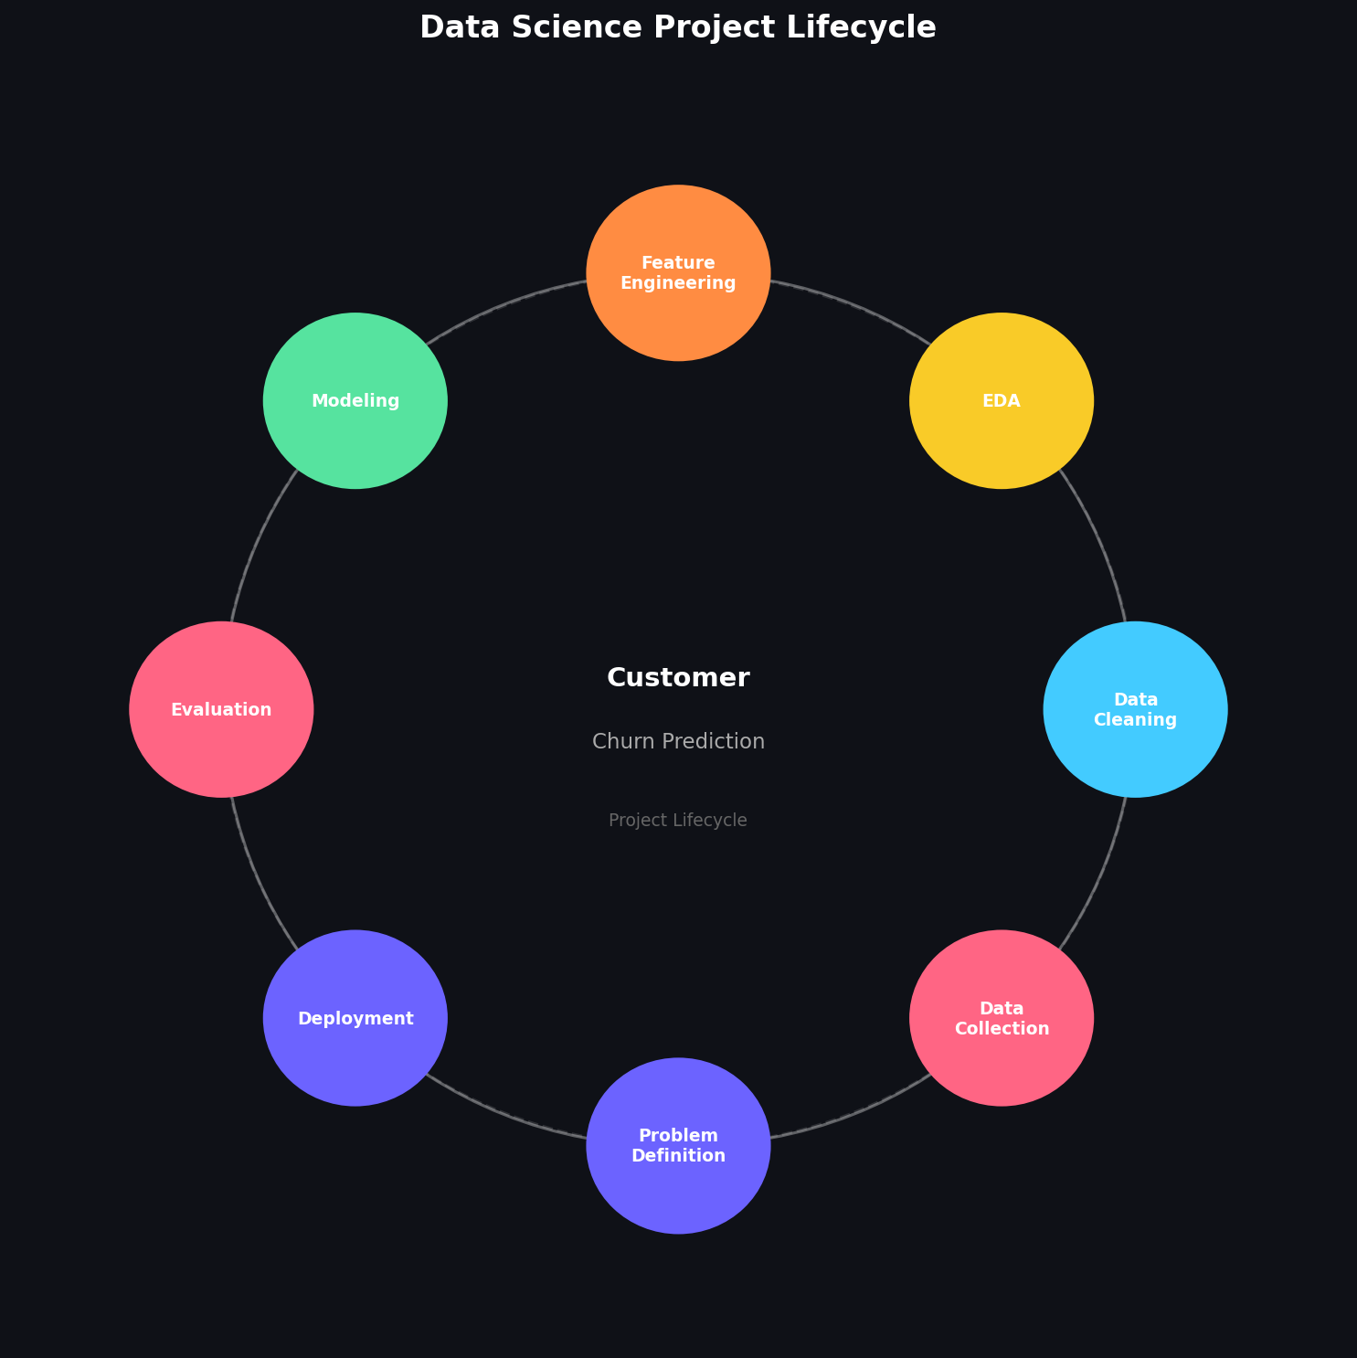
Figure: Data Science Project Lifecycle for Customer Churn Prediction

2. Project Objectives & Scope

2.1 Primary Objectives
- O1: Develop a binary classification model to predict customer churn with AUC-ROC ≥ 0.88.
- O2: Identify the top 10 features driving churn behaviour.
- O3: Reduce false-negative rate (missed churners) to below 15%.
- O4: Deliver a scoring pipeline that can classify 1 million customers in under 10 minutes.
- O5: Produce actionable, interpretable outputs for the marketing and retention teams.

2.2 Secondary Objectives
- Establish a reusable data pipeline for future churn cohorts.
- Create an interactive dashboard for ongoing churn monitoring.
- Document all steps to facilitate knowledge transfer.

2.3 Scope
IN-SCOPE:
- Historical customer data (last 24 months): demographics, contract, billing, usage, support.
- Supervised ML classification (Logistic Regression, Random Forest, XGBoost, LightGBM).
- Batch prediction pipeline scored monthly.
- Explainability using SHAP values.
- Automated model retraining trigger on performance degradation.
OUT-OF-SCOPE:
- Real-time streaming prediction (future phase).
- Social media sentiment analysis.
- Customer lifetime value optimisation (separate project).
- Mobile application development.

3. Methodology & Strategy
The project follows the industry-standard CRISP-DM (Cross-Industry Standard Process for Data Mining) methodology, adapted with modern MLOps practices. Each phase is time-boxed and has well-defined entry and exit criteria.

Phase 1: Business Understanding
Collaborate with business stakeholders to define churn precisely (e.g., no activity for 60 days), agree on success KPIs, and document constraints such as data privacy regulations.

Phase 2: Data Understanding & Collection
Identify data sources (CRM, billing system, call data records, helpdesk tickets), assess data quality, and create a data dictionary. Expected features: ~80 raw variables.

Phase 3: Data Preparation
Execute ETL pipelines using pandas. Handle missing values via median/mode imputation and MICE for complex patterns. Encode categorical variables (one-hot, target encoding). Normalise numerical features using StandardScaler/RobustScaler. Address class imbalance using SMOTE or class_weight='balanced'.

Phase 4: Modelling
Train baseline (Logistic Regression), intermediate (Random Forest), and advanced (XGBoost, LightGBM) models. Use Optuna for hyperparameter optimisation. Compare models on a stratified train/validation/test split (60/20/20).

Phase 5: Evaluation
Evaluate using AUC-ROC, F1-score, Precision-Recall curve, and business metrics (revenue at risk captured). Run 5-fold stratified cross-validation for robustness.

Phase 6: Deployment
Package the best model as a REST API using FastAPI. Schedule monthly batch scoring via Apache Airflow. Store predictions in a data warehouse for the retention dashboard.
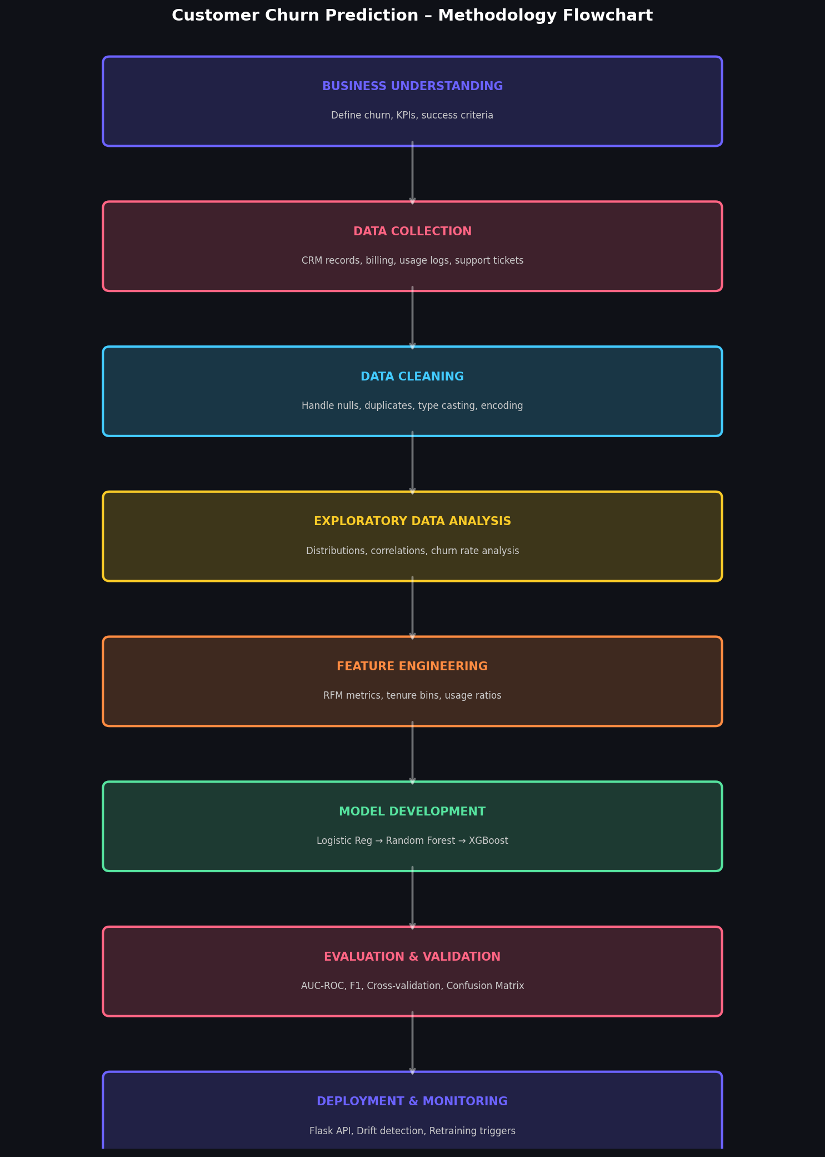
Figure: Customer Churn Prediction – Methodology Flowchart (CRISP-DM adapted)

4. Timeline & Resource Allocation
The project is planned over a 30–35 hour engagement for the planning and strategy phase. The Gantt chart below illustrates the allocation of effort across key activities.
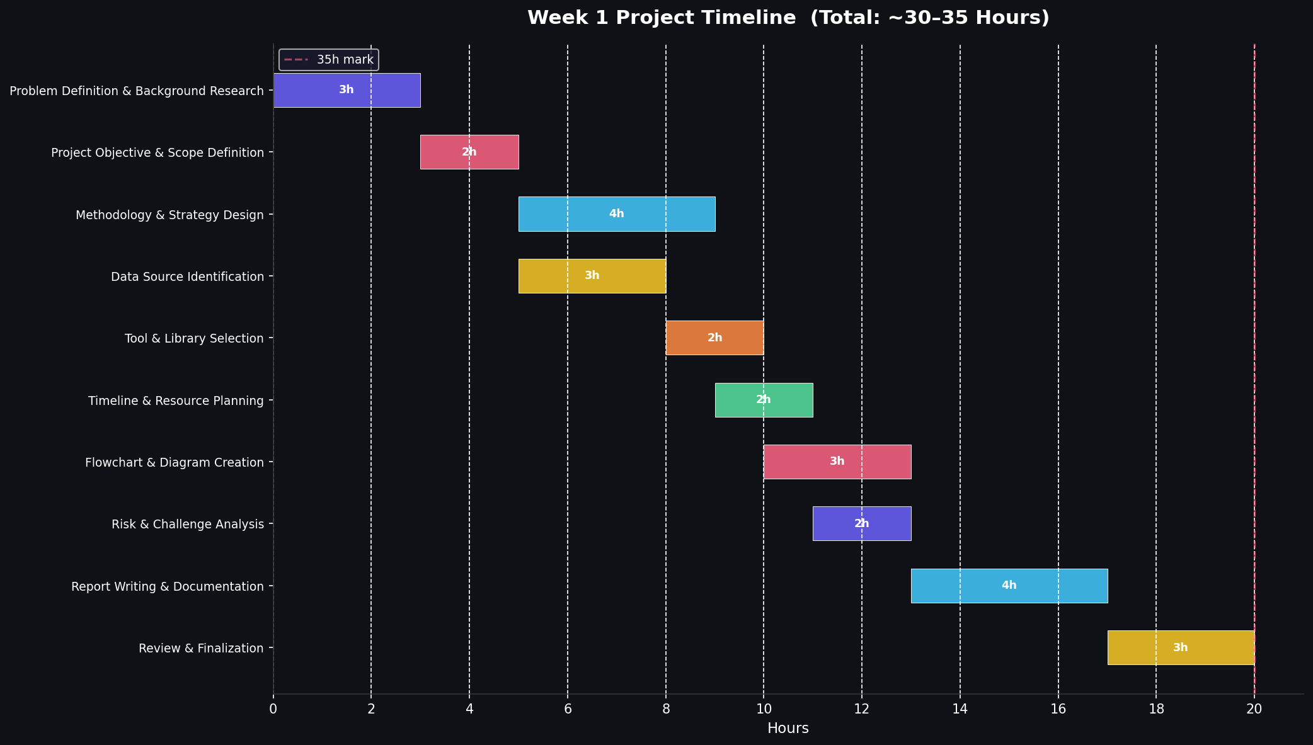
Figure: Project Timeline – Gantt Chart (30–35 Hours Total)

Effort Summary Table:
Activity | Hours | Deliverable
Problem Definition & Background Research | 3h | Problem statement doc
Project Objective & Scope Definition | 2h | Scope document
Methodology & Strategy Design | 4h | Methodology plan
Data Source Identification | 3h | Data dictionary draft
Tool & Library Selection | 2h | Tech stack decision
Timeline & Resource Planning | 2h | Gantt chart
Flowchart & Diagram Creation | 3h | 3 PNG diagrams
Risk & Challenge Analysis | 2h | Risk register
Report Writing & Documentation | 4h | Week 1 DOCX
Review & Finalization | 3h | Reviewed final doc
TOTAL | 28h | —

4.1 Python Tools & Libraries
Category | Libraries / Tools | Purpose
Data Manipulation | pandas, numpy | Data loading, wrangling, aggregation
Visualisation | matplotlib, seaborn, plotly | EDA plots, dashboards, interactive charts
Machine Learning | scikit-learn, XGBoost, LightGBM | Model training and evaluation
Explainability | SHAP, eli5 | Feature importance, LIME explanations
Experiment Tracking | MLflow | Run tracking, model registry
Pipeline Automation | Apache Airflow | Scheduled batch scoring pipelines
Model Serving | FastAPI, uvicorn | REST API for real-time predictions
Imbalance Handling | imbalanced-learn (SMOTE) | Address class imbalance
Hyperparameter Opt. | Optuna | Automated hyperparameter search
Report Generation | python-docx, Jupyter | DOCX reports, notebook presentations

5. Expected Outcomes

Predictive Model
A production-ready churn prediction model with AUC-ROC ≥ 0.88, enabling the retention team to prioritise outreach to the top 20% highest-risk customers.

Business Impact
Expected reduction of annual churn from 22% to 16–18%, translating to $15–20M in recovered annual revenue.

Customer Insights
A ranked list of the 10 most predictive features driving churn, informing product and pricing strategy.

Reusable Pipeline
A modular, fully documented ETL + ML pipeline reusable for future cohorts and other customer analytics projects.

Monitoring Dashboard
A live Power BI / Plotly Dash dashboard tracking churn probability distributions, model drift, and retention campaign effectiveness.

6. Anticipated Challenges & Mitigation Strategies
Challenge | Impact | Mitigation Strategy
Class imbalance (churn ~22%) | High | Use SMOTE oversampling + class_weight='balanced'; evaluate on F1 not accuracy
Missing data in usage logs | Medium | MICE imputation for MAR; flag indicators for MNAR patterns
Feature multicollinearity | Medium | VIF analysis; use tree-based models that handle correlation natively
Concept drift post-deployment | High | Monitor PSI monthly; trigger retraining when PSI > 0.2
Data privacy & GDPR compliance | High | Anonymise PII; use differential privacy where applicable
Stakeholder alignment | Medium | Weekly status meetings; dashboard for non-technical stakeholders
Computational resources | Low | Use cloud spot instances for training; cache preprocessed datasets

7. Conclusion
This Week 1 planning document establishes a solid strategic foundation for the Customer Churn Prediction project. By adopting the CRISP-DM methodology with modern MLOps practices, leveraging Python's powerful data science ecosystem, and maintaining rigorous documentation standards, the project is positioned to deliver measurable business value. The 30–35 hour planning investment ensures every subsequent phase — data collection, modelling, evaluation, and deployment — proceeds with clarity and purpose.
The comprehensive risk register and mitigation strategies ensure the team is prepared for common data science pitfalls. With executive buy-in secured through a clear ROI narrative and transparent success metrics, this project represents a benchmark for data-driven decision-making within the organisation.

