Week 2 – EDA & Visualization Framework
Customer Churn Prediction | Exploratory Data Analysis Plan

1. Introduction to EDA
Exploratory Data Analysis (EDA) is the critical first analytical phase of any data science project. Coined by statistician John Tukey in 1977, EDA involves summarising data's main characteristics, often using visual methods, before any formal modelling begins. It acts as a dialogue between the analyst and the data — revealing structure, spotting anomalies, testing assumptions, and generating hypotheses that guide the modelling strategy.
In the context of the Customer Churn Prediction project, EDA serves three primary functions: (1) understanding the distribution and relationships of 80+ raw features, (2) identifying data quality issues that must be resolved before modelling, and (3) generating preliminary hypotheses about which customer behaviours most strongly predict churn.

1.1 Why EDA Matters
- Prevents garbage-in-garbage-out: catches data quality issues before they corrupt models.
- Guides feature selection: identifies highly correlated or low-variance features to drop.
- Informs model choice: skewed data → tree models; linear relationships → regression.
- Builds stakeholder trust: visualisations make data tangible and understandable.
- Surfaces business insights even before ML modelling is complete.
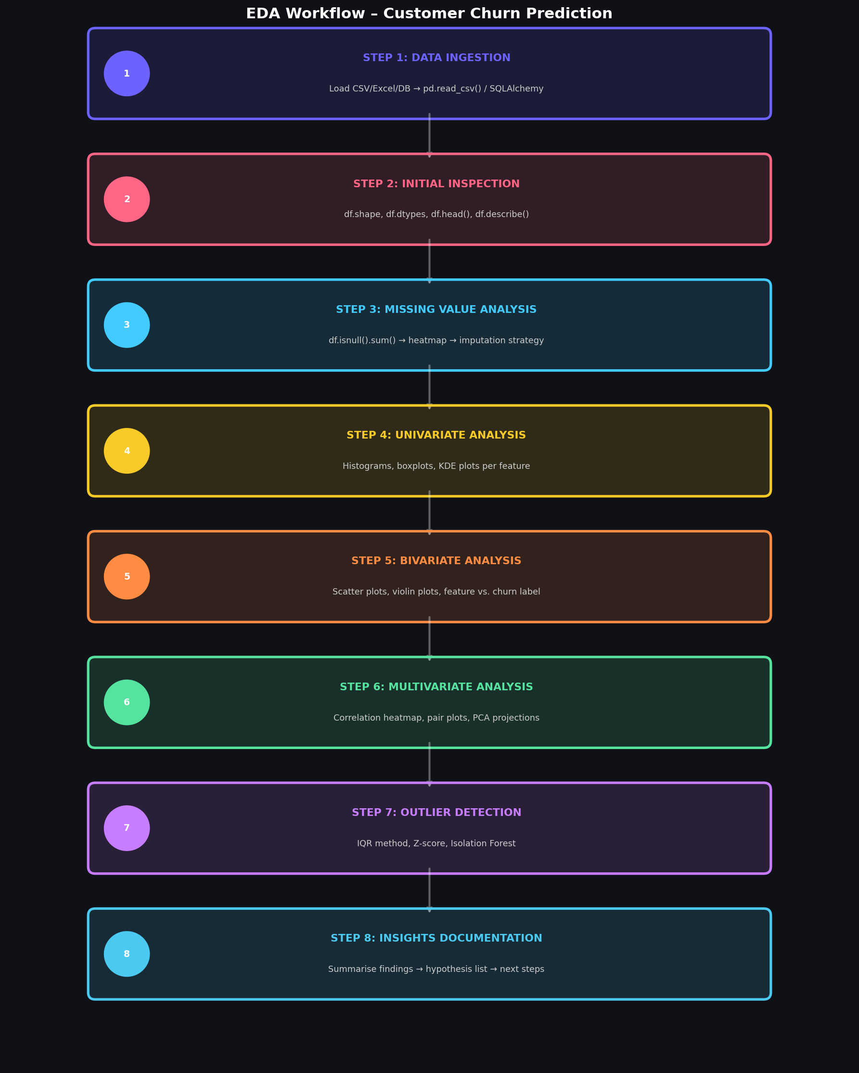
Figure: Step-by-Step EDA Workflow for Customer Churn Prediction

2. Data Types & Potential Features
The Customer Churn dataset is expected to comprise approximately 80 raw variables across five data domains. Understanding the data type of each variable determines which exploration technique and visualisation method is appropriate.
Data Domain | Example Features | Type | Analysis Approach
Demographics | Age, Gender, SeniorCitizen, Dependents | Categorical / Discrete | Bar charts, group comparisons
Contract Info | ContractType, PaperlessBilling, PaymentMethod | Categorical (Nominal) | Frequency tables, churn rates
Service Usage | MonthlyCharges, TotalCharges, DataUsageGB | Continuous (Float) | Histograms, KDE, box plots
Engagement | Tenure, NumSupportCalls, NumProductsUsed | Discrete (Int) | Bar charts, violin plots
Network Quality | DropCallRate, AvgNetworkLatency, Outages | Continuous (Float) | Scatter, correlation heatmap

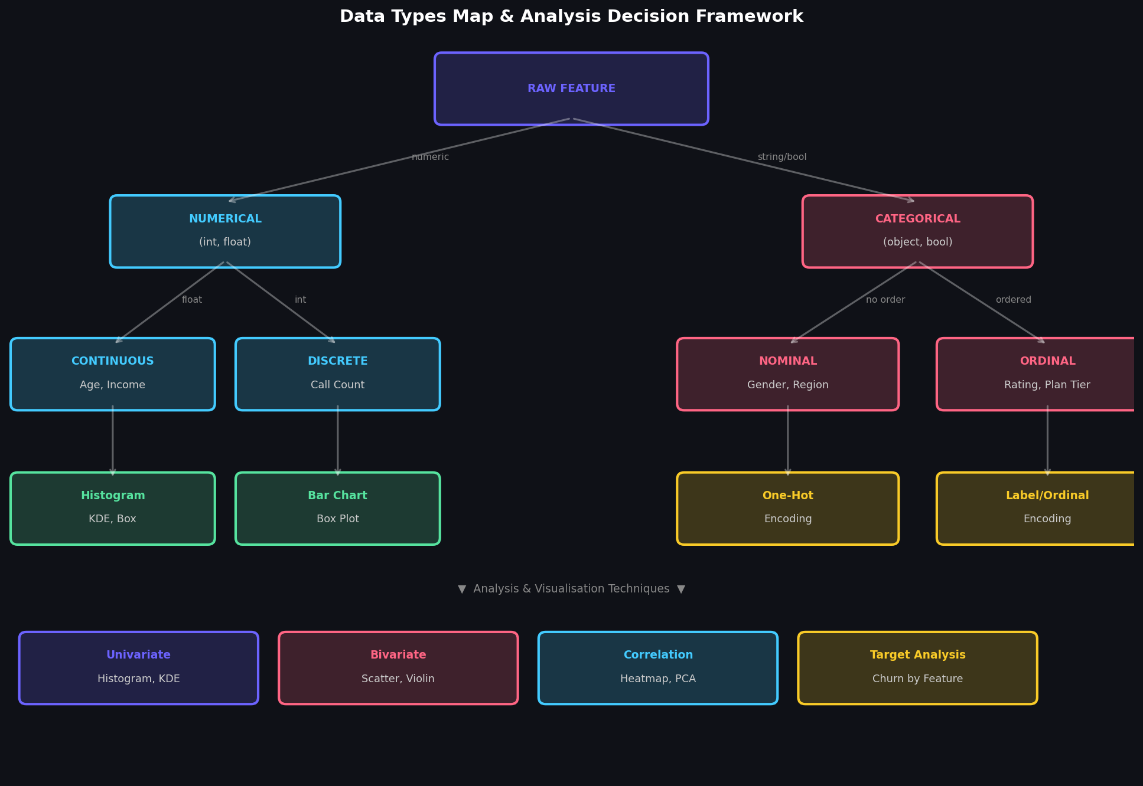
Figure: Data Types Map & Analysis Decision Framework

3. Data Exploration Techniques

3.1 Univariate Analysis
Univariate analysis examines each variable individually. The goal is to understand its distribution, central tendency, spread, and presence of outliers.

• Histograms
Reveal shape of distribution (normal, skewed, bimodal).
plt.hist(df['monthly_charges'], bins=30)

• KDE Plots
Smooth probability density estimate; better than histograms for continuous data.
df['tenure'].plot.kde()

• Box Plots
Visualise median, IQR, and outliers simultaneously.
sns.boxplot(y=df['total_charges'])

• Bar Charts
Frequency of categorical variables.
df['contract'].value_counts().plot.bar()

• Value Counts
Exact category frequencies.
df['internet_service'].value_counts(normalize=True)

3.2 Bivariate Analysis
Bivariate analysis examines relationships between two variables, particularly between each feature and the target variable (churn).

• Churn Rate by Category
Group by categorical feature → compute churn rate → bar chart.
df.groupby('contract')['churn'].mean().plot.bar()

• Scatter Plots
Show relationship between two continuous features; colour by churn.
sns.scatterplot(data=df, x='tenure', y='monthly_charges', hue='churn')

• Violin Plots
Distribution shape + summary statistics split by churn label.
sns.violinplot(data=df, x='churn', y='monthly_charges')

• Point-Biserial Corr.
Correlation between binary target and continuous features.
df.corr()['churn'].sort_values()

3.3 Multivariate Analysis
Multivariate analysis considers interactions among three or more variables, revealing complex patterns not visible in simpler analyses.

• Correlation Heatmap
Full correlation matrix of all numerical features.
sns.heatmap(df.corr(), annot=True, cmap='coolwarm')

• Pair Plot
All-vs-all scatter matrix; coloured by churn.
sns.pairplot(df[num_cols], hue='churn')

• PCA Biplot
Reduce to 2D; visualise cluster separation.
from sklearn.decomposition import PCA; pca = PCA(2); X_pca = pca.fit_transform(X)

• Parallel Coordinates
Visualise all features simultaneously across observations.
pd.plotting.parallel_coordinates(df_sample, 'churn')

4. Handling Missing Data & Outliers

4.1 Missing Value Strategy
Missing Pattern | Threshold | Strategy
MCAR (Missing Completely At Random) | < 5% | Simple median/mode imputation
MAR (Missing At Random) | 5–30% | MICE (Multiple Imputation by Chained Equations)
MNAR (Missing Not At Random) | Any | Flag indicator column + domain imputation
Structural Missing | Any | Treat as a separate category (e.g., 'No Service')

4.2 Outlier Detection & Treatment
We use multiple methods to detect outliers, applying different treatments based on context:
Method | Detection Criterion | Treatment
IQR Method | Values outside [Q1-1.5×IQR, Q3+1.5×IQR] | Cap to fence (Winsorisation)
Z-Score | |Z| > 3 | Remove or cap
Isolation Forest | Unsupervised anomaly detection | Flag as anomaly; investigate
Domain Knowledge | Business rules (e.g., tenure > 120 months) | Remove or correct

5. Visualisation Strategies
A structured visualisation plan ensures every analytical question has a corresponding chart. The strategy matrix below maps analysis goals to specific plot types and Python implementation tools.
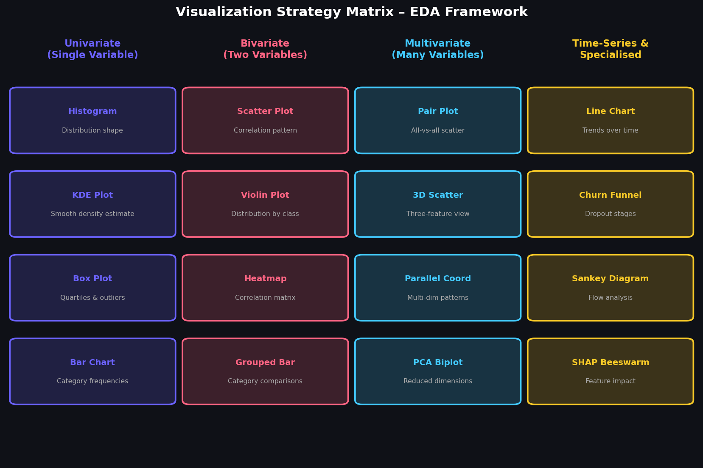
Figure: Visualization Strategy Matrix – Four Categories of EDA Plots

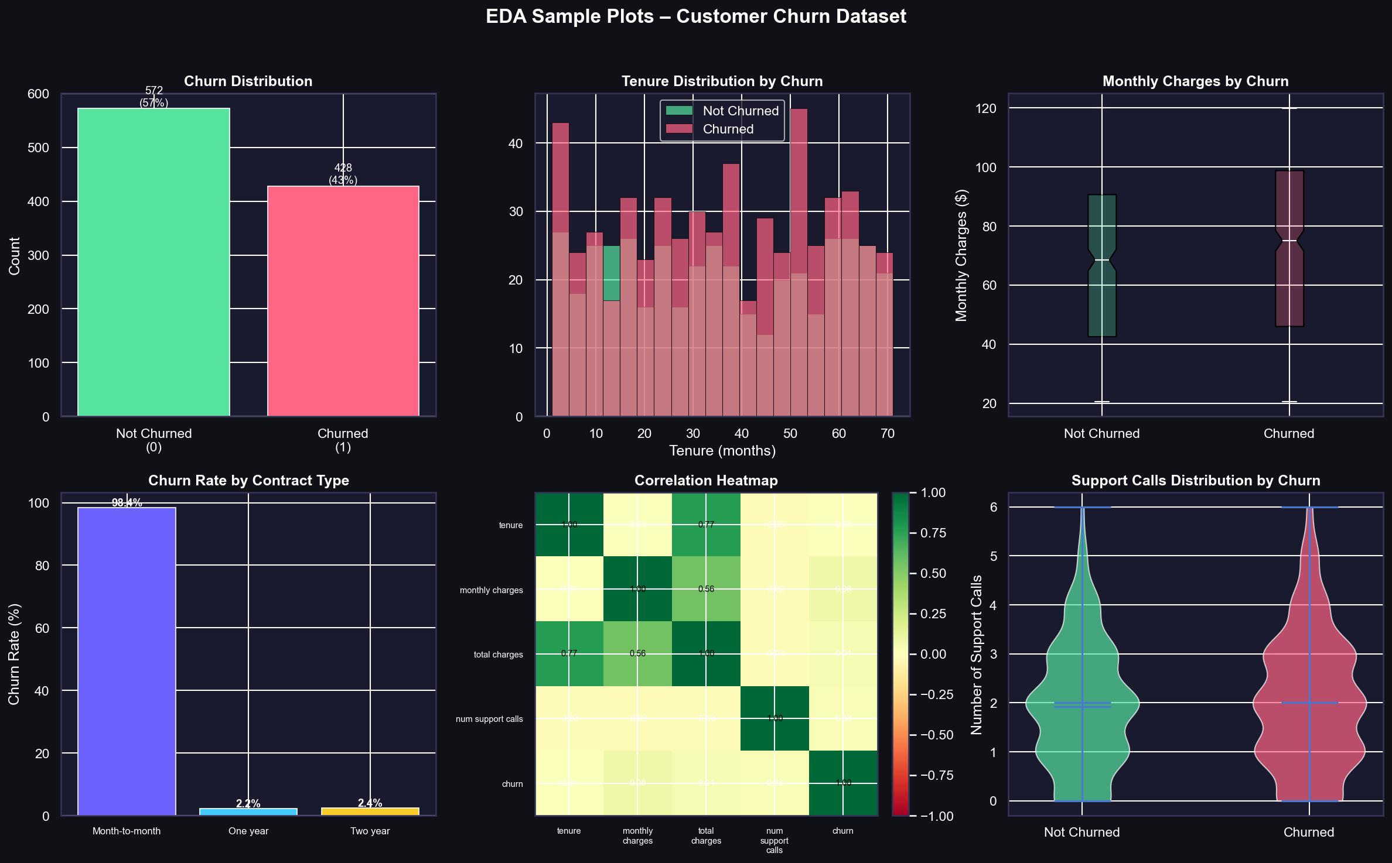
Figure: Sample EDA Output Plots Generated on Synthetic Churn Dataset

6. Tools & Python Libraries
Library | Version | EDA Role
pandas | 2.2.x | Data loading, cleaning, groupby, pivot tables, missing value handling
numpy | 1.26.x | Numerical computation, array operations, statistical functions
matplotlib | 3.9.x | Low-level plotting; full customisation; save high-DPI PNGs
seaborn | 0.13.x | Statistical plot library built on matplotlib; heatmaps, violin, pair
plotly | 5.22.x | Interactive dashboards; scatter, sunburst, Sankey, parallel coords
scipy | 1.13.x | Statistical tests (chi-squared, t-test, ANOVA) for EDA validation
scikit-learn | 1.5.x | PCA, Isolation Forest, preprocessing (StandardScaler, encoder)
missingno | 0.5.x | Specialised visualisation of missing value patterns

7. Reporting & Documentation Plan
All EDA findings will be documented in a structured Jupyter Notebook and summarised in a concise EDA Report. The report will follow this template:
- Executive Summary (1 page): Key findings, class balance, top 3 patterns discovered.
- Dataset Overview: Shape, data types, coverage dates, source systems.
- Data Quality Report: Missing value counts, outlier flags, duplicate rows.
- Univariate Analysis: Histograms/KDE for each numerical feature; bar charts for categorical.
- Bivariate Analysis: Churn rate by key features; scatter plots; violin plots.
- Multivariate Analysis: Correlation heatmap; PCA projection; pair plot subset.
- Key Hypotheses: Numbered list of hypotheses generated for modelling phase.
- Data Preparation Recommendations: Feature engineering ideas, encoding strategies.
- Appendix: Full correlation matrix; distribution plots for all 80 features.

8. Conclusion
This Week 2 framework establishes a comprehensive, systematic approach to EDA that is adaptable to any structured tabular dataset. By combining univariate, bivariate, and multivariate techniques with a rich library of Python visualisation tools, the framework ensures no important pattern goes undetected before modelling begins. The structured documentation plan ensures findings are communicated clearly to both technical and non-technical stakeholders, setting the stage for informed, hypothesis-driven modelling in Week 3.

