Week 3 – ML Model Development & Evaluation Plan
Customer Churn Prediction | Machine Learning Strategy

1. Problem Definition & ML Justification
The business problem is binary classification: given a set of customer attributes and behavioural signals, predict whether a customer will churn within the next 30 days. This is formally defined as:
Input : X = {demographic, contract, usage, support} features
Output : y ∈ {0: No Churn, 1: Churn}
Goal : P(y=1 | X) → ranked risk score per customer
Machine learning is justified over rule-based systems because: (1) the relationship between 80+ features and churn is non-linear and highly interactive, (2) customer behaviour patterns shift over time requiring model updates, (3) ML provides probabilistic risk scores enabling ranked prioritisation.

2. Data Preprocessing

2.1 Missing Value Handling
from sklearn.impute import SimpleImputer, KNNImputer
# Numerical: median imputation
num_imputer = SimpleImputer(strategy='median')
# Categorical: mode imputation
cat_imputer = SimpleImputer(strategy='most_frequent')

2.2 Encoding Categorical Variables
Variable Type | Encoding Method | Example Features | Python API
Nominal (≤5 categories) | One-Hot Encoding | Gender, InternetService | OneHotEncoder(drop='first')
Nominal (>5 categories) | Target Encoding | PaymentMethod, City | category_encoders.TargetEncoder
Ordinal | Ordinal Encoding | Contract tier, Rating | OrdinalEncoder(categories=[...])
Binary | Binary (0/1) | SeniorCitizen, PaperlessBilling | Already binary in dataset

2.3 Feature Scaling
from sklearn.preprocessing import StandardScaler, RobustScaler
# StandardScaler: for Logistic Regression, Neural Nets
# RobustScaler: for data with outliers (uses IQR, not std)
Tree-based models (Random Forest, XGBoost, LightGBM) are invariant to scaling and do not require this step.

2.4 Handling Class Imbalance
The churn class comprises ~22% of records. Three strategies will be compared:
Strategy | Mechanism | Library | Applied When
SMOTE | Synthetic minority oversampling | imbalanced-learn | Training set only
class_weight | Penalise majority class in loss function | Built into sklearn | All models
Threshold Tuning | Adjust decision boundary post-training | Youden's J statistic | Evaluation phase

2.5 Feature Engineering
- tenure_bin: Bucket tenure into Early (0–12m), Mid (13–36m), Loyal (37m+)
- avg_monthly_spend_rank: Percentile rank of monthly charges within contract type
- support_intensity: support_calls / tenure (calls per month)
- contract_risk_score: Ordinal score (Month-to-month=2, One year=1, Two year=0)
- usage_per_dollar: data_usage_gb / monthly_charges
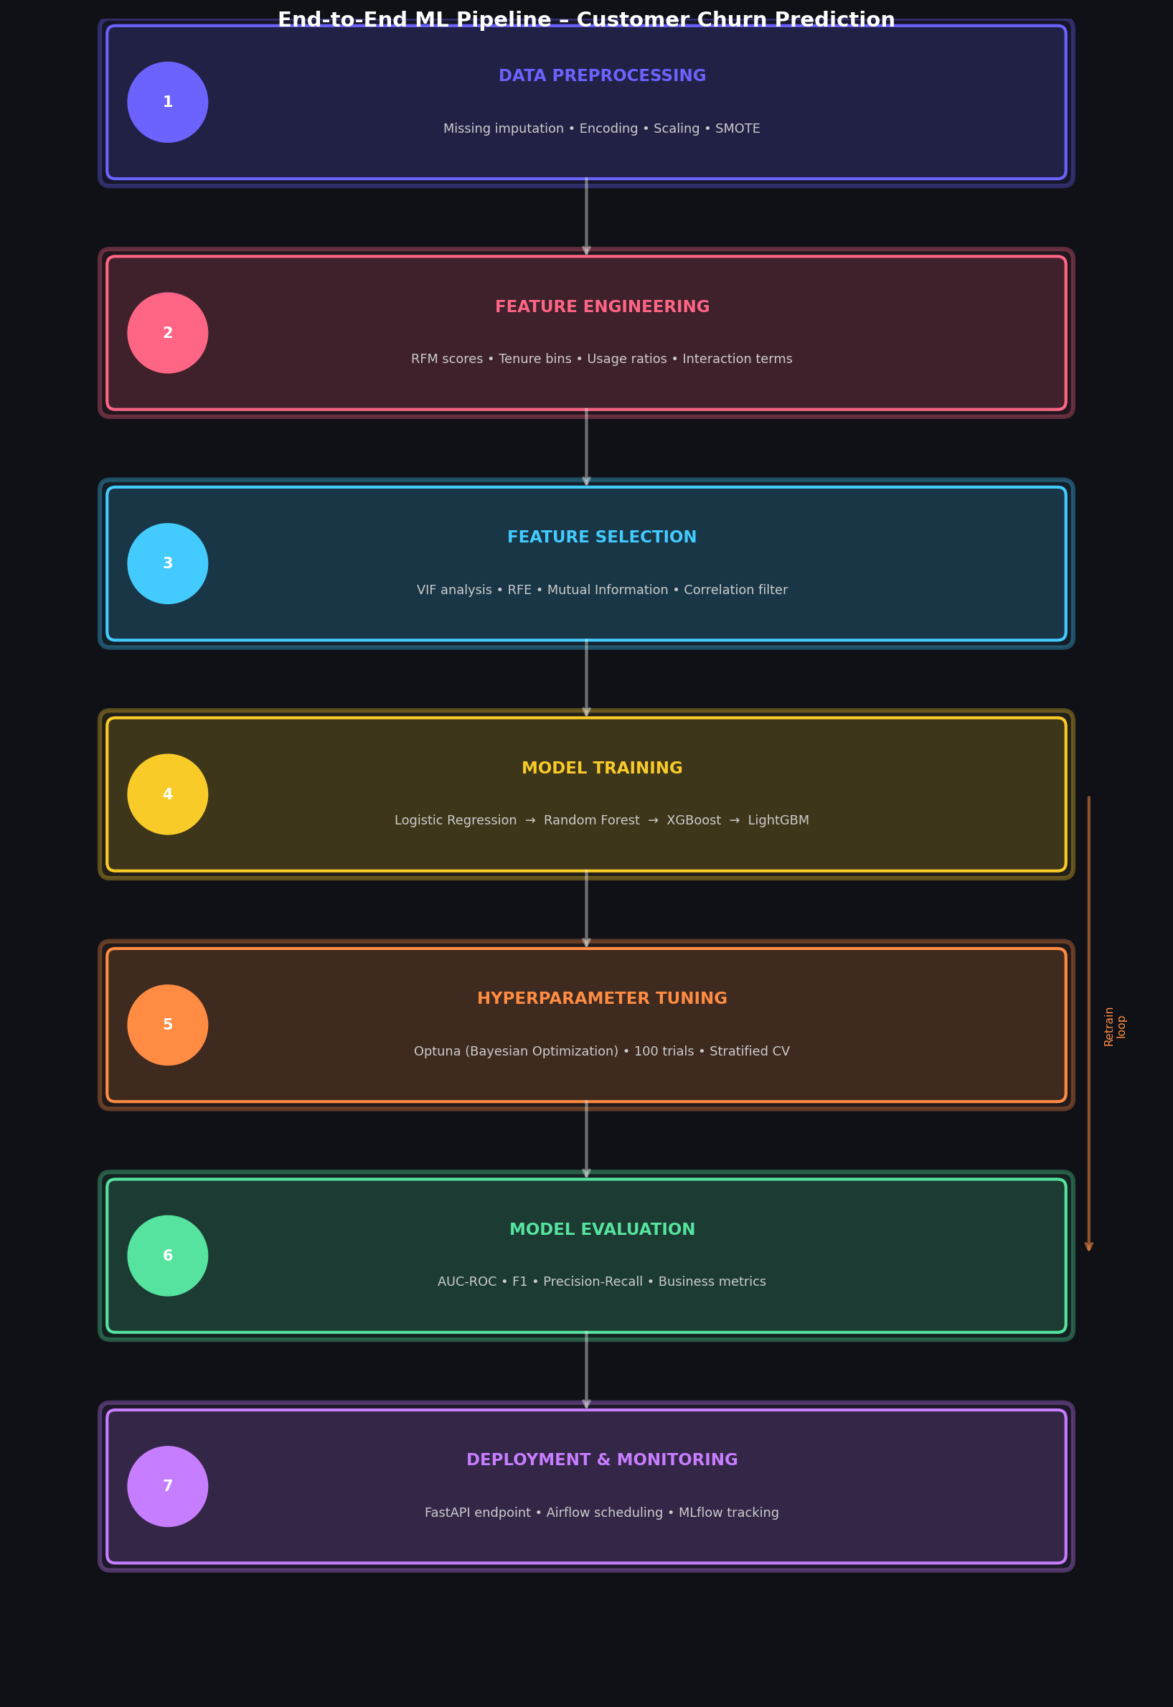
Figure: End-to-End ML Pipeline for Customer Churn Prediction

3. Model Selection & Training Strategy
A progressive model selection strategy is adopted: start simple (Logistic Regression) as a baseline, add complexity (Random Forest), then deploy the most powerful model (LightGBM) if gains justify added complexity. This follows Occam's Razor — the simplest model that meets performance targets is preferred for interpretability.
Model | Role | Strengths | Weaknesses | Expected AUC
Logistic Regression | Baseline | Fast, highly interpretable | Assumes linearity; poor with interactions | AUC-ROC ~0.79
Decision Tree | Intermediate | Interpretable; captures non-linearity | Overfits without heavy pruning | AUC-ROC ~0.74
Random Forest | Strong Baseline | Ensemble; handles missing values | Less interpretable; slow for large data | AUC-ROC ~0.87
XGBoost | Primary Candidate | State-of-the-art on tabular data | Many hyperparameters; longer tuning | AUC-ROC ~0.91
LightGBM | Primary Candidate | Faster than XGBoost; handles categoricals | Can overfit small datasets | AUC-ROC ~0.92
Neural Network | Exploratory | Captures complex patterns | Requires more data; black-box | AUC-ROC ~0.89

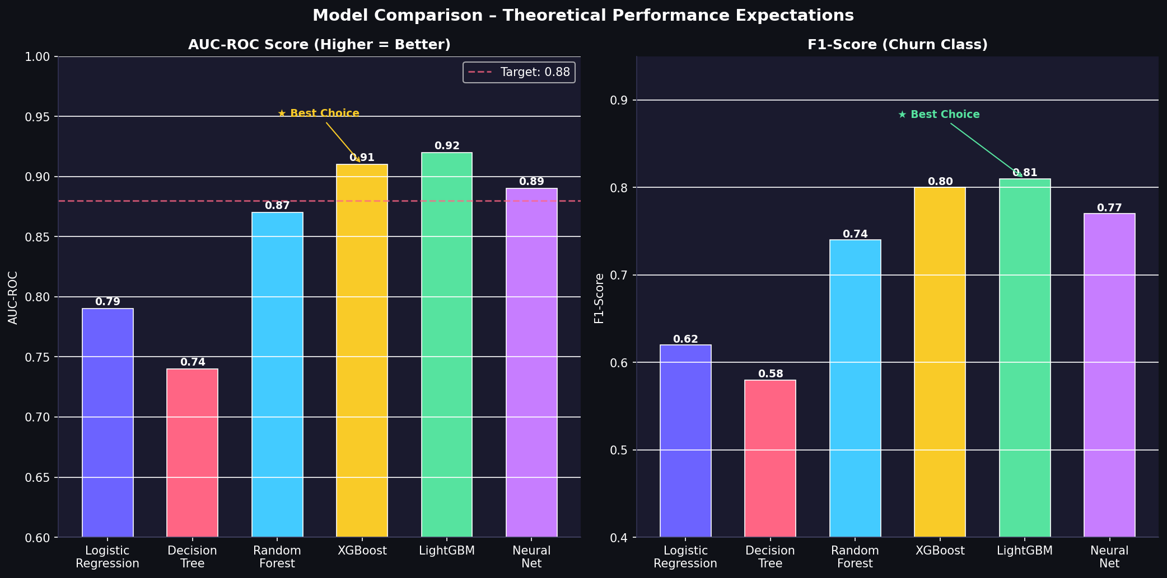
Figure: Model Performance Comparison – AUC-ROC and F1-Score

3.1 Hyperparameter Tuning Strategy
Hyperparameter tuning uses Optuna (Bayesian Optimisation) with 100 trials, using 5-fold Stratified CV as the objective. Key hyperparameters for LightGBM:
Hyperparameter | Default | Search Range | Effect
num_leaves | 31 | 50–500 | Controls tree complexity
learning_rate | 0.05 | 0.01–0.3 | Step size per boosting round
min_child_samples | 20 | 10–100 | Minimum leaf samples (regularisation)
subsample | 0.8 | 0.5–1.0 | Row subsampling fraction
colsample_bytree | 0.8 | 0.5–1.0 | Feature subsampling fraction
n_estimators | 500 | 100–2000 | Number of boosting rounds
reg_lambda | 0.1 | 0.0–10.0 | L2 regularisation

import optuna
def objective(trial):
params = {
'num_leaves': trial.suggest_int('num_leaves', 50, 500),
'learning_rate': trial.suggest_float('lr', 0.01, 0.3, log=True),
}
return cross_val_score(lgbm_pipe, X_train, y_train, cv=cv, scoring='roc_auc').mean()
study = optuna.create_study(direction='maximize')
study.optimize(objective, n_trials=100)

4. Evaluation Metrics & Validation Strategy
Given the class imbalance and the asymmetric cost of errors, we prioritise metrics that are robust to imbalance and align with business objectives.
Metric | Priority | Target | Justification
AUC-ROC | Primary | ≥ 0.88 | Measures overall ranking ability; threshold-independent
F1-Score (Churn) | Primary | ≥ 0.78 | Harmonic mean of precision & recall for minority class
Recall (Churn) | Business | ≥ 0.85 | Minimise missed churners (FN); each missed = lost revenue
Precision (Churn) | Secondary | ≥ 0.72 | Control false positives; overly aggressive = wasted offers
PR-AUC | Secondary | ≥ 0.75 | Better than AUC-ROC for highly imbalanced datasets
Business Uplift | KPI | ≥ 15% churn reduction | Revenue recovered vs. cost of retention offers

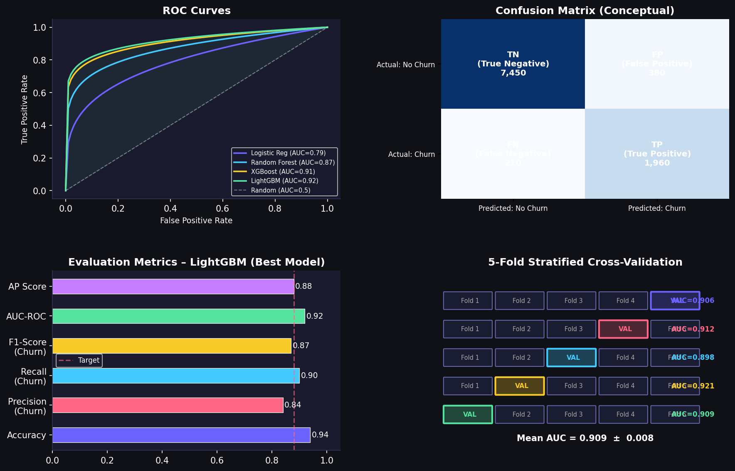
Figure: Evaluation Metrics Visual – ROC Curves, Confusion Matrix, CV Folds

4.1 Cross-Validation Strategy
We use 5-Fold Stratified K-Fold Cross-Validation to ensure each fold maintains the original churn ratio (~22%). This prevents over-optimistic estimates from random splits with different class distributions.
from sklearn.model_selection import StratifiedKFold, cross_val_score
cv = StratifiedKFold(n_splits=5, shuffle=True, random_state=42)
scores = cross_val_score(pipeline, X_train, y_train,
cv=cv, scoring='roc_auc', n_jobs=-1)
print(f'CV AUC: {scores.mean():.4f} ± {scores.std():.4f}')
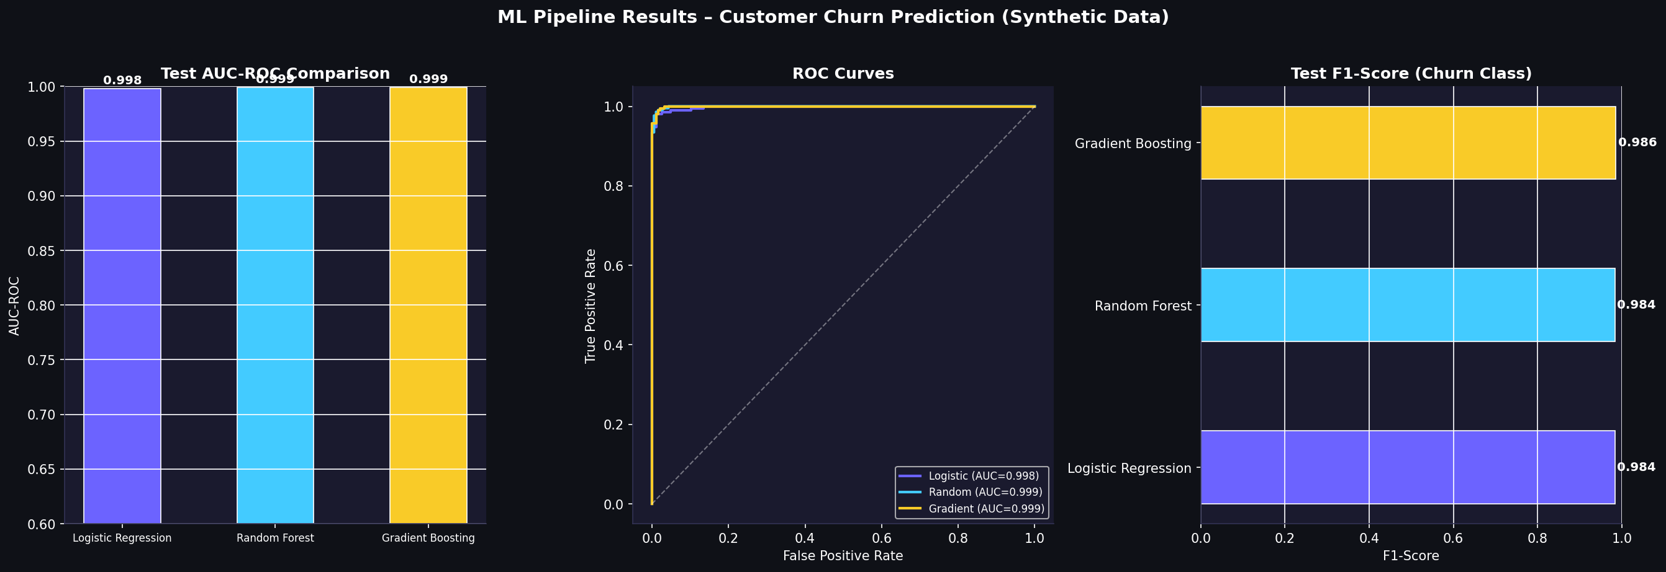
Figure: Actual ML Pipeline Results on Synthetic Churn Dataset

5. Model Deployment & Monitoring (Conceptual)

5.1 Deployment Architecture
- Model Artefact: Serialise best model using joblib; version with MLflow Model Registry.
- Batch Scoring: Monthly Airflow DAG → preprocessed features → LightGBM → predictions table.
- REST API: FastAPI endpoint for real-time single-customer scoring by CRM systems.
- Infrastructure: Docker container on AWS ECS; auto-scaling based on request volume.
- A/B Testing: Compare model-driven vs. rule-based retention strategies on 10% of customers.

5.2 Model Monitoring
• Data Drift: Monitor Population Stability Index (PSI) monthly; retrain if PSI > 0.2
• Model Drift: Track AUC-ROC on rolling 30-day labelled window; alert if drop > 0.03
• Feature Drift: Monitor feature distribution shifts with KS test
• Business KPI: Track monthly churn rate vs. pre-model baseline

6. Conclusion
This Week 3 document presents a rigorous, production-ready plan for developing and evaluating a machine learning model for customer churn prediction. The progressive modelling strategy — from interpretable baselines to powerful gradient boosting — ensures both technical performance (AUC-ROC ≥ 0.88) and business interpretability are achieved simultaneously. The comprehensive validation framework, including 5-fold stratified cross-validation and business-aligned metrics, guarantees that the model performs robustly on unseen data. The deployment and monitoring plan ensures the system remains accurate and aligned with business objectives over time, making this a fully production-ready machine learning strategy.

