**Exercise 1: Configuring a Basic Spring Application**

**Scenario:**

Your company is developing a web application for managing a library. You need to use the Spring Framework to handle the backend operations.

**Steps:**

1. **Set Up a Spring Project:**
   * Create a Maven project named **LibraryManagement**.
   * Add Spring Core dependencies in the **pom.xml** file.
   * 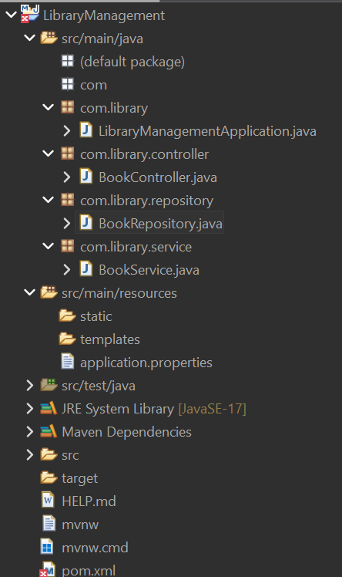
2. **Configure the Application Context:**
   * Create an XML configuration file named **applicationContext.xml** in the **src/main/resources** directory.
   * Define beans for **BookService** and **BookRepository** in the XML file.
3. **Define Service and Repository Classes:**
   * Create a package **com.library.service** and add a class **BookService**.

**Package com.library.service**

package com.library.service;

import org.springframework.beans.factory.annotation.Autowired;

import org.springframework.stereotype.Service;

import com.library.repository.BookRepository;

*@Service*

public class BookService {

private final BookRepository bookRepository;

// Constructor-based dependency injection

*@Autowired*

public BookService(BookRepository bookRepository) {

this.bookRepository = bookRepository;

}

public void displayService() {

System.***out***.println("BookService: Service is working...");

bookRepository.displayRepo();

}

}

* + Create a package **com.library.repository** and add a class **BookRepository**.

**package com.library.repository :**

package com.library.repository;

import org.springframework.stereotype.Repository;

*@Repository* // ✅ This is required so Spring can register the bean

public class BookRepository {

public void displayRepo() {

System.***out***.println("BookRepository: Fetching book data...");

}

}

**Run the Application:**

* + Create a main class to load the Spring context and test the configuration.

[**http://localhost:8080/books**](http://localhost:8080/books)

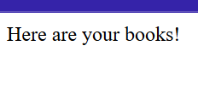

**Exercise 2: Implementing Dependency Injection**

**Scenario:**

In the library management application, you need to manage the dependencies between the BookService and BookRepository classes using Spring's IoC and DI.

**Steps:**

1. **Modify the XML Configuration:**
   * Update **applicationContext.xml** to wire **BookRepository** into **BookService**.

**applicationContext.xml :**

<?xml version="1.0" encoding="UTF-8"?>

<beans xmlns="http://www.springframework.org/schema/beans"

xmlns:xsi="http://www.w3.org/2001/XMLSchema-instance"

xsi:schemaLocation="

http://www.springframework.org/schema/beans

http://www.springframework.org/schema/beans/spring-beans.xsd">

<!-- BookRepository Bean -->

<bean id="bookRepository" class="com.library.repository.BookRepository"/>

<!-- BookService Bean with Dependency Injection -->

<bean id="bookService" class="com.library.service.BookService">

<property name="bookRepository" ref="bookRepository"/>

</bean>

</beans>

1. **Update the BookService Class:**
   * Ensure that **BookService** class has a setter method for **BookRepository**.

**BookService.java :**

package com.library.service;

import org.springframework.beans.factory.annotation.Autowired;

import org.springframework.stereotype.Service;

import com.library.repository.BookRepository;

*@Service*

public class BookService {

private final BookRepository bookRepository;

*@Autowired* // constructor injection

public BookService(BookRepository bookRepository) {

this.bookRepository = bookRepository;

}

public String displayService() {

return "BookService: Service is working...\n" + bookRepository.displayRepo();

}

}

**BookRepository.java :**

package com.library.repository;

import org.springframework.stereotype.Repository;

*@Repository*

public class BookRepository {

public String displayRepo() {

return "BookRepository: Fetching book data...";

}

}

3.**Test the Configuration:**

* + Run the **LibraryManagementApplication** main class to verify the dependency injection.

**LibraryManagementApplication,java :**

package com.library;

import org.springframework.boot.SpringApplication;

import org.springframework.boot.autoconfigure.SpringBootApplication;

*@SpringBootApplication*

public class LibraryManagementApplication {

public static void main(String[] args) {

SpringApplication.*run*(LibraryManagementApplication.class, args);

}

}

**OUTPUT:**



[**http://localhost:8080/books**](http://localhost:8080/books)

**Exercise 3: Implementing Logging with Spring AOP**

**Scenario:**

The library management application requires logging capabilities to track method execution times.

**Steps:**

1. **Add Spring AOP Dependency:**
   * Update **pom.xml** to include Spring AOP dependency.

**UPDATED pom.xml :**

<?xml version="1.0" encoding="UTF-8"?>

<project xmlns="http://maven.apache.org/POM/4.0.0" xmlns:xsi="http://www.w3.org/2001/XMLSchema-instance"

xsi:schemaLocation="http://maven.apache.org/POM/4.0.0 https://maven.apache.org/xsd/maven-4.0.0.xsd">

<modelVersion>4.0.0</modelVersion>

<parent>

<groupId>org.springframework.boot</groupId>

<artifactId>spring-boot-starter-parent</artifactId>

<version>3.5.3</version>

<relativePath/> <!-- lookup parent from repository -->

</parent>

<groupId>com.library</groupId>

<artifactId>LibraryManagement</artifactId>

<version>0.0.1-SNAPSHOT</version>

<name>LibraryManagement</name>

<description>Demo project for Spring Boot</description>

<url/>

<licenses>

<license/>

</licenses>

<developers>

<developer/>

</developers>

<scm>

<connection/>

<developerConnection/>

<tag/>

<url/>

</scm>

<properties>

<java.version>17</java.version>

</properties>

<dependencies>

<dependency>

<groupId>org.springframework.boot</groupId>

<artifactId>spring-boot-starter-data-jpa</artifactId>

</dependency>

<dependency>

<groupId>org.springframework.boot</groupId>

<artifactId>spring-boot-starter-web</artifactId>

</dependency>

<dependency>

<groupId>org.springframework.boot</groupId>

<artifactId>spring-boot-devtools</artifactId>

<scope>runtime</scope>

<optional>true</optional>

</dependency>

<dependency>

<groupId>com.h2database</groupId>

<artifactId>h2</artifactId>

<scope>runtime</scope>

</dependency>

<dependency>

<groupId>org.springframework.boot</groupId>

<artifactId>spring-boot-starter-test</artifactId>

<scope>test</scope>

</dependency>

<dependency>

<groupId>org.springframework.boot</groupId>

<artifactId>spring-boot-starter-aop</artifactId>

</dependency>

</dependencies>

<build>

<plugins>

<plugin>

<groupId>org.springframework.boot</groupId>

<artifactId>spring-boot-maven-plugin</artifactId>

</plugin>

</plugins>

</build>

</project>

1. **:Create an Aspect for Logging:**
   * Create a package **com.library.aspect** and add a class **LoggingAspect** with a method to

log execution times.

**Package com.library.aspect :**

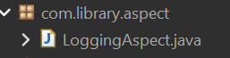

**LoggingAspect:**

package com.library.aspect;

import org.aspectj.lang.ProceedingJoinPoint;

import org.aspectj.lang.annotation.Around;

import org.aspectj.lang.annotation.Aspect;

import org.springframework.stereotype.Component;

*@Aspect*

*@Component*

public class LoggingAspect {

*@Around*("execution(* com.library.service.*.*(..))")

public Object logExecutionTime(ProceedingJoinPoint joinPoint) throws Throwable {

String methodName = joinPoint.getSignature().toShortString();

long start = System.*currentTimeMillis*();

System.***out***.println(">> [AOP] Starting method: " + methodName);

Object result = joinPoint.proceed();

long end = System.*currentTimeMillis*();

System.***out***.println(">> [AOP] Completed method: " + methodName + " in " + (end - start) + " ms");

return result;

}

}

1. **Enable AspectJ Support:**
   * Update **applicationContext.xml** to enable **AspectJ** support and register the aspect.

**applicationContext.xml :**

<?xml version="1.0" encoding="UTF-8"?>

<beans xmlns="http://www.springframework.org/schema/beans"

xmlns:xsi="http://www.w3.org/2001/XMLSchema-instance"

xsi:schemaLocation="

http://www.springframework.org/schema/beans

http://www.springframework.org/schema/beans/spring-beans.xsd">

<!-- BookRepository Bean -->

<bean id="bookRepository" class="com.library.repository.BookRepository"/>

<!-- BookService Bean with Dependency Injection -->

<bean id="bookService" class="com.library.service.BookService">

<property name="bookRepository" ref="bookRepository"/>

</bean>

</beans>

1. **Test the Aspect:**
   * 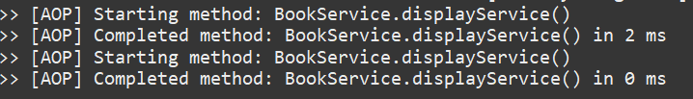Run the **LibraryManagementApplication** main class and observe the console for log messages indicating method execution times.

**Exercise 4: Creating and Configuring a Maven Project**

**Scenario:**

You need to set up a new Maven project for the library management application and add Spring dependencies.

**Steps:**

1. **Create a New Maven Project:**
   * Create a new Maven project named **LibraryManagement**.

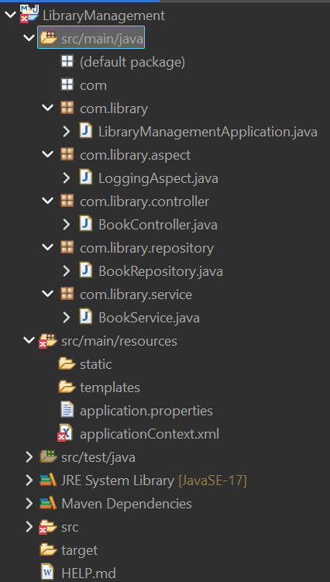

1. **Add Spring Dependencies in pom.xml:**
   * Include dependencies for Spring Context, Spring AOP, and Spring WebMVC.
2. <?xml version="1.0" encoding="UTF-8"?>
3. <project xmlns="http://maven.apache.org/POM/4.0.0" xmlns:xsi="http://www.w3.org/2001/XMLSchema-instance"
4. xsi:schemaLocation="http://maven.apache.org/POM/4.0.0 https://maven.apache.org/xsd/maven-4.0.0.xsd">
5. <modelVersion>4.0.0</modelVersion>
6. <parent>
7. <groupId>org.springframework.boot</groupId>
8. <artifactId>spring-boot-starter-parent</artifactId>
9. <version>3.5.3</version>
10. <relativePath/> <!-- lookup parent from repository -->
11. </parent>
12. <groupId>com.library</groupId>
13. <artifactId>LibraryManagement</artifactId>
14. <version>0.0.1-SNAPSHOT</version>
15. <name>LibraryManagement</name>
16. <description>Demo project for Spring Boot</description>
17. <url/>
18. <licenses>
19. <license/>
20. </licenses>
21. <developers>
22. <developer/>
23. </developers>
24. <scm>
25. <connection/>
26. <developerConnection/>
27. <tag/>
28. <url/>
29. </scm>
30. <properties>
31. <java.version>17</java.version>
32. </properties>
33. <dependencies>
34. <dependency>
35. <groupId>org.springframework.boot</groupId>
36. <artifactId>spring-boot-starter-data-jpa</artifactId>
37. </dependency>
38. <dependency>
39. <groupId>org.springframework.boot</groupId>
40. <artifactId>spring-boot-starter-web</artifactId>
41. </dependency>
42. <dependency>
43. <groupId>org.springframework.boot</groupId>
44. <artifactId>spring-boot-devtools</artifactId>
45. <scope>runtime</scope>
46. <optional>true</optional>
47. </dependency>
48. <dependency>
49. <groupId>com.h2database</groupId>
50. <artifactId>h2</artifactId>
51. <scope>runtime</scope>
52. </dependency>
53. <dependency>
54. <groupId>org.springframework.boot</groupId>
55. <artifactId>spring-boot-starter-test</artifactId>
56. <scope>test</scope>
58. </dependency>
59. <dependency>
60. <groupId>org.springframework.boot</groupId>
61. <artifactId>spring-boot-starter-aop</artifactId>
62. </dependency>
63. </dependencies>
64. <build>
65. <plugins>
66. <plugin>
67. <groupId>org.springframework.boot</groupId>
68. <artifactId>spring-boot-maven-plugin</artifactId>
69. </plugin>
70. </plugins>
71. </build>
72. </project>

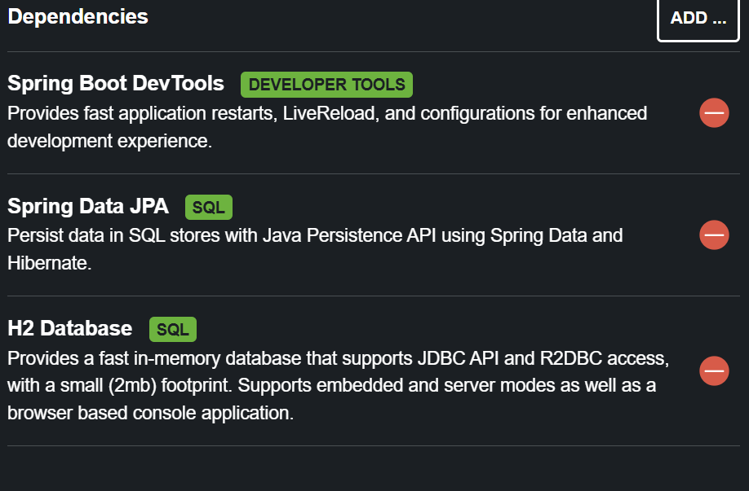

1. **Configure Maven Plugins:**
   * Configure the Maven Compiler Plugin for Java version 1.8 in the pom.xml file.

**localhost:8080**

**Exercise 5: Configuring the Spring IoC Container**

**Scenario:**

The library management application requires a central configuration for beans and dependencies.

**Steps:**

1. **Create Spring Configuration File:**
   * Create an XML configuration file named **applicationContext.xml** in the **src/main/resources** directory.

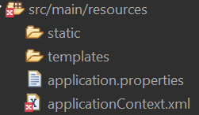

* + Define beans for **BookService** and **BookRepository** in the XML file.

**BEAN’s of BookService and BookRepository :**

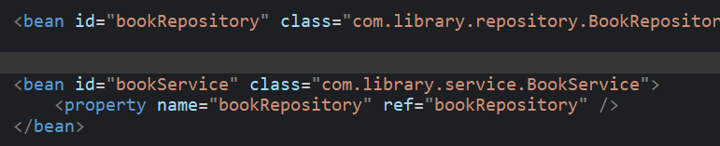

1. **Update the BookService Class:**
   * Ensure that the **BookService** class has a setter method for **BookRepository**.

**BookService with setter method :**

package com.library.service;

import com.library.repository.BookRepository;

public class BookService {

private BookRepository bookRepository;

// ✅ Setter for Spring DI

public void setBookRepository(BookRepository bookRepository) {

this.bookRepository = bookRepository;

}

public void displayService() {

System.***out***.println("BookService: Service is working...");

bookRepository.displayRepo();

}

}

1. **Run the Application:**
   * Create a main class to load the Spring context and test the configuration.

**Mian calss**

package com.library;

import org.springframework.context.ApplicationContext;

import org.springframework.context.support.ClassPathXmlApplicationContext;

import com.library.service.BookService;

public class LibraryManagementApplication {

public static void main(String[] args) {

ApplicationContext context = new ClassPathXmlApplicationContext("applicationContext.xml");

BookService bookService = context.getBean("bookService", BookService.class);

bookService.displayService();

}

}



[**http://localhost:8080/books**](http://localhost:8080/books)

**Exercise 6: Configuring Beans with Annotations**

**Scenario:**

You need to simplify the configuration of beans in the library management application using annotations.

**Steps:**

1. **Enable Component Scanning:**
   * Update **applicationContext.xml** to include component scanning for the **com.library** package.

**Update applicationContext.xml :**

<?xml version="1.0" encoding="UTF-8"?>

<beans xmlns="http://www.springframework.org/schema/beans"

xmlns:xsi="http://www.w3.org/2001/XMLSchema-instance"

xmlns:context="http://www.springframework.org/schema/context"

xsi:schemaLocation="

http://www.springframework.org/schema/beans

https://www.springframework.org/schema/beans/spring-beans.xsd

http://www.springframework.org/schema/context

https://www.springframework.org/schema/context/spring-context.xsd">

<!-- Enable annotation scanning in com.library and sub-packages -->

<context:component-scan base-package="com.library" />

</beans>

1. **Annotate Classes:**
   * Use **@Service** annotation for the **BookService** class.

**@Service annotation in BookService :**

package com.library.service;

import org.springframework.beans.factory.annotation.Autowired;

import org.springframework.stereotype.Service;

import com.library.repository.BookRepository;

*@Service*

public class BookService {

*@Autowired*

private BookRepository bookRepository;

public void displayService() {

System.***out***.println("BookService: Service is working...");

bookRepository.displayRepo();

}

}

* + Use **@Repository** annotation for the **BookRepository** class.

**@Repository annotation in BookRepository :**

package com.library.repository;

import org.springframework.stereotype.Repository;

*@Repository*

public class BookRepository {

public void displayRepo() {

System.***out***.println("BookRepository: Fetching book data...");

}

}

1. **Test the Configuration:**
   * Run the **LibraryManagementApplication** main class to verify the annotation-based configuration.

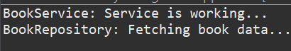

**OUTPUT from console**

**Exercise 7: Implementing Constructor and Setter Injection**

**Scenario:**

The library management application requires both constructor and setter injection for better control over bean initialization.

**Steps:**

1. **Configure Constructor Injection:**
   * Update applicationContext.**xml** to configure constructor injection for **BookService**.

**Update applicationContext.xml with constructor injection for BookService :**

<?xml version="1.0" encoding="UTF-8"?>

<beans xmlns="http://www.springframework.org/schema/beans"

xmlns:xsi="http://www.w3.org/2001/XMLSchema-instance"

xsi:schemaLocation="

http://www.springframework.org/schema/beans

https://www.springframework.org/schema/beans/spring-beans.xsd">

<!-- BookRepository Bean -->

<bean id="bookRepository" class="com.library.repository.BookRepository" />

<!-- BookService Bean with constructor + setter injection -->

<bean id="bookService" class="com.library.service.BookService">

<!-- Constructor injection -->

<constructor-arg value="LibraryAppService"/>

<!-- Setter injection -->

<property name="bookRepository" ref="bookRepository"/>

</bean>

</beans>

1. **Configure Setter Injection:**
   * Ensure that the **BookService** class has a setter method for **BookRepository** and configure it in **applicationContext.xml**.

**BookService with a setter method for BookRepository :**

package com.library.service;

import com.library.repository.BookRepository;

public class BookService {

private BookRepository bookRepository;

private String serviceName;

// Constructor injection

public BookService(String serviceName) {

this.serviceName = serviceName;

}

// ✅ Setter injection

public void setBookRepository(BookRepository bookRepository) {

this.bookRepository = bookRepository;

}

public void displayService() {

System.***out***.println("[" + serviceName + "] BookService: Service is working...");

bookRepository.displayRepo();

}

}

1. **Test the Injection:**
   * Run the **LibraryManagementApplication** main class to verify both constructor and setter injection.

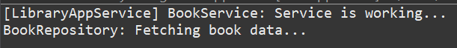

**Exercise 8: Implementing Basic AOP with Spring**

**Scenario:**

The library management application requires basic AOP functionality to separate cross-cutting concerns like logging and transaction management.

**Steps:**

1. **Define an Aspect:**
   * Create a package **com.library.aspect** and add a class **LoggingAspect**.

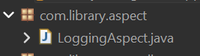

1. **Create Advice Methods:**
   * Define advice methods in **LoggingAspect** for logging before and after method execution.

**LoggingAspect.java :**

package com.library.aspect;

import org.aspectj.lang.JoinPoint;

public class LoggingAspect {

public void logBefore(JoinPoint joinPoint) {

System.***out***.println("[AOP BEFORE] Method: " + joinPoint.getSignature().getName());

}

public void logAfter(JoinPoint joinPoint) {

System.***out***.println("[AOP AFTER] Method: " + joinPoint.getSignature().getName());

}

}

1. **Configure the Aspect:**
   * Update **applicationContext.xml** to register the aspect and enable **AspectJ** auto-proxying.
2. <!-- AspectJ Weaver -->
3. <dependency>
4. <groupId>org.aspectj</groupId>
5. <artifactId>aspectjweaver</artifactId>
6. <version>1.9.20.1</version>
7. </dependency>

**4. Test the Aspect:**

* + Run the **LibraryManagementApplication** main class to verify the AOP functionality.

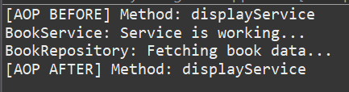

**Exercise 9: Creating a Spring Boot Application**

**Scenario:**

You need to create a Spring Boot application for the library management system to simplify configuration and deployment.

**Steps:**

1. **Create a Spring Boot Project:**
   * Use **Spring Initializr** to create a new Spring Boot project named **LibraryManagement**.

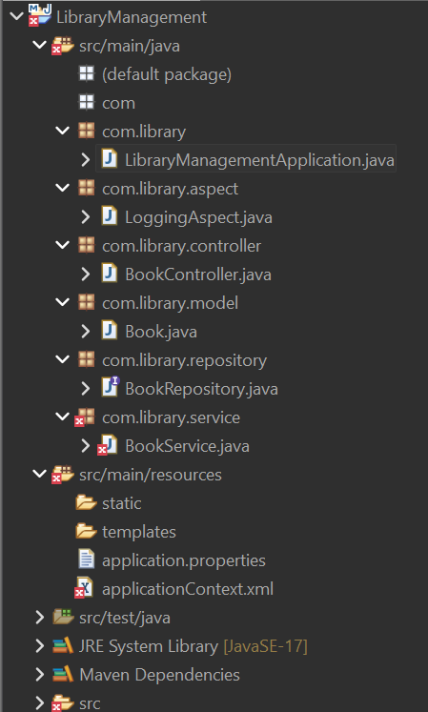

1. **Add Dependencies:**
   * Include dependencies for **Spring Web, Spring Data JPA, and H2 Database**.
2. <!-- Spring Data JPA -->
3. <dependency>
4. <groupId>org.springframework.boot</groupId>
5. <artifactId>spring-boot-starter-data-jpa</artifactId>
6. </dependency>
7. <!-- Spring Web -->
8. <dependency>
9. <groupId>org.springframework.boot</groupId>
10. <artifactId>spring-boot-starter-web</artifactId>
11. </dependency>
13. <!-- H2 Database (in-memory DB for testing) -->
14. <dependency>
15. <groupId>com.h2database</groupId>
16. <artifactId>h2</artifactId>
17. <scope>runtime</scope>
18. </dependency>
19. **Create Application Properties:**
    * Configure database connection properties in **application.properties**.
20. # H2 console
21. spring.h2.console.enabled=true
22. spring.h2.console.path=/h2-console
23. # JPA settings
24. spring.datasource.url=jdbc:h2:mem:librarydb
25. spring.datasource.driverClassName=org.h2.Driver
26. spring.datasource.username=sa
27. spring.datasource.password=
28. spring.jpa.database-platform=org.hibernate.dialect.H2Dialect
29. spring.jpa.hibernate.ddl-auto=update
30. **Define Entities and Repositories:**
    * Create **Book** entity and **BookRepository** interface.

**Book :**

package com.library.model;

import jakarta.persistence.*;

*@Entity*

public class Book {

*@Id*

*@GeneratedValue*(strategy = *GenerationType*.***IDENTITY***)

private Long id;

private String title;

private String author;

// Getters & Setters

public Long getId() { return id; }

public void setId(Long id) { this.id = id; }

public String getTitle() { return title; }

public void setTitle(String title) { this.title = title; }

public String getAuthor() { return author; }

public void setAuthor(String author) { this.author = author; }

}

**Create a REST Controller:**

* + Create a **BookController** class to handle CRUD operations.

1. package com.library.controller;
2. import com.library.model.Book;
3. import com.library.repository.BookRepository;
4. import org.springframework.beans.factory.annotation.Autowired;
5. import org.springframework.web.bind.annotation.*;
6. import java.util.List;
7. *@RestController*
8. *@RequestMapping*("/books")
9. public class BookController {
10. *@Autowired*
11. private BookRepository bookRepository;
12. // GET all books
13. *@GetMapping*
14. public List<Book> getAllBooks() {
15. return bookRepository.findAll();
16. }
17. // GET book by ID
18. *@GetMapping*("/{id}")
19. public Book getBookById(*@PathVariable* Long id) {
20. return bookRepository.findById(id).orElse(null);
21. }
22. // POST create new book
23. *@PostMapping*
24. public Book addBook(*@RequestBody* Book book) {
25. return bookRepository.save(book);
26. }
27. // PUT update book
28. *@PutMapping*("/{id}")
29. public Book updateBook(*@PathVariable* Long id, *@RequestBody* Book updatedBook) {
30. return bookRepository.findById(id).map(book -> {
31. book.setTitle(updatedBook.getTitle());
32. book.setAuthor(updatedBook.getAuthor());
33. return bookRepository.save(book);
34. }).orElse(null);
35. }
36. // DELETE book
37. *@DeleteMapping*("/{id}")
38. public void deleteBook(*@PathVariable* Long id) {
39. bookRepository.deleteById(id);
40. }
41. }
42. **Run the Application:**
    * Run the Spring Boot application and test the REST endpoints.

GET = List all books

POST = {"title":"ABC", "author":"XYZ"}

PUT = Update book

DELETE = Delete book

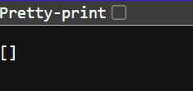

<http://localhost:8080/books> url with zero books