ML Assignment -1

Group Members:
Yagna Karthik Vaka (S20170010170)
Sri Phani Sainath Kanala (S20170010063)

Our understanding of the concept

In k – nearest neighbour classifier (k-NNC), we draw a sphere which contains k nearest neighbours of X.
Among these k nearest neighbours, according to the majority of classes around we decide the predicted class label.
But to obtain optimal k value for having most accuracy of the classifier we apply cross validation technique and to find the distances we use Minkowski Distance formula.
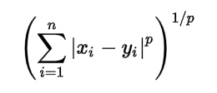

In r-fold cross validation, we partition the training set into r blocks and consider all except one as training set and the remaining as the test set.
For the range of k values (here 1 to 10) find the accuracy on the test set. We take the mean of all the accuracies of test set nodes for the whole range of 1 to 10. The maximum of mean of all the test accuracy rates,corresponding k value will be the best k value for the given classifier.
We can further have variety of variations in finding the distance between two nodes. This is done by changing the value of p (here 1 to 5) in Minkowski distance formula. It becomes Euclidean distance when p = 2.
We repeat the above with all possible range of k values and p values. Our best bet for the classifier gives us the maximum accuracy rate on the test set with minimum error.
We explained our code in respective (ML1.c && ML2.c) comments.
Results obtained….

1. Wheat seeds Data set.
We obtained maximum accuracy when p=1 and different values of k (1 to 10).You can observe the values of accuracy percentages in below image.
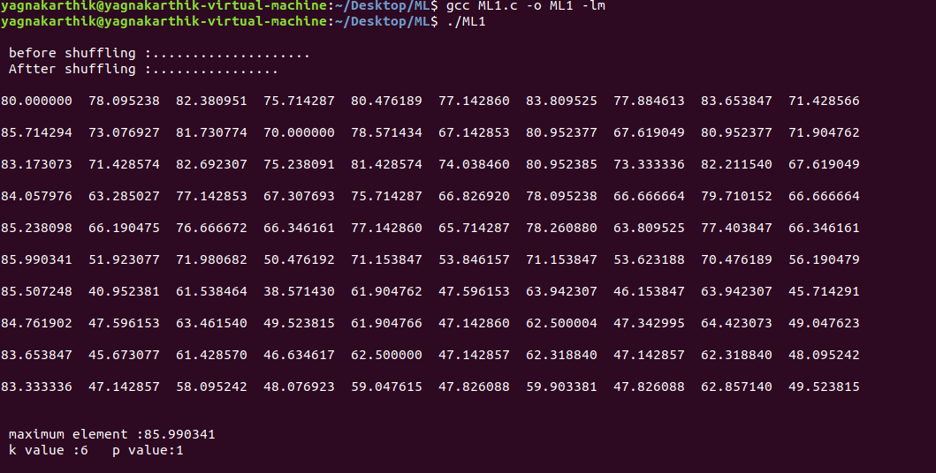
As we are shuffling the data each time ,the pair of k and p values for which we are getting maximum accuracies is changing .Also we are getting maximum accuracies between 85 .0to 90.0%.
2.Optical recognition of Handwritten digits dataset:
Here we compared our results with the results provided in that dataset link(optdigits.names).
Dataset results(expected):
(K,p) values ----- accuracy
1,2 -------- 98.00%
2,2 -------- 97.30%
3,2 -------- 97.21%
4,2 -------- 97.43%
5,2 -------- 97.05%
6,2 -------- 97.03%
7,2 -------- 97.26%
8,2 -------- 97.17%
9,2 -------- 97.20%
10,2 -------- 97.74%
11,2 -------- 97.79%

Dataset results(obtained):
(K,p) values ----- accuracy
1,2 -------- 95.00%
2,2 -------- 94.30%
3,2 -------- 97.31%
4,2 -------- 94.63%
5,2 -------- 97.25%
6,2 -------- 97.43%
7,2 -------- 97.76%
8,2 -------- 97.47%
9,2 -------- 97.40%
10,2 -------- 97.84%
11,2 -------- 97.99%

Thank you……..

