

Medstaza

TEAM NAME :**TechNoLogic**

TEAM MEMBERS:

* **Karthik nr**
* **sricharan p**
* **prakash b**
* **mohan kumar sk**

**INTRODUCTION:**

Hello o’ brave soul reading this now, we at Team TechNoLogic are aiming to eradicate the corrupt and cheap practices of some pharmacists.

Our team member Mr.Veera Prathab came up with this idea after witnessing malpractices like selling of expired medicines and repacking of used ones.

Instead of being just another spectator to corruption, we at TechNoLogic decided to do something about this malpractice.

**HOW IT WORKS? **

* Firstly, we generate a bar code or QR Code for a particular medicine.
* The Bar code/QR Code is used to check the integrity of the pharmacist.
* The QR code is scanned and contains info about the medicine i.e. the medicine’s expiry date, cost and name, etc.
* The QR code generated has an encrypted unique tablet ID which remains hidden in the app.
* An unique ID given to the pharmacists/vendors gets registered in the database when the tablet is scanned.
* Medicines have to be sold by scanning the barcode. This should be enforced by the government.
* An App developed for the End Users displays the necessary details of the medicines after scanning.
* LabView software is used to distinguish the genuine medicines from its counter-part, the stalled ones.(IN FUTURE)

**WHY SHOULD THIS BE IMPLEMENTED?**

* Prevention of resale of expired medicines.
* Info at your fingerprints via QR code.
* Saves on labeling discrepancies.
* Incineration of expired medicines can be done immaculately.
* Unpublicized pharmacies can be spotted and eradicated.

**SOFTWARE USED:-**

* WAMP SERVER
* **PHP MYADMIN**
* **MYSQL**
* **APACHE**
* MIT APP INVENTOR
* LABVIEW
* PHP 7
* HTML 5
* JAVASCRIPT

**QR CODE :**

**WHAT IS A QR CODE?**

A QR code is a two-dimensional square bar code which can store encoded data. Most of the time the data is a link to an URL.

**HOW TO READ A QR CODE?**

Reading - or scanning - a QR Code is a easy 3-step process, as explained in the graphics below. You have to open your reading application and point your camera at the QR Code. It is then recognized by the application which carries out the associated action - like opening a web page.

# Can a QR Code be hacked?

Hacking a QR Code means that the action triggered would have been modified through a manipulation.

This is not possible, since this is the way the small square modules are arranged that determines this action (the data is encoded by the module arrangement). To change this action, one would have to change the arrangement of the modules. This implies physically modifying the QR Code if it has been printed.

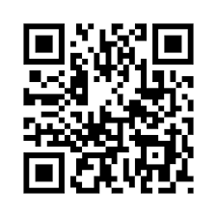

**LabVIEW :**

**Laboratory Virtual Instrument Engineering Workbench** (LabVIEW) is a system-design platform and development environment for a visual programming language from National Instruments.

The graphical language is named "G"; not to be confused with G-code. Originally released for the Apple Macintosh in 1986, LabVIEW is commonly used for data acquisition, instrument control, and industrial automation on a variety of operating systems (OSs), including Microsoft Windows, various versions of the Unix, Linux, and MacOS.

Laboratory Virtual Instrument Engineering Workbench (LabVIEW) is a system-design platform and development environment for a visual programming language from National Instruments.

The graphical language is named "G"; not to be confused with G-code. Originally released for the Apple Macintosh in 1986, LabVIEW is commonly used for data acquisition, instrument control, and industrial automation on a variety of operating systems (OSs), including Microsoft Windows, various versions of Unix, Linux, and MacOS.

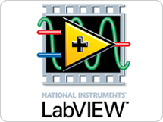

**MIT App Inventor :**

MIT App Inventor is an intuitive, visual programming environment that allows everyone – even children – to build fully functional apps for smartphones and tablets. Those new to MIT App Inventor can have a simple first app up and running in less than 30 minutes. And what's more, our blocks-based tool facilitates the creation of complex, high-impact apps in significantly less time than traditional programming environments. The MIT App Inventor project seeks to democratize software development by empowering all people, especially young people, to move from technology consumption to technology creation.

Blocks-based coding programs inspire intellectual and creative empowerment. MIT App Inventor goes beyond this to provide real empowerment for kids to make a difference -- a way to achieve social impact of immeasurable value to their communities. In fact, App Inventors in school and outside of traditional educational settings have come together

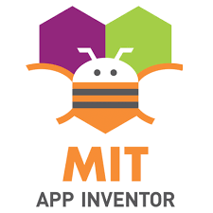

**WampServer :**

Wamp Server refers to a software stack for the Microsoft Windows operating system, created by Romain Bourdon and consisting of the Apache web server, OpenSSL for SSL support, MySQL database and PHP programming language.[1][2]

Wamp Server will install Apache, PHP5 and MySQL on your Windows system. Wamp Server comes with a service manager as a tray icon. It will allow you to easily manage your server. You can install all releases of Apache, MySQL and PHP as add-ons.



**project MEDSTAZA:**

Let’s play a game of facts! Let’s assume to possess a time machine and let’s travel down the lane, say 20 years back. How much of a concern was medical mafia, medical scam, duplication of medicines and selling of stalled medicines? Think once, think twice, again, and again, and again… You will find minimal cases related to the above mentioned scenarios.

Now, Lets head back

from where we started . The present medical industry has become a hub where medicines are looked up as revenue and people are looked up as medium of transaction of revenue.

The importance given to basic requisites that of expiry date and adulterated medicines is very minimal. People have their lives at stake. Enough of playing the fact’s game. Let’s get down under to see the likely changes that we have a right to incorporate in our project.

But before that lets take a look at the **Definition of Counterfeiting :**

A counterfeit medicine is one which is deliberately and fraudulently mislabeled with respect to identity and/ or source. Counterfeiting of medicines can apply to both branded and generic products. Generally, counterfeit products may include products with the correct ingredients or with the wrong ingredients, without active ingredients, with in correct quantities of activities ingredients or with fake packaging.

**Why are Medicines a Target?**

Medicines represent one of the most regulated sectors of industrial activity. Why do they attract counterfeiters? – Fakes can be made relatively cheaply (at least as profitable as narcotics – lower risk) – Many countries, especially in the developing world lack adequate regulation and enforcement – Even in the industrialized countries, the risk of prosecution and penalties for counterfeiting are inadequate – The way in which medicines reach the consumer is also different from other goods: the end-user has little knowledge of the product – a ‘credence’ good

* Getting back in track to our project, A mobile application is developed so as to scan QR Code which contains the details of the tablet (name, expiry date, cost)
* This application is one that is beneficial for the customers.
* Pharmacists will contain a software (MEDSTAZA) which will send the data of the medicines which are to be sold to the consumers, and verify the integrity of the tablet from the adulterated medicines.
* Each pharmacist will be given a unique LOGIN and PASSWORD.
* The data sent by the pharmacist is stored in a centralized database which can be accessed by both the government and pharmaceutical companies.
* If an identical QR code is scanned twice, an alert would be sent to the database .Hence the forged tablet is sorted out.
* If any case of discrepancy, it would be monitored by the government officials and the accused vendor’s unique ID will be sorted out.
* On investigating the medicine supplier, the counterfeit medicine seller can be found.

**pROJECT SHOWDOWN:**

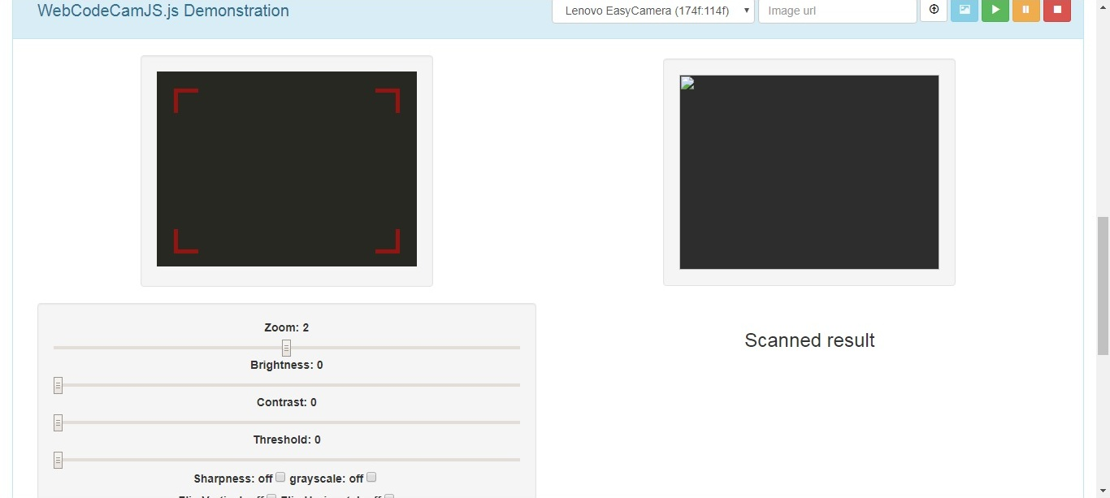

**Labview:**

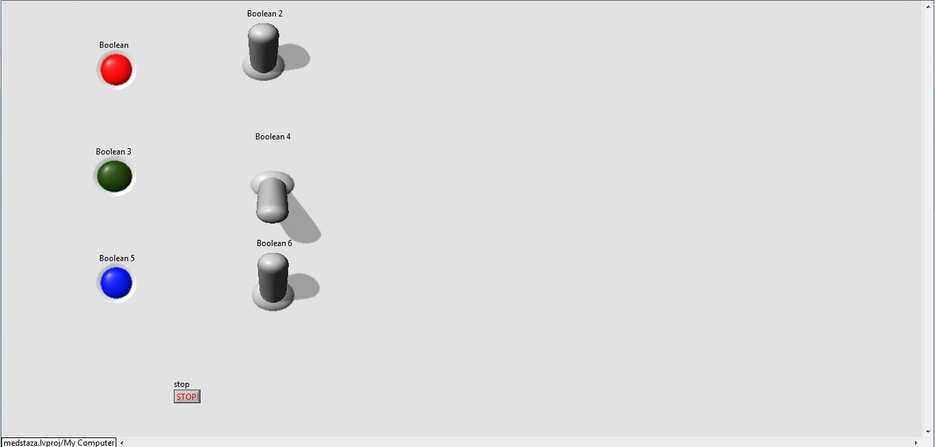

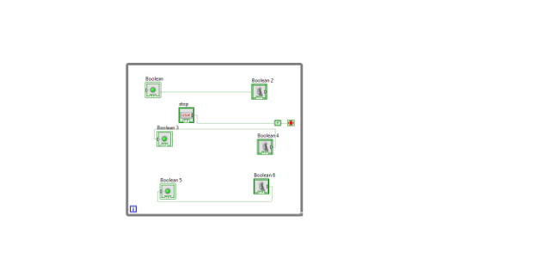

**mobile app(before scanning):**

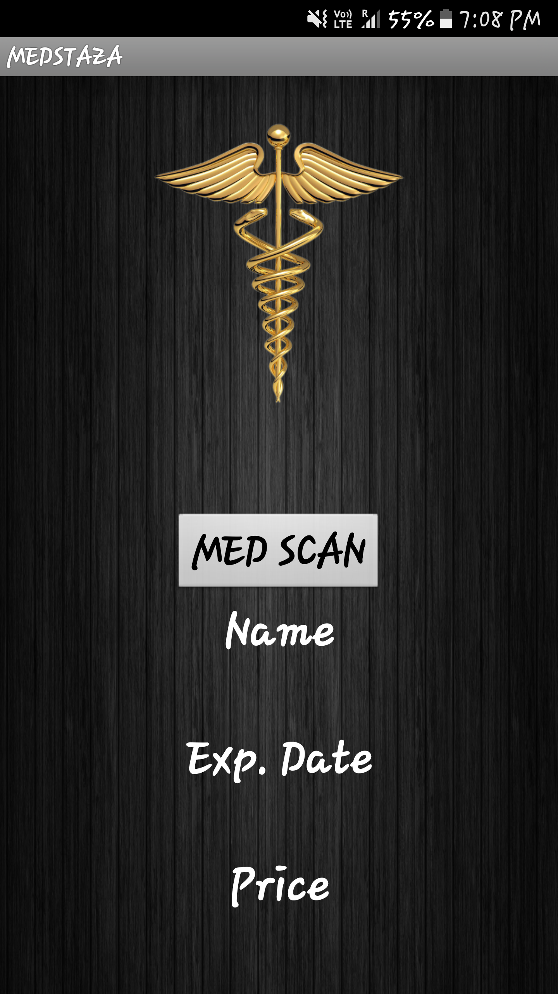

**mobile app(after scanning):**

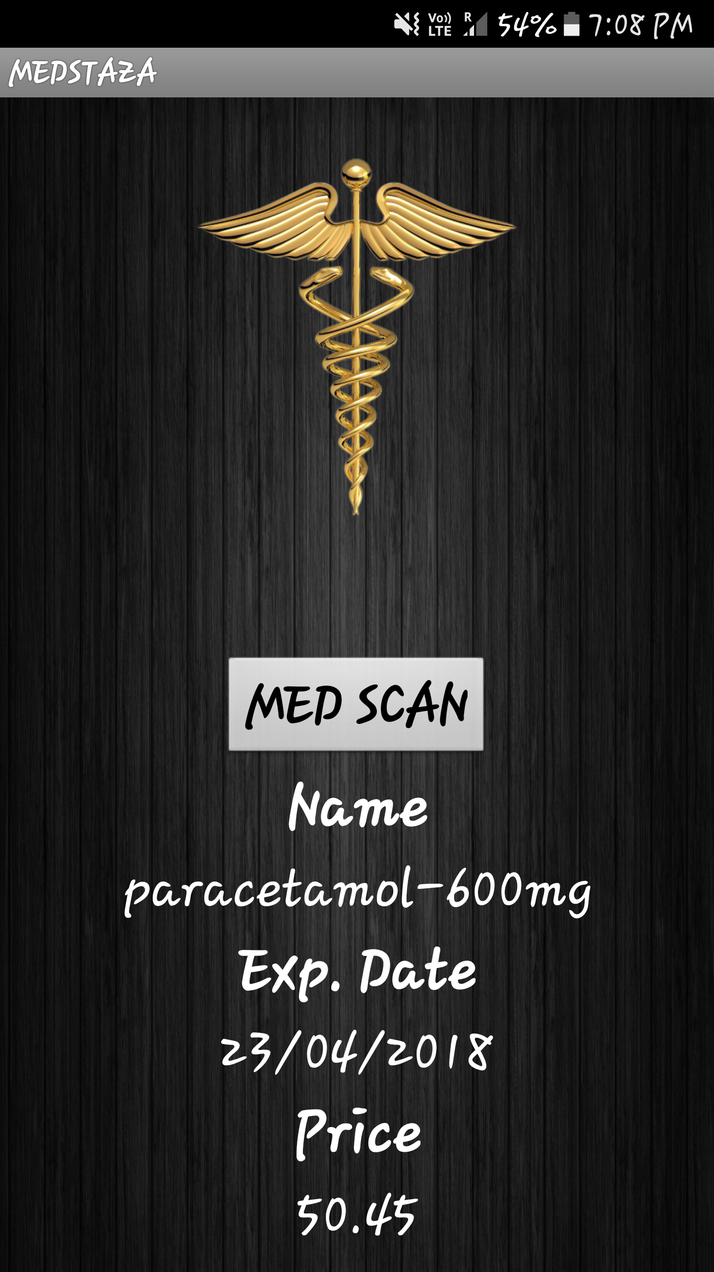

**bibliography:**

* **http://ai2.appinventor.mit.edu/**
* [**https://www.youtube.com/watch?v=_w3qzrvf6j4&list=TLGGXFttOiNe3S8yNTAxMjAxOA**](https://www.youtube.com/watch?v=_w3qzrvf6j4&list=TLGGXFttOiNe3S8yNTAxMjAxOA)
* [**http://www.wampserver.com/en/**](http://www.wampserver.com/en/)

# Learning WAMP Server Development – Training DVD

* **Hands-On Introduction to LabVIEW for Scientists and Engineers 3rd Edition**

**By John Essick**

CONCLUSION

**“LIKE OUR LIVES, MEDICINES TOO HAVE AN EXPIRY DATE!”**

**“TOGETHER, LET’S TAKE A DECISION, LET’S CHANGE THE FATE OF THE FATE!”**