HOTEL MANAGEMENT

Submitted by:

* Karthik Rao Minupala (14CS01022)
* Karthik Arji(14CS01001)

**Contents**

* Introduction……………………………………………………………………………………
* Software Needed……………………………………………………………………………
* Design process………………………………………………………………
* Entity-Relationship Model………………………………………………………………
* Relational Model………………………………………………………………
* Triggers…………………………………………………………………………………………..
* Applications……………………………………………………………………………………
* Limitations, Conclusion and Discussion…………………………………………..
* Future aspect………………………………………………………………………………
* References……………………………………………………………………………………..

**Introduction:**

Project titled “HOTEL MANAGEMENT SYSTEM” is a web based application to serve the management needs of a hotel.

• It has several features for customers which includes -

* Database Maintenance
* Hotel Room Reservation
* Hotel Room Availability
* Hotel Check-In & Check-Out Date
* Billing & Invoicing System .

• It also have features for management of employees etc.

• This application is build on basing a relational database.

**Software Needed:**

1)Backend (Database): MySQL version 5.7

2)Frontend (Web Technologies): HTML5 and PHP5

3)The local area server is having been hosted using XAMPP v3.2.2

**Design process:**

**• A conceptual design to entire problem of managing a hotel.**

**• Figuring the data storage requirements for process.**

**• Identifying the entities of storage.**

**• Specifying the entities and fields.**

**• Figuring all the actions or processes to achieve the required functionalities.**

**• Relating the data and actions to make a Entity-Relationship model.**

***Software development paradigm:-***

**The software development paradigm used in developing this software is waterfall. In this every phase is executed very carefully one after another.**

**Any other SDLC model follows this technique as its basic unit. The various phases of waterfall model which model with its working is as follows:**

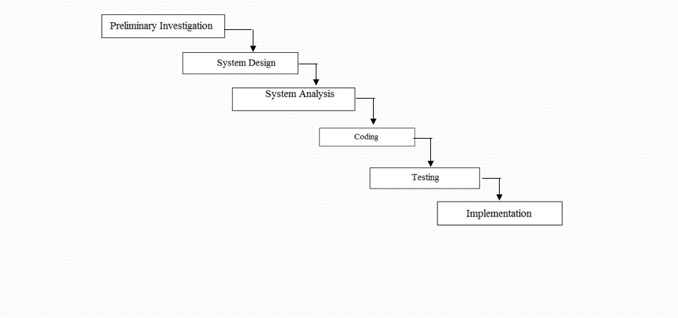

**ENTITY RELATIONSHIP DIAGRAM**

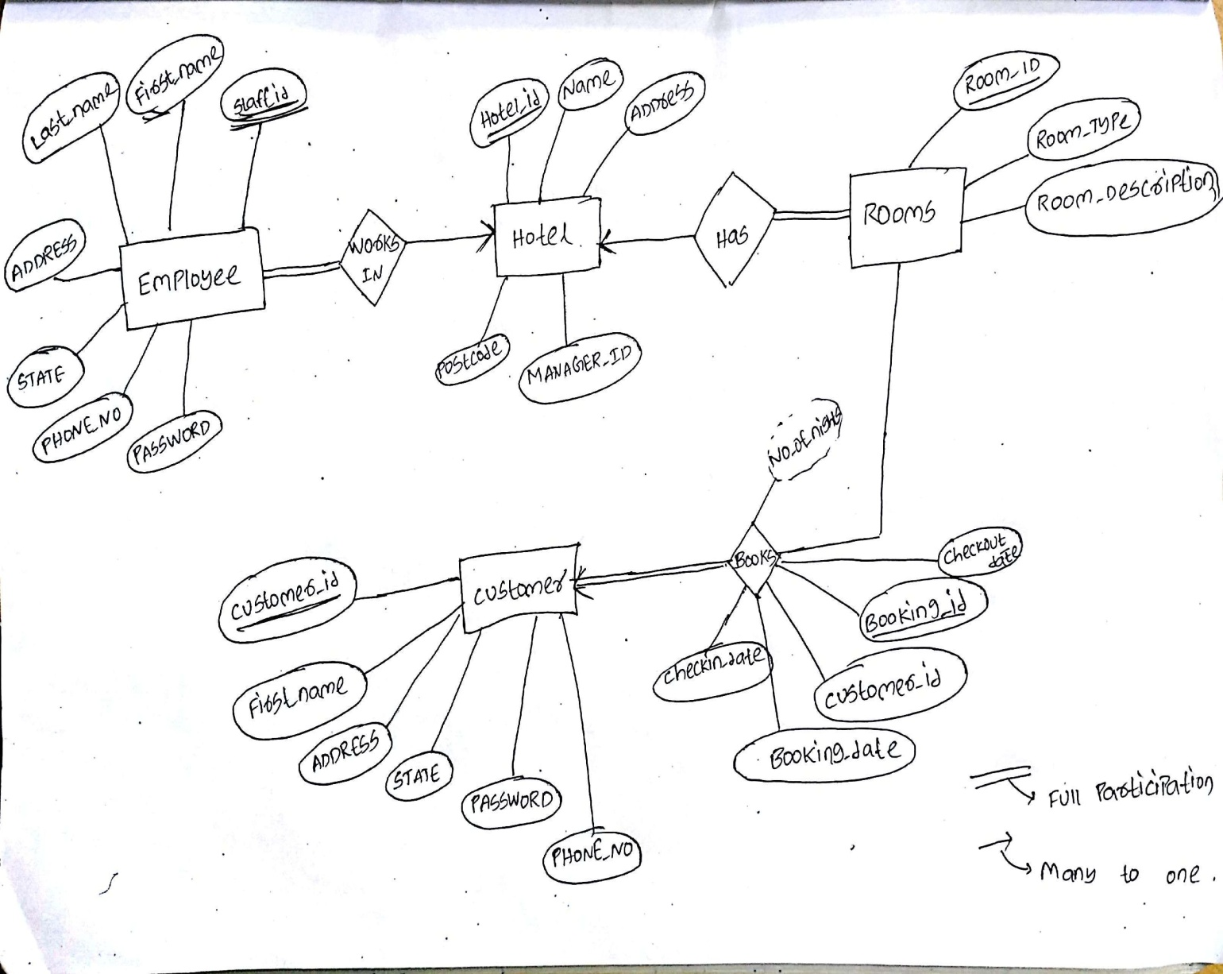

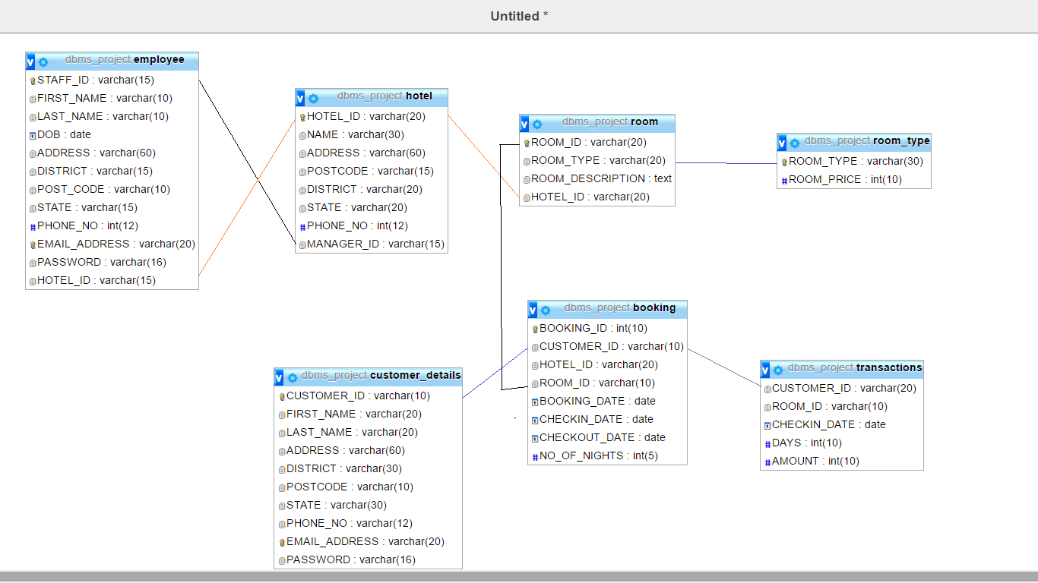

**Triggers**

**1)‘trig_check’ :** Trigger if checkin_date is greater than checkout_date.

**2)‘trig_cancel’ :** Trigger on cancelling the room and deleting the booking from history table and insertion in transaction table.

**3)trig_login:** Trigger on profile table after registration, username and password records are added to login table.

APPLICATIONS:-

1)We can book a room in a hotel from anywhere by logging the portal.

2)There will be two different logins for customer and employee where customer can only book and cancel a room on a particular date.

3)Employee can see the status the hotel rooms only in which he is working.

4) To enable online booking via the internet

4)Avoid data entry errors by use of input masks.

5) Enforce security measures to avoid unauthorized access to guest records.

***Future aspect:-***

In future our software can also be used for hotels that provide both lodging and fooding facilities, in such case our software would also keep a record of food supplements and recruited staffs in our database.

In other words our software would provide staff management as well as restaurant management.

The inclusion of these features would definitely make our software highly demanding and would be a grand success in practical field.

**Limitations, Conclusion and Discussion:**

**1)We can also have sign up for employee in the homepage itself .**

**2)there are some difficulties like cancelling the rooms after sometime from booking may lead to availabilty of less rooms before cancels a room.**

**3) Views are used to show data in user end for security of the data**

**4)Procedures are used to for booking rooms.**

**REFERENCES:**