**23CSE111**

**OBJECT ORIENTED PROGRAMMING**

**LAB REPORT**



**Department of Computer Science Engineering**

**Amrita School of Computing**

**Amrita Vishwa Vidyapeetham, Amaravati Campus**

**Name: v.karthik sai tej reddy**

**Verified By Roll No: av.sc.u4cse24343**

**WEEK 01**

**PROGRAM-1:**

**AIM:** Download and Install Java Software

**PROCEDURE:**

**Step 1: Download JDK 21**

1. Open your web browser and go to the Oracle JDK Downloads page
2. Scroll down to the Java SE Development Kit 21 section.
3. Choose the Windows x64 Installer version.
4. Click on Download, then Wait for the download to complete

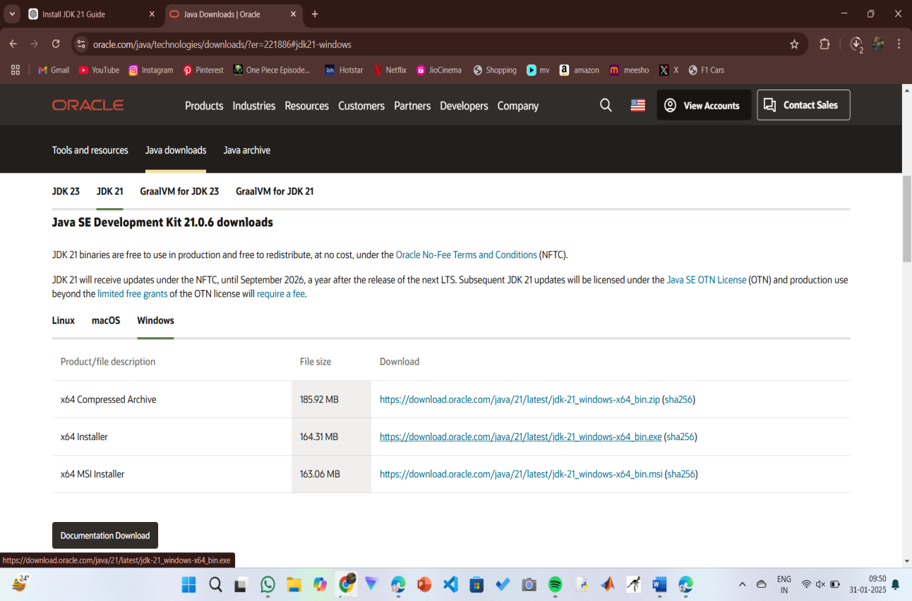

**Step 2:** **Install JDK 21**

1. Locate the downloaded jdk-21_windows-x64_bin.exe file.
2. Double-click to launch the installer.
3. Click Next on the setup wizard.
4. Choose the installation path (default is C:\Program Files\Java\jdk-21).
5. Click Next, then click Install.
6. Wait for the installation to complete.
7. Click Close once the installation is finished.

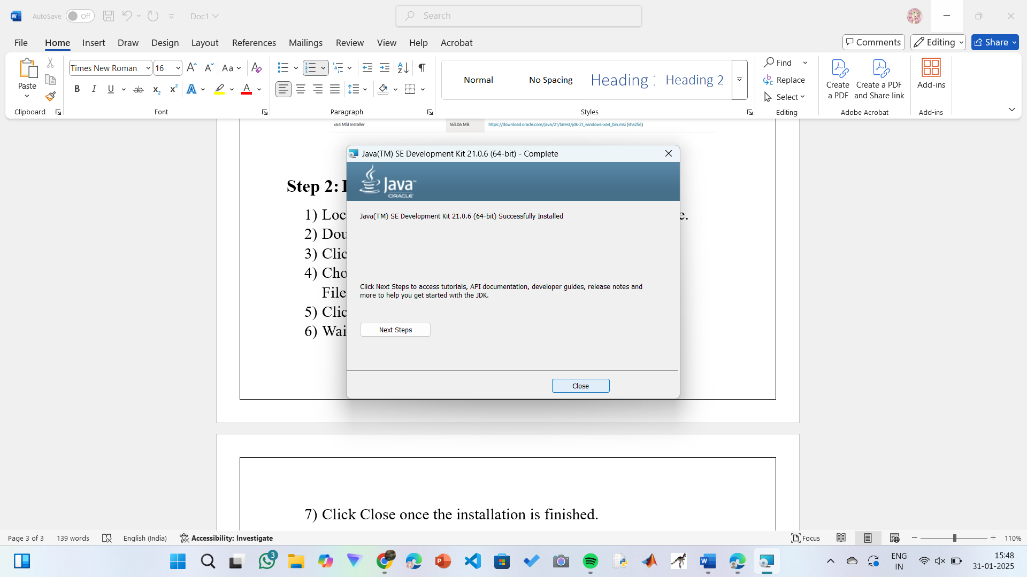

**Step 3: Setting up the path**

1) Go to “Windows C” Drive on Desktop

2) Choose Program Files, select Java, then JDK 21, then select Bin.

3) Select and copy the path at the address bar.

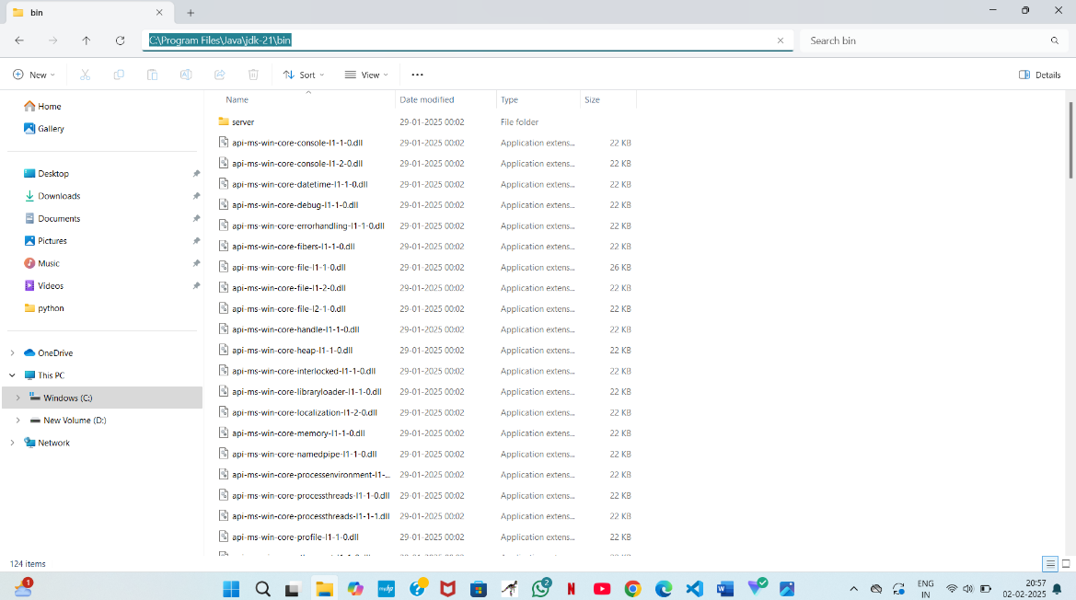

**Step 4: Open System Properties**

1. Press Windows + R, type sysdm.cpl , and click Ok-
2. The System Properties window will open.
3. Navigate to the Advanced tab.
4. Click on Environment Variables at the bottom.

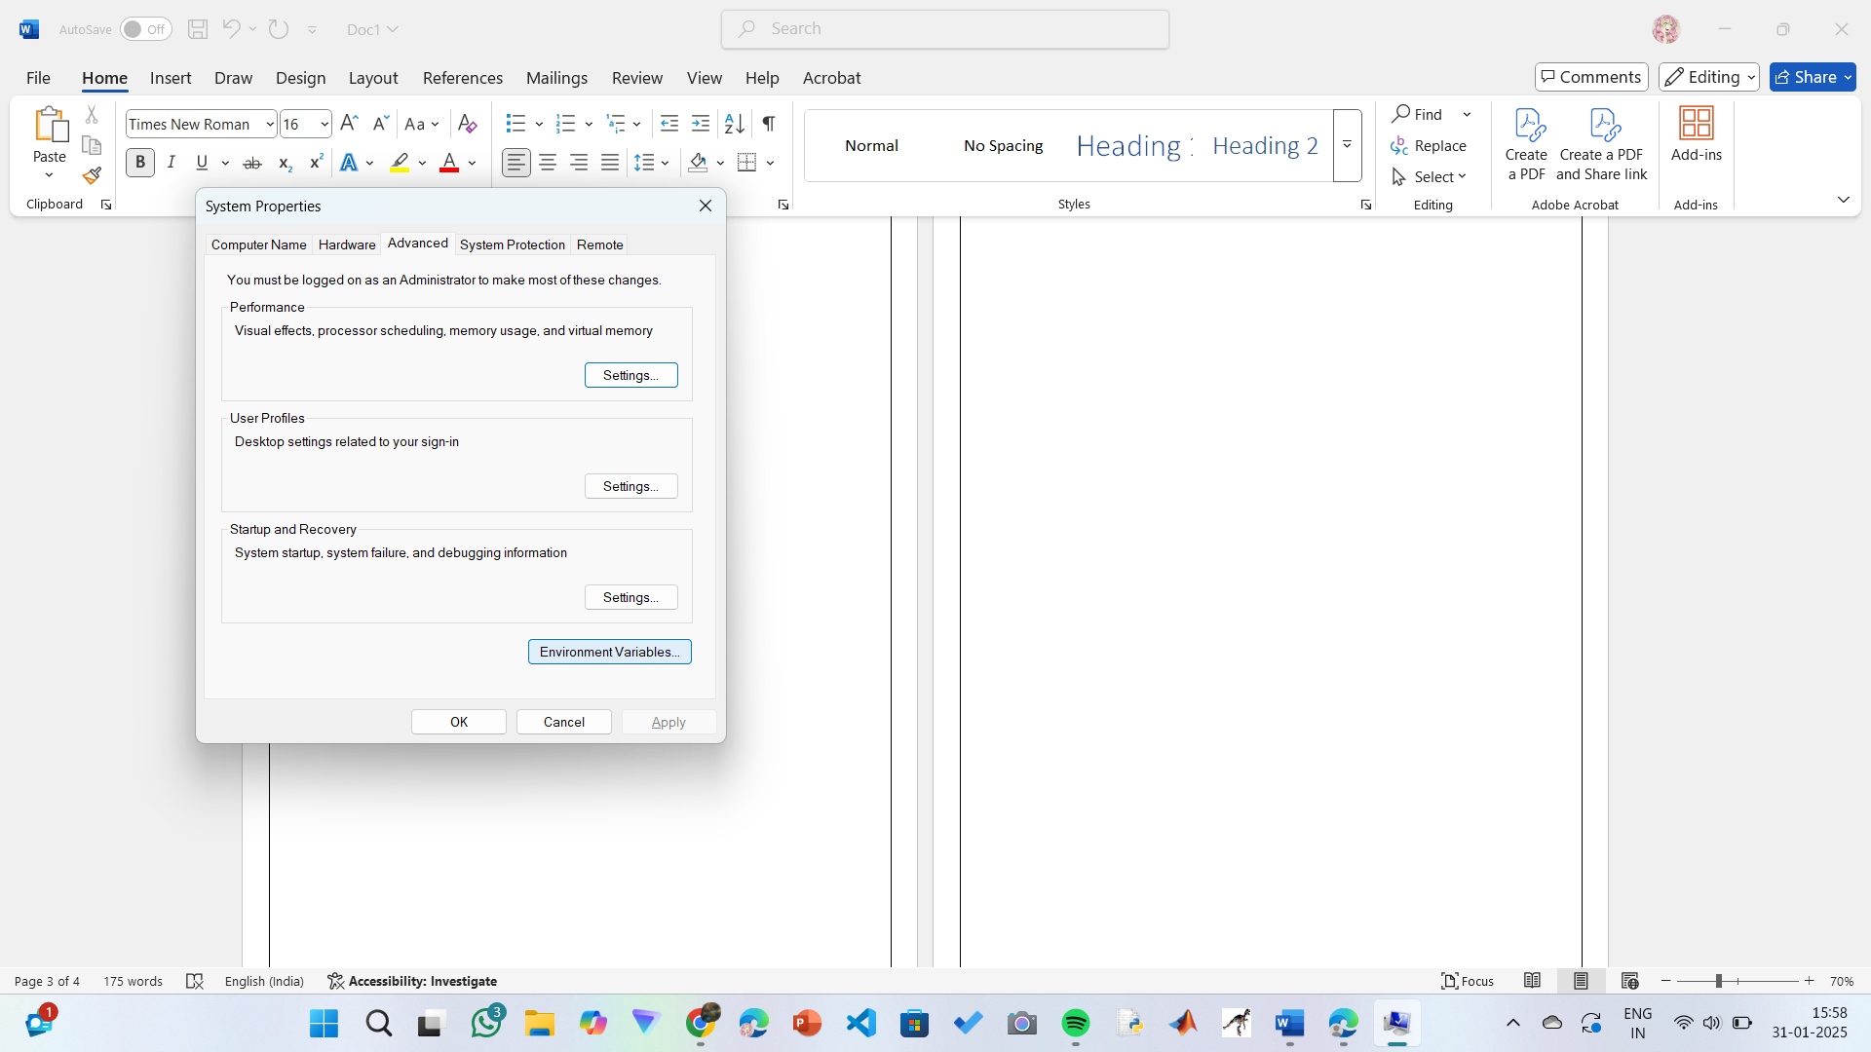

**Step 5: Set JAVA_HOME**

1)Under System Variables, click New.

2)Set the Variable name as JAVA_HOME.

3)Set Variable value as C:\Program Files\Java\jdk-21 (or your installation path).

4)Click OK.

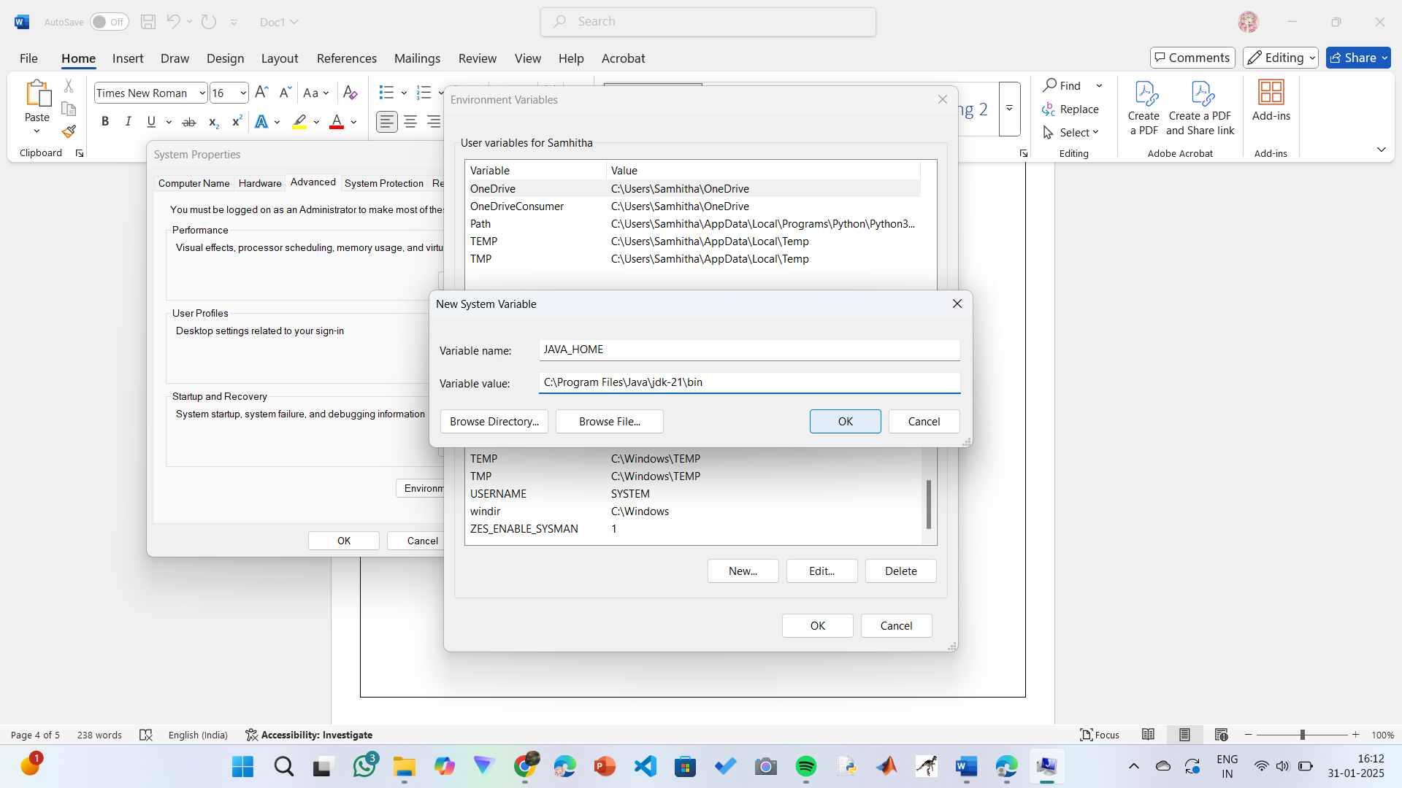

**Step 6: Update PATH Variable**

1)In System Variables, find Path and click Edit.

2)Click New and add: C:\Program Files\Java\jdk-21\bin

3)Click OK to save.

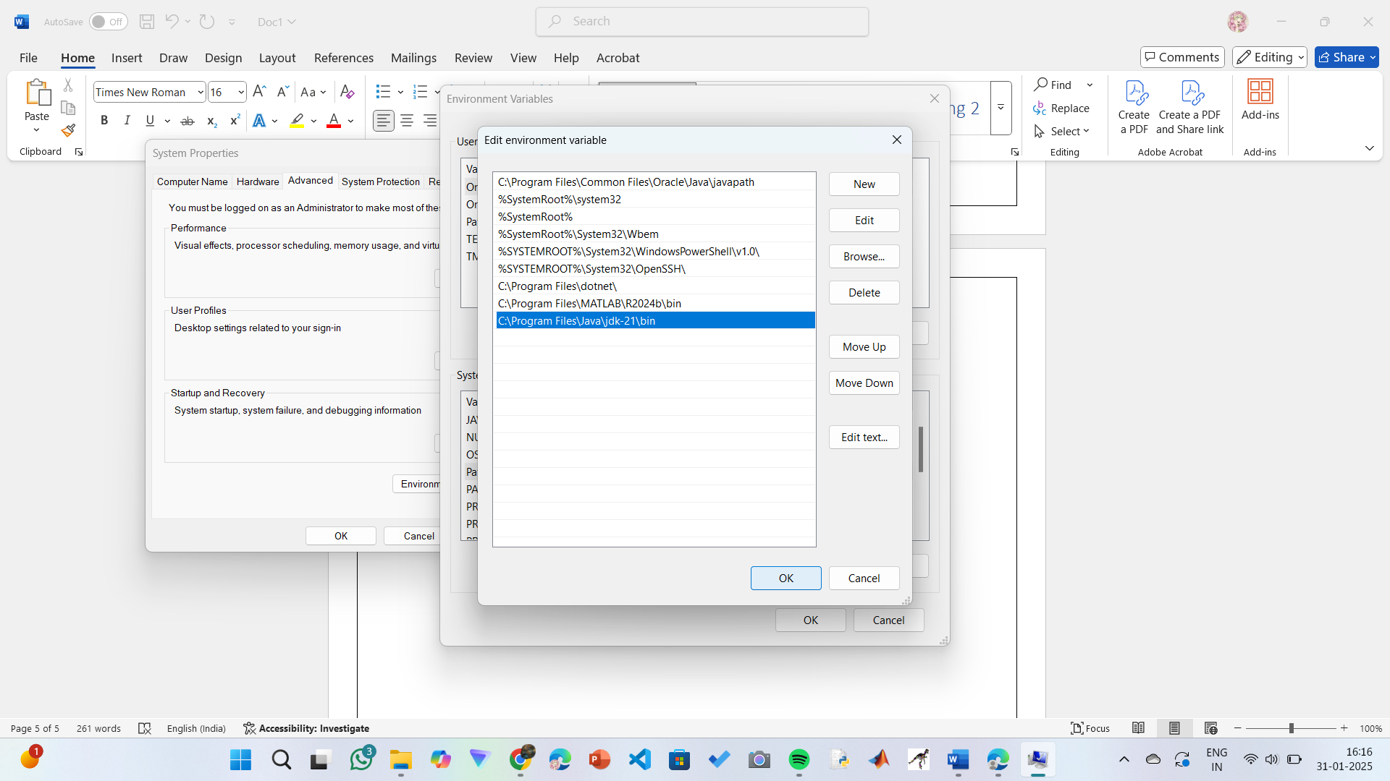

**Step 7:Verify Installation**

1. Open Command Prompt.
2. Type the following command: **java --version** and press Enter.

**OUTPUT:**

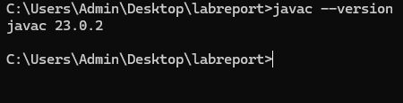

**PROGRAM-2:**

**AIM:** Write a Java program to print the message “Welcome to Java Programming.”

Code :-

class first

{

    public static void main (String ar[ ] )

    {

        //to print hello world

        System.out.println("HELLO WORLD....");

    }

}

**Output:**

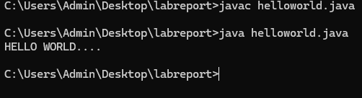

**PROGRAM-3:**

**AIM:** Write a Java Program that prints Name, Roll No, Section of a student.

**CODE:**

**STUDENT DETAILS:**

Code :-

class student

{

    public static void main(String ar[])

    {

        System.out.println("Name    : KARTHIK ");

        System.out.println("Class   : CSE-C");

        System.out.println("Roll.No : AV.SC.U4CSE24343");

        System.out.println("Branch  : COMPUTER SCIENCE ENGINEERING");

        System.out.println("College : AMRITA VISHWA VIDHYAPEETHAM");

        System.out.println("AMARAVATHI");

    }

}

**OUTPUT:**

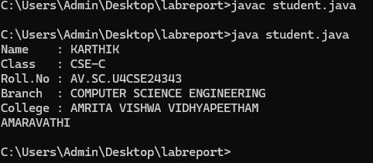

ERROR TABLE:

|  |  |
| --- | --- |
| **Code Error** | **Code rectification** |
| 1. writing small “S”in place of”S”   In system.out.println()  2)not giving strings to the name and scetion | 1. code is rectified by keeping capital “S” 2. Giving strings to name and section |

WEEK – 2

**Program – 1**

AIM :- // Write a JAVA Code to print Fibonacci Series.

Code :-

import java.util.Scanner;

class fibonacci

{

 public static void main(String ar[])

 {

    Scanner sc = new Scanner(System.in);

    System.out.println("Enter a value : ");

    int x=sc.nextInt();

    int a=0,b=1,c;

    System.out.println(a);

    System.out.println(b);

    for(int i=0;i<=x;i++)

    {

        System.out.println(a+"");

        c=a+b;

        a=b;

        b=c;

    }

 }

}

**OUTPUT:**

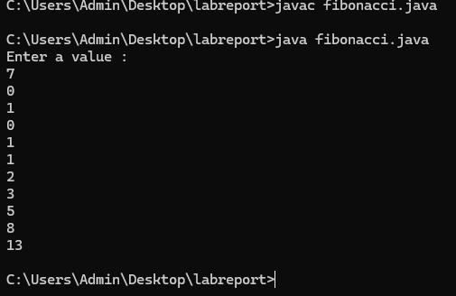

ERROR TABLE:

|  |  |
| --- | --- |
| **Code Error** | **Code rectification** |
| 1. Giving space between next and Double. 2. Not giving parenthesis after closing the input. | 1. Should not give space between next and Double. 2. We must put parenthesis after closing the input. |

**2.AIM:**Calculate the simple interest

**CODE:**

import java.util.Scanner;

class SI

{

    public static void main(String ar[])

    {

        float si;

        Scanner input=new Scanner(System.in);

        System.out.println("Enter Principle amount : ");

        int p=input.nextInt();

        System.out.println("Enter Rate of Interest : ");

        float r=input.nextFloat();

        System.out.println("Enter Time in Years : ");

        int t=input.nextInt();

        si=(p*t*r)/100;

        System.out.println("Simple Interest : "+si);

    }

}

**OUTPUT:**

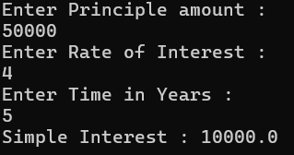

ERROR TABLE:

|  |  |
| --- | --- |
| **Code Error** | **Code rectification** |
| 1. Giving space between next and Double. 2. Not giving parenthesis after closing the input. | 1. Should not give space between next and Double. 2. We must put parenthesis after closing the input. |

**3.AIM:** // Write a JAVA Code to find Factorial of a given number

**CODE:**

class factorial

{

    public static void main(String ar[])

    {

        Scanner sc = new Scanner(System.in);

        System.out.println("Enter a number : ");

        int n = sc.nextInt();

        int x=1;

        for(int i=1;i<=n;i++)

        {

            x=x*i;

        }

        System.out.println("Factorial of Number : "+x);

    }

}

**OUTPUT:**

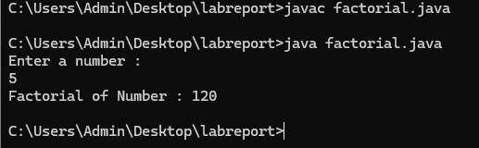

ERROR TABLE:

|  |  |
| --- | --- |
| **Code Error** | **Code rectification** |
| 1. While using for iteration, not giving the conditions correctly. 2. Declaring the data type as double instead of int. | 1. We should give iterative statements correctly. 2. We should give the data type as int for integers. |

**4.AIM:** : // Write a JAVA Code to convert Celsius temperature into Fahrenheit temperature and vice versa.

**CODE:**

class temp

{

public static void main (String ar[])

{

Scanner sc = new Scanner(System.in);

System.out.println("Enter 0 to convert Celcius into Fahrenheit Temperature.");

System.out.println("Enter 1 to convert Fahrenheit into Celcius Temperature.");

int n = sc.nextInt();

if (n==0)

{

System.out.println("Enter Temperature : ");

float x = sc.nextFloat();

double t=(x*1.8)+32;

System.out.println("Converted Temperature : "+t);

}

else if (n==1)

{

System.out.println("Enter Temperature : ");

float x = sc.nextFloat();

double t=(x-32)/1.8;

System.out.println("Converted Temperature : "+t);

}

else

{

System.out.println("Enter Valid Input");

}

}

}

**OUTPUT:**

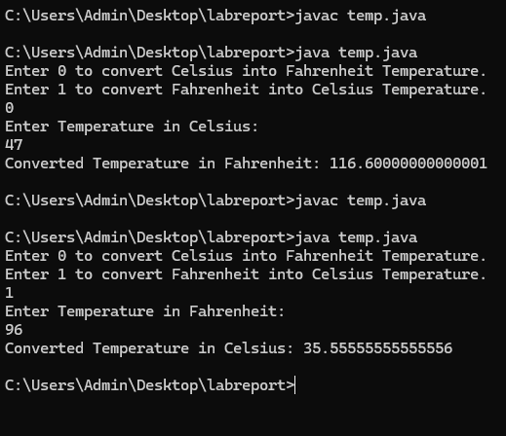

ERROR TABLE:

|  |  |
| --- | --- |
| **Code Error** | **Code rectification** |
| 1. While printing the variable not giving + sign. 2. Not closing the scanner. | 1. We should give correct indentation. 2. Closing the scanner is must. |

**5.AIM**: : // Write a JAVA Code to calculate Area of Rectangle and Area of Triangle using herons formula.

**CODE:**

class area

{

public static void main(String ar[])

{

Scanner sc = new Scanner(System.in);

System.out.println("Enter Length of Rectangle : ");

float x = sc.nextFloat();

System.out.println("Enter Breadth of Rectangle : ");

float y = sc.nextFloat();

float z=x*y;

System.out.println("Area of Rectangle : "+z);

System.out.println(“To find Area of Triangle”);

System.out.println("a : ");

double a=sc.nextDouble

System.out.println("b : ");

double b=sc.nextDouble();

System.out.println("c : ");

double c=sc.nextDouble();

double s = a+b+c/2;

double area = Math.sqrt(s*(s-a)*(s-b)*(s-c));

System.out.println("Area of Triangle : "+s);

input.close();

}

}

**OUTPUT:**

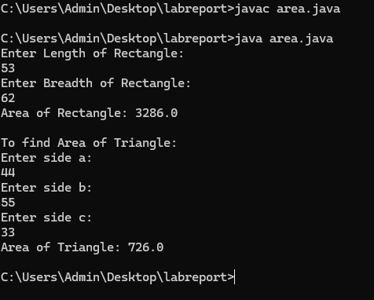

ERROR TABLE:

|  |  |
| --- | --- |
| **Code Error** | Code rectification |
| 1. While printing the variable not giving + sign. 2. Not closing the scanner. | 1. We should give correct indentation. 2. Closing the scanner is must. |

**WEEK -3:**

**AIM:** : Write a JAVA Code to create java program with following instructions

1.Create a class with name car

2. Create four attributes named car_color ,Car_brand,fuel_type,mileage

3. Create three methods named start(), stop(). Service()

4. Create three objects named car1,car2 and car3

**CODE:**

import java.util.*;

class car

{

    public String Car_color;

    public String Car_brand;

    public String fuel_type;

    public int mileage;

   public void start()

   {

       System.out.println("Car Started:");

       System.out.println("Car color is :"+Car_color);

       System.out.println("Car Brand is:"+Car_brand);

       System.out.println("Car fuel type is:"+fuel_type);

       System.out.println("Car mileage is:"+mileage);

   }

    public void service()

   {

       System.out.println("Car Started:");

       System.out.println("Car color is :"+Car_color);

       System.out.println("Car Brand is:"+Car_brand);

       System.out.println("Car fuel type is:"+fuel_type);

       System.out.println("Car mileage is:"+mileage);

   }

    public void stop()

   {

       System.out.println("Car Started:");

       System.out.println("Car color is :"+Car_color);

       System.out.println("Car Brand is:"+Car_brand);

       System.out.println("Car fuel type is:"+fuel_type);

       System.out.println("Car mileage is:"+mileage);

   }

public static void main(String args[])

{

    car car1 = new car();

    car1.Car_color = "Pink";

    car1.Car_brand = "Audi";

    car1.fuel_type = "Deisel";

    car1.mileage = 100;

   car1.start();

    car car2 = new car();

    car2.Car_color = "Black";

    car2.Car_brand = "Tesla";

    car2.fuel_type = "EV";

    car2.mileage = 200;

    car2.stop();

    car car3 = new car();

    car3.Car_color = "Blue";

    car3.Car_brand = "BMW";

    car3.fuel_type = "Petrol";

    car3.mileage = 300;

    car1car3.service();

 }

}

**OUTPUT:**

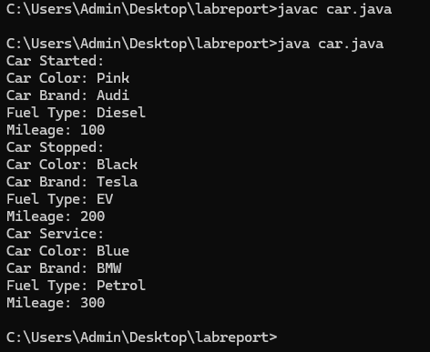

ERROR TABLE:

|  |  |
| --- | --- |
| **Code Error** | **Code rectification** |
| car.java:44: error: ';' expected  car1.start() | By giving semicolon at last to statement. |

**Class diagram:**

|  |
| --- |
| **car**  **-----------------------**  **-car_color:string**  **-car_brand:string**  **-fuel_type:string**  **-milage:double**  **----------------------**  **+start():void**  **+stop():void**  **+service():void** |

**Program – 2**

**AIM:** // Write a JAVA Code to create a class bankAccount with methods deposit() and withdrawl

**CODE:**

public class BankAccount {

    public double balance;

    public BankAccount(double initialBalance) {

        balance = initialBalance;

    }

    public void deposit(double amount) {

        if (amount > 0) {

            balance += amount;

            System.out.println("Deposited " + amount + ". New balance is " + balance);

        } else {

            System.out.println("Deposit amount must be positive.");

        }

    }

    public void withdraw(double amount) {

        if (amount > 0 && amount <= balance) {

            balance -= amount;

            System.out.println("Withdrew " + amount + ". New balance is " + balance);

        } else {

            System.out.println("Invalid withdrawal amount. Check your balance.");

        }

    }

    public static void main(String[] args) {

        BankAccount account = new BankAccount(100); // Initial balance of 100

        account.deposit(100000);

        account.withdraw(30000);

        account.withdraw(1500); // Invalid withdrawal

    }

}

**OUTPUT:**

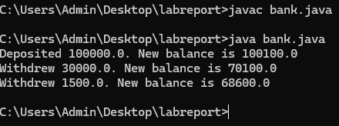

ERROR TABLE :

|  |  |
| --- | --- |
| **Code Error** | **Code rectification** |
| Parenthesis is missing | Added parenthesis to the statement. |

Class diagram:

|  |
| --- |
| BankAccount  ----------------------------------------------------------  -balance: double  ----------------------------------------------------------  +BankAccount(intialBalance: double)  +deposit(amount: double):void  +withdraw(amount: double):void |

**WEEK -4:**

**Program – 1**

**AIM:**  Write a java program with class named book. A class should contain various attributes such as title, author, year of publication. It should also contain a constructor with parameters which initializes title, author and year of publication. Create a method which displays the details of the book. Display the details of two books.

**CODE:**

class addition

{

public int add(int a, int b)

{

return a+b;

}

}

class subtraction extends addition{

public int sub(int a, int b)

{

return a-b;

}

}

class multiplication extends subtraction

{

public int mult(int a, int b)

{

return a*b;

}

}

class division extends multiplication

{

public int div(int a,int b)

{

return a/b;

}

}

class calculator2

{

public static void main(String args[])

{

division d = new division();

System.out.println("Addition is:"+d.add(8,2));

System.out.println("Subtraction is:"+d.sub(8,2));

System.out.println("Mult"+d.mult(5,6));

System.out.println("Divison is:"+d.div(4,2));

}

}

public class book

{

    String title;

    String author;

    int year;

    // Constructor

    public book(String title, String author, int year) {

        this.title = title;

        this.author = author;

        this.year = year;

    }

    // Method

    public void displayDetails() {

        System.out.println("Title: " + title);

        System.out.println("Author: " + author);

        System.out.println("Year of publication: " + year);

        System.out.println();

    }

    public static void main(String[] args) {

        //objects

        book book1 = new book("book 1", "author 1", 1999);

        book book2 = new book("book 2", "author 2", 2000);

        //book details

        System.out.println("Book 1 Details:");

        book1.displayDetails();

        System.out.println("Book 2 Details:");

        book2.displayDetails();

    }

}

**OUTPUT:**

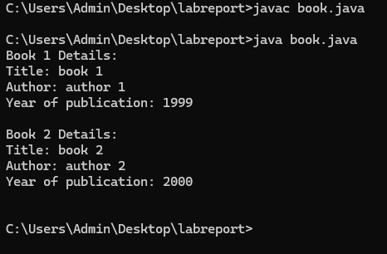

ERROR TABLE:

|  |  |
| --- | --- |
| **Code Error** | **Code rectification** |
| book.java:28: error: cannot find symbol  book1.display(); | By adding,  book1.displayDetails(); |

Class diagram:

|  |
| --- |
| book |
| - title: String  - author: String  - year: int |
| + Book(title: String, author: String, year: int)  + displayDetails(): void |
| + main(args: String[]): void |

**Program – 2**

**AIM:**  Create a java program with class name “myclass” with static variable count of int type. Initialize it to zero and a constant variable pi of type double. Initialize pi to 3.14 as attributes of class. Now define a constructor for “myclass” that increments the count variable each time an object of “myclass” is created. Finally print the final values of count and pi variables. Create three objects.

**CODE:**

public class myclass

{

    static int count = 0;

    final double PI = 3.14;

    myclass() {

        count++;

    }

    void display() {

        System.out.println("Count: " + count);

        System.out.println("PI: " + PI);

    }

    public static void main(String[] args) {

        myclass obj1 = new myclass();

        myclass obj2 = new myclass();

        myclass obj3 = new myclass();

        obj3.display();

    }

}

**OUTPUT:**

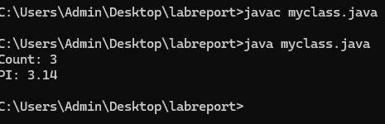

ERROR TABLE:

|  |  |
| --- | --- |
| **Code Error** | **Code rectification** |
| myclass.java:7: error: illegal start of expression  count+; | By adding,  count++; |

Class diagram:

|  |
| --- |
| myclass |
| - static count: int  - final PI: double |
| + MyClass()  + display(): void  + main(args: String[]): void |

IMPORTANT POINTS:

1. We must declare the initial value of the variable before declaring the final one.
2. Here the main objective is to increase the count according to the number of objects we make, i.e the count increases when the no.of objects are increasing.

**WEEK -5:**

1. **AIM:**  create a calculator using the operation including adding, subtraction,multiplication,and division using multilevel inheritance and display desired output

every class one method (int a ,int b)

pass values as parameter during method call

**CODE:**

class addition

{

public int add(int a, int b)

{

return a+b;

}

}

class subtraction extends addition{

public int sub(int a, int b)

{

return a-b;

}

}

class multiplication extends subtraction

{

public int mult(int a, int b)

{

return a*b;

}

}

class division extends multiplication

{

public int div(int a,int b)

{

return a/b;

}

}

class calculator2

{

public static void main(String args[])

{

division d = new division();

System.out.println("Addition is:"+d.add(8,2));

System.out.println("Subtraction is:"+d.sub(8,2));

System.out.println("Mult"+d.mult(5,6));

System.out.println("Divison is:"+d.div(4,2));

}

}

**OUTPUT:**

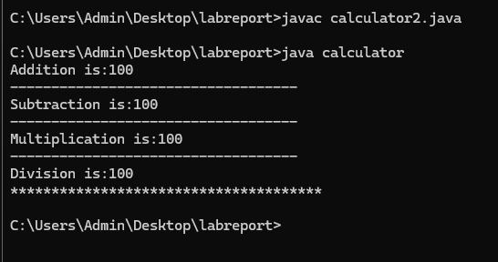

Negative case:

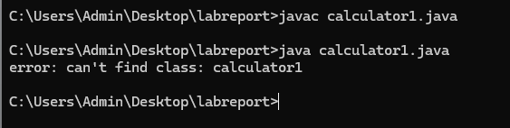

ERROR TABLE:

|  |  |
| --- | --- |
| **Code Error** | **Code rectification** |
| can't find main(String[]) method in class: Calculator | By adding this method |

Classs diagram:

|  |
| --- |
| Class : addition |
| + add( int a ,int b) |
|  |

|  |
| --- |
| Class : subtraction |
| + sub( int a ,int b) |

|  |
| --- |
| Class : multiplication |
| + multi( int a ,int b) |

|  |
| --- |
| Class : divission |
| + div( int a ,int b) |

important points :

1. used contructor and ssigned values as int a and int b.
2. used multilevel unheritance .

used this keyword to assign values

**Program – 2**

**AIM:** A vehicle rental company wants to develop a system that maintains Information about different types of vehicles available for rent The Company rents out cars, bikes and truck and they need a program to Store details about each vehicle, such as brand and speed Cars should have an additional property: number of doors Bikes should have a property indicating whether they have gears or not The system should also include a function to display details about each vehicle And indicate when a vehicle is starting

**CODE:**

class vehicle{

String brand;

int speed;

public vehicle(String brand,int speed){

this.brand=brand;

this.speed=speed;

}

public static void main(String[] args) {

car obj1=new car("maruti",133,7);

bike obj2=new bike("unicorn",75,true);

truck obj3=new truck("zimban",120,16);

}

}

class car extends vehicle{

int noofdoors;

public car(String brand, int speed,int noofdoors) {

super(brand, speed);

this.noofdoors=noofdoors;

System.out.println(brand);

System.out.println(speed);

System.out.println(noofdoors);

}

}

class bike extends vehicle{

boolean gears;

public bike(String brand,int speed,boolean gears){

super(brand, speed);

this.gears=gears;

System.out.println(brand);

System.out.println(speed);

System.out.println(gears);

}

}

class truck extends vehicle{

int weight;

public truck(String brand,int speed,int weight){

super(brand,speed);

this.weight=weight;

System.out.println(brand);

System.out.println(speed);

System.out.println(weight);

}

public static void main(String[] args) {

car obj1=new car("maruti",133,7);

bike obj2=new bike("unicorn",75,true);

truck obj3=new truck("zimban",120,16);

}

}

**OUTPUT:**

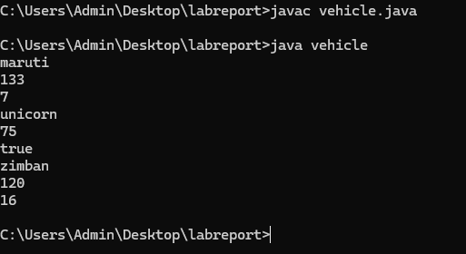

Negative case:

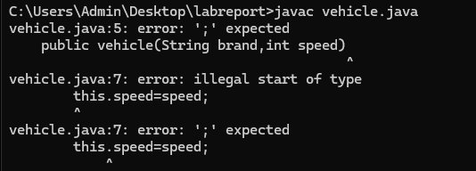

ERROR TABLE:

|  |  |
| --- | --- |
| **Code Error** | **Code rectification** |
| Vehicle.java:28: error: cannot find symbol  c1.showCarDetails; | By adding  c1.showCarDetails(); |

Class Diagram :-

+----------------------------+

| Vehicle |

+----------------------------+

| - brand: String |

| - speed: int |

+----------------------------+

| +Vehicle(String, int) |

| +start(): void |

+----------------------------+

▲

------------------------------|------------------------------

| | |

+---------------+ +---------------+ +------------------+

| Car | | Bike | | Truck |

+---------------+ +---------------+ +------------------+

| - doors: int | | - hasGears:| | - capacity: int|

| | | boolean | | |

+-----------------+ +---------------+ +------------------+

| +Car(...) | | +Bike(...) | | +Truck(...) |

| +showCar...()| | +showBike...()| | +showTruck...()|

+---------------+ +------------------+ +-------------------+

**Important points:**

1.Inheritance:

Obtaining the qualities from parent class.

2.hirechial inheritance: different child class obtaing qualities from one parent.

**WEEK -6:**

**AIM**: Write a java program to create a vehicle class with a method displayInfo().Override this method in the car subclass to provide specific information a about car

**CODE:**

class Car extends Vehicle2 {

Car(String brand, int speed, int capacity) {

super(brand, speed, capacity);

}

public void displayInfo() {

System.out.println("Car Details:");

System.out.println("--------------------------------");

System.out.println("Brand: " + brand);

System.out.println("Speed: " + speed + " km/h");

System.out.println("Capacity: " + capacity + " people");

}

}

public class vehicle2 {

public static void main(String[] args) {

Vehicle2 vehicle = new Vehicle2("Luna", 78, 5);

vehicle.displayInfo();

System.out.println();

Car car = new Car("bonda", 120, 7);

System.out.println("car details are given below :");

car.displayInfo();

}

}

**OUTPUT:**

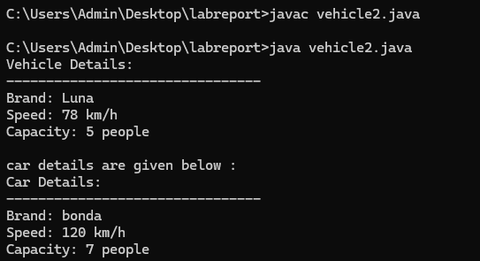

Negative case: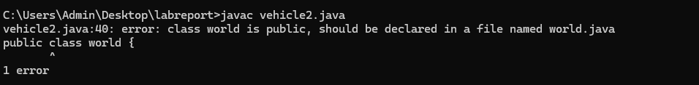

Class Diagram :-

+---------------------------+

| Vehicle |

+----------------------------+

| +displayInfo(): void |

+---------------------------+

▲

|

+---------------------------+

| Car |

+---------------------------+

| +displayInfo(): void |

+--------------------------+

+------------------+

| info |

+------------------+

| +main(String[]): void |

+------------------+

Important points:

1. **Inheritance** allows the Car class to reuse the Vehicle class functionality without repeating code.

2. **Method Overriding** enables the Car class to provide its own implementation of the displayInfo() method.

3. **Polymorphism** makes the code flexible, allowing different classes (e.g., Car, Bike) to provide customized behavior for displayInfo().

**2.**

**AIM**: A college is developing an automated admission system that verifies student eligibility for UG and PG programs. Each program has different eligibility criteria based on the student’s percentage in their previous Qualification:

UG admissions require a minimum of 60%

PG admissions require a minimum of 70%

**CODE:**

class University {

String name;

int percentile;

University(String name, int percentile) {

this.name = name;

this.percentile = percentile;

}

public void office() {

System.out.println("Admission criteria are mentioned below.");

}

}

class PG extends University {

PG(String name, int percentile) {

super(name, percentile);

}

@Override

public void office() {

if (percentile >= 70) {

System.out.println(name + " is eligible for PG admission.");

} else {

System.out.println(name + " is not eligible for PG admission.");

}

}

}

class UG extends University {

UG(String name, int percentile) {

super(name, percentile);

}

@Override

public void office() {

if (percentile >= 60) {

System.out.println(name + " is eligible for UG admission.");

} else {

System.out.println(name + " is not eligible for UG admission.");

}

}

}

public class Admissions {

public static void main(String[] args) {

UG ugStudent = new UG("krishna", 95);

PG pgStudent = new PG("manoj", 96);

ugStudent.office();

pgStudent.office();

}

}

**OUTPUT:**

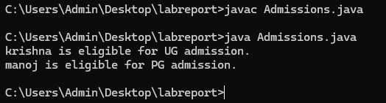

Negative case:

Class Diagram :-

+---------------------+

| College |

+---------------------+

| + main(String[]): void |

+---------------------+

| - Scanner object used |

| - String a (program) |

| - double b (percentage)|

| - if-else logic for eligibility |

+---------------------+

ERROR TABLE:

|  |  |
| --- | --- |
| **Code Error** | **Code rectification** |
| College.java:21: error: ';' expected  elif (a.equals("PG")) {  ^  College.java:28: error: 'else' without 'if'  else {  ^ | Replacing elif with else if. |

IMPORTANT POINTS:

1.**Inheritance** allows PG and UG classes to reuse the University class’s attributes and constructor.

2. **Method Overriding** customizes the office() method in PG and UG classes to implement specific admission criteria.

3. **Polymorphism** enables the same office() method to behave differently for PG and UG objects based on their typ

3.

**AIM**: Create a Shape class with a method calculateArea() that is overloaded forDifferent shapes. Then, create a subclass circle that overrides the calculateArea() method for a circle

**CODE:**

class Shape {

public void calculateArea(int length, int width) {

int area = length * width;

System.out.println("Area of Rectangle: " + area);

}

public void calculateArea(double base, double height) {

double area = 0.5 * base * height;

System.out.println("Area of Triangle: " + area);

}

public void calculateArea(int side) {

int area = side * side;

System.out.println("Area of Square: " + area);

}

}

class Circle extends Shape {

public void calculateArea(double radius) {

double area = 3.14 * radius * radius;

System.out.println("Area of Circle: " + area);

}

}

public class calculateArea {

public static void main(String[] args) {

Shape shape = new Shape();

shape.calculateArea(5, 45);

shape.calculateArea(7.0, 34.0);

shape.calculateArea(7);

Circle circle = new Circle();

circle.calculateArea(15.0);

}

}

**OUTPUT:**

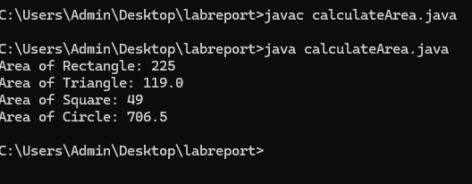

Negative case:

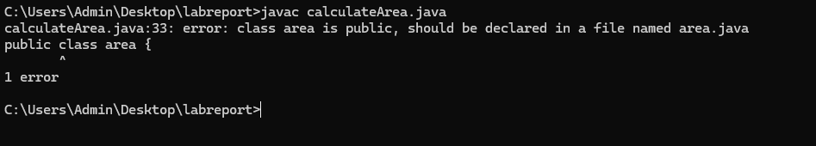

Class Diagram :-

+-----------------------------+

| Shape |

+-----------------------------+

| + calcArea(double side) |

| + calcArea(double length, double breadth) |

+-----------------------------+

▲

|

+-----------------------------+

| Circle |

+-----------------------------+

| + calcArea(double radius) |

+-----------------------------+

+-----------------------------+

| Area |

+-----------------------------+

| + main(String[] args): void |

+-----------------------------+

ERROR TABLE:

|  |  |
| --- | --- |
| **Code Error** | **Code rectification** |
| Parenthesis is missing in line 16 | Adding parenthesis to the statement. |

IMPORTANT POINTS :

1. **Method Overloading** allows the Shape class to calculate areas for different shapes (rectangle, triangle, square) using multiple calculateArea() methods with different parameters.
2. **Method Overriding** in the Circle class provides a custom implementation of calculateArea() for calculating the area of a circle.
3. **Polymorphism** enables objects of different types (e.g., Shape, Circle) to call the appropriate version of calculateArea() based on the object type and input parameters.

**4.**

**AIM**:Create a calculator class with overloaded methods to perform addition

1. Add two integers 2. Add two doubles 3. Add three integers

**CODE:**

public class Addition {

    void addition(int a, int b) {

        System.out.println("Addition of two integers :"+(a+b));

    }

    void addition(double a, double b){

        System.out.println("Addition of two double numbers :"+(a+b));

    }

    void addition(int a,int b,int c){

        System.out.println("Addition of three integers :"+(a+b+c));

    }

}

class overload{

    public static void main(String[] args) {

    Addition obj = new Addition();

    obj.addition(10, 15);

    obj.addition(20, 15, 15);

    obj.addition(55.5, 44.5);

}

}

ERROR TABLE:

|  |  |
| --- | --- |
| **Code Error** | **Code rectification** |
| Missing semicolon in line 14 | By adding semicolon to that line |

IMPORTANT POINTS :-

1. The program demonstrates **method overloading** — multiple methods with the same name but different parameters.
2. The Addition class has three addition() methods handling different data types and number of arguments.
3. Overloading improves **code readability and reusability** by grouping similar operations under one method name.
4. The main() method in the overload class creates an object and calls all overloaded versions of addition().

**OUTPUT:**

